Mitchell River 2022
East Gippsland region

This report card summarises the 2022 Native Fish Report Card (NFRC) survey in the Mitchell River
Sites 11, EGCMA, Electrofishing

Fish found in Mitchell River for NFRC
Target species
Australian Bass
Australian Grayling
Non-target species captured since 2017*
Large-bodied native species
Cox’s Gudgeon
Long-finned Eel
Short-finned Eel
Short-head Lamprey
Striped Gudgeon
Tupong
A further 10 species which are estuarine (see next page)

Small-bodied native species
Australian Smelt
Common Galaxias
Dwarf Flatheaded Gudgeon
Flatheaded Gudgeon
Australian Anchovy (estuarine sp.)
Port Jackson Glassfish (estuarine sp.)

Exotic species
Common Carp

* These non-target species were incidentally captured during NFRC surveys since 2017 but not measured as for target species. LOGOS – ARI, DELWP
Mitchell River 2022
Fish Community

NFRC target species
The NFRC Program began in 2017, with a focus on targeting the monitoring of population dynamics of key iconic fish species that have high recreational and/or conservation values, in large rivers across Victoria. In the Mitchell River, the target species are Australian Bass and Australian Grayling. Surveys occur in February each year, at 11 sites from Bairnsdale to Kingswell Bridge. The Mitchell River uses Smith-root boat electrofishing, with elevated salinities at the two bottom sites requiring Grassl boat electrofishing¹. The equipment and habitats surveyed are focused on these species, which are measured to determine population structures. Other fish species that are incidentally captured are recorded, but not measured to determine their population structures.

Summary of key health indicators for target species in 2022
Species | Key Health Indicators
 | Recent recruitment | Multiple size classes | Mature fish present
Australian Bass | Yes | Yes | Yes
Australian Grayling | - | - | -

Recent recruitment means young-of-year fish
*- cannot be determined due to low abundances

Australian Bass are close to the edge of their natural range in the Mitchell River system. Historically they occurred no further west than Wilsons Promontory. Australian Bass are an important recreational species in the Mitchell River with the population aided by stockings. Australian Grayling were once widespread throughout coastal Victoria, including the Mitchell River system. Changes to flow regimes and barriers have impacted this species. The detection of Australian Grayling in four of the five years indicates that conditions are suitable for the population.

Non-target species
The non-target fish species that have been incidentally recorded in the Mitchell River during NFRC surveys since 2017 are:

Large-bodied native species
Other large-bodied species recorded in surveys are Black Bream, Cox’s Gudgeon, Eastern Australian Salmon, Estuary Perch, Flat-tail Mullet, Long-finned Eel, Luderick, River Garfish, Sand Mullet, Sea Mullet, Short-finned Eel, Short-head Lamprey, Striped Gudgeon, Tailor, Tupong and
Yellow-eye Mullet. Ten of these species (Black Bream, Eastern Australian Salmon, Estuary Perch, Flat-tail Mullet, Luderick, River Garfish, Sand Mullet, Sea Mullet, Tailor and Yellow-eye Mullet) are considered as estuarine species. Long-finned and Short-finned Eel, Short-headed Lamprey and Tupong are diadromous species found throughout coastal Victoria. Within Victoria, Cox’s Gudgeon and Striped Gudgeon are only found in coastal areas of eastern Victoria. Cox’s Gudgeon is listed as endangered under the Flora and Fauna Guarantee Act 1988 in Victoria. Cox’s Gudgeon was recorded in 2019 (the first record in the Mitchell catchment since 1982) and again in 2021 and 2022. The Striped Gudgeon was recorded in 2017 and 2018.

Small-bodied native species
The Australian Smelt is a common species distributed across all of Victoria. The Common Galaxias is a diadromous species found across coastal Victoria. Flatheaded Gudgeon is common across Victoria, whilst Dwarf Flatheaded Gudgeons have a more restricted distribution and a rarer. Both Australian Anchovy and Port Jackson Glassfish are estuarine species and are only expected to be detected at the most downstream two sites.

Exotic fish species
Common Carp have been detected in all sampling years and are widespread throughout the Mitchell River, with juvenile Common Carp detected as far as Kingswell Bridge in 2020.

Other native species known from the Mitchell River
Some fish species known to occur in the Mitchell River have never been recorded during NFRC surveys. For example, no Climbing Galaxias, Dwarf Galaxias, Mountain Galaxias or Spotted Galaxias, Flinders Pygmy Perch, Pouched Lamprey or River Blackfish have been detected in the surveys. The Climbing Galaxias, Spotted Galaxias and Pouched Lamprey are diadromous species occurring in coastal Victoria. The Climbing Galaxias and Spotted Galaxias have patchy distributions and are found in lowland areas but are hard to detect using NFRC sampling methodology. The Pouched Lamprey was considered widespread but in recent times adults are rarely seen and are usually active nocturnally. The Mountain Galaxias is found on both sides of the Great Dividing Range from Melbourne eastwards in Victoria. In the Mitchell River they are widespread and patchy in the lower areas, but more common in higher altitudes and are hard to detect using the NFRC sampling methodology. The Dwarf Galaxias (listed as vulnerable nationally under the Environmental Protection and Biodiversity Conservation Act 1992) and Flinders Pygmy Perch (listed as vulnerable in Victoria under the Flora and Fauna Guarantee Act 1988) are often found in offstream habitats. The River Blackfish are a lowland species, generally found at altitudes below 200 metres. This species has suffered a decline in distribution and abundance across Victoria and was historically considered to be widespread, but with a patchy distribution within the Mitchell River basin².

Other notable species
Surveys have also recorded Platypus.

LOGOS – ARI, DELWP, NFRC

1. Lieschke, Jason A., Dean, Jan, C and Pickworth, Andrew 2019. Extending the Effectiveness of Electrofishing to Estuarine Habitats: Laboratory and Field Assessments. Transactions of the American Fisheries Society, 148:584–591.
2. Lieschke, J.A., Dodd, L., Stoessel, D., Raadik, T.A., Steelcable A., Kitchingman, A. and Ramsey, D. (2013). The status of fish populations in Victorian rivers 2004–2011 – Part A. Arthur Rylah Institute for Environmental Research Technical Report Series No. 246. Department of Environment and Primary Industries, Heidelberg, Victoria.

Mitchell River 2022
Environmental and Management Context

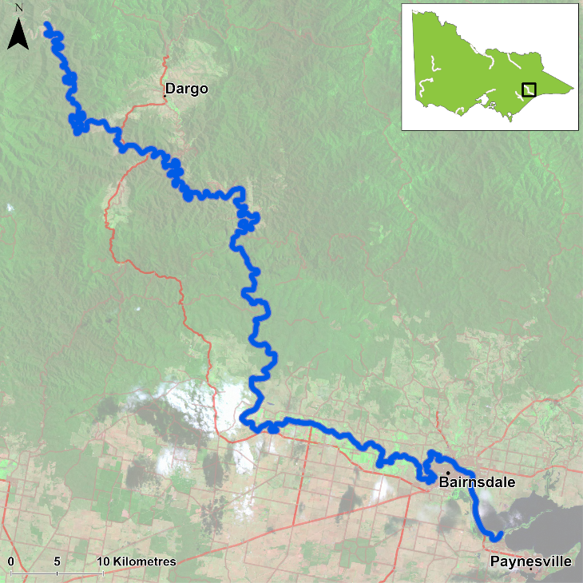
Figure 1. Map showing the section of Mitchell River where NFRC sampling occurs

Environment
Higher than normal flow conditions were experienced in 2022 compared to 2017-20 with 2021 being slightly higher than 2017-20. During 2020 and 2021 there was elevated turbidites due to increased sediment loads following the 2019/2020 fires. These elevated turbidities will have decreased electrofishing efficiency in those two years. The higher flows restricted access to one site, therefore only 10 sites were fished in 2022.

River rehabilitation efforts in the Mitchell River
Many rehabilitation actions have occurred, and are underway, to improve the health of the Mitchell River. These are informed in particular by the East Gippsland Waterway Strategy 2014-2022. Efforts include revegetation, weed control and fencing of riparian areas, bank stabilisation and reintroduction of instream woody habitat. Some monitoring of the fish community has occurred including associated with rehabilitation efforts. In the upper Mitchell River catchment well above the NFRC area, there have been surveys of a suite of threatened galaxiid species as well as Forest Protection Survey Program (FPSP) surveys of fish and crayfish. The East Gippsland Catchment Management Authority, DELWP and VFA support rehabilitation and management of the Mitchell River and its fish community.

PHOTOS
LOGOS – ARI, DELWP, NFRC

Australian Bass

Mitchell River, East Gippsland region

Key Health Indicators
Recent recruitment Yes
Multiple size classes Yes
Mature fish present Yes

Monitoring Results
Total number of fish caught 109
Fish per 1km of waterway 18.3
Largest fish by length (cm) 39.9
Largest fish by weight (kg) 1.30
% of the catch that is legal size 10.1

Australian Bass (Percalates novemaculeata) - formerly Macquaria novemaculeata - are a targeted recreational fishing species in the Mitchell River. Recruits, juveniles and adults have been collected in all six years of surveys (Figure 4). The population abundance is dominated by recruits, which are likely from stockings. Even though recruits made up over 50% of the fish collected in 2022, there was a wide range of size classes including large adult fish (Figure 5). In 2022, there was an increase in juveniles, the most juveniles collected since 2017.

Stocking
Ten thousand Australian Bass were stocked in late 2016; 150,000 in late 2017; 30,000 in late 2018, 44,000 in 2019; 66,000 in 2020 and 100,000 in November 2021.
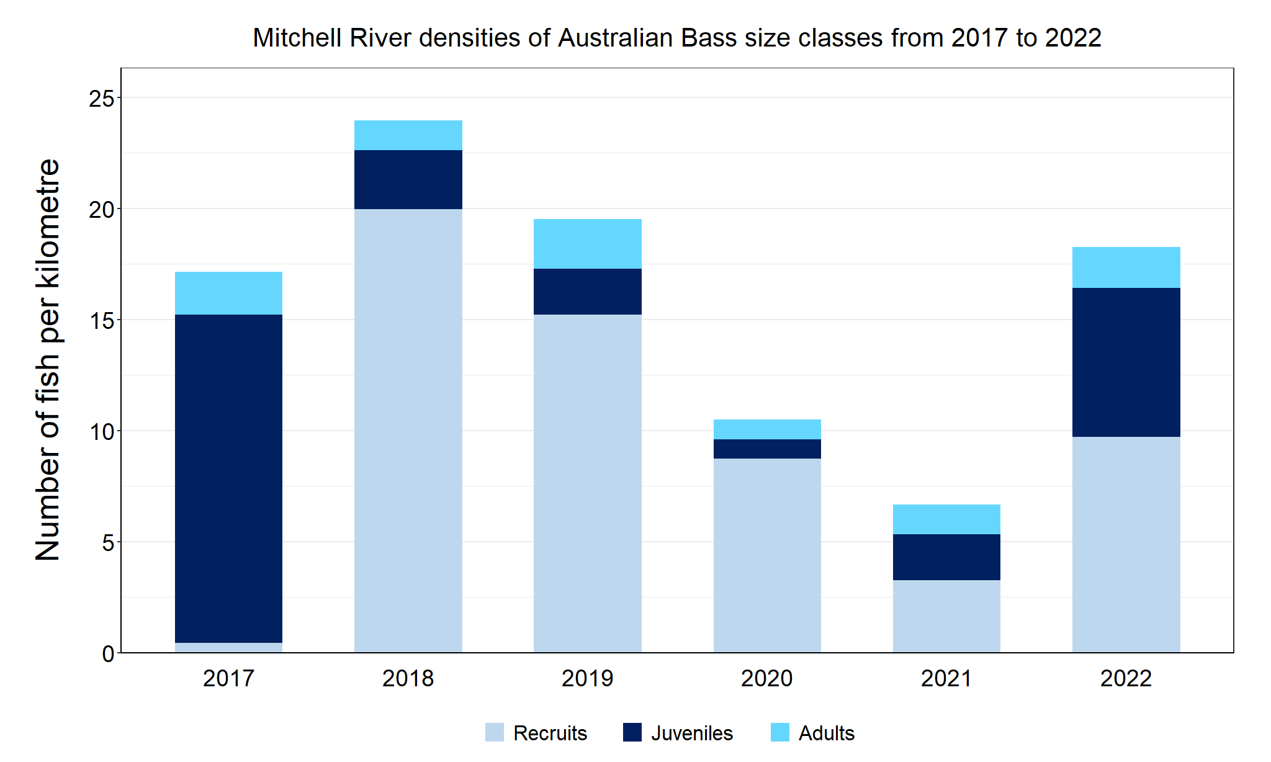
Figure 4. The densities of recruits, juveniles and adult Australian Bass in the Mitchell River from 2017 to 2022

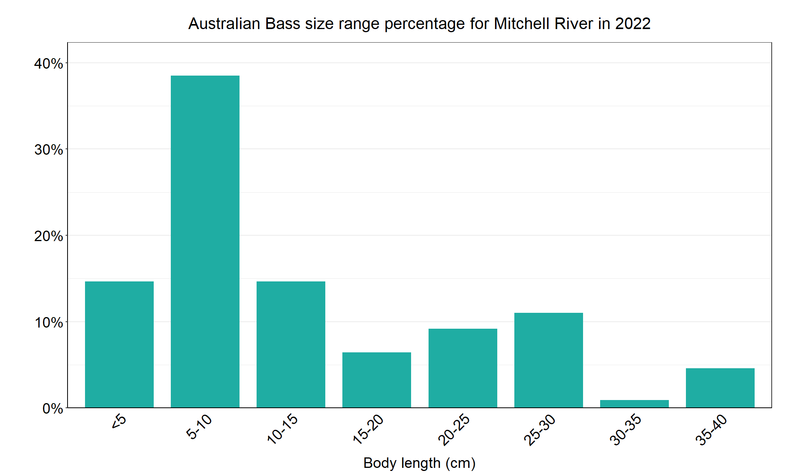
Figure 5. The size range percentage of Australian Bass in the Mitchell River in 2022

Australian Grayling

Australian Grayling, East Gippsland region

Key Health Indicators
Recent recruitment Cannot be determined
Multiple size classes Cannot be determined
Mature fish present Cannot be determined

Monitoring Results
Total number of fish caught 3
Fish per 1km of waterway 0.5
Largest fish by length (cm) 11.1
Largest fish by weight (kg) 0.01
% of the catch that is legal size NA

Australian Grayling (Prototroctes maraena) is a diadromous species which has undergone declines in distribution and abundance across its range. The species is listed as endangered in Victoria (Flora and Fauna Guarantee Act 1988) and nationally (Environmental Protection and Biodiversity Act 1992). While NFRC expects to only capture low numbers of this species, the monitoring can provide a greater understanding of the current status of the populations which is essential to inform management of these species. Due to the low abundances of Australian Grayling collected during NFRC the key health indicators cannot be determined. However, low abundances of adults have been captured in 2017, 2019, 2020 and 2021 (Figure 6). Low abundances of recruits were detected in 2020 and 2021, while low abundances of juveniles were detected in 2017 and 2022 (Figure 6; Figure 7). The juveniles detected in 2022 are likely the same year class as recruits detected in 2021. This indicates stream conditions were suitable for recruits to be attracted into the system in 2020, despite elevated sediment loads following the 2019/2020 fires and that they have survived through to 2022. It is worth noting that seven adult fish were recorded in the Dargo River (a tributary of Mitchell River) during autumn 2019 as part of another program (Wild Trout Fisheries Management program -Lieschke unpublished data).

Stocking
No stocking has occurred.
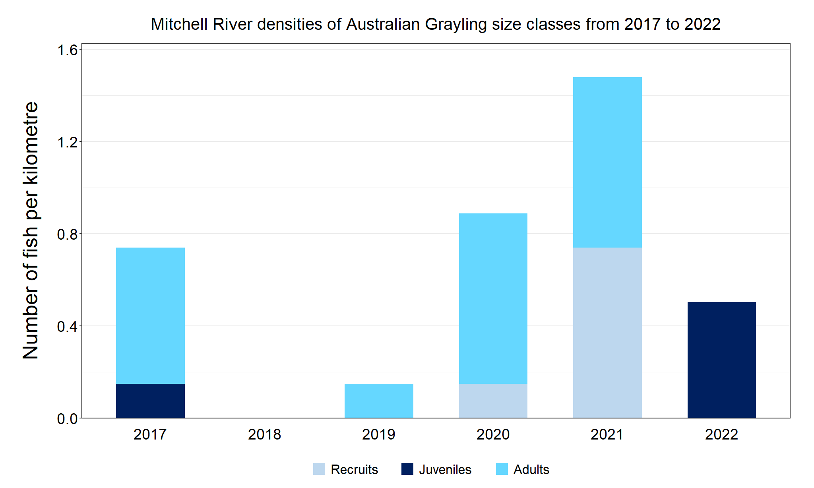
Figure 6. The densities of recruits, juveniles and adult Australian Grayling in the Mitchell River from 2017 to 2022

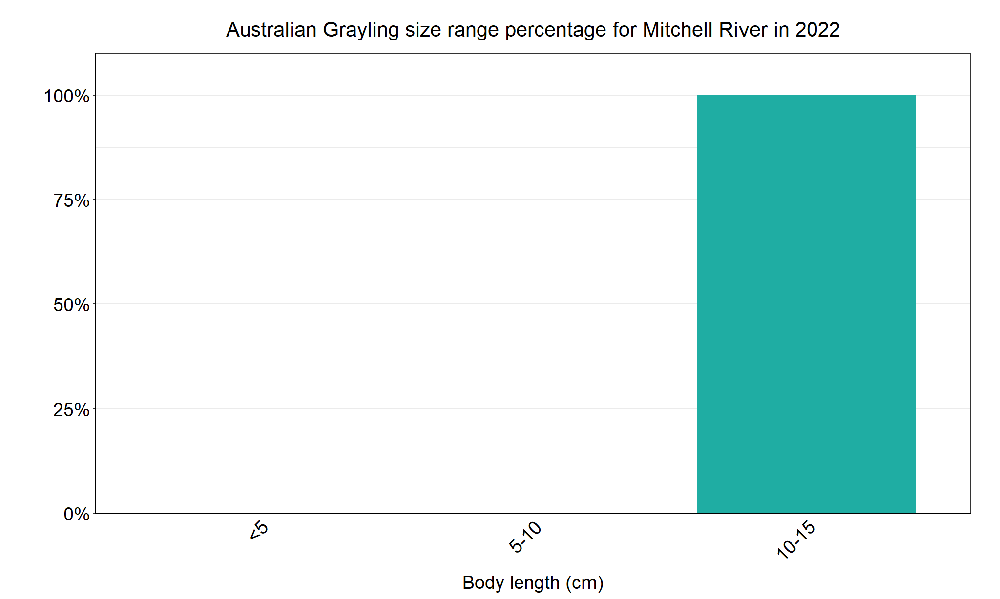
Figure 7. The size range percentage of Australian Grayling in the Mitchell River in 2022

We acknowledge and respect Victorian Traditional Owners as the original custodians of Victoria’s land and waters, their unique ability to care for Country and deep spiritual connection to it. We honour Elders past and present whose knowledge and wisdom has ensured the continuation of culture and traditional practices.

