Ovens River 2022
North East region

This report card summarises the 2022 Native Fish Report Card (NFRC) survey in the Ovens River
Sites 12, NECMA, Electrofishing

Fish found in Ovens River for NFRC
Target species
Golden Perch
Macquarie Perch
Murray Cod
Trout Cod

Non-target species captured since 2017*
Large-bodied native species
River Blackfish
Two-spined Blackfish

Small-bodied native species
Australian Smelt
Carp Gudgeon
Flatheaded Gudgeon
Unspecked Hardyhead
Obscure Galaxias

Exotic species
Common Carp
Eastern Gambusia
Goldfish
Oriental Weatherloach
Redfin
Rainbow Trout

* These non-target species were incidentally captured during NFRC surveys since 2017 but not measured as for target species

LOGOS – ARI, DELWP

Ovens River 2022
Fish Community

NFRC target species
The NFRC Program began in 2017, with a focus on targeting the monitoring of population dynamics of key iconic fish species that have high recreational and/or conservation values, in large rivers across Victoria. In the Ovens River, the target species are Golden Perch, Macquarie Perch, Murray Cod and Trout Cod. Surveys occur in March/April each year, at 12 sites from just downstream of Porepunkah to the junction with Lake Mulwala (Boorhaman North). The equipment and habitats surveyed are focused on these species, which are measured to determine population structures. Other fish species that are incidentally captured are recorded, but not measured to determine their population structures.

Summary of key health indicators for target species in 2022
Species | Key Health Indicators
 | Recent recruitment | Multiple size classes | Mature fish present
Golden Perch | No | No | Yes
Macquarie Perch | Yes | Yes | Yes
Murray Cod | Yes | Yes | Yes
Trout Cod | No | Yes | Yes

Both Macquarie Perch and Trout Cod were historically abundant in the lower and mid Ovens River, but experienced dramatic declines until they were considered locally extinct. The status of both species has now improved in recent times. Overall, the Ovens River appears to be maintaining healthy Murray Cod and Trout Cod populations. Golden Perch are historically rare upstream of Wangaratta, while low numbers of adults are consistently found downstream. An integrated program for the recovery of Macquarie Perch is showing encouraging results. As the section surveyed is downstream of the cooler trout waters, large abundances of these species are not expected in the NFRC surveys.

Non-target species
The non-target fish species that have been incidentally recorded in the Ovens River during NFRC surveys since 2017 are:

Large-bodied native species
Other large-bodied species recorded in fish surveys are River Blackfish and Two-spined Blackfish. Two-spined Blackfish are only found at the top few sites monitored in the Ovens River. Across its range, the species occurs above 200 m altitude, with few records down to 180 m altitude (this correlates to around Whoroully in the Ovens system). River Blackfish are a lowland species, generally found at altitudes below 200 metres. This species has suffered a decline in distribution and abundance across Victoria. It has been recorded in all years in the Ovens system, being more frequently recorded upstream of Wangaratta.

Small-bodied native species
Some of the small-bodied species recorded within the Ovens River, including Australian Smelt and Flatheaded Gudgeon, are common and widespread throughout this river and more broadly within the Murray-Darling Basin. The Unspecked Hardyhead is a lowland species and only found in the lower regions of tributaries of the Murray River. This species is not expected to be found at the upper sites. Similarly, Carp Gudgeon are a lowland species and are not expected to be recorded above 200 m altitude. These are more common in slower flowing habitats, especially downstream Wangaratta. The Obscure Galaxias is normally found in lowland areas up to 260 m altitude.

Exotic fish species
Common Carp and Goldfish are widely distributed across sampling sites, with Eastern Gambusia more common in the slower flowing waters. Redfin are also distributed throughout, but in lower abundances. Weatherloach are increasing in distribution and abundance and are found in slower flowing areas, often in silt substrate. This species often disperses during floods. Rainbow Trout are a cool water species and were collected at the most upstream site in 2022. This is not unexpected after the cool and wet spring summer of 2021/2.

Other native fish species known from the Ovens River
Some fish species known to occur in the Ovens River have never been recorded during NFRC surveys and for some species is likely due to the habitats they live in not being surveyed. For example, no Flatheaded Galaxias, Silver Perch or Southern Pygmy Perch have been recorded. Both Flatheaded Galaxias and Southern Pygmy Perch are often more common in offstream habitats such as billabongs, wetlands and lagoons. Silver Perch have been historically recorded to up to 140 m altitude and have experienced dramatic declines across their range.

Other notable species
Surveys have also recorded Murray Crayfish, Yabbies, Eastern Long-necked Turtles and Platypus.

LOGOS – ARI, DELWP, NFRC

Ovens River 2022
Environmental and Management Context

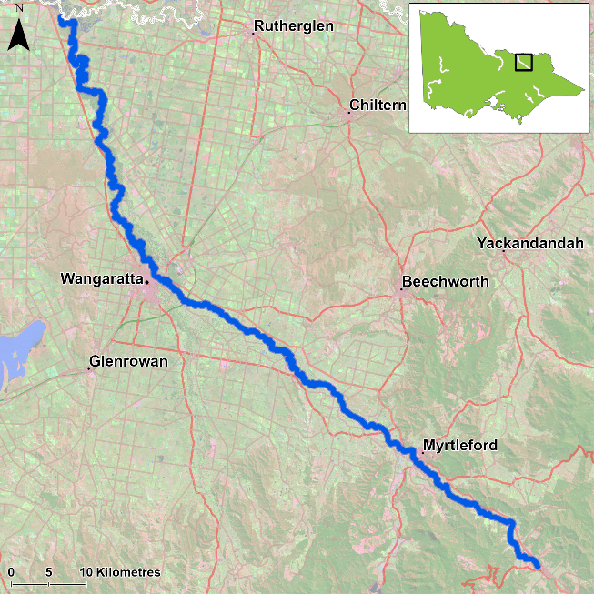
Figure 1. Map showing the section of Ovens River where NFRC sampling occurs

Environment
In 2022, river flows were similar to 2020 and 2021, but higher than 2017-19 sampling events. The higher flows impact on the sampling efficiency, especially for small species or small individuals of large-bodied species. The 2020-22 survey results are therefore likely lower than comparable sampling conditions in 2017-19.

River rehabilitation efforts in the Ovens River
River rehabilitation efforts in the Ovens River
Many rehabilitation actions have occurred, and are underway, to improve the health of the Ovens River and its suite of large-bodied native fish species including Murray Cod, Trout Cod, Golden Perch and Macquarie Perch. These are informed by the North East Waterway Strategy 2014-22. In particular, since 2008, there has been a large scale coordinated effort by many government agencies and the community to protect and plant streamside vegetation, install instream woody habitat and fishways to improve fish passage, and remove Carp. These efforts include the Demonstration Reach program and targeted monitoring for Macquarie Perch and Trout Cod, as well as reintroduction and recovery efforts. The North East Catchment Management Authority, DELWP and VFA support rehabilitation and management of the Ovens River and its fish community.

PHOTOS
LOGOS – ARI, DELWP, NFRC

Golden Perch

Ovens River, North East region

Key Health Indicators
Recent recruitment No
Multiple size classes No
Mature fish present Yes

Monitoring Results
Total number of fish caught 3
Fish per 1km of waterway 0.44
Largest fish by length (cm) 34.5
Largest fish by weight (kg) 1.13
% of the catch that is legal size 100

Low abundances of Golden Perch (Macquaria ambigua) were detected in all years, with a slight increase in density detected in 2021 (Figure 4). Golden Perch were only collected downstream of Wangaratta in 2017 and 2018 with all individuals collected being adults. From 2019-21 juvenile Golden Perch were captured upstream of Wangaratta, with a single juvenile also detected downstream of Wangaratta in 2020 and 2021. These are the first small Golden Perch detected in the Ovens River and are likely to be the result of Golden Perch being stocked into the Ovens River (first stockings in 2017). Recruits of this species are difficult to catch using this sampling methodology of electrofishing and none have been detected in all six years of sampling (Figure 4; Figure 5). Adult Golden Perch were also collected upstream of Wangaratta in 2021 and 2022.

Stocking
In 2016 no Golden Perch were stocked; 30,000 stocked in 2017; 50,293 in early 2018; 51,000 in 2019; 54,000 in 2020; 50,000 in February 2021 and 54,000 in February/March 2022.
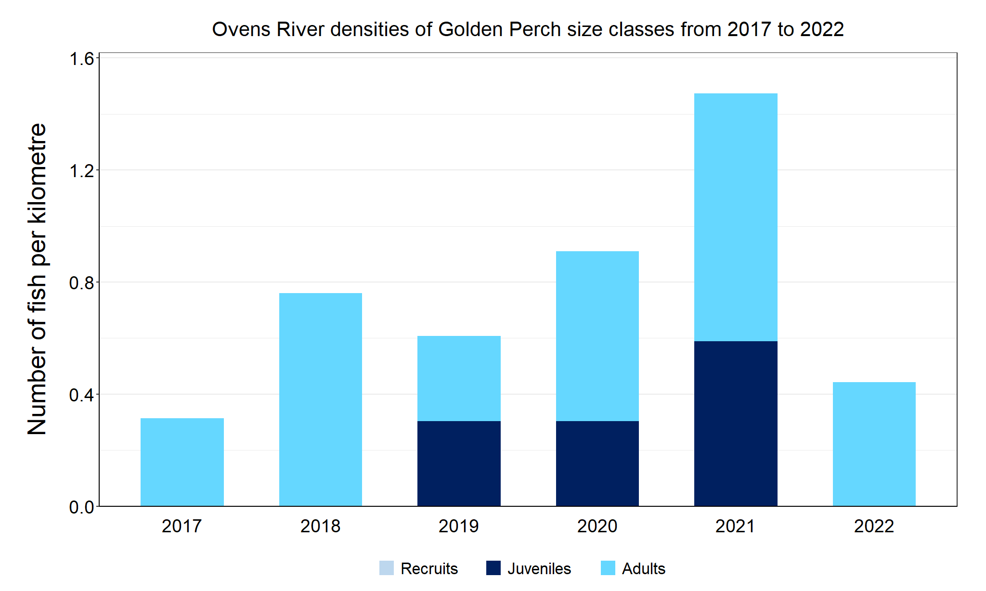
Figure 4. The densities of recruits, juveniles and adult Golden Perch in the Ovens River from 2017 to 2022

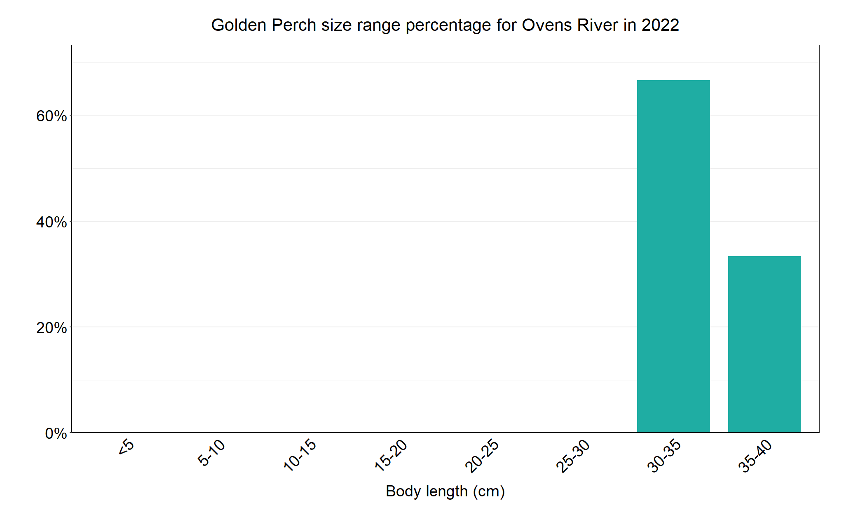
Figure 5. The size range percentage of Golden Perch in the Ovens River in 2022

Macquarie Perch

Ovens River, North East region

Key Health Indicators
Recent recruitment Yes
Multiple size classes Yes
Mature fish present Yes

Monitoring Results
Total number of fish caught 43
Fish per 1km of waterway 6.33
Largest fish by length (cm) 35.1
Largest fish by weight (kg) 0.71
% of the catch that is legal size NA

The abundance of Macquarie Perch (Macquaria australasica) declined during the three-year period of 2017 to 2019, with steady abundances since then (Figure 6). Few adults are recorded each year, with no adults recorded in 2020 and the most in 2022. No recruitment was recorded in 2021 (Figure 6). Most Macquarie Perch collected in all six years of sampling are predominantly juveniles (Figures 6, 7). From 2013- 2018 there was a concerted effort to translocate fish of different sizes and ages from Lake Dartmouth, rather than only stock fingerlings. Sixty-two ex-broodstock fish from the Yarra River and Lake Dartmouth were also released in 2016. A genetic analysis indicated that the Macquarie Perch caught in 2018 were a mix of fish that were stocked, translocated, and the result of natural breeding in the Ovens River, with recruits detected from both Yarra River and Lake Dartmouth fish1. The fish that resulted from natural breeding within the Ovens River had ancestors that were translocated fish from the Yarra River and Lake Dartmouth; there was much greater representation (thereby survival and recruitment) of fish with a mixed ancestry or ancestry from the Yarra River only. All Macquarie Perch have been captured upstream of Wangaratta but have extended more than 20km upstream of the stocking sites in the Ovens and lower Buffalo River, as well as in recent years, the King River near Edi. The most recent evaluation done on genetic samples since the intensive 2018 assessment indicated 94.1% of fish of the 2020-2022 Ovens/King River sample, were locally-born, with stocked fish comprising 5.9%2. This supports success of past management actions in establishing a population with natural recruitment continuing. Given the species is long-lived and has undergone population crashes shortly after establishment in other areas, continued monitoring is critical to track the success of the establishment of this species in the Ovens system.

Stocking
Stocking of fingerlings started in the Ovens River in 2011, and translocations from Lake Dartmouth started in 2014. Stockings relevant to NFRC survey areas include: 6400 fingerlings and 62 adult fish (ex-broodfish) into the Ovens River in 2016; 8300 fingerlings and 675 translocated fish in 2017; 15,000 fingerlings, 10 adult broodfish and 474 translocated fish in 2918 (following NFRC surveys); 7500 fingerlings in 2019; 700 fingerlings in 2020; 32,000 fingerlings in 2021 and 40,000 fingerlings in January 2022. All translocations involved a range of sizes from young-of-year to adults.
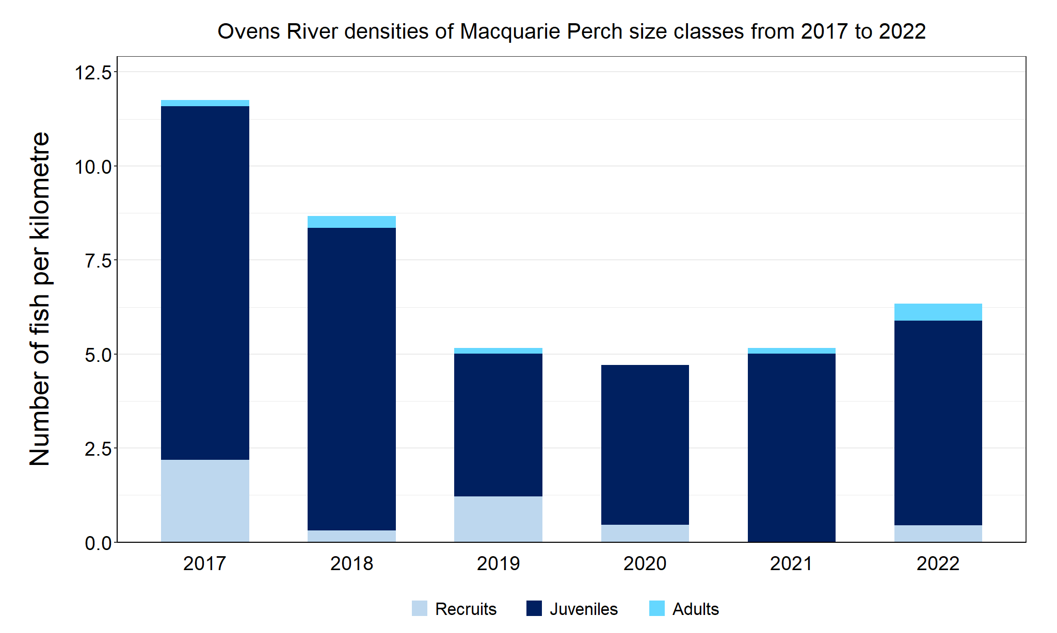
Figure 6. The densities of recruits, juveniles and adult Macquarie Perch in the Ovens River from 2017 to 2022

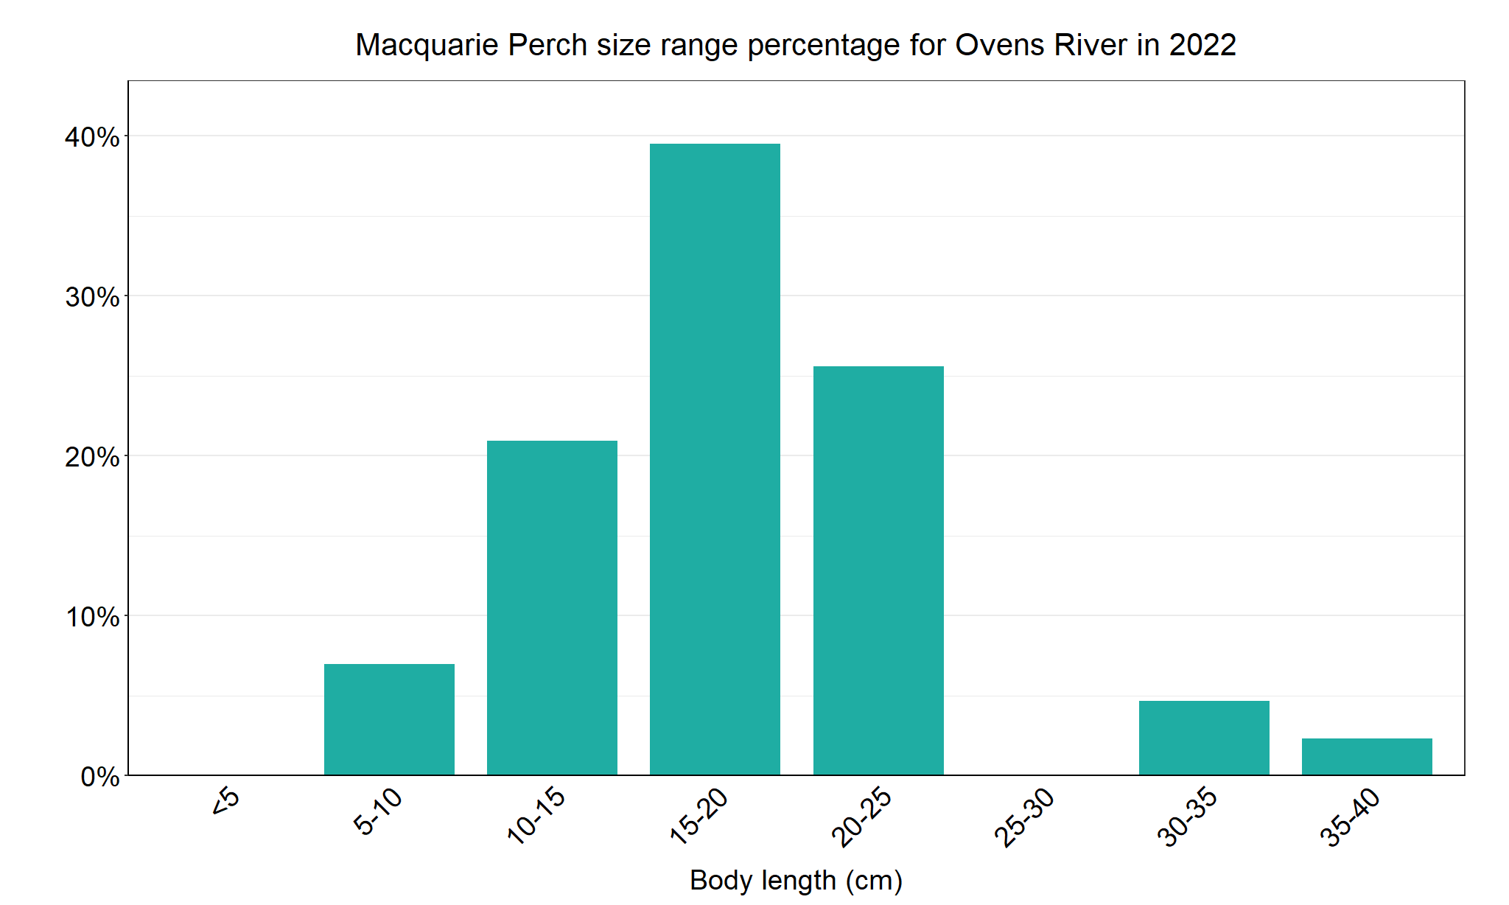
Figure 7. The size range percentage of Macquarie Perch in the Ovens River in 2022

- Maiko L. Lutz, Zeb Tonkin, Jian D.L. Yen, Glen Johnson, Brett A. Ingram, Joanne Sharley, Jarod Lyon, David G. Chapple, Paul Sunnucks and Alexandra Pavlova (2020). Using multiple sources during reintroduction of a locally extinct population benefits survival and reproduction of an endangered freshwater fish. Evolutionary Applications; 00:1–15.
- Sunnucks, P., Pavlova, A., 2022. Macquarie Perch recovery: Genetic management of the Upper Buffalo and Ovens Rivers. Unpublished internal report to DELWP Bushfire Biodiversity Response and Recovery program.
Murray Cod

Ovens River, North East region

Key Health Indicators
Recent recruitment Yes
Multiple size classes Yes
Mature fish present Yes

Monitoring Results
Total number of fish caught 142
Fish per 1km of waterway 20.91
Largest fish by length (cm) 97.3
Largest fish by weight (kg) 19
% of the catch that is legal size 19

Multiple size classes of Murray Cod (Maccullochella peelii) including mature and young-of-year fish were caught in all six years (Figure 8). Although abundances were lower in 2022, the surveys captured a range of sizes from 5-10cm to oversize (greater than 80cm) (Figure 9). The largest Murray Cod recorded in 2022 was 97cm long and Murray Cod were detected at every site surveyed. As no Murray Cod stocking occurs in the Ovens River it is likely that a large proportion of Murray Cod are from wild spawnings. The abundances of Murray Cod detected, the evidence of recruitment every year, and the presence of legal and oversize fish in the system indicate that the Murray Cod population is healthy. The Ovens River has the highest number of fish per kilometre surveyed compared to the other NFRC rivers which targeted Murray Cod (Goulburn, Gunbower and Lindsay-Mullaroo).

Stocking
No recent stocking has occurred in the area surveyed.

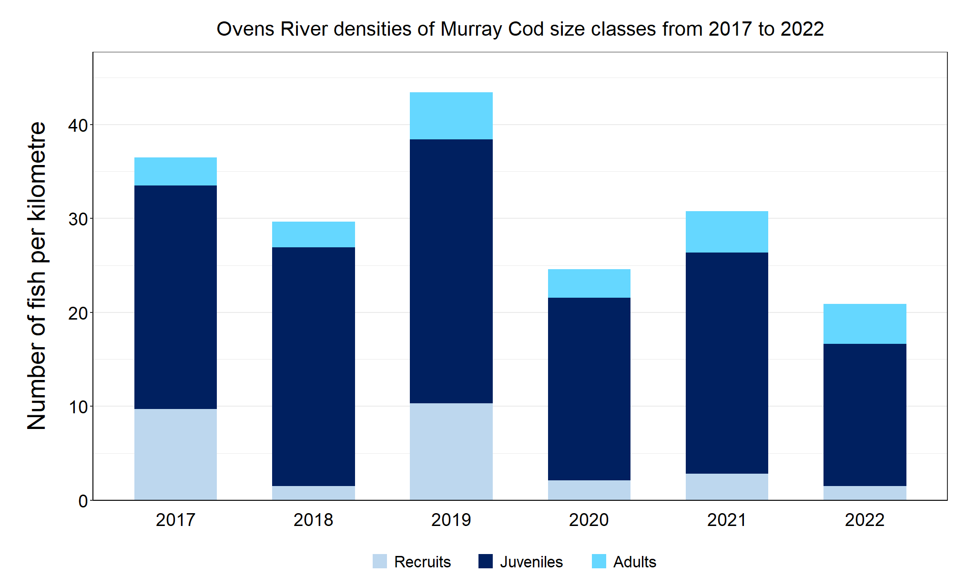
Figure 8. The densities of recruits, juveniles and adult Murray Cod in the Ovens River from 2017 to 2022

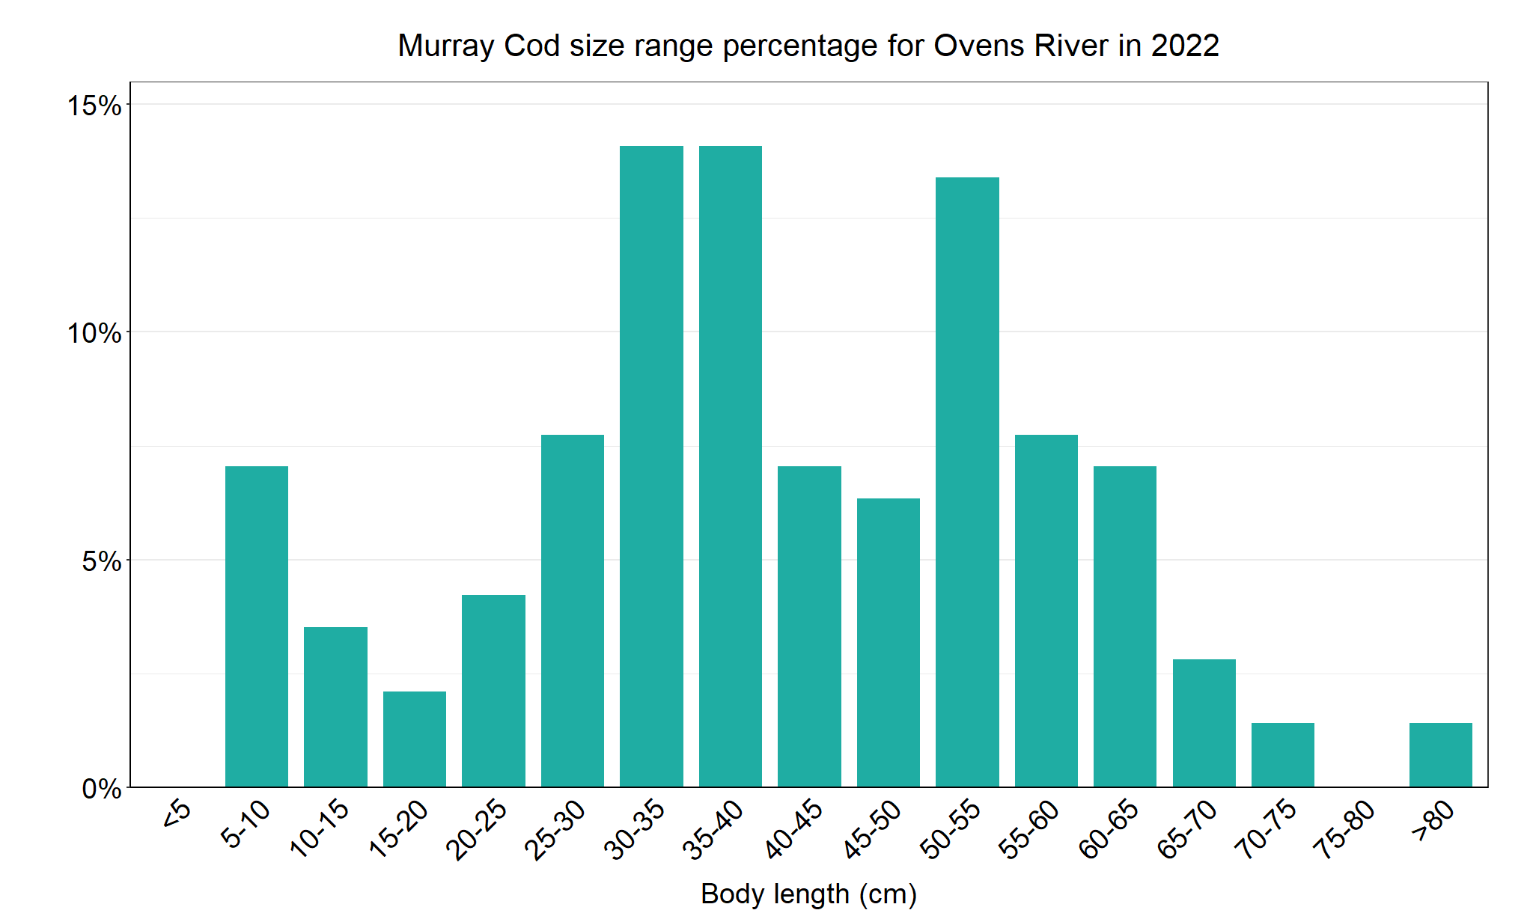
Figure 9. The size range percentage of Murray Cod in the Ovens River in 2022

Trout Cod

Ovens River, North East region

Key Health Indicators
Recent recruitment Yes
Multiple size classes Yes
Mature fish present Yes

Monitoring Results
Total number of fish caught 64
Fish per 1km of waterway 9.42
Largest fish by length (cm) 54.5
Largest fish by weight (kg) 2.11
% of the catch that is legal size NA

Abundances of Trout Cod (Maccullochella macquariensis) across NFRC surveys have generally remained high (Figure 10). The lower abundance detected in 2020 correlates with higher flows and associated high turbidity which would have reduced the likelihood of capturing fish. Multiple size classes including mature and young-of-year fish were captured in five of the six years. A wide range of sizes was detected in 2022 (Figure 11). The wide size range and detection of recruits, juveniles and adults in most years indicates that conditions in the Ovens River are supporting the survival of this species throughout its lifecycle.

Stocking
No Trout Cod stocking has occurred in the Ovens River system since January 2006.

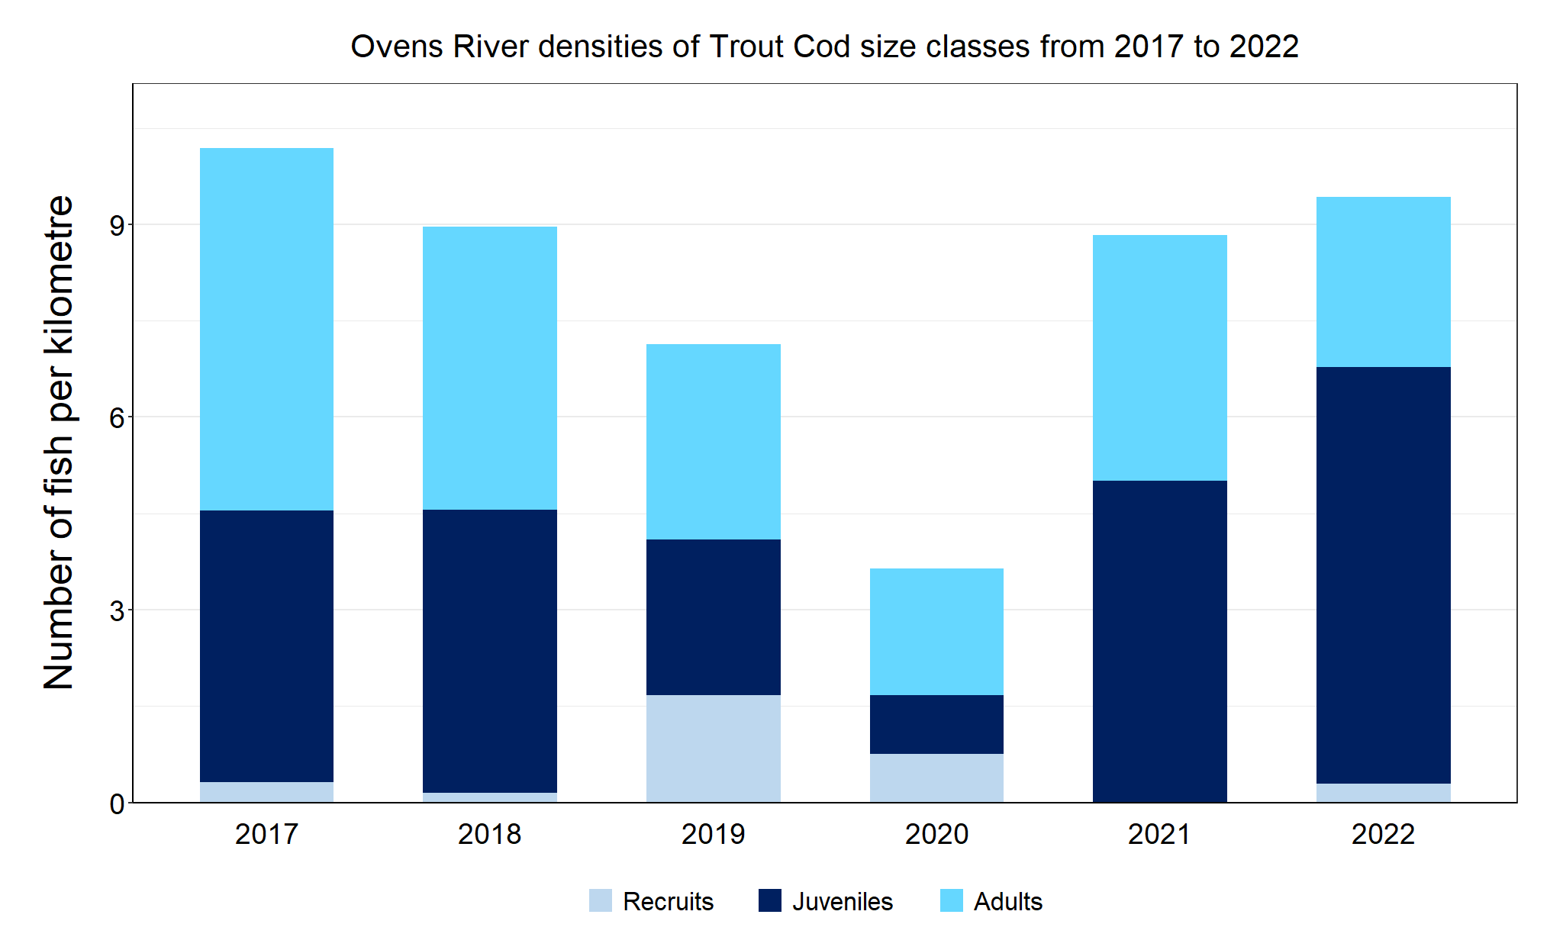
Figure 10. The densities of recruits, juveniles and adult Trout Cod in the Ovens River from 2017 to 2022

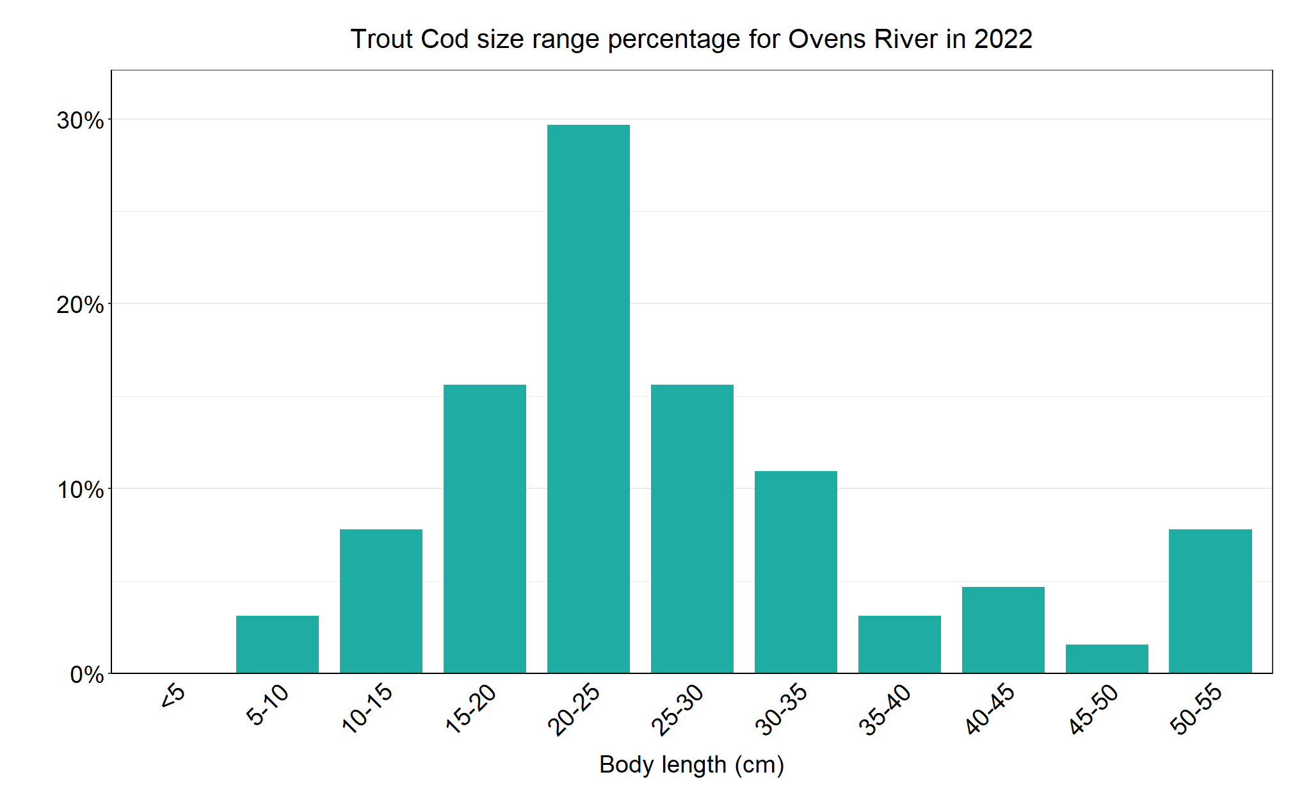
Figure 11. The size range percentage of Trout Cod in the Ovens River in 2022

We acknowledge and respect Victorian Traditional Owners as the original custodians of Victoria’s land and waters, their unique ability to care for Country and deep spiritual connection to it. We honour Elders past and present whose knowledge and wisdom has ensured the continuation of culture and traditional practices.

