**Glenelg River 2023**

***Glenelg Hopkins region***

**This report card summarises the 2023 Native Fish Report Card (NFRC) survey in the Glenelg River**

**Sites 10, GHCMA, Electrofishing**

**Fish found in Glenelg River for NFRC**

**Target species**

Estuary Perch

**Non-target species captured since 2017\***

**Large-bodied native species**

Australian Bass

Australian Grayling

Black Bream (estuarine sp.)

Freshwater Catfish

Golden Perch

Mulloway (estuarine sp.)

River Blackfish

Short-finned Eel

Tupong

Yellow-eye Mullet (estuarine sp.)

**Small-bodied native species**

Australian Smelt

Bridled Goby (estuarine sp.)

Carp Gudgeon

Common Galaxias

Flatheaded Gudgeon

Southern Pygmy Perch

Variegated Pygmy Perch

**Exotic species**

Common Carp

Eastern Gambusia

Goldfish

Rainbow Trout

Redfin

Tench

* These non-target species were incidentally captured during NFRC surveys since 2017 but not measured as for target species

LOGOS – ARI, DEECA

**Glenelg River 2023**

**Fish Community**

**NFRC target species**

**The NFRC Program began in 2017, with a focus on targeting the monitoring of population dynamics of key iconic fish species that have high recreational and/or conservation values, in large rivers across Victoria. In the Glenelg River, the target species is Estuary Perch. Surveys occur in February/March each year, at 10 sites from Dartmoor to Yat Nat (between Balmoral and Rocklands Reservoir). In 2022 and 2023, two sites could not be fished due to access logistics, with two new sites added into the estuary between Sapling Creek Boat ramp and Dartmoor in 2023. The equipment and habitats surveyed are focused on this species, which are measured to determine population structures. Other fish species that are incidentally captured are recorded, but not measured to determine their population structures.**

**Summary of key health indicators for target species in 2023**

|  |  |  |  |
| --- | --- | --- | --- |
| **Species** | **Key Health Indicators** | | |
|  | Recent recruitment | Multiple size classes | Mature fish present |
| Estuary Perch | No | Yes | Yes |

*Recent recruitment means young-of-year fish*

Estuary Perch are considered an estuarine species, which often moves into lower freshwater reaches of rivers, particularly rivers with elevated baseline salinity levels.

**Non-target species**

The non-target fish species that have been incidentally recorded in the Glenelg River during NFRC surveys since 2017 are:

**Large-bodied native species**

Other large-bodied species recorded in surveys are Australian Bass, Australian Grayling, Black Bream, Freshwater Catfish, Golden Perch, Mulloway, River Blackfish, Short-finned Eel, Tupong and Yellow-eye Mullet. A single Australian Grayling was collected in 2019 with another single individual recorded in 2021. These are only the second and third records of this species in the Glenelg River system; the other confirmed record was 124 years ago. Black Bream, Mulloway and Yellow-eye Mullet are estuarine species, with Black Bream and Yellow-eye mullet often detected in the lower freshwater reaches of streams. River Blackfish are a lowland species, generally found at altitudes below 200 metres. This species has suffered a decline in distribution and abundance across the State1, however, numerous individuals have been detected in the Glenelg River (ARI unpublished data). Short-finned Eel are a diadromous (migratory between salt water and fresh water) species found throughout coastal Victoria.

**Large-bodied native species which have been introduced to the river**

Australian Bass, Freshwater Catfish and Golden Perch are considered translocated species in the Glenelg River.

**Small-bodied native species**

Some of the small-bodied species recorded within the Glenelg River, including Australian Smelt and Flatheaded Gudgeon are common across the state. Carp Gudgeon are a lowland species and considered often hard to detect via boat electrofishing. The Common Galaxias and Tupong are diadromous species common across coastal Victoria. Pygmy Perch species are more common in offstream habitats such as billabongs, wetlands and lagoons. Variegated Pygmy Perch have been detected in all seven years of NFRC sampling. Bridled Goby are an estuarine species.

**Exotic fish species**

Common Carp, Eastern Gambusia, Goldfish and Redfin are widely distributed across sampling sites, but the likelihood of their detection and abundances increases as you move upstream. Small (young-of-year) Carp were also detected at most sites in 2019. In 2017-18 and 2020-22, small Carp have been restricted to the upper sites, indicating the widespread dispersal and spawning of this species during the 2018 spawning season. The presence of small Carp every year at the upper sites also indicates they are spawning in these areas in most, if not all years. Rainbow Trout are restricted in distribution to the Warrock area. Tench have been detected in all six sampling years, albeit in low abundances.

**Other native species known from the Glenelg River**

Some fish species known to occur in the Glenelg River have never been recorded during NFRC surveys. For example, no Climbing Galaxias, Obscure Galaxias, Spotted Galaxias, Little Galaxias, Pouched Lamprey or Short-headed Lamprey have been detected in the surveys. Both Climbing Galaxias and Spotted Galaxias historically had patchy distributions within the Glenelg River system and are hard to detect using the NFRC sampling methodology. Similarly, both lamprey species had patchy distributions historically, while Obscure Galaxias are hard to detect using the NFRC sampling methodology. Little Galaxias are normally found in lower altitude areas but are found in the Glenelg River upstream of Rocklands Reservoir (outside of the NFRC sampling area).

**Other notable species**

Surveys have also recorded Eastern Long-necked Turtles, Glenelg Spiny Crayfish, Platypus and Yabbies.

LOGOS – ARI, DEECA, NFRC

1. Khan MT, Khan TA, Wilson ME 2004. Habitat use and movement of river blackfish (Gadopsis marmoratus R.) in a highly modified Victorian stream, Australia. *Ecology of Freshwater Fish,* 13: 285–293.

**Glenelg River 2023**

**Environmental and Management Context**

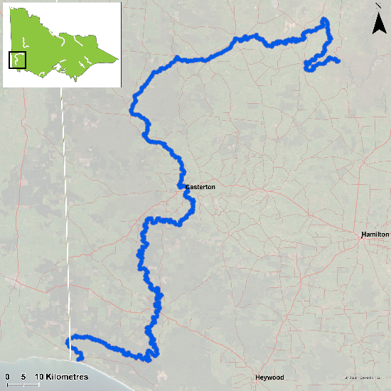

Figure 1. Map showing the section of Glenelg River where NFRC sampling occurs

**Environment**

Low flow conditions were present in all seven sampling seasons. Two sites were not fished in 2022 and 2023 due to limitations in access. Two new sites were added in the estuary in 2023 to replace these sites. It is expected the addition of the two new estuarine sites will increase the abundance of Estuary Perch detected during sampling.

**River rehabilitation efforts in the Glenelg River**

Many rehabilitation actions have occurred, and are underway, to improve the health of the Glenelg River. These are informed by the Glenelg Hopkins Waterway Strategy 2014-2022 and the Glenelg River Restoration Program. Actions include revegetation, weed control and fencing of riparian areas, reintroduction of instream woody habitat, allocations of water for the environment, removal of migration barriers and pest control. There are a range of fish monitoring efforts related to these management efforts. These include the Victorian Environmental Flow Monitoring and Assessment Program ([VEFMAP](https://www.ari.vic.gov.au/research/rivers-and-estuaries/assessing-benefits-of-water-for-the-environment)). The [Glenelg Hopkins Catchment Management Authority](https://www.ghcma.vic.gov.au/), DEECA and the Victorian Fisheries Authority support rehabilitation and management of the Glenelg River and its fish community.

PHOTOS

LOGOS – ARI, DEECA, NFRC

**Estuary Perch**

**Glenelg River, Glenelg Hopkins region**

**Key Health Indicators**

Recent recruitment No

Multiple size classes Yes

Mature fish present Yes

**Monitoring Results**

Total number of fish caught 131

Fish per 1km of waterway 16.18

Largest fish by length (cm) 51.1

Largest fish by weight (kg) 2.06

% of the catch that is legal size 51.1

Estuary Perch (*Percalates colonorum* - formerly *Macquaria colonorum*) is an estuarine species that can inhabit the lower freshwater reaches of streams. Within the Glenelg River, the species moves further inland than other rivers in Victoria. No Estuary Perch have been detected as far upstream as Balmoral, but sites have been included this far upstream to monitor the potential for further expansion in range, as the species seems to be slowly moving further upstream (based on previous surveys). Without the two new estuarine sites, the abundance of Estuary Perch was slightly higher in 2023 and has been consistent between all seven years (Figure 2a). The abundances appear much higher when the two estuarine sites are added in in 2023 (Figure 2b). This is not unexpected, as Estuary Perch are largely an estuarine species. These new sites are expected to be continued from here-on in. Multiple size classes, including mature and juvenile fish, were captured in all seven years, with young-of-year fish also detected in 2018. This is an indication that conditions in the Glenelg River are supporting spawning, recruitment, and survival of this species throughout its lifecycle and providing good, ongoing angling opportunities. A wide range of sizes was collected in 2023 (Figure 3), with 51% being adults.

**Stocking**

No stocking has occurred.

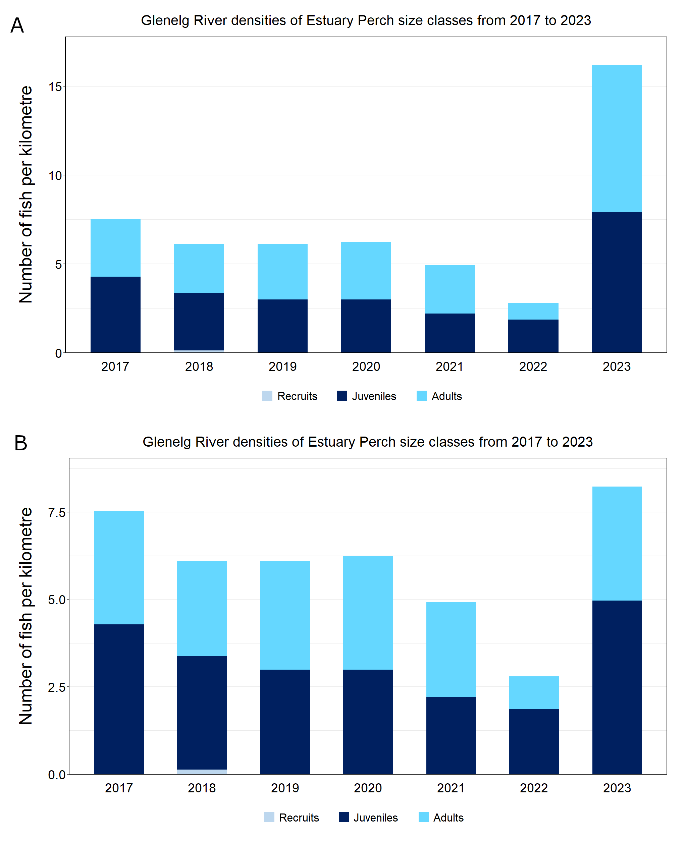Figure 2. The densities of recruits, juveniles and adult Estuary Perch in the Glenelg River from 2017 to 2023 .A) without the two new estuarine sites; B) with the two new estuarine sites.

Figure 3. The size range percentage of Estuary Perch in the Glenelg River in 2023

We acknowledge and respect Victorian Traditional Owners as the original custodians of Victoria’s land and waters, their unique ability to care for Country and deep spiritual connection to it. We honour Elders past and present whose knowledge and wisdom has ensured the continuation of culture and traditional practices.

Logo© The State of Victoria Department of Energy, Environment and Climate Action 2023. This work is licensed under a Creative Commons Attribution 4.0 International licence. To view a copy of this licence, visit creativecommons.org/licenses/by/4.0/

ISSN 2981-9008 Online (pdf/word)