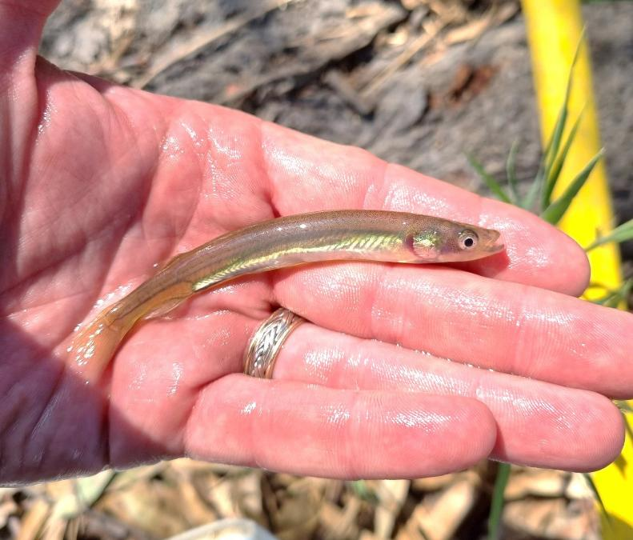



Detection and management of the threatened
OFFICIAL
Flat-headed Galaxias (Galaxias rostratus) in Victoria
Testing eDNA and physical sampling, and analysing population genetics
T.A. Raadik, D.J. Stoessel, N. Murphy, P.J. Unmack and P. Rose January 2026

Arthur Rylah Institute for Environmental Research Technical Report Series No. 400



Arthur Rylah Institute for Environmental Research Department of Energy, Environment and Climate Action PO Box 137, Heidelberg, Victoria 3084
Phone (03) 9450 8600
Website: www.ari.vic.gov.au

Citation: Raadik, T.A., Stoessel, D.J., Murphy, N., Unmack, P.J. and Rose, P. (2026). Detection and management of the threatened Flat-headed Galaxias (Galaxias rostratus) in Victoria: Testing eDNA and physical sampling, and analysing population genetics. Arthur Rylah Institute for Environmental Research Technical Report Series No. 400. Department of Energy, Environment and Climate Action, Heidelberg, Victoria.

Front cover photo: Flat-headed Galaxias (Galaxias rostratus) (Daniel Stoessel) Edited by Jeanette Birtles (Organic Editing)
ISSN 1835-3835 (pdf)
ISBN 978-1-76176-929-0 (pdf)

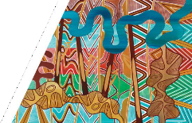

We acknowledge and respect Victorian Traditional Owners as the original
custodians of Victoria’s land and waters, their unique ability to care for Country
and deep spiritual connection to it.
We honour Elders past and present whose knowledge and wisdom has ensured the continuation of culture and traditional practices.
DEECA is committed to genuinely partnering with Victorian Traditional Owners and Victoria’s Aboriginal community to progress their aspirations.

© The State of Victoria Department of Energy, Environment and Climate Action 2026.
Creative Commons
This work is licensed under a Creative Commons Attribution 4.0 International licence; visit the Creative Commons website (http://creativecommons.org/licenses/by/4.0/).
You are free to re-use the work under that licence, on the condition that you credit the State of Victoria as author. The licence does not apply to any images, photographs or branding, including the Victorian Coat of Arms, and the Victorian Government, the Department and the ARI logos.
Disclaimer
This publication may be of assistance to you, but the State of Victoria and its employees do not guarantee that the publication is without flaw of any kind or is wholly appropriate for your particular purposes and therefore disclaims all liability for any error, loss or other consequence which may arise from you relying on any information in this publication.

Accessibility
To receive this document in an alternative format, phone the Customer Service Centre on 136 186, email customer.service@deeca.vic.gov.au, or contact the National Relay Service on 133 677. Available at the Department of Energy, Environment and Climate Action (DEECA) website (www.deeca.vic.gov.au).

Detection and management of the threatened Flat-headed Galaxias (Galaxias rostratus) in Victoria

Testing eDNA and physical sampling, and analysing population genetics

Tarmo A. Raadik1, Daniel J. Stoessel1, Nicholas Murphy2, Peter J. Unmack3 and Peter Rose4

¹Arthur Rylah Institute for Environmental Research 123 Brown Street, Heidelberg, Victoria 3084
²Department of Ecology, Environment and Evolution School of Life Sciences, Latrobe University Bundoora, Victoria 3083
³Unmack AquaEvolutionary,
37 Yarra Street, Kaleen, ACT 2617
⁴North Central Catchment Management Authority 628–634 Midland Highway, Huntly VIC 3551

Arthur Rylah Institute for Environmental Research

Technical Report Series No. 400

Acknowledgements

We thank North Central Catchment Management Authority (Peter Rose), for providing the funding for this work, Zak Atkins (Snowline Ecology) for field assistance, Dion Iervasi (Austral Research and Consulting) for providing additional Flat-headed Galaxias tissue clips for analysis, and Michael Nicol [Arthur Rylah Institute for Environmental Research, Department of Energy, Environment and Climate Action (ARI, DEECA)] for drafting the maps. The field work was undertaken according to the following permits: Fisheries General (Research) RP827; FFG 10009666; AEC 22-007.

Contents
Acknowledgements ii
Summary 1
- Introduction 3
  - Study location and site selection 4
- Methods 5
  - Physical sampling 5
  - Environmental DNA 6
  - Population genetics 7
- Results 8
  - Physical sampling 8
  - eDNA 13
  - Population genetics 15
    - Spatial pattern 15
- Discussion 21
- Conclusion 23
- References 24
Appendices 26
Appendix 1. Survey site information 26
Table A1. Survey site information, including sites at which Flat-headed Galaxias had previously been recorded 26
Appendix 2. Selected site images 30
Upper Murray Basin 30
Kiewa Basin 33
Ovens Basin 36
Broken Basin 40
Goulburn Basin 42

Tables

Table 1. Results of physical sampling, eDNA water sample collection, and eDNA analysis for Flat-headed Galaxias. 9
Table 2. Scoring criteria for sites and replicate water samples, based on qPCR results for the detection of Flat-headed Galaxias DNA. 13
Table 3. Number (N) of tissue clips from Flat-headed Galaxias individuals from four river basins sent to DArT for sequencing, and successfully sequenced for SNPs 15
Table 4. Population genetic values for Flat-headed Galaxias 19
Table 5. Comparison of genetic differentiation between Flat-headed Galaxias populations based on the fixation index (FST values). 19
Table 6. Number of polymorphic loci for five Murray–Darling Basin native fish species, including the total number of loci (nLoc), average number of polymorphic loci per population (pLoc), and the range of values across all populations (range) 20

Figures

Figure 1. Adult Flat-headed Galaxias, with a close-up of the distinctive dorsally flattened head, long snout, and large silver eye. Image credit: Tarmo A. Raadik 3
Figure 2. Location of survey sites in north-eastern Victoria, including sites with previous records of Flat-headed Galaxias (red squares) 5
Figure 3. eDNA water sampling (left) and pump and filters (right). Image credits: Daniel J. Stoessel (left), Tarmo A. Raadik (right). 6
Figure 4. eDNA water sample collection and analysis steps. 6
Figure 5. Survey results for physical sampling for Flat-headed Galaxias. 8
Figure 6. Flat-headed Galaxias collected from (left) Goulburn River billabong (site 38) and (right) Sandy Creek (site 43). Image credit: Daniel J. Stoessel. 13
Figure 7. Results of Flat-headed Galaxias DNA detection from water samples. 14
Figure 8. PCoA plot for Flat-headed Galaxias showing axis 1 versus axis 2. 16
Figure 9. PCoA plot for Flat-headed Galaxias showing axis 1 versus axis 3. 16
Figure 10. Maximum likelihood tree for Flat-headed Galaxias in northern Victoria. 18

Summary

Context:
The Flat-headed Galaxias (Galaxias rostratus) is a small native freshwater fish species that has undergone a dramatic decline in range and abundance in the Murray–Darling Basin. It is now considered extinct in South Australia and critically endangered nationally and in New South Wales. Most of the remaining populations are in north-eastern Victoria, where the species is rarely encountered. Due to sampling difficulties, the locations of self-sustaining populations are unknown. In addition, the species’ biology, ecology, and habitat requirements are very poorly understood. Consequently, conservation management has not commenced due to a lack of knowledge and effective detection techniques.

Aims:
- To evaluate whether Flat-headed Galaxias can be detected through environmental DNA (eDNA) analysis of water samples taken from the wild in potentially occupied habitats in north-eastern Victoria, where the species is still known to exist.
- To evaluate the 1.5-µL tubes DNA probe developed for Flat-headed Galaxias.
- To undertake physical sampling for detection of the species, including at sites at which eDNA sampling has been undertaken, for comparison of the detection results.
- To undertake the first population genetics analysis for the species to inform future conservation actions (if enough individuals are located).

Methods:
- Seventeen survey sites were selected in north-eastern Victoria, where Flat-headed Galaxias had been previously recorded, and these were supplemented with an additional 43 sites (60 sites total).
- Physical sampling for Flat-headed Galaxias was undertaken at the field sites using backpack electrofishing. When individuals were captured, a tissue sample was taken from individuals for genetics analysis.
- The presence/absence data obtained from the physical sampling were compared with the eDNA sampling results.
- At each site, three or four replicate water samples were taken from a set of spaced-out subsites. They were filtered in the field, and the filters containing the membranes and the residues were brought back to the laboratory for DNA analysis. Three quantitative polymerase chain reaction (qPCR) replicate tests were run on each water sample. A positive Flat-headed Galaxias detection was defined as a sample having more than one positive qPCR result (i.e. two or three of the replicate qPCRs were positive for Flat-headed Galaxias DNA). A positive DNA detection site was defined as a site having one or more positive Flat-headed Galaxias detection replicate samples.
- For the population genetics analysis, DNA was extracted from Flat-headed Galaxias tissue and sequenced using DArTseq™ for single-nucleotide polymorphisms (SNPs). The SNP dataset was then analysed to obtain population genetic metrics.

Results:
- Field sampling was undertaken over 2 weeks. Of the 60 sites visited, 18 were dry.
- Physical sampling was undertaken at sites that had water. A total of 44 Flat-headed Galaxias were detected at 4 sites, 3 of which were in the Goulburn River system and 1 in the Mitta Mitta River system. This confirmed the ongoing presence of the species in Victoria. Considering the limited survey effort, all wet sites are considered likely to have a high abundance of Flat-headed Galaxias, with the numbers of individuals collected ranging from 5 to 16 (the historical records were usually of 1 to 2 fish).
- Positive Flat-headed Galaxias DNA detections were found at 10 sites, which included the 4 sites with physical sampling detections. In addition to the 10 positive DNA detection sites, 4 sites had ambiguous results (no positive DNA detections at subsites, but 1 of the 3 replicate qPCR results for at least 1

subsite was positive). While these ‘ambiguous’ sites fall below our criteria for a positive detection, they require re-analysis, or re-sampling followed by analysis, to clarify the results.
- Tissue clips from 72 Flat-headed Galaxias individuals across northern Victoria were analysed (43 were collected in this study, and 29 were collected previously), and 65 of these were successfully amplified for SNPs. Principal Coordinates Analysis (PCoA) was undertaken to broadly categorise the individuals into geographic groups. The Goulburn River populations clustered together, except for the population at Cornella Creek, which was also distinct from the populations in north-eastern Victoria (in the Murray, Mitta Mitta and Kiewa basins). Similar patterns to those indicated by the PCoA ordinations were found in the phylogenetic tree. The average observed heterozygosity by drainage varied from 0.119 to 0.175. The expected heterozygosities were like those observed. Further, the number of private alleles varied considerably between populations, with populations from billabongs in the Goulburn River and Mitta Mitta River (including Cornella Creek) having many private alleles. Using polymorphic loci to make a coarse comparison of the genetic diversity in Flat-headed Galaxias with that of five other species of small freshwater fish from the Murray–Darling Basin (two threatened and narrow range, and three non-threatened and widespread) indicated that, while likely having lost genetic diversity, Flat-headed Galaxias retains reasonable levels of genetic diversity.

Conclusions and Implications:
This study demonstrated that the detection of Flat-headed Galaxias DNA in field-collected eDNA from water samples is possible and that the species-specific assay was functional. Physical sampling was also able to detect Flat-headed Galaxias, and this corroborated the eDNA results at four sampling sites. Analysis of the eDNA indicated that Flat-headed Galaxias DNA was present at 10 sites in the upper Murray, Kiewa, Ovens and Goulburn basins, which exceeded the number of site detections by physical sampling. The current method of physical sampling is difficult and time-consuming, and given that it is considered inefficient, it may have underestimated the presence of Flat-headed Galaxias. A positive physical sampling detection of Flat-headed Galaxias requires the collection of a specimen, so it will always require a considerable effort.
Conversely, positive eDNA detection only requires demonstrating the presence of the target DNA. The collection of water samples can be very rapid and efficient, and many sites can be sampled over a short period of time. Once the eDNA samples have been analysed, the findings can inform the efforts of the physical sampling, if it is required, indicating likely detection sites for more efficient use of resources.
Once a high level of confidence in the eDNA results has been reached, effort can be expended in improving the physical sampling methods for the efficient capture of Flat-headed Galaxias at sites where the species is known to occur, particularly in larger water bodies. Additional eDNA and physical sampling comparisons need to be undertaken to further verify the effectiveness of the technique and to understand the ambiguous detection results. Nevertheless, eDNA is already a valuable tool for the detection of Flat-headed Galaxias, and the knowledge that has been gained about its population abundance and distribution can now underpin effective conservation actions.
The first population genetics analysis for Flat-headed Galaxias has provided valuable data for initiating and guiding the conservation management of the species. Flat-headed Galaxias shows moderate geographic structure across the extant populations that is consistent with the geographic distances and the increasing human-induced fragmentation, and it retains moderate levels of genetic variation. The management of this diversity in various conservation actions will be important to maximise the evolutionary potential of the species, particularly through captive or natural-hatchery breeding and translocations to establish additional populations.

Introduction

The Flat-headed Galaxias (Galaxias rostratus) is a small native freshwater fish, reaching up to 150 mm in total length (Figure 1). It was once widespread throughout the lowland reaches of the south-eastern Murray–Darling Basin (Cadwallader and Backhouse 1983; Allen et al. 2003; Lintermans 2007), and it was common in the Murray and Murrumbidgee catchments in New South Wales (NSW). There are also single records from the mid-Lachlan catchment, and from a billabong of the Macquarie River near Bathurst (McDowall and Frankenberg 1981; Llewellyn 2005; Gilligan et al. 2019). In northern Victoria, the species has been recorded from the Avoca, Loddon, Goulburn, Broken, Ovens, Kiewa, and upper-Murray catchments [McDowall and Frankenberg 1981; Lintermans 2007; Whiterod et al. 2019; Tarmo Raadik, Arthur Rylah Institute for Environmental Research (ARI), unpublished data]. In South Australia, one historic record exists from the late 1800s along the Murray River as far downstream as Murray Bridge (McDowall and Frankenberg 1981; Hammer et al. 2009).
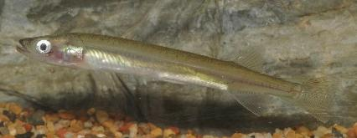
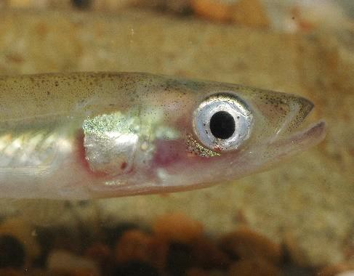

Figure 1. Adult Flat-headed Galaxias, with a close-up of the distinctive dorsally flattened head, long snout, and large silver eye. Image credit: Tarmo A. Raadik.
Flat-headed Galaxias has undergone a severe decline in range and abundance and is now restricted to catchments of the mid- to upper Murray River in north-eastern Victoria, and upstream of Yarrawonga in NSW (Allen et al. 2003; Gilligan et al. 2019; Whiterod et al. 2019). In NSW, despite targeted sampling, it has only been recorded on four occasions since 2006, and only once since 2012, and there are no known resident populations (Gilligan et al. 2019). Flat-headed Galaxias is now presumed absent from the Macquarie, Lachlan and Murrumbidgee catchments and the lower- to mid-Murray catchment in NSW, and from South Australia (Hammer et al. 2009, Gilligan et al. 2019; Whiterod et al. 2019). In Victoria, the species is still occasionally collected in surveys; however, the location of large, self-sustaining populations is unknown. Due to the contraction in range and the decline in abundance, Flat-headed Galaxias is listed as critically endangered nationally (Australian Environment Protection and Biodiversity Conservation Act 1999) and in NSW (Fisheries Management Act 1994) and vulnerable in Victoria (Flora and Fauna Guarantee Act 1988), though this is under review (DELWP 2021).
The conservation management of Flat-headed Galaxias is complicated by the lack of knowledge of its population status and distribution, its evolutionary potential (genetic diversity), its habitat preferences, and its biology and ecology. While it is a highly vagile species and unique in appearance compared with other sympatric species of galaxiids, it is rarely encountered, though this appears to be related to it being difficult to detect by standard surveying methods. Consequently, it is now also referred to as the ‘Ghost Fish’, unexpectedly seen, but absent when looked for! Flat-headed Galaxias has also not been caught in sufficient numbers to enable assessment of its genetic status and habitat. Consequently, to progress the conservation management of Flat-headed Galaxias, greater knowledge of the species is needed, which requires location of the remaining populations, and thus improved detection methods.
Environmental DNA (eDNA) is increasingly being used as a complementary method of determining the presence of rare species, as it allows the detection of individuals based on the presence of their DNA (Thomsen and Willerslev 2015; Balasingham et al. 2018; Taberlet et al. 2018). For fish, DNA is constantly shed or excreted into the water (e.g. via cells, tissue, scale slime, urine, faeces, eggs/sperm), and water samples can be tested for the presence of DNA to confirm the occupancy of the target species. It is not necessary to sample at the precise location of the occurrence of the species—its DNA can be picked up further downstream from the individuals in flowing water environments (e.g. streams), or nearby in still environments (e.g. swamps and lakes). Consequently, eDNA detection may be more efficient than traditional physical sampling methods (e.g. netting, electrofishing), which can be costly and time-consuming (Thomsen

and Willerslev 2015; Balasingham et al. 2018; Beng and Corlett 2020) when the rapid detection of occupancy by the target species is required. The use of eDNA enables targeted physical sampling to be undertaken at positive detection sites, leading to a more efficient use of resources.
The reliability of eDNA as a detection method is, however, often unknown. It can vary from species to species and from habitat to habitat and is affected by the number of target animals present; their life stage, behaviour, body size, metabolic activity, and stress level; and by the water quality, water movement, and environmental conditions at a site (Goldberg et al. 2016; Beng and Corlett 2020). Maximising the eDNA detection of rare species requires a species-specific DNA probe that has been developed to only detect the target taxon (highly specific), even at low DNA abundance, and is thus highly sensitive (Furlan and Gleeson 2016; Bylemans et al. 2019; Hinlo et al. 2017). An eDNA probe for Flat-headed Galaxias has recently been developed by the NSW Department of Primary Industries and Rural Development (DPIRD) Fisheries; however, its accuracy has until now not been evaluated. The probe, therefore, requires field testing to ensure it is reliable and that the detection probability of the species has been maximised.
Here, we aimed to investigate whether Flat-headed Galaxias could be detected in eDNA by field-evaluating the species-specific DNA probe on water samples collected from potentially occupied habitats in northern Victoria, and by comparing the results with those obtained by physical sampling for the species. We also collected tissue from any captured individuals to undertake the first genetics analysis of populations of the species, to inform future conservation actions.

Study location and site selection
Based on recent historical collections of Flat-headed Galaxias in Victoria (undertaken <30 years ago), the study was restricted to the north-east of the state, extending from the Goulburn River basin to the Upper Murray River basin. Within this area, 17 sites were selected based on more recent detections (<20 years ago), with additional sites being added during the actual field work based on their potential for providing suitable habitat (Figure 2, Table A1).

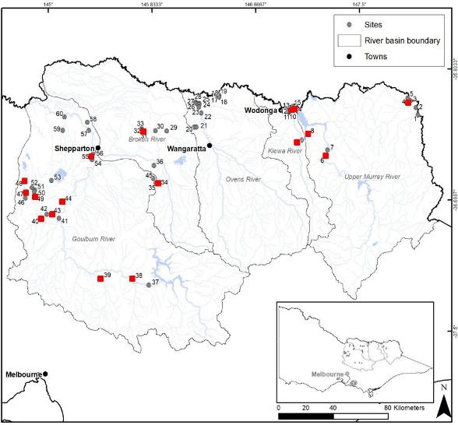
Figure 2. Location of survey sites in north-eastern Victoria, including sites with previous records of Flat-headed Galaxias (red squares).

Methods

The field survey consisted of physical sampling for Flat-headed Galaxias, the collection of fin clips for genetics analysis from individuals, and the collection of replicate water samples for eDNA analysis.

Physical sampling
Physical sampling targeting Flat-headed Galaxias was undertaken using a backpack electrofisher (Smith-Root® Model LR-20B) with a standard braided wire cathode and a 150-mm diameter anode. The unit was operated at settings of 100 Hz and 150 to 250 V and only in wadable reaches of water bodies during daylight hours.
Captured fish were identified to species and counted. Flat-headed Galaxias were measured for length (mm caudal fork length—CFL) and weight (to the nearest 0.1 g), and a fin-clip (of less than 2 mm²) was taken from the caudal fin (using sharp medical-grade scissors) for population genetics analysis (see Guy et al.
1996). Following processing in the field, all fish were returned to the water at the site of capture.
The fin clips were placed into individually labelled 3-mL vials containing 100% ethanol and stored while in the field in a portable fridge. On return to the office, the fin clips were placed into a freezer (at –20°C).

Environmental DNA
Water samples were collected from each site where eDNA collection was to be undertaken. The samples were taken from the stream or wetland, in flowing reaches where possible, using a water sample pump (Figure 3, left). At each site, a series of replicate samples were randomly undertaken, at ‘subsites’ arranged across the sampling zone, each separated from the others by a distance of at least 10 metres. Four samples were collected from most sites (Figure 4), though only three were collected from three of the sites due to a lack of filters. For each replicate, water was filtered through a 5.0-µm Self-preserving Smith-Root® eDNA filter (Figure 3, right) until either the filter membrane became clogged or a volume of 3 L was reached. Due to the unavailability of a sufficient number of 5.0-µm filters, a combination of other filters (1.2-µm or 0.45-µm filters) was used at some sites. The volume of water filtered per sample was recorded, and each filter was uniquely numbered and placed into a portable refrigerator for storage within 30 minutes of collection.
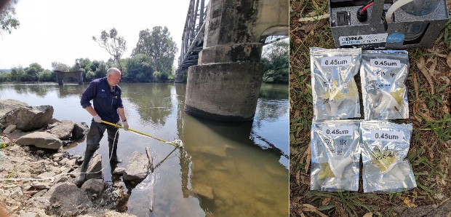

Figure 3. eDNA water sampling (left) and pump and filters (right). Image credits: Daniel J. Stoessel (left), Tarmo A. Raadik (right).
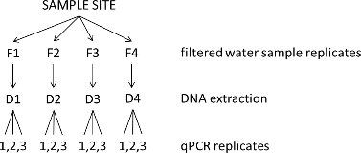

Figure 4. eDNA water sample collection and analysis steps.
In the laboratory, DNA was extracted from each replicate sample from each site (Figure 4), following a modified QIAGEN DNeasy protocol (Spens et al. 2017). To do this, each filter was removed from its individually labelled packet and the membrane cut in half. One half of the membrane was returned to the packet from which it had been removed and placed back into cold storage for future analysis if required. The other half was cut into 3–5 mm strips using scissors that had been sterilised using 50% bleach. Filter membrane pieces were then air-dried to remove ethanol and placed in 1.5-mL tubes, to which was added 720µL of Buffer ATL and 80µL of Proteinase K. The filters were then digested overnight at 55°C.
The following day, the supernatant was removed, 200µL of which was placed into each of two separate tubes, with equal volumes of Buffer AL and 100% ethanol. Both tubes were then sequentially passed through DNA mini spin columns until all DNA was bound to the columns. The standard DNeasy protocol was then followed. As DNA extractions occurred over multiple sessions, extraction blanks were undertaken during each extraction session (following the same procedure, but without the addition of filter membranes) to control for any potential contamination.

Quantitative PCR (qPCR) reactions were then undertaken using a species-specific primer developed for Flat-headed Galaxias for this project by the NSW Department of Primary Industries (DPI) Fisheries, using tissue provided by the Arthur Rylah Institute for Environmental Research, DEECA. The Galros3 assay (G3), was identified by NSW DPI Fisheries (Meaghan Duncan pers. comm.) as the best candidate for field research and so was utilised here via PrimeTime qPCR probe assays (Integrated DNA Technologies). A primer:probe ratio of 2:1 and a 5' dye/3' quencher were used, with all assays using a 6-FAM/ZEN/IBQF dye/quencher combination. Three qPCRs (qPCR replicates) were undertaken on each DNA extraction residue for each site replicate (Figure 4).
The qPCR conditions for all the probe assays were 5.0μL PrimeTime™ Gene Expression Master Mix (Integrated DNA Technologies), 0.5 μL 20× Primetime qPCR Assay, 2.5μL H20, and 2.0μL of DNA extraction. For all samples, including controls, qPCRs were undertaken in triplicate on a Bio-Rad CFX96 Touch™ thermal cycler under the following conditions: 95°C for 3 minutes, 50 cycles of 95°C for 20 seconds, and 60°C annealing for 30 seconds. Only samples for which two out of three replicates returned a positive result were counted as indicative of the species’ presence at the site. As the species-specific qPCR probe had not been previously field-tested, successful qPCR results were sent to Macrogen for Sanger sequencing to confirm the species identity.
To check potential false negatives in the results, testing for PCR inhibition was undertaken. PCR inhibition can be introduced by the co-extraction of factors such as plant polyphenols and humic acid. Any negative qPCR reactions were subsequently tested with the addition of a Gblock™ Gene Fragment; all samples amplified, suggesting that PCR inhibition was not a factor in the results obtained in this study.

Population genetics
To assess the genetics of populations of Flat-headed Galaxias, tissue from individuals was sent to Diversity Arrays Technology (DArT Pty Ltd, Canberra, Australia) for DNA extraction and single-nucleotide polymorphism (SNP) sequencing. DNA was sequenced using DArTseq™, a variation of the double-digest Restriction site–Associated DNA (RAD) technique, which combines next-generation sequencing, complexity reduction using restriction enzymes, and implicit fragment size selection, as described by Kilian et al. (2012). The sequencing methods followed those of Georges et al. (2018).
The SNP dataset was then returned for analysis of population genetic metrics. The data and associated metadata were read into a genlight object (adegenet; Jombart 2008) to facilitate processing with the dartR
2.9.3 package (Gruber et al. 2018). We made two subsets of the data, one filtered to remove missing data at
0.95 filtering [which allows for up to 5% missing data per locus (=SNP)] and a second one with no missing data. Reproducibility (based on DArT’s repeated sequencing of ~33% of individuals to check they obtain the same answer twice) was filtered at 1. All secondary loci were removed for Principal Coordinates Analysis (PCoA), retaining the locus with the highest average polymorphism information content (avgPIC) value.
Ordination-based analyses were used to examine the relationship between individuals. For each of the datasets, genetic similarity was visualised among individuals and populations using ordination (PCoA; Gower 1966) as implemented in the gl.pcoa and gl.pcoa.plot functions of dartR. A phylogenetic approach was also used to visualise the relationships. Maximum likelihood (ML) was applied to concatenated sequences. The ML analysis was conducted using RAxML 8.2.12 (Stamatakis 2014) on the CIPRES cluster (Miller et al.
2010) using the model GTRCAT and searching for the best-scoring ML tree using the model GTRGAMMA in a single program run, with bootstrapping set to finish based on the autoMRE majority rule criterion. The tree was imported to Mega 7.0 (Kumar et al. 2016), formatted, and midpoint rooted.
For each dataset, the number of polymorphic loci, fixed differences, private alleles, heterozygosity, fixation index (FIS), and genetic differentiation between populations (FST) were determined using the gl.report.pa, gl.report.heterozygosity and gl.fst.pop functions in dartR.

Results

Physical sampling
Field sampling was undertaken over two 1-week periods, in mid to late March 2022. Of the 60 sites visited (Table 1, Figure 1), 18 (30%) were found to be dry (Figure 5). Physical sampling at the remaining sites resulted in the capture of 15,382 fish, representing 14 species (data not provided).
A total of 44 Flat-headed Galaxias were captured at four sites in two river basins (Figure 5). In the Upper Murray Basin, five individuals were collected from a billabong of the Mitta Mitta River next to Yabba Road (site 6). In the Goulburn Basin, 14 individuals were collected from a billabong off Halls Flat Road (site 38), 16 individuals from a dam on a tributary of Sandy Creek (site 42), and a further 9 individuals from the same system in another dam a short distance downstream (site 43) (Figure 5 and Figure 6, Table 1).

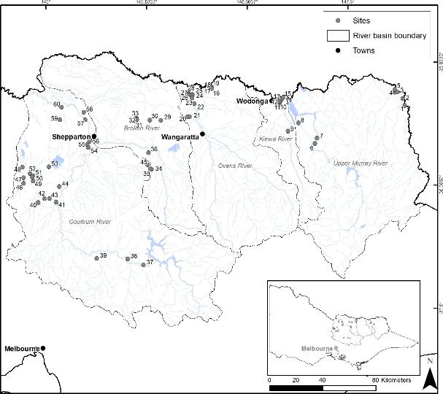


Figure 5. Survey results for physical sampling for Flat-headed Galaxias.
Green circles = Flat-headed Galaxias collected; grey circles = Flat-headed Galaxias not recorded; brown circles = dry sites; black square = site abandoned due to sampling difficulty.

Table 1. Results of physical sampling, eDNA water sample collection, and eDNA analysis for Flat-headed Galaxias.
Includes waterbodies with previous Flat-headed Galaxias records (bold text), sites where Flat-headed Galaxias were detected by physical sampling (YES) or where the site was dry (Dry), number of Flat-headed Galaxias recorded, number of eDNA water samples collected, including the filter size and volume of water filtered, and results of eDNA water analysis: green bold text = positive (unequivocal) Flat-headed Galaxias DNA detection (= more than one of three qPCR positive DNA results per water sample replicate); orange bold text
= ambiguous detection (= one of three qPCR positive DNA results per water sample replicate); black text = no detection (no positive qPCR results). eDNA = environmental DNA.

Site no. | Waterbody | Location | Flat-headed Galaxias recorded | No. | eDNA water sample replicate code | eDNA filter size (µm) | Water volume (ml)
1 | Murray River | Billabong, off Towong Hill Road, Towong |  |  | 2/1, 2/2, 2/3, 2/4 | All 5.0 | 590, 300, 340,  350
2 | Murray River | Billabong, off Murray River Road |  |  | 3/1, 3/2, 3/3, 3/4 | All 5.0 | 300, 300, 250,  290
3 | Murray River | At bridge on Tintaldra Road, downstream side, Tintaldra |  |  | 4/1, 4/2, 4/3, 4/4 | All 5.0 | 1800, 1800, 1800,  1950
4 | Cudgewa Creek | From bridge on Murray River Road to 180 m upstream |  |  | 1/1, 1/2, 1/3 | All 5.0 | 1730, 1580, 1600
5 | Cudgewa Creek | Cudgewa Back Creek, billabong just upstream of Clarke Reserve |  |  | 5/1, 5/2, 5/3, 5/4 | All 5.0 | 300, 400, 200,  200
6 | Mitta Mitta River | Billabong, off Yabba Road | YES | 5 | 6/1, 6/2, 6/3, 6/4 | 1.2, 1.2, 5.0, 5.0 | 200, 210, 700,  510
7 | Mitta Mitta River | Billabong, off Omeo Road |  |  | 7/1, 7/2, 7/3, 7/4 | All 5.0 | 230, 460, 600,  510
8 | Sandy Creek | At Bryants Gap Road |  |  | 8/1, 8/2, 8/3, 8/4 | All 5.0 | 2000, 2000, 2000,  2000
9 | Gap Creek | At bridge on Kiewa Valley Highway, Kergunyah
10 | Kiewa River | Billabong, off Brooks Terrace, Killara
11 | Kiewa River | Billabong, off Brooks Terrace, Killara
12 | Kiewa River | Billabong, off Bakers Lane, Killara |  |  | 9/1, 9/2, 9/3, 9/4 | All 5.0 | 1100, 1850, 3000,  1530

Site no. | Waterbody | Location | Flat-headed Galaxias recorded | No. | eDNA water sample replicate code | eDNA filter size (µm) | Water volume (ml)
13 | Finns Creek | At bridge on Consibee Lane
14 | Ryans Billabong | Off Ryan Road |  |  | 10/1, 10/2, 10/3, 10/4 | All 5.0 | 900, 580, 570,  1000
15 | Snowdons Billabong | Billabong, on the edge of Snowdons Road
16 | Lake Moodemere | Off Lake Road, Lake Moodemere Reserve |  |  | 15/1, 15/2, 15/3, 15/4 | All 0.45 | 200, 580, 200,  200
17 | Ovens River | Billabong, off Hynes Road
18 | Ovens River | Inlet off Murray River, off Hynes Road, Lake Moodemere Reserve
19 | Ovens River | Billabong off Hynes Road, Lake Moodemere Reserve |  |  | 14/1, 14/2, 14/3, 14/4 | All 1.2 | 200, 110, 200,  180
20 | Sandy Creek | Tributary, Boweya Road | Dry
21 | Chinaman Creek | Boweya Road | Dry
22 | Ovens River | Billabong next to McLaughlins Track |  |  | 13/1, 13/2, 13/3, 13/4 | All 1.2 | 400, 280, 210,  280
23 | Ovens River | Billabong, off Robinsons Track |  |  | 12/1, 12/2, 12/3, 12/4 | 5.0, 0.45, 0.45,  0.45 | 3150, 200, 250,  200
24 | Ovens River | Upstream and downstream of McQuades Bend Track, Warby–Ovens National Park
25 | Ovens River | Billabong, off Kings Road |  |  | 11/1, 11/2, 11/3, 11/4 | All 5.0 | 3900, 550, 1500,  1150
26 | Ovens River | Billabong next to Puzzle Bend Track, Warby–Ovens National Park
27 | Ovens River | Off track off Tarrawonga Road, near 'Glendalyn Park'

Site no. | Waterbody | Location | Flat-headed Galaxias recorded | No. | eDNA water sample replicate code | eDNA filter size (µm) | Water volume (ml)
28 | Ovens River | Billabong, off Camerons Track |  |  | 10A/1, 10A/2, 10A/3, 10A/4 | All 5.0 | 700, 500, 490,  1200
29 | Boosey Creek | Benalla/Yarrawonga Road | Dry
30 | Broken Creek | Tributary, St James Road, St James | Dry
31 | Nine Mile Creek | Waggarandall Road | Dry
32 | Nine Mile Creek | Off Waggarandall Road | Dry
33 | Nine Mile Creek | Dam, off Evans Road
34 | Five Mile Creek | Downstream of Mack Road
35 | Baddaginnie Creek | At Mack Road | Dry
36 | Broken River | Tributary, Tarnook Road | Dry
37 | Goulburn River | Billabong, off Back Eildon Road |  |  | 1-1, 1-2, 1-3 | All 5.0 | 40, 450, 540
38 | Goulburn River | Billabong, off Halls Flat Road | YES | 14 | 2-1, 2-2, 2-3 | All 5.0 | 250, 150, 250
39 | Yea River | Billabong, Yea Wetlands |  |  | 3-1, 3-2, 3-3, 3-4 | All 5.0 | 260, 310, 400,  790
40 | Compton Creek | Dam, off Heathcote/Nagambie Road |  |  | 7-1, 7-2, 7-3, 7-4 | All 5.0 | 600, 290, 325,  400
41 | Tahbilk Lagoon | Off Billabong Drive, Tahbilk Winery
42 | Sandy Creek | Dam on a tributary | YES | 16 | 5-1, 5-2, 5-3, 5-4 | All 5.0 | 690, 500, 490,  360
43 | Sandy Creek | Tributary, Billich Wetlands | YES | 9
44 | Reedy Lake | End of track, south-east end | Dry
45 | Woolpress Creek | Tarnook Road | Dry

Site no. | Waterbody | Location | Flat-headed Galaxias recorded | No. | eDNA water sample replicate code | eDNA filter size (µm) | Water volume (ml)
46 | Cornella Creek | Tait Hamilton Road | Dry
47 | Cornella Creek | Davey Road | Dry
48 | Cornella Creek | Upstream of Mitchell Street |  |  | 13-1, 13-2, 13-3, 13-4 | All 5.0 | 940, 960, 975,  925
49 | Wanalta Creek | Dam on floodplain, east of Gobarup
50 | Wanalta Creek | Off Davey Road | Dry
51 | Wanalta Creek | Off Pardy Road | Dry
52 | Wanalta Creek | Upstream of Cornella Church Road
53 | Waranga Basin | Tributary, dam, Rushworth |  |  | 14-1, 14-2, 14-3, 14-4 | All 5.0 | 600, 700, 690,  600
54 | Goulburn River | Billabong, off Darcy’s Track | Dry
55 | Black Billabong | Off Darcys Track | Dry
56 | Goulburn River | Billabong off Common Track
57 | Goulburn River | Billabong, off track off Dead Man Track |  |  | 9-1, 9-2, 9-3, 9-4 | All 5.0 | 290, 400, 180,  350
58 | Loch Garry | Billabong off Loch Garry Road |  |  | 10-1, 10-2, 10-3, 10-4 | All 5.0 | 100, 90, 125, 100
59 | Boughyard Creek | Devenish/Wangaratta Road | Dry
60 | Goulburn River | Billabong, off Munro Road | Dry

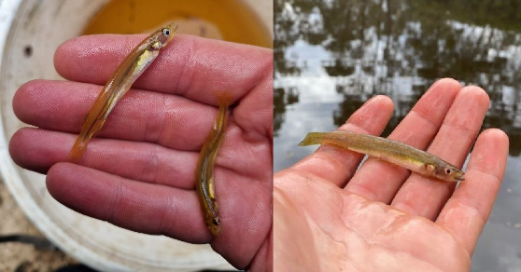
Figure 6. Flat-headed Galaxias collected from (left) Goulburn River billabong (site 38) and (right) Sandy Creek (site 43). Image credit: Daniel J. Stoessel.

eDNA
Water samples for DNA analysis were collected from 25 of the 42 sites at which surface water was present (Table 1), with 4 replicates being taken at 22 sites, and 3 replicates at 3 sites (sites 4, 27 and 28).
Consequently, 97 filters containing residue were available for analysis, and an additional three filters were collected from each of two blank ‘sites’ (bottled water), one ‘site’ on each field trip, to function as field controls. The location of the collection of each water sample was unknown to laboratory staff, as the samples were only identified by the site and replicate number.
A qPCR replicate was considered positive if Flat-headed Galaxias DNA was detected. Based on the number of positive qPCR results from the replicates from an eDNA extraction, the water sample replicate and their specific site were scored as positive, ambiguous, or negative for Flat-headed Galaxias DNA following the criteria in Table 2 (see Also Table 1 and Figure 4). Note that a site was considered ambiguous (i.e. an equivocal result) if only one qPCR result was positive in one or more water sample replicates from that site, since none of the replicate water samples themselves could be scored as positive.

Table 2. Scoring criteria for sites and replicate water samples, based on qPCR results for the detection of Flat-headed Galaxias DNA.
qPCR = quantitative polymerase chain reaction.

Score Sample level | Positive | Ambiguous | Negative
Filtered water sample | More than 1/3 positive qPCR replicates | 1/3 positive qPCR replicates | 0/3 positive qPCR replicates
Site | 1 or more positive filtered samples | 1 or more ambiguous filtered samples, but no positive filtered samples | No positive or ambiguous filtered samples

A total of 309 qPCR reactions were undertaken (103 filters x 3 replicates each). The detection results are presented with colour coding of the water sample codes at each sample site in Table 1. DNA of Flat-headed Galaxias was detected by the Galros3 primer at 14 sites (green or orange text; Table 1), with positive (green text) detections (2/3 or 3/3 positive qPCR replicates) from 20 water samples from 10 sites (sites 6, 7, 8, 12, 14, 16, 23, 38, 39, 42) (Table 1, Figure 7).
Four sites were ambiguous (orange text, Table 1; Figure 7) for the detection of Flat-headed Galaxias DNA. Two sites (19 and 28) had multiple water samples (2 and 3, respectively) in which 1 of 3 qPCR replicates showed a positive qPCR, which may indicate positive detections at the site level, while a further two sites (25 and 40) had a single water sample with only 1 of 3 showing positive qPCR, which suggests that eDNA may

be present but not in quantities that enable a definitive result from the primer used. While these sites are close geographically to positive sites (e.g. sites 40 and 42, Figure 7), they are currently considered inconclusive with respect to the detection of Flat-headed Galaxias DNA.
All sequenced qPCR products were confirmed as Flat-headed Galaxias. All negative samples tested positive for the control DNA; therefore, the negative results were not due to PCR inhibition.
All positive samples returned Quantification Cycle (Cq) scores (i.e. the number of copies of target DNA) ranging from 31.5 to 38.4. The Mitta Mitta River billabong off Yabba Road (site 6) had the most detections, with up to 655,000 copies of Flat-headed Galaxias DNA being detected.
While mainly 5.0-µm filters were used for this study, some smaller filter sizes were also used. However, there was no obvious association between filter size and detection rate. Positive qPCR reactions resulted from water samples collected from all filter sizes (5.0 µm, 1.2 µm and 0.45 µm), though 9 of the 10 positive detections occurred at sites where at least one 5.0-µm filter was positive (Table 1). However, the tenth positive detection site only used 0.45-µm filters (site 16, Lake Moodemere). There was also no apparent association between the amount of water being filtered in a sample and the number of DNA copies detected at any individual site (data not provided).

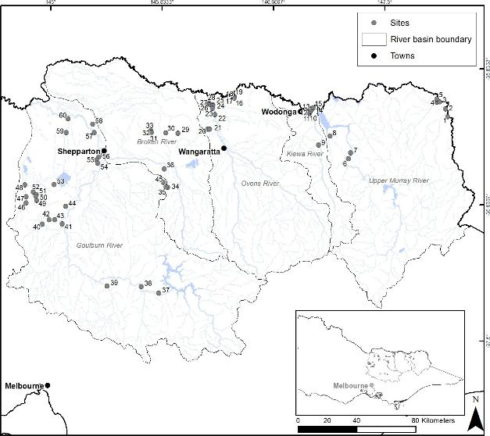

Figure 7. Results of Flat-headed Galaxias DNA detection from water samples.
Green circles = positive detection; orange circles = ambiguous detection; grey circles = no detection.

Population genetics
Tissue clips collected from 72 Flat-headed Galaxias individuals from across four geographically separated river basins were sent to DArT Pty Ltd for DNA extraction and sequencing (Table 3). These included tissue from 43 individuals collected in this study, and from 29 individuals from recent (<25 years ago) samples from elsewhere in northern Victoria.
Of the 72, a total of 65 Flat-headed Galaxias individuals were successfully amplified for SNPs (Table 3).
The initial dataset before filtering had 5849 SNPs. Filtering for reproducibility = 1 decreased this to 4769 loci. Filtering by missing data is always a balance between trying to retain as many individuals as possible and trying to retain as many loci as possible. Three samples from the Corowa area and the Avoca sample had higher levels of missing data: GRSnakMurr.3 0.598, GRChinMurr.1 0.762, GRSnakMurr.2 0.826 and GRStrahAvoc.1 0.868. All other samples had values of between 0.895 and 0.959. Given that each of these samples was from geographically distinct populations, they were retained. Filtering for missing loci, with a threshold of 0.95, retained 3542 SNPs. Increasing this threshold to 1 (i.e. no missing data) resulted in the retention of 2017 loci. For the PCoA analysis, any secondary loci were removed, which resulted in 3412 and 1997 loci, respectively.

Table 3. Number (N) of tissue clips from Flat-headed Galaxias individuals from four river basins sent to DArT for sequencing, and successfully sequenced for SNPs
Numbers in bold indicate tissue samples collected from the current survey. PCoA codes refer to Figure 6 and Figure 8.

Waterbody | River basin | N | SNPs | PCoA code
Billabong | Mitta Mitta | 5 | 5 | Mitta_Mitta
Sandy Creek | Mitta Mitta | 1 | 1 | Sandy_Mitta
Compton Creek | Goulburn | 4 | 4 | Compton
Cornella Creek | Goulburn | 9 | 9 | Cornella
Billabongs | Goulburn | 22 (14+8) | 19 | Goulburn
Sandy Creek | Goulburn | 24 | 23 | Sandy
Strathfillian Creek | Avoca | 1 | 1 | Strathfillian
Green Lake | Avoca | 2 | 0 | –
Chinamans Lagoon | Mid-Murray | 1 | 1 | Chinamans
Snake Island Billabong | Mid-Murray | 3 | 2 | Snake_Island
 | Total | 72 | 65

Spatial pattern
The PCoA results for all the populations of Flat-headed Galaxias broadly separated them into geographic groups. The first PCoA (axis 1 vs axis 2) shows the individuals clustered into three broad groups: (1) the Goulburn River billabongs plus Compton Creek, (2) Sandy Creek (Goulburn) and (3) a broad group including the Mitta Mitta River basin, mid-Murray River Basin, Avoca River Basin (Strathfillian Creek) and Cornella Creek (Goulburn River Basin) fish (Figure 9).

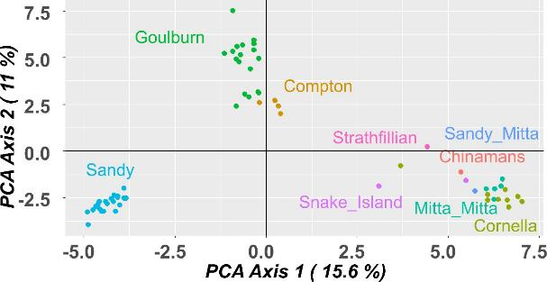

Figure 8. PCoA plot for Flat-headed Galaxias showing axis 1 versus axis 2.
The second PCoA (axis 1 vs axis 3) shows the third axis separating the Cornella Creek fish from the Mitta Mitta, mid-Murray, and Avoca fish (Figure 7). The mid-Murray fish cluster (Snake_Island and Chinamans) is in an intermediate position between the Mitta Mitta fish (Mitta_Mitta and Sandy_Mitta) and the Goulburn fish (Sandy, Goulburn, Compton, Cornella) but closer to the Mitta Mitta fish, indicating a closer genetic relationship with the Mitta Mitta fish. This is supported by the geographic separation of these populations, with those in the mid-Murray, near Corowa, being geographically closer to the Mitta Mitta populations than those in the Goulburn River system.

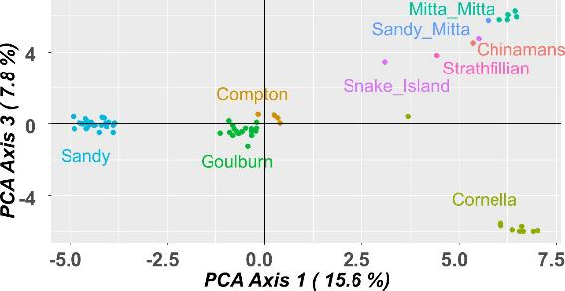

Figure 9. PCoA plot for Flat-headed Galaxias showing axis 1 versus axis 3.

Similar patterns to those in the PCoA ordinations were found in the phylogenetic tree (Figure 10). Fish from each river basin grouped separately, with the closest relationship being indicated between the Mitta Mitta River Basin and mid-Murray River Basin fish. As per the PCoA, the Goulburn River Basin population from Cornella Creek was the first branching lineage, followed by the population from Sandy Creek, with the Compton Creek population having a closer relationship to the Goulburn River billabongs fish than the Cornella Creek or Sandy Creek fish. The distinction of the Cornella Creek population from the rest of the populations within the Goulburn River Basin (Sandy Creek, Goulburn River billabongs, Compton Creek) appears likely, supported by the geographical separation of the populations and the potential limits to fish dispersal. The Cornella Creek system is endoreic (internally draining), with no natural stream connection to the Goulburn River system, and the other Goulburn River populations are linked to one another via the Goulburn River channel upstream of Goulburn Weir.
The one key difference between the PCoA and the phylogenetic tree is that the Avoca River Basin (Strathfillian Creek) individual is quite distinct in the tree. This discrepancy may be an artefact of the PCoA analysis due to uneven sample sizes.
The average observed heterozygosity by drainage varied from 0.119 to 0.175, except in the Avoca River Basin (Strathfillian Creek), where it was much lower at 0.052 (Table 4). The expected heterozygosity values were like the observed values except in the populations with a sample size of 1, where the expected heterozygosities were approximately half of the observed values. The number of polymorphic loci in each population was lowest in populations with low sample sizes (i.e. 1 or 2 individuals). Most sites with higher sample sizes had 40% to 51% of their loci being variable, except at Compton Creek (Goulburn River Basin), which was slightly lower at 31% (Table 4).
The number of private alleles varied considerably between populations. Sandy Creek (Goulburn River Basin), despite having the largest sample size, had a small number of private alleles (46, Table 4).
Populations from billabongs in the Goulburn and Mitta Mitta river basins, plus Cornella Creek (Goulburn River Basin), all had higher numbers of private alleles. The FST values were also high (Table 5) but appeared to increase consistently with increasing geographic distances between populations.

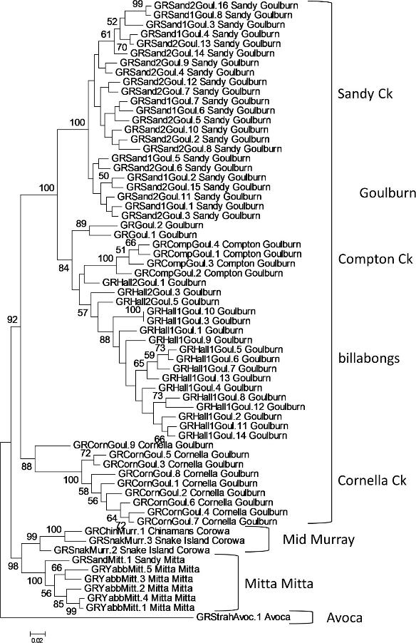

Figure 10. Maximum likelihood tree for Flat-headed Galaxias in northern Victoria.

Table 4. Population genetic values for Flat-headed Galaxias.
Pop = population; N = sample size; nLoc = number of loci; pLoc = number of variable or polymorphic loci; propPoly = proportion of polymorphic loci; mLoc = number of invariant or monomorphic loci; Ho = observed heterozygosity; HoSD = standard deviation of observed heterozygosity; He = estimated heterozygosity values; HeSD = standard deviation of estimated heterozygosity; Fis = fixation index; priv = number of private alleles.

Pop | N | nLoc | pLoc | prop Poly | mLoc | Ho | HoSD | He | HeSD | FIS | Priv
Goulburn | 19 | 2017 | 1022 | 0.51 | 995 | 0.135 | 0.182 | 0.140 | 0.180 | 0.061 | 164
Compton | 4 | 2017 | 620 | 0.31 | 1397 | 0.136 | 0.242 | 0.113 | 0.181 | -0.055 | 24
Cornella | 9 | 2017 | 864 | 0.43 | 1153 | 0.134 | 0.202 | 0.133 | 0.183 | 0.048 | 114
Sandy (Goulburn) | 23 | 2017 | 798 | 0.40 | 1219 | 0.119 | 0.187 | 0.116 | 0.176 | -0.008 | 46
Mitta Mitta | 5 | 2017 | 841 | 0.42 | 1176 | 0.162 | 0.233 | 0.140 | 0.182 | -0.041 | 137
Sandy (Mitta Mitta) | 1 | 2017 | 353 | 0.18 | 1664 | 0.175 | 0.380 | 0.088 | 0.190 | 0.000 | 33
Chinamans | 1 | 2017 | 257 | 0.13 | 1760 | 0.127 | 0.334 | 0.064 | 0.167 | 0.000 | 7
Snake Island | 2 | 2017 | 630 | 0.31 | 1387 | 0.162 | 0.275 | 0.126 | 0.190 | 0.039 | 43
Strathfillian | 1 | 2017 | 105 | 0.05 | 1912 | 0.052 | 0.222 | 0.026 | 0.111 | 0.000 | 184

Table 5. Comparison of genetic differentiation between Flat-headed Galaxias populations based on the fixation index (FST values).
NA = not available.

Population | Goulburn | Compton | Cornella | Sandy  (Goulburn) | Mitta Mitta | Sandy (Mitta Mitta) | Chinamans | Snake Island
Goulburn | –
Compton | 0.177 | –
Cornella | 0.279 | 0.317 | –
Sandy (Goulburn) | 0.208 | 0.285 | 0.341 | –
Mitta Mitta | 0.308 | 0.332 | 0.287 | 0.376 | –
Sandy (Mitta Mitta) | 0.307 | 0.370 | 0.294 | 0.397 | 0.081 | –
Chinamans | 0.286 | 0.381 | 0.289 | 0.396 | 0.193 | NA | –
Snake Island | 0.264 | 0.305 | 0.265 | 0.332 | 0.173 | 0.088 | −0.122 | –
Strathfillian | 0.512 | 0.584 | 0.533 | 0.594 | 0.515 | NA | NA | 0.452

To understand the status of the Flat-headed Galaxias, with respect to its current level of genetic variation, requires a comparison with the genetic variation of other small-bodied native fish species in the Murray–Darling Basin. However, it is difficult from SNP data to compare genetic diversity across species, as only polymorphic loci are retained within the dataset—measures like heterozygosity are only comparable within a dataset. The number of polymorphic loci, though, does provide some comparison across species, even if only qualitatively.
We compared the summarised data on the polymorphic loci in Flat-headed Galaxias with unpublished data for five other small-bodied native fish species from the Murray–Darling Basin (P.J. Unmack, unpublished data), including two highly threatened species, two widespread species, and a second galaxiid species (Table 6). While filtering parameters, sample sizes per population, and the characteristics of each species differed, the assessment highlighted that, despite its major decline, Flat-headed Galaxias still retains reasonable levels of genetic diversity. The number of polymorphic loci for the threatened Flat-headed Galaxias was understandably lower than that for the widespread, non-threatened species, but also higher than that for the threatened species. Interestingly, loci values for the non-threatened Mountain Galaxias (Galaxias olidus) were lower than for Flat-headed Galaxias, but this may reflect the fact that most remnant Mountain Galaxias populations are from small upland creeks, with smaller population sizes and more limited historical gene flow.

Table 6. Number of polymorphic loci for five Murray–Darling Basin native fish species, including the total number of loci (nLoc), average number of polymorphic loci per population (pLoc), and the range of values across all populations (range).
MDB = Murray–Darling Basin; T = threatened species; W = widespread non-threatened species.

Species | No. of populations | Region | nLoc | pLoc | Range
Flat-headed Galaxias | 9 | Murray | 2017 | 610 | 105–1022
Agassiz’s Glassfish ^{T}  (Ambassis agassizii) | 10 | MDB | 890 | 201 | 65–305
Southern Purple-spotted Gudgeon ^{T}  (Mogurnda adspersa) | 17 | MDB | 1445 | 103 | 24–203
Mountain Galaxias ^{W}  (Galaxias olidus) | 53 | Murrumbidgee | 3638 | 315 | 122–622
Australian Smelt ^{W}  (Retropinna semoni) | 11 | Murray | 5724 | 1267 | 718–1712
Unspecked Hardyhead ^{W} (Craterocephalus stercusmuscarum fulvus) | 7 | Murray | 3446 | 1219 | 985–1493

Discussion

We successfully detected Flat-headed Galaxias at four sites through both physical sampling and detection of their DNA. Their DNA was also detected at several additional sites. The corroboration of the presence of Flat-headed Galaxias at these four sites by physical sampling demonstrates that the presence of Flat-headed Galaxias can be detected from its DNA in water samples at occupied sites, and confirms that the Galros3 DNA primer is effective for this species. Further, the number of Flat-headed Galaxias collected (44) supplemented the smaller number of existing tissue samples (26), and we were able to undertake the first population genetics analysis for the species.
The four sites where Flat-headed Galaxias were captured represent 9.5% of the 42 sites where physical sampling was undertaken. However, positive eDNA detections were made at 10 sites, extending across the suspected range of the species, from the Mitta Mitta River in the Upper Murray Basin, westward across the Kiewa and Ovens basins, and to the Goulburn Basin. Similarly, the corroborated DNA and physical sampling sites for Flat-headed Galaxias also spanned this range, though they were absent from the Kiewa and Ovens basins. Given our confirmation that the DNA probe can detect Flat-headed Galaxias, it is highly likely that the positive DNA detections at the additional six sites that were not corroborated by physical sampling are also real indications of the species’ presence. Further physical surveys are required at these sites to confirm the presence of Flat-headed Galaxias, thereby confirming the success of DNA detection for this species, and enabling an assessment of their population abundance.
Flat-headed Galaxias DNA was detected from eDNA at a further four sites (19, 25, 28, 40; Table 1), but did not meet our criteria for a positive detection at the water sample or site level (Table 2). At these sites, only one of the three replicate qPCRs performed on each water sample detected Flat-headed Galaxias DNA, so the results from these locations are considered ambiguous. The ambiguous water sample results were obtained for one of four replicates (at sites 25 and 40), two of four replicates (at site 19), and three of four replicates (at site 28). The water samples were collected with 5-µm filters, except at site 19, where 1.2-µm filters were used: filter size did not seem to be a contributing factor, as the finer filter used at site 19 outperformed the larger filter size at sites 25 and 40 for positive qPCR results. To further investigate the ambiguous results with respect to the small number of positive detections, additional replicate qPCRs on the remaining samples could be run, or additional water samples could be collected from these sites and analysed.
Physical sampling at the sites was limited due to time and budgetary constraints; hence, only a small area at each location was sampled over a short period of time. Therefore, it is not surprising that more Flat-headed Galaxias detections were made with eDNA than with physical sampling, as DNA detections do not require the capture of individuals. Consequently, the non-detection of Flat-headed Galaxias from physical sampling at sites may be overestimated, particularly if the Flat-headed Galaxias population abundance was low, the preferred habitat was marginal, or the water bodies were spatially large (e.g. Ryans Billabong, site 14; Lake Moodemere, site 16). Greater sampling effort, and potentially using additional gear types, may have increased the Flat-headed Galaxias physical detection success.
The value of physical sampling is in its ability to detect Flat-headed Galaxias if the population abundance is large, such as at the Goulburn River billabong (site 38), the dams on Sandy Creek (sites 42 and 43), and in the Mitta Mitta billabong (site 6). These sites likely represent self-sustaining populations that will be valuable for the conservation management of the species. We note that, except at site 6, the presence of Flat-headed Galaxias at these sites was visually observed when first approaching. As the species characteristically swim just under the water surface, they create a narrow but long, straight bow wave when startled as they streak away from the bank.
Further, as Flat-headed Galaxias had been previously recorded from the Mitta Mitta Billabong, Sandy Creek dam (site 42), and the Goulburn River billabong, their re-collection potentially indicates long-term use at these sites, or preferred habitat when sites become re-wetted if they intermittently dry out. The second Sandy Creek detection (site 42) is a new location record, though it is a short distance upstream from site 43. This does suggest that populations may be spread along stream reaches and may take refuge in isolated pools in intermittently flowing systems.
The potential for a high number of non-detections of Flat-headed Galaxias from physical sampling to be false negatives precludes an assessment of the potential population decline based on the number of non-detection sites. However, given that 5 (29%) of the 17 sites where Flat-headed Galaxias had been previously recorded (sites 31, 34, 44, 47, 55) were now dry, there may be an ongoing decline in the distribution of the species and a vulnerability during increasingly dry periods or supra-seasonal drought. This increases the urgency of implementing a broad-scale eDNA detection program to identify the remnant wild populations of Flat-headed Galaxias across their range, to support conservation recovery actions.

Overall, the use of eDNA for the initial detection of Flat-headed Galaxias populations appears to be more efficient than physical sampling, due to not requiring the capture of an individual—which is usually difficult, time-consuming, and problematic due to various environmental factors leading to a low detection probability. While a reasonable effort of physical sampling, to improve detection probability, may limit the number of sites that can be surveyed to a couple per day, eDNA sampling can be relatively rapid, with multiple water samples able to be collected from several sites per day. The eDNA analysis results can direct physical sampling, if it is required, to positive detection sites with more efficient use of resources. Once a high level of confidence in the eDNA results has been reached, effort can be expended in improving the physical sampling methods for the efficient capture of Flat-headed Galaxias at sites where the species is known to occur, particularly in larger water bodies.
Additional eDNA and physical sampling need to be undertaken using the Galros3 probe to further verify the effectiveness of the technique and to understand the ambiguous detection results. Additional sites in catchments that are known to contain Flat-headed Galaxias should also be sampled.
The population genetics analysis used tissue from across the former range of Flat-headed Galaxias in Victoria, including the Murray River (NSW), though the bulk of the samples came from individuals collected in this study. Consequently, although the number of individuals from many previously known widespread populations are represented, this analysis should be considered valuable to conservation recovery, as it is based on all the available material. That said, the analysis can be improved by the addition of tissue from more individuals and from other populations, if they are found.
Unsurprisingly, Flat-headed Galaxias have almost certainly lost genetic diversity, no doubt related to their significant decline in range and local abundance, and this is broadly reflected in the genetics results.
Geographic structure is present and may have been exacerbated by the degree of fragmentation and population declines, as genetic drift will play a stronger role with absent or decreasing gene flow over time. Even populations that were within the same subcatchments (e.g. Sandy Creek and Goulburn River billabong) showed high degrees of divergence, based on the presence of private alleles and high FST (fixation index) values, consistent with a lack of contemporary gene flow.
However, while genetic diversity has been reduced, and the overall genetic differences between populations are not great, surprisingly, the populations appear to retain a reasonable amount of genetic diversity, based on the number of polymorphic loci found in each population. Compared with Unspecked Hardyhead (Craterocephalus stercusmuscarum fulvus) and Southern Purple-spotted Gudgeon (Mogurnda adspersa), two highly threatened freshwater fish from the Murray–Darling Basin, Flat-headed Galaxias has a higher number of polymorphic loci. This number, however, is lower than that found in Murray–Darling Basin populations of Australian Smelt (Retropinna semoni) and Unspecked Hardyhead (Craterocephalus fluviatilis), two widespread, non-threatened species. In contrast, polymorphic loci values for Mountain Galaxias (Galaxias olidus), a widespread but fragmented, non-threatened, relatively sedentary upland species, are lower than for the vagile Flat-headed Galaxias, which is found in more lowland aquatic habitats. This may reflect the fact that most remnant populations of Mountain Galaxias are from small upland creeks with smaller population sizes and more limited historical gene flow.
The genetic results provide some guidance for genetic conservation management of Flat-headed Galaxias. Based on the increasing importance placed in the conservation biology literature on considering translocations between less genetically related populations to bolster genetic diversity and fitness (Frankham et al. 2019), we recommend mixing individuals from the different populations in an attempt to conserve the broader genetic diversity.
Therefore, for hatchery production of individuals and/or translocations to establish new populations, mixing of individuals from distant populations should be undertaken, such as between the billabong populations in the Goulburn and Mitta Mitta basins, as well as Cornella Creek. Each of these populations has a higher number of private alleles and polymorphic loci than the other populations. It is also important to expand the search for extant populations in other subcatchments, as populations within them are likely to contain additional genetic diversity.
Given that four larger populations of Flat-headed Galaxias are now known, a conservation strategy may be to harvest individuals to establish additional populations in isolated farm dams or semi-controlled urban water bodies, as is currently being done in the Southern Purple Spotted Gudgeon and Southern Pygmy Perch (Nannoperca australis) programs. These new sites can function as natural hatcheries and, if productive, they can provide individuals for stocking to bolster wild populations or to establish additional populations in the wild without the expense and risk of captive rearing. However, an issue to consider is the role genetic drift may play in stocked populations, as loss in genetic diversity is likely to occur when going from a larger habitat (wild site) to a smaller one (dam or urban water body). This has been demonstrated during translocations of the threatened native fish Redfin Blue-eye (Scaturiginichthys vermeilipinnis) from a larger source spring population into smaller springs (Furlan et al. 2020).

For Flat-headed Galaxias, a strategy to avoid genetic diversity loss may be to establish numerous natural hatchery populations and to use as many of these as possible when translocating and establishing new wild populations. For example, if 500 individuals are required for translocation to a site, it would be better to source 50 individuals from each of 10 populations than 250 individuals from each of two populations. This would minimise the chances of genetic drift reducing genetic variation across the total “captive” (i.e. natural hatchery) population.

Conclusion

This project has demonstrated that the presence of Flat-headed Galaxias, a species difficult to detect using traditional survey methods, can be determined in the absence of capturing a specimen, by screening a water sample for its DNA. This method, while requiring further validation, shows promise in being a rapid and efficient detection method, when compared with physical sampling, with considerable potential for undertaking rapid initial screening of whole catchments. Once undertaken, physical sampling can then be directed to positive detection sites. This efficient detection method will underpin the development and implementation of conservation management for Flat-headed Galaxias in south-eastern Australia.
The first genetics analysis of populations of this species has provided valuable data that may be used in the conservation management of the species. Despite having suffered a large decline in range and abundance, Flat-headed Galaxias show moderate geographic structure across extant populations consistent with the geographic distances and the increasing anthropogenically induced fragmentation of its habitat. The species retains moderate levels of genetic variation over its range, which may be used in conservation efforts to maximise the evolutionary potential of the species.

References

Allen, G.R., Midgley, S.H. and Allen, M. (2003). Field Guide to the Freshwater Fishes of Australia, revised edition. CSIRO publishing, Collingwood, Australia.
Balasingham, K.D., Walter, R.P., Mandrak, N.E. and Heath, D.D. (2018). Environmental DNA detection of rare and invasive fish species in two Great Lakes tributaries. Molecular Ecology 27, 112–127. doi:10.1111/mec.14395.
Beng, K.C. and Corlett, R.T. (2020). Applications of environmental DNA (eDNA) in ecology and conservation: Opportunities, challenges and prospects. Biodiversity and Conservation 29 (7), 2089–2121. doi:10.1007/s10531-020-01980-0
Bylemans, J., Gleeson, D., Duncan, R.P., Hardy, C.M. and Furlan, E.M. (2019). A performance evaluation of targeted eDNA and eDNA metabarcoding analyses for freshwater fishes. Environmental DNA 1, 402–414. doi.org/10.1002/edn3.41
Cadwallader, P.L. and Backhouse, G.N. (1983). A Guide to the Freshwater Fish of Victoria. Government Printer, Melbourne, Victoria.
Department of Environment, Land, Water and Planning (DELWP). (2021). Flora and Fauna Guarantee Act 1988 – Threatened List. Department of Environment, Land, Water and Planning, East Melbourne, Victoria.
Frankham, R., Ballou, J.D., Ralls, K., Eldridge, M., Dudash, M.R., Fenster, C.B., Lacy, R.C. and Sunnucks, P. (2019). A Practical Guide for Genetic Management of Fragmented Animal and Plant Populations. Oxford University Press, Oxford, UK. doi:10.1093/oso/9780198783411.001.0001
Furlan, E. and Gleeson, D. (2016). Improving reliability in environmental DNA detection surveys through enhanced quality control. Marine and Freshwater Research 68, 388–395. doi:10.1071/mf15349
Furlan, E.M., Gruber, B., Attard, C.R.M., Wager, R.N.E., Kerezsy, A., Faulks, L.K., Beheregaray, L.B. and Unmack, P.J. (2020). Assessing the benefits and risks of translocations in depauperate species: a theoretical framework with empirical validation. Journal of Applied Ecology 57, 831–841.
Georges, A., Gruber, B., Pauly, G.B., White, D., Adams, M., Young, M.J., Kilian, A., Zhang, X., Shaffer, H.B. and Unmack, P.J. (2018). Genome-wide SNP markers breathe new life into phylogeography and species delimitation for the problematic short-necked turtles (Chelidae: Emydura) of eastern Australia. Molecular Ecology 27, 5195–5213.
Gilligan, D., Pearce, L. and Raadik, T.A. (2019). Galaxias rostratus. The IUCN Red List of Threatened Species 2019, e.T8814A129041409. doi:10.2305/IUCN.UK.2019- 3.RLTS.T8814A129041409.en
Goldberg, C.S., Turner, C.R., Deiner, K., Klymus, K.E., Thomsen, P.F., Murphy, M.A., Spear, S.F., McKee, A., Oyler-McCance, S.J., Cornman, R.S. and Laramie, M.B. (2016). Critical considerations for the application of environmental DNA methods to detect aquatic species. Methods in Ecology and Evolution 7 (11), 1299–1307.
Gower, J.C. (1966). Some distance properties of latent root and vector methods used in multivariate analysis. Biometrika 53, 325–338.
Gruber, B., Unmack, P.J., Berry, O. and Georges, A. (2018). dartR: an R package to facilitate analysis of SNP data generated from reduced representation genome sequencing. Molecular Ecology Resources 18, 691–699. doi:10.1111/1755-0998.12745
Guy, C.S., Blankenship, H.L. and Nielson L.A. (1996). Tagging and marking. In: Murphy, B.R. and Willis,
D.W. (Eds.) Fisheries Techniques, pp. 353–379. American Fisheries Society, Bethesda, Maryland, 2nd edn.
Hammer, M., Wedderburn, S. and van Weenan, J. (2009). Action Plan for South Australian Freshwater Fishes. Native Fish Australia (SA) Inc., Adelaide, SA.
Hinlo, R., Gleeson, D., Lintermans, M. and Furlan, E. (2017). Methods to maximise recovery of environmental DNA from water samples. PLoS ONE 12 (6), e0179251. doi:10.1371/journal.pone.0179251
Jombart, T. (2008). Adegenet: a R package for the multivariate analysis of genetic markers. Bioinformatics
24, 1403–1405.

Kilian, A., Wenzl, P., Huttner, E., Carling, J., Xia, L., Blois, H., Caig, V., Heller-Uszynska, K., Jaccoud, D., Hopper, C., Aschenbrenner-Kilian, M., Evers, M., Peng, K., Cayla, C., Hok, P. and Uszynski, G. (2012). Diversity Arrays Technology: a generic genome profiling technology on open platforms. In: Pompanon, F. and Bonin, A. (Eds.) Data Production and Analysis in Population Genomics: Methods and Protocols, pp. 67–89. Humana Press, Totowa, NJ, USA.
Kumar, S., Stecher, G. and Tamura, K. (2016). MEGA7: molecular evolutionary genetics analysis version 7.0 for bigger datasets. Molecular Biology and Evolution 33, 1870–1874.
Lintermans, M. (2007). Fishes of the Murray–Darling Basin: An Introductory Guide. Murray-Darling Basin Commission, Canberra, ACT.
Llewellyn, L.C. (2005). Breeding biology, and egg and larval development of Galaxias rostratus Klunzinger, the Murray Jollytail from inland New South Wales. Australian Zoologist 33(2), 141–165.
McDowall, R.M. and Frankenberg, R.S. (1981). The galaxiid fishes of Australia. Records of the Australian Museum 33 (10), 443–605.
Miller, M.A., Pfeiffer, W. and Schwartz, T. (2010). Creating the CIPRES Science Gateway for inference of large phylogenetic trees. In: Proceedings of the Gateway Computing Environments Workshop (GCE), New Orleans, LA, USA, November, 2010, pp. 1–8.
Spens, J., Evans, A.R. Halfmaetern, D., Knudsen, S.W., Sengupta, M.E., Mak, S.S.T., Sigsgaard, E.E. and Hellström, M. (2017). Comparison of capture and storage methods for aqueous macrobial eDNA using an optimized extraction protocol: advantage of enclosed filter. Methods in Ecology and Evolution 8 (5), 635–645.
Stamatakis, A. (2014). RAxML version 8: a tool for phylogenetic analysis and post-analysis of large phylogenies. Bioinformatics 30, 1312–1313.
Taberlet, P., Bonin, A., Zinger, L. and Coissac, E. (2018). Environmental DNA. For Biodiversity Research and Monitoring. Oxford University Press, Oxford, United Kingdom.
Thomsen, P.F. and Willerslev, E. (2015). Environmental DNA – an emerging tool in conservation for monitoring past and present biodiversity. Biological Conservation 183, 4–18. doi:10.1016/j.biocon.2014.11.019
Whiterod, N., Zukowski, S., Ellis, I., Pearce, L., Raadik, T., Rose, P., Stoessel, D. and Wedderburn, S. (2019). The present status of key small-bodied threatened freshwater fishes in the southern Murray–Darling Basin, 2019. A report to the Tri-State Murray NRM Regional Alliance. Aquasave–Nature Glenelg Trust, Goolwa Beach, SA.

Appendices

Appendix 1. Survey site information

Table A1. Survey site information, including sites at which Flat-headed Galaxias had previously been recorded
RB = river basin number; bold waterbody name = previous Flat-headed Galaxias location; BP = electrofisher, backpack; E = eDNA water sample; O = observation only; Year last recorded = year of last record of Flat-headed Galaxias.

Site no. | R B | Waterbody | Location | Decimal latitude | Decimal longitude | Date | Gear type | Year last recorded
1 | 1 | Murray River | Billabong, off Towong Hill Road, Towong | −36.13499 | 147.99753 | 29/03/2022 | BP, E
2 | 1 | Murray River | Billabong, off Murray River Road | −36.08708 | 147.97877 | 29/03/2022 | BP, E
3 | 1 | Murray River | At bridge on Tintaldra Road, downstream side, Tintaldra | −36.04583 | 147.93188 | 29/03/2022 | E
4 | 1 | Cudgewa Creek | From bridge on Murray River Road to 180 m upstream | −36.04659 | 147.91064 | 28/03/2022 | BP, E | 2002
5 | 1 | Cudgewa Creek | Cudgewa Back Creek, billabong just upstream of Clarke Reserve | −36.027667 | 147.910328 | 29/03/2022 | BP, E
6 | 1 | Mitta Mitta River | Billabong, off Yabba Road | −36.40964 | 147.25504 | 29/03/2022 | BP, E | 1993
7 | 1 | Mitta Mitta River | Billabong, off Omeo Road | −36.385 | 147.26444 | 29/03/2022 | BP, E
8 | 1 | Sandy Creek | At Bryants Gap Road | −36.27328 | 147.11313 | 30/03/2022 | BP, E | 2002
9 | 2 | Gap Creek | At bridge on Kiewa Valley Highway, Kergunyah | −36.32902 | 147.02668 | 30/03/2022 | BP | 2002
10 | 2 | Kiewa River | Billabong, off Brooks Terrace, Killara | −36.137502 | 146.95203 | 30/03/2022 | BP
11 | 2 | Kiewa River | Billabong, off Brooks Terrace, Killara | −36.136726 | 146.951988 | 30/03/2022 | BP
12 | 2 | Kiewa River | Billabong, off Bakers Lane, Killara | −36.13208 | 146.94951 | 30/03/2022 | BP, E
13 | 2 | Finns Creek | At bridge on Consibee Lane | −36.12357 | 146.96066 | 30/03/2022 | BP
14 | 2 | Ryans Billabong | Off Ryan Road | −36.11351 | 146.9702 | 30/03/2022 | BP, E | 1976
15 | 3 | Snowdons Billabong | Billabong, on edge of Snowdons Road | −36.101759 | 146.98081 | 30/03/2022 | BP | 1976
16 | 3 | Lake Moodemere | Off Lake Road, Lake Moodemere Reserve | −36.050317 | 146.382487 | 31/03/2022 | BP

Site no. | R B | Waterbody | Location | Decimal latitude | Decimal longitude | Date | Gear type | Year last recorded
17 | 3 | Ovens River | Billabong, off Hynes Road | −36.041849 | 146.383862 | 31/03/2022 | BP, E
18 | 3 | Ovens River | Inlet off Murray River, off Hynes Road, Lake Moodemere Reserve | −36.041808 | 146.383212 | 31/03/2022 | BP
19 | 3 | Ovens River | Billabong off Hynes Road, Lake Moodemere Reserve | −36.042522 | 146.380677 | 1/04/2022 | BP, E
20 | 3 | Sandy Creek | Tributary, Boweya Road | −36.2427 | 146.18537 | 28/03/2022 | O
21 | 3 | Chinaman Creek | Boweya Road | −36.24309 | 146.20189 | 28/03/2022 | O
22 | 3 | Ovens River | Billabong next to McLaughlins Track | −36.15384 | 146.23898 | 31/03/2022 | BP, E
23 | 3 | Ovens River | Billabong, off Robinsons Track | −36.115474 | 146.219448 | 31/03/2022 | BP, E
24 | 3 | Ovens River | Upstream and downstream of McQuades Bend Track, Warby–Ovens National Park | −36.100221 | 146.221354 | 31/03/2022 | BP
25 | 3 | Ovens River | Billabong, off Kings Road | −36.091639 | 146.222753 | 31/03/2022 | BP, E
26 | 3 | Ovens River | Billabong next to Puzzle Bend Track, Warby–Ovens National Park | −36.093786 | 146.206794 | 31/03/2022 | BP
27 | 3 | Ovens River | Off track off Tarrawonga Road, near 'Glendalyn Park' | −36.091317 | 146.193097 | 31/03/2022 | BP
28 | 3 | Ovens River | Billabong, off Camerons Track | −36.078982 | 146.189897 | 31/03/2022 | BP, E
29 | 4 | Boosey Creek | Benalla/Yarrawonga Road | −36.26987 | 145.96191 | 28/03/2022 | O
30 | 4 | Broken Creek | Tributary, St James Road, St James | −36.26969 | 145.87047 | 28/03/2022 | O
31 | 4 | Nine Mile Creek | Waggarandall Road | −36.26636 | 145.76177 | 28/03/2022 | O | 1997
32 | 4 | Nine Mile Creek | Off Waggarandall Road, north end of reserve | −36.26405 | 145.75858 | 28/03/2022 | O
33 | 4 | Nine Mile Creek | Dam, off Evans Road, just off Nine Mile Creek | −36.256576 | 145.757732 | 28/03/2022 | BP
34 | 4 | Five Mile Creek | In pool downstream of Mack Road, east-south-east of Baddaginnie | −36.60235 | 145.88658 | 28/03/2022 | BP | 1990
35 | 4 | Baddaginnie Creek | At Mack Road, upstream of culvert | −36.60098 | 145.87572 | 28/03/2022 | O
36 | 4 | Broken River | Tributary, Tarnook Road | −36.49041 | 145.85937 | 28/03/2022 | O
37 | 5 | Goulburn River | Billabong, off Back Eildon Road, across road from Eildon Water Holiday Park | −37.251456 | 145.826185 | 21/03/2022 | BP
38 | 5 | Goulburn River | Billabong, off Halls Flat Road, about 2 km south-west of Alexandra | −37.21146 | 145.692094 | 21/03/2022 | BP | 2002

Site no. | R B | Waterbody | Location | Decimal latitude | Decimal longitude | Date | Gear type | Year last recorded
39 | 5 | Yea River | Billabong in John Cummins Reserve, Yea Wetlands, Yea | −37.208951 | 145.430855 | 22/03/2022 | BP | 2001
40 | 5 | Compton Creek | Dam, off Heathcote/Nagambie Road, 3 km south of Graytown | −36.830727 | 144.93581 | 22/03/2022 | BP | 2015
41 | 5 | Tahbilk Lagoon | Off Billabong Drive, Tahbilk Winery | −36.827772 | 145.087998 | 22/03/2022 | BP
42 | 5 | Sandy Creek | Dam on tributary, just downstream of Heathcote/Nagambie Road | −36.804681 | 145.026856 | 22/03/2022 | BP, E
43 | 5 | Sandy Creek | Tributary, dam off Heathcote/Nagambie Road, Billich Wetlands | −36.804099 | 145.02865 | 22/03/2022 | BP | 2019
44 | 5 | Reedy Lake | End of track, south-east end | −36.72233 | 145.11287 | 22/03/2022 | O | 1989
45 | 5 | Woolpress Creek | Tarnook Road | −36.57116 | 145.8549 | 28/03/2022 | O
46 | 5 | Cornella Creek | At Tait Hamilton Road | −36.70036 | 144.81151 | 24/03/2022 | O
47 | 5 | Cornella Creek | At Davey Road | −36.66359 | 144.8136 | 24/03/2022 | O | 2017
48 | 5 | Cornella Creek | Between Mitchell Street (Bendigo/Murchison Road) and Waranga Western Channel | −36.59075 | 144.802261 | 24/03/2022 | BP, E | 2010
49 | 5 | Wanalta Creek | Dam on floodplain, 300 m from corner of Dryden Road and Tait Hamilton Road, 4 km east of Gobarup | −36.684726 | 144.893049 | 23/03/2022 | BP | 2013
50 | 5 | Wanalta Creek | Off Davey Road | −36.659569 | 144.885566 | 23/03/2022 | O
51 | 5 | Wanalta Creek | Off Pardy Road | −36.650117 | 144.890413 | 23/03/2022 | O
52 | 5 | Wanalta Creek | Upstream of bridge on Cornella Church Road, south-west of Wanalta | −36.63454 | 144.867304 | 23/03/2022 | BP
53 | 5 | Waranga Basin | Tributary, dam, Rushworth | −36.587969 | 145.025711 | 24/03/2022 | BP, E
54 | 5 | Bruces Billabong | Off Darcy’s Track, Shepparton Regional Park | −36.4491 | 145.34969 | 23/03/2022 | O
55 | 5 | Black Billabong | Off Darcy’s Track, Shepparton Regional Park | −36.437208 | 145.346309 | 23/03/2022 | O | 1981
56 | 5 | Goulburn River | Billabong off Common Track, Shepparton Regional Park, 7 km south-west of Shepparton | −36.417015 | 145.365366 | 23/03/2022 | BP
57 | 5 | Goulburn River | Billabong, off unnamed track off Dead Man Track, 3 km east of Coomboona | −36.270723 | 145.32899 | 23/03/2022 | BP, E

Site no. | R B | Waterbody | Location | Decimal latitude | Decimal longitude | Date | Gear type | Year last recorded
58 | 5 | Loch Garry | Billabong off Loch Garry Road, Loch Garry Wildlife Reserve | −36.219378 | 145.316286 | 23/03/2022 | BP, E
59 | 5 | Boughyard Creek | Devenish/Wangaratta Road | −36.26987 | 145.11643 | 28/03/2022 | O
60 | 5 | Goulburn River | Billabong, off Horse Shoe Track | −36.17473 | 145.22965 | 23/03/2022 | O

Appendix 2. Selected site images

Upper Murray Basin
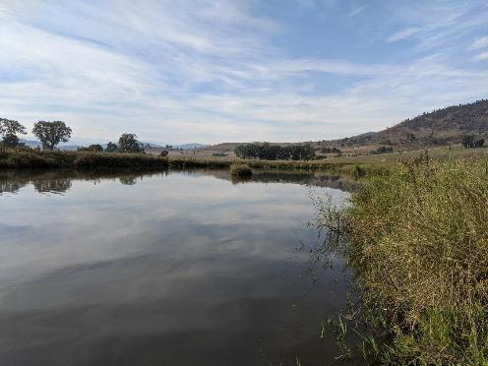
Site 1: Billabong off Towong Hill Road, Murray River, 29/03/2022. Image credit: Tarmo A. Raadik
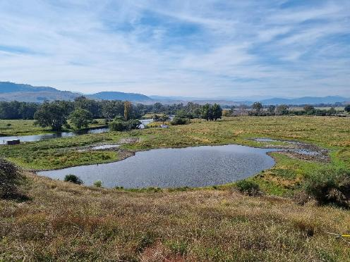
Site 2: Billabong off Murray River Road, Murray River, 29/03/2022. Image credit: Daniel J. Stoessel

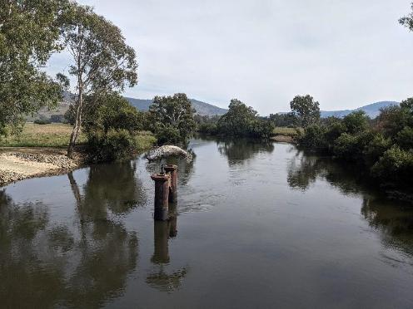
Site 3: Murray River, Tintaldra, 29/03/2022. Image credit: Tarmo A. Raadik. Downstream from the historical Flat-headed Galaxias location. No detection in this study
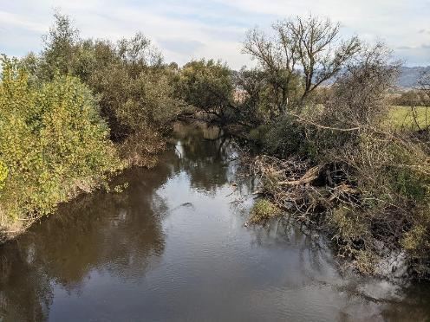
Site 4: Cudgewa Creek, Murray River Road, 29/03/2022. Image credit: Tarmo A. Raadik. Historical Flat-headed Galaxias location. Not detected in this study

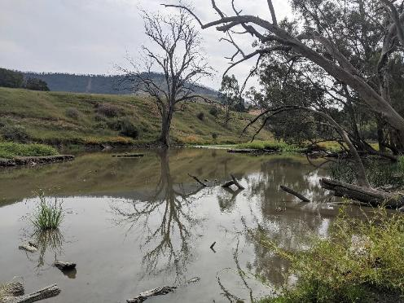
Site 5: Billabong on Cudgewa Back Creek, 29/03/2022. Image credit: Tarmo A. Raadik
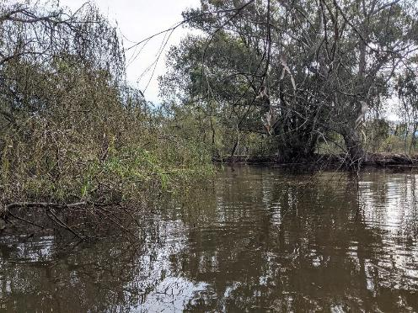
Site 6: Billabong off Yabba Road, Mitta Mitta River, 29/03/2022. Image credit: Tarmo A. Raadik. Historical Flat-headed Galaxias location. Re-collected and positive eDNA detection in this study

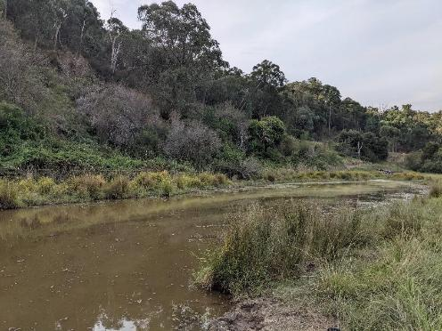
Site 7: Billabong off Omeo Road, Mitta Mitta River, 29/03/2022. Image credit: Tarmo A. Raadik. Positive Flat-headed Galaxias eDNA detection in this study

Kiewa Basin
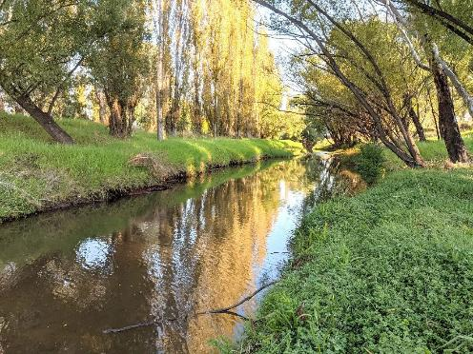
Site 8: Sandy Creek, Bryants Gap Road, 30/03/2022. Image credit: Tarmo A. Raadik. Historical Flat-headed Galaxias location. Positive eDNA detection in this study

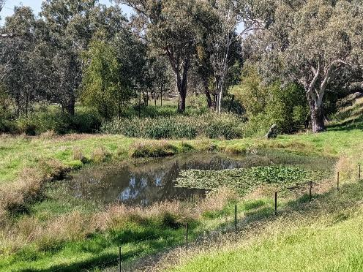
Site 10: Billabong off Brooks Terrace, Killara, Kiewa River, 30/03/2022. Image credit: Tarmo A. Raadik
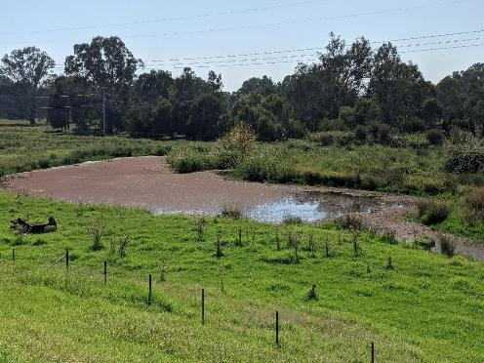
Site 11: Billabong off Brooks Terrace, Killara, Kiewa River, 30/03/2022. Image credit: Tarmo A. Raadik

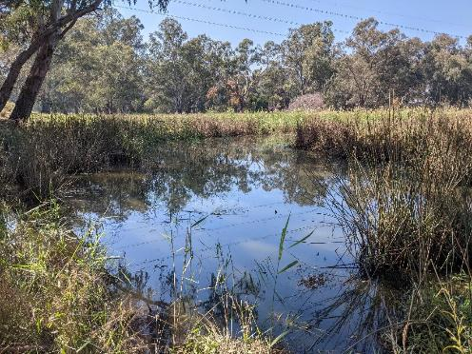
Site 12: Billabong, off Bakers Lane, Killara 30/03/2022. Image credit: Tarmo A. Raadik. Positive Flat-headed Galaxias eDNA detection in this study
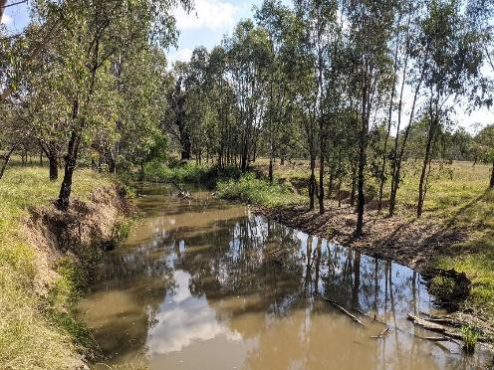
Site 13: Finns Creek, Consibee Lane, 30/03/2022. Image credit: Tarmo A. Raadik. Historical Flat-headed Galaxias location. Not detected in this study

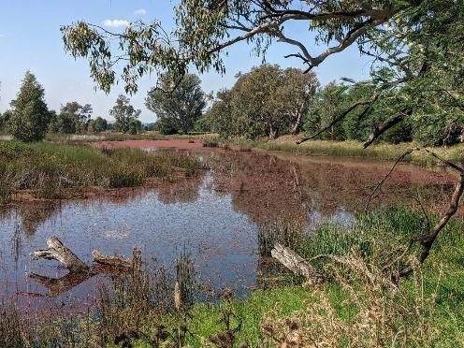
Site 14: Ryans Billabong, off Ryan Road, 30/03/2022. Image credit: Tarmo A. Raadik. Historical Flat-headed Galaxias location. Positive eDNA detection in this study

Ovens Basin
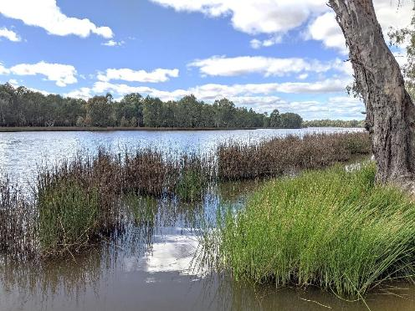
Site 16: Lake Moodemere, off Lake Road, 31/03/2022. Image credit: Tarmo A. Raadik. Positive Flat-headed Galaxias eDNA detection in this study

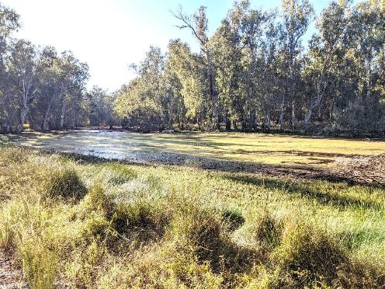
Site 17: Billabong off Hynes Road, lower Ovens River, 31/03/2022. Image credit: Tarmo A. Raadik
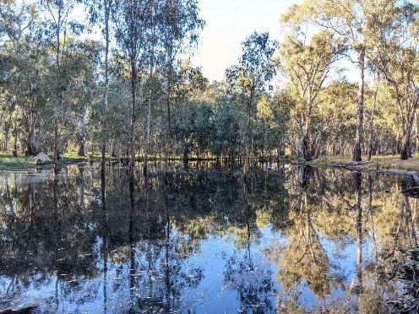
Site 19: Billabong off Hynes Road, near Lake Moodemere, 1/04/2022. Image credit: Tarmo A. Raadik

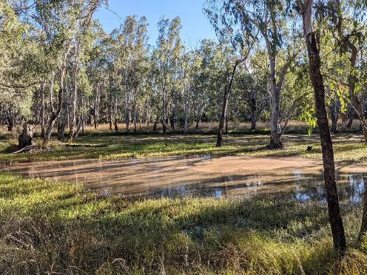
Site 22: Billabong next to McLaughlins Track, lower Ovens River, 31/03/2022. Image credit: Tarmo A. Raadik
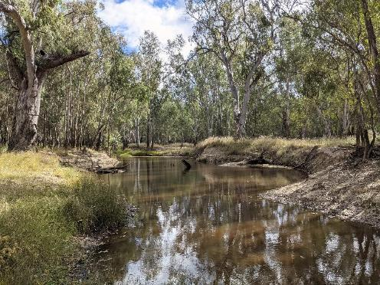
Site 23: Billabong off Robinsons Track, lower Ovens River, 31/03/2022. Image credit: Tarmo A. Raadik.
Positive Flat-headed eDNA detection in this study

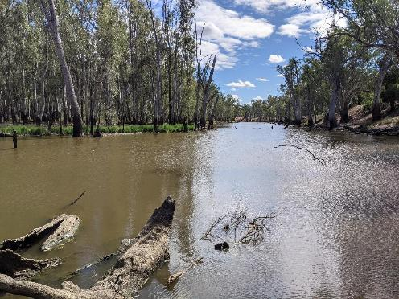
Site 25: Billabong off Kings Road, lower Ovens River, 31/03/2022. Image credit: Tarmo A. Raadik
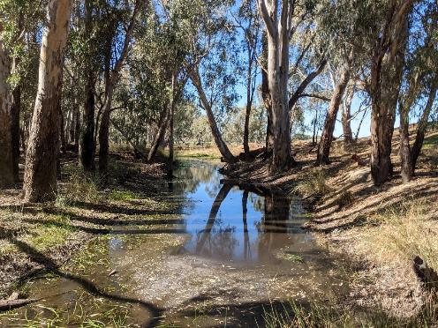
Site 26: Billabong near Puzzle Bend Track, lower Ovens River, 1/03/2022. Image credit: Tarmo A. Raadik

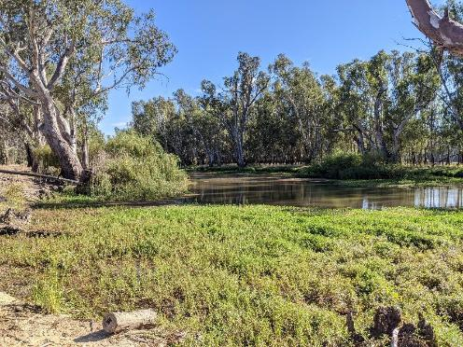
Site 27: Billabong near ‘Glendalyn Park’, lower Ovens River, 31/03/2022. Image credit: Tarmo A. Raadik

Broken Basin
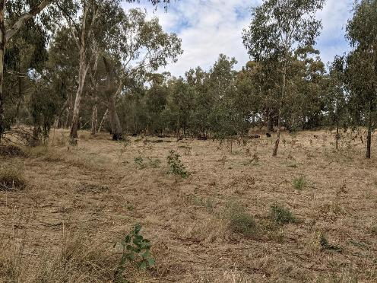
Site: 31: Nine Mile Creek, Waggarandall Road, 28/03/2022. Image credit: Tarmo A. Raadik. Historical Flat-headed Galaxias location

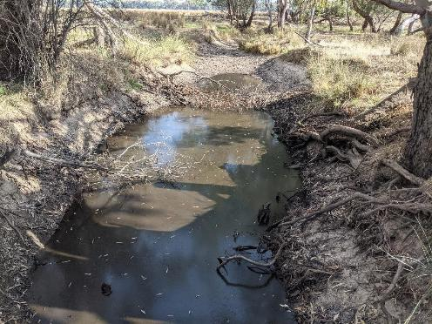
Site 34: Five Mile Creek, Mack Road, east of Baddaginnie, 28/03/2022. Image credit: Tarmo A. Raadik.
Historical Flat-headed Galaxias location. Not detected in this study
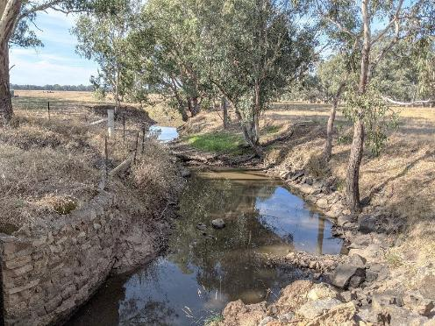
Site 35: Baddaginnie Creek, at Mack Road, east of Baddaginnie, 28/03/2022. Image credit: Tarmo A. Raadik

Goulburn Basin
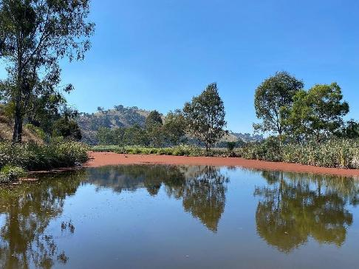
Site 37: Billabong off Back Eildon Road, Goulburn River, 21/03/2022. Image credit: Daniel J. Stoessel
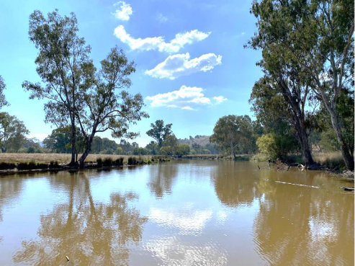
Site 38: Billabong, Goulburn River, off Halls Flat Road, 21/03/2022. Image credit: Daniel J. Stoessel.
Historical Flat-headed Galaxias location. Re-collected and positive eDNA detection in this study

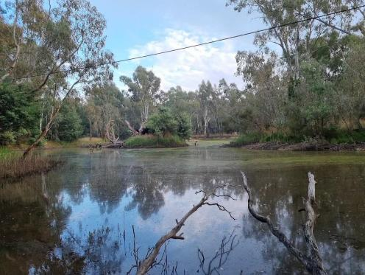
Site 39: Yea River billabong, Yea, 22/03/2022. Image credit: Daniel J. Stoessel. Historical location for Flat-headed Galaxias. Positive eDNA detection in this study
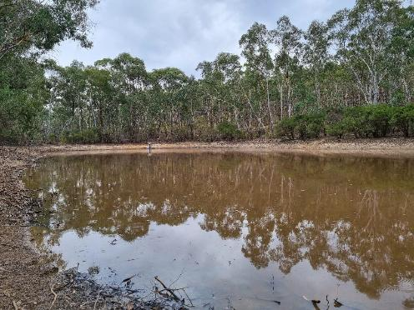
Site 40: Dam on tributary of Compton Creek, off Heathcote/Nagambie Road, 22/03/2022. Image credit: Daniel J. Stoessel – Historical Flat-headed Galaxias location. Not detected in this study

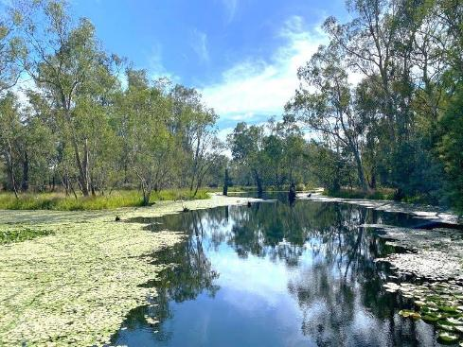
Site 41: Tahbilk Lagoon off Billabong Drive, 22/03/2022. Image credit: Daniel J. Stoessel
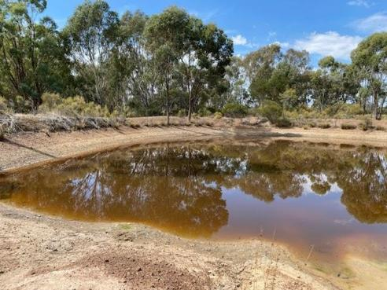
Site 42: Dam on Sandy Creek tributary downstream of Heathcote/Nagambie Road, 22/03/2022. Image credit: Daniel J. Stoessel. Flat-headed Galaxias historically further downstream. Re-collected and positive eDNA detection in this study

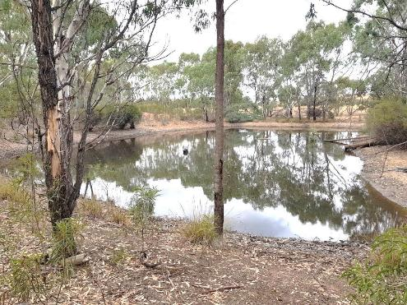
Site 43: Dam on tributary of Sandy Creek (Billich Wetlands), 22/03/2022. Image credit: Scott Raymond.
Historical Flat-headed Galaxias location. Re-collected in this study
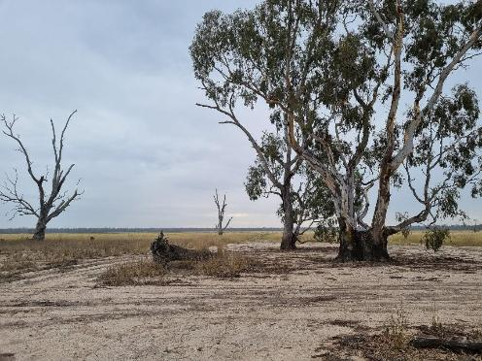
Site 44: Reedy Lake, 22/03/2022. Image credit: Daniel J. Stoessel. Historical Flat-headed Galaxias location

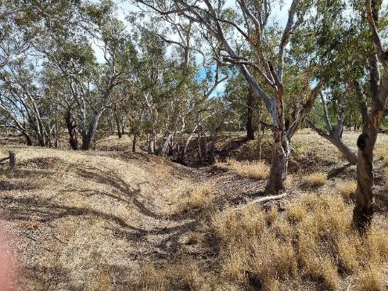
Site 46: Cornella Creek, Tait Hamilton Road, 24/03/2022. Image credit: Daniel J. Stoessel
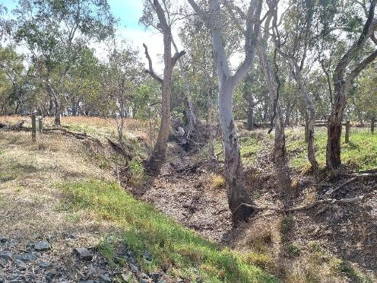
Site 47: Cornella Creek, Davey Road, 24/03/2022. Image credit: Daniel J. Stoessel. Historical Flat-headed Galaxias location

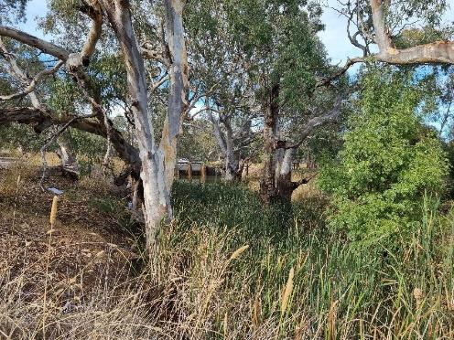
Site 48: Cornella Creek, upstream of Mitchell Street, Colbinabbin, 24/03/2022. Image credit: Daniel J. Stoessel. Historical Flat-headed Galaxias location. Not detected in this study
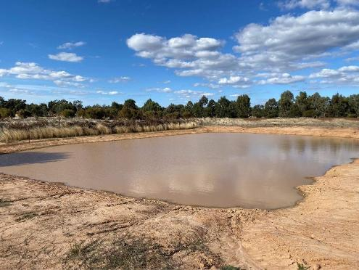
Site 49: Wanalta Creek, dam on floodplain 24/03/2022. Image credit: Daniel J. Stoessel. Historical Flat-headed Galaxias location. Not detected in this study

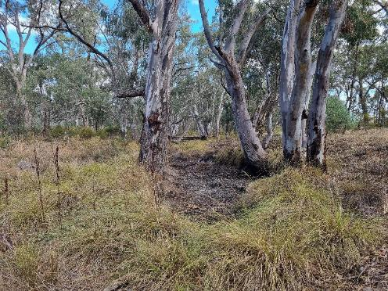
Site 50: Wanalta Creek, Davey Road, 23/03/2022. Image credit: Daniel J. Stoessel
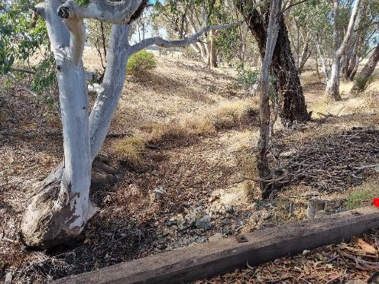
Site 51: Wanalta Creek, off Pardys Road, 23/03/2022. Image credit: Daniel J. Stoessel

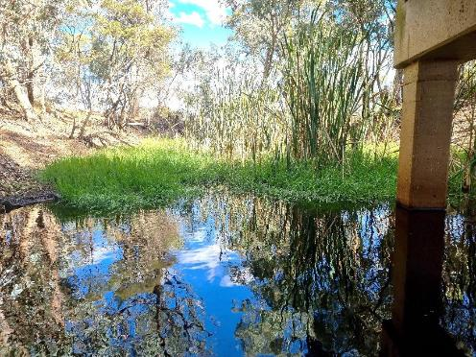
Site 52: Wanalta Creek, Cornella Church Road, 23/03/2022. Image credit: Daniel J. Stoessel
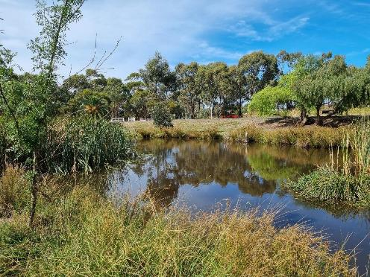
Site 53: Dam on a tributary of Waranga Basin, Rushworth, 24/03/2022. Image credit: Daniel J. Stoessel

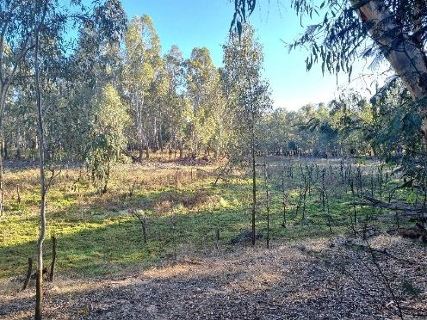
Site 54: Bruces Billabong, Goulburn River, off Darcys Track, 23/03/2022. Image credit: Daniel J. Stoessel
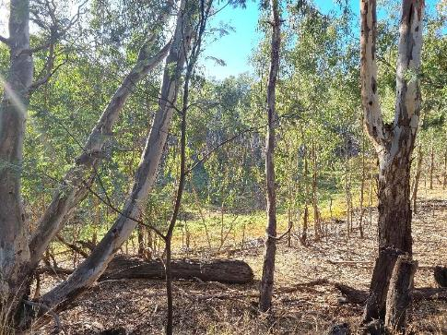

Site 55: Black Billabong, off Darcys Track, 23/03/2022. Image credit: Daniel J. Stoessel.
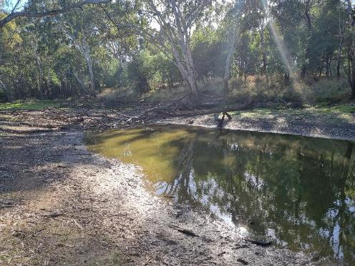
Site 56: Billabong, Goulburn River, off Common Track, 23/03/2022. Image credit: Daniel J. Stoessel
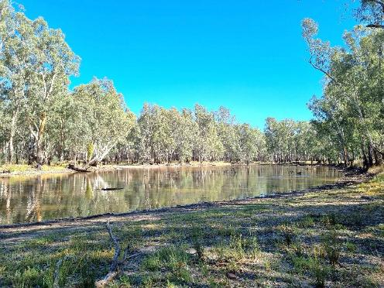
Site 57: Billabong, Goulburn River, off Deadman Track, 23/03/2022. Image credit: Daniel J. Stoessel

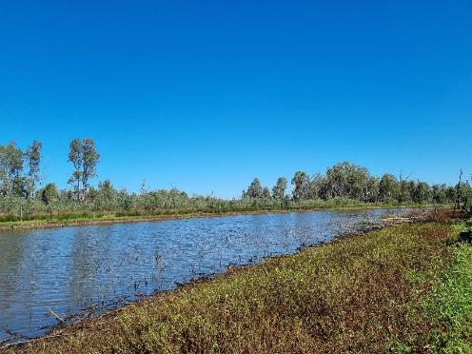
Site 58: Loch Garry off Loch Garry Road, 23/03/2022. Image credit: Daniel J. Stoessel
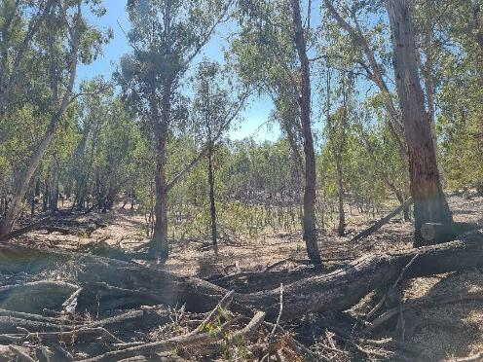
Site 60: Billabong, Goulburn River, off Horse Shoe Track, 23/03/2022. Image credit: Daniel J. Stoessel

www.deeca.vic.gov.au www.ari.vic.gov.au

