|  |
| --- |
| Evaluating revegetation outcomes through community based monitoring |
| S. Jellinek, T. O’Brien, A. Bennett |
| September 2020 |

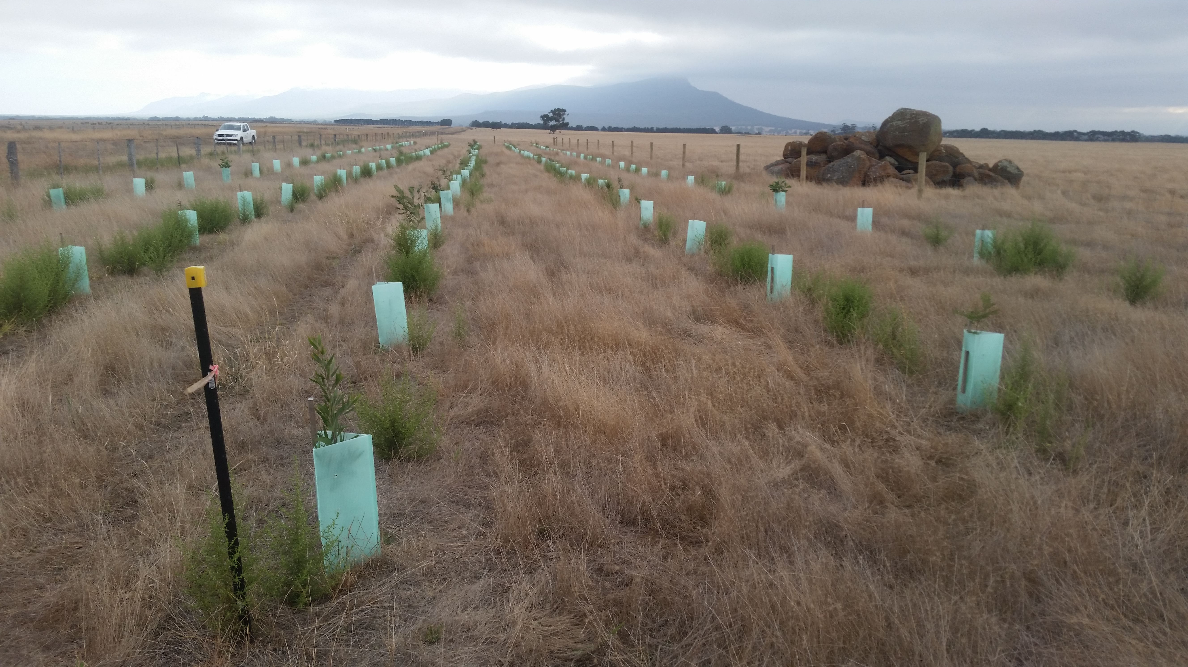

Arthur Rylah Institute for Environmental Research  
Technical Report Series No. 321

 

|  |  |
| --- | --- |
| |  | | --- | | Acknowledgement  We acknowledge and respect Victorian Traditional Owners as the original custodians of Victoria’s land and waters, their unique ability to care for Country and deep spiritual connection to it. We honour Elders past and present whose knowledge and wisdom has ensured the continuation of culture and traditional practices.  We are committed to genuinely partner, and meaningfully engage, with Victoria’s Traditional Owners and Aboriginal communities to support the protection of Country, the maintenance of spiritual and cultural practices and their broader aspirations in the 21st century and beyond. |   Arthur Rylah Institute for Environmental Research Department of Environment, Land, Water and Planning PO Box 137 Heidelberg, Victoria 3084 Phone (03) 9450 8600 Website. [www.ari.vic.gov.au](http://www.ari.vic.gov.au)  **Citation**. Jellinek, S., O’Brien, T. and Bennett, A. (2020). Evaluating revegetation outcomes through community based monitoring. Arthur Rylah Institute for Environmental Research Technical Report Series No. 321. Department of Environment, Land, Water and Planning, Heidelberg, Victoria.  **Front cover photo**. Revegetation near the Grampians, Victoria. Photo by S. Jellinek.  Logo© The State of Victoria Department of Environment, Land, Water and Planning 2020  ISSN 1835-3827 (print) ISSN 1825-3835 (pdf) ISBN 978-1-76105-376-4 (pdf/online/MS word)  This work is licensed under a Creative Commons Attribution 3.0 Australia licence. You are free to re-use the work under that licence, on the condition that you credit the State of Victoria as author. The licence does not apply to any images, photographs or branding, including the Victorian Coat of Arms, the Victorian Government logo, the Department of Environment, Land, Water and Planning logo and the Arthur Rylah Institute logo. To view a copy of this licence, visit [http.//creativecommons.org/licenses/by/3.0/au/deed.en](http://creativecommons.org/licenses/by/3.0/au/deed.en)  **Disclaimer** This publication may be of assistance to you but the State of Victoria and its employees do not guarantee that the publication is without flaw of any kind or is wholly appropriate for your particular purposes and therefore disclaims all liability for any error, loss or other consequence which may arise from you relying on any information in this publication.  Accessibility  If you would like to receive this publication in an alternative format, please telephone the DELWP Customer Service Centre on 136 186, email [customer.service@delwp.vic.gov.au](mailto:customer.service@delwp.vic.gov.au) or contact us via the National Relay Service on 133 677 or [www.relayservice.com.au](http://www.relayservice.com.au). This document is also available on the internet at [www.delwp.vic.gov.au](http://www.delwp.vic.gov.au) |

Evaluating revegetation outcomes through community based monitoring

Sacha Jellinek1,2,3, Tim A. O’Brien1, Andrew F. Bennett2

1 Arthur Rylah Institute for Environmental Research   
123 Brown Street, Heidelberg, Victoria 3084

2 Department of Ecology, Environment and Evolution, La Trobe University, Bundoora

3 Present address: School of Ecosystem and Forest Sciences, University of Melbourne, Burwood

Date

Arthur Rylah Institute for Environmental Research  
Technical Report Series No. 321

Acknowledgements

We would like to thank community members and field staff in regional Victoria who took the time to set-up and monitor their revegetated areas. This project would not have been possible without their support. Members of the Catchment Management Authorities (CMAs), particularly Jim Begley and Jenny Wilson from the Goulburn Broken CMA and Chris Pitfield from the Corangamite CMA provided advice on the monitoring guidelines.

We would also like to thank the Governance Committee including Matt White (ARI), Dr Kim Lowe (ARI) and Professor Michael Clarke (La Trobe University) who provided valuable feedback on the ongoing development of this project. Dr Angie Haslem (La Trobe University) provided advice on analysing the data while Dr Joe Greet (University of Melbourne) and Dr Peter Harrison (University of Tasmania) provided advice on R Project code and analysis.

The project was funded with support from the Victorian Government through the Sustainability Fund Biodiversity On-ground Actions program.

Contents

Tables ii

Figures ii

Summary 1

1 Introduction 3

2 Methods 4

2.1 Site locations 4

2.2 Revegetation monitoring methods 5

2.2.1 Plot layout 5

2.2.2 Analysis 6

2.3 Participant questionnaire 6

3 Results 7

3.1 Revegetation monitoring 7

3.2 Questionnaire 10

4 Discussion 12

4.1 Social outcomes 12

4.2 Plant survival 12

5 Recommendations 14

References 17

Appendices 20

Appendix 1. Survey questions 20

Appendix 2. The variation in annual rainfall in different IBRA Bioregions 21

Appendix 3. Output of the Generalised Linear Mixed Model analysing the influence of environmental variables on plant survival. 21

Tables

Table 1. The number of sites and plots surveyed across Victoria from June 2019 – April 2020 5

Table 2. Percentage survival after the first summer of revegetation species 7

Figures

Figure 1. The locations of the sites monitored in 2019 and 2020 4

Figure 2: An example of the monitoring plot used to assess plant survival in tubestock plantings 6

Figure 3. Species counts (abundance) per site within each CMA in spring (June – September 2019) and after the first summer (March – April 2020) 8

Figure 4. Species richness per site within each of the five IBRA Bioregions in which the study was undertaken from spring (June – September 2019) and after the first summer (March – April 2020) 8

Figure 5. Species abundance (counts) per site within each of the five IBRA Bioregions in which the study was undertaken from spring (June – September 2019) and after the first summer (March – April 2020) 9

Figure 6. Individual species counts per site for the 16 most commonly planted species during the study undertaken from spring (June – September 2019) to after the first summer (March – April 2020). 9

Figure 7. The effect of protection by guards on plant survival between plants that were guarded (Y) compared to those that were not guarded (N). 10

Figure 8. Affiliation of participants who responded to the questionnaire 11

Figure 9. Participants response to ease of understanding and undertaking the revegetation monitoring methods 11

Summary

Context

This project was developed to gain a better understanding of community-based revegetation outcomes across Victoria. Large amounts of federal and state funds go towards revegetation actions in Victoria, but little is known about the effectiveness of these actions or the biodiversity outcomes that result from restoring degraded landscapes. This project worked with community groups to monitor revegetated areas to obtain a better understanding of the effectiveness of restoration actions in Victoria.

Background

The aim of this project was to develop a quick and scientifically robust monitoring method for revegetation projects undertaken by community groups and organisations to better understand how well plants survived after planting, and what influenced their survival and growth.

In Phase 1 of the project (June 2018 - June 2019), we contacted a number of CMAs and Landcare Groups, including non-government organisations such as Bush Heritage and Greening Australia, to understand where revegetation activities were being undertaken across the state and by which groups. We then developed a draft monitoring protocol and commenced revegetation monitoring on 11 sites around the state. This trial showed that the monitoring method adequately surveyed plant survival and was easily used by regional staff. We also tested if there was a difference between the results that different surveyors provided and found that results did not differ significantly (ARI staff & regional/Landcare staff).

Initial results indicated that planting success varied across the state and between species. It was then determined that more sites (50 - 100) were needed to adequately test the monitoring method. Phase 2 of the project started in July 2019 and was extended to May 2020. This report outlines the outcomes of the second phase of that project.

Methods

In June and July 2019, community groups, Catchment Management Authorities (CMAs) and Landcare facilitators, as well as local non-government organisations (Bush Heritage and Greening Australia) and corporations (Melbourne Water, Gippsland Water and VicRoads) were contacted to take part in the second phase of the project (emailed to approximately 150 people). An information flyer (Factsheet 1), including past survey results and the survey methods, was produced to assist with this recruitment process. In total, 43 individuals or groups responded, and 16 individuals or groups took part in the monitoring.

Initially the monitoring method recorded how many plants or seeds of each species were planted (usually in winter and spring), and then their survival after the first summer (i.e. in the following Autumn). Information collected included land-use history, the type of planting undertaken (e.g. windbreaks, patches), the site location (e.g. paddock, near bushland) and the landscape topography (e.g. flats, slope, floodplain, etc.). Sites were monitored in Spring to early Summer 2019 and re-monitored in Autumn (March - April) 2020. All species monitored were from tubestock plantings (although the method was also used on direct seeding sites in the Wimmera and Mallee), and the survival (counts) and height of each species was recorded.

A questionnaire was sent to all original participants (n = 43) post-monitoring (April 2020) to assess how useful they believed the monitoring methods were and what actions would assist them to use the methods in the future.

Results

Overall, 65 sites containing 137 plots were monitored by practitioners.

Two attributes, average annual rainfall and whether plants were protected by guards, were strong predictors of plant survival. The average survival of plants (overall counts) per plot after the 2019/20 summer was 61%.

Plots in East Gippsland, West Gippsland and Port Phillip & Westernport Catchment Management Authorities (CMAs) had the highest survival (>60%), and plots in the North Central and Corangamite CMAs the lowest (<50%). Plots in East Gippsland and Port Phillip & Westernport had the highest planting densities with >4,000 plants per hectare. The figure below provides spring and post-summer counts for the 16 species most commonly planted during the study.

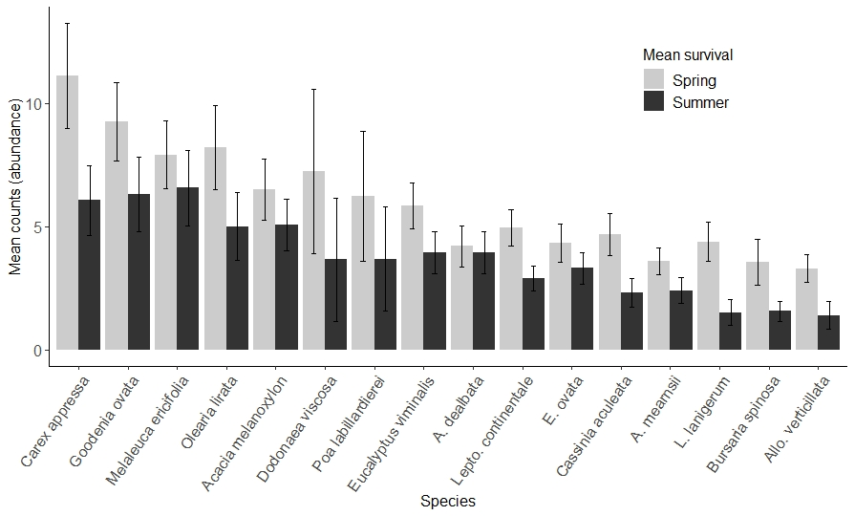

Conclusions and implications

This study highlights the value of community-based monitoring in assessing revegetation outcomes across the state. It shows that:

* Revegetation outcomes differ in different CMAs and bioregions
* There is variation between species and life-forms in survival in revegetated areas
* Biotic and abiotic factors have an influence on revegetation outcomes
* Community groups need to be supported in undertaking revegetation monitoring through funding and the development of a cloud-based database and associated app.
* Survival of plantings is greatest in higher rainfall areas and where plants are protected by tree guards. Planting survival is also likely to be influenced by factors such as extreme temperatures and climate change, so adaptive revegetation activities for future climates may be necessary. This could include altering the timing of revegetation actions and using climate-adapted plant provenances during planting.

1. Introduction

Land clearing, urban development and agriculture have ongoing negative effects on native flora and fauna in Australia (Collard et al., 2020), resulting in one of the highest extinction records globally, with many native plants, animals and ecological communities in decline (Waldron et al., 2017). The scale of the changes occurring to the flora and fauna is much larger than current conservation actions to address these threats, resulting in the continued decline of biodiversity in Australia (Freudenberger, 2018). To reverse this decline habitat restoration needs to occur, with adequate funding to ensure large-scale conservation activities can be undertaken (Freudenberger, 2018). The Society for Ecological Restoration defines restoration as both the regeneration and reconstruction (also known as revegetation) of native vegetation (Gann et al., 2019).

Revegetation in Australia has been a key component of government conservation policy in recent years, both to tackle threatened species declines as well as to help sequester carbon. For example, the Federally funded 20 Million Trees program was a flagship component under the Australian Governments National Landcare Program (2014 – 2020), which provided $70 million in funding to replant 20 million trees (trees, shrubs and associated understorey) (NLP, 2019). On average, Australian Government spending on natural resource management (NRM) programmes is $268 million per year, less than 0.5% of the value of gross agricultural production in Australia (Freudenberger, 2018) or 0.06% of the Australian Government’s annual revenue (Driscoll et al., 2017). This relatively low level of funding for conservation actions contributes to the decline in state of the environment and the extinction crisis in Australia (Geyle et al., 2018).

Revegetation, with native vegetation, is a key component of habitat restoration and is recognised as an essential requirement in the recovery of threatened species and communities in Australia. It allows land managers and agencies to increase the extent of native bushland for plant and animal communities (Collard et al., 2020). For example, the Victoria Biodiversity 2037 plan proposes under the goal '*Victoria’s natural environment is healthy’* that 200,000 ha of native vegetation will be revegetated in priority areas to ensure connectivity between remnant habitats (DELWP, 2017). Revegetation can also contribute to more sustainable rural landscapes by reducing soil loss, providing shelter for stock, and capturing and storing carbon (Freudenberger, 2018). Similarly, revegetation along gullies and creeks can help protect water quality by filtering run-off from the surrounding landscape (Freudenberger, 2018), and provide social benefits by contributing to aesthetic values and ecosystem services (Jellinek et al., 2013b, Jellinek et al., 2019).

Revegetation activities have benefits for a range of native fauna, including birds (Lindenmayer et al., 2017, Bennett et al., 2006), mammals (Munro et al., 2009), reptiles and invertebrates (Jellinek et al., 2013a, Jellinek et al., 2014). However, few studies have assessed revegetation outcomes in the first few years of establishment, and whether these restored communities start to resemble their remnant analogues over time (England et al., 2013, Ruiz-Jaen and Aide, 2005, Jellinek et al., 2020). Similarly, land managers and restoration practitioners generally do not have the capacity to monitor revegetated areas; and it is seldom a part of their funding agreements, which generally focus on on-ground works, or reporting outcomes. However, land managers and community groups can play a vital role in the collection and compilation of monitoring data during restoration projects if they are have the resources to do so (Catterall et al., 2012, Hobbs, 2018).

This project was undertaken by La Trobe University and the Arthur Rylah Institute, Department of Environment, Land, Water & Planning (DELWP) as a part of the Adaptive Learning program, a four-year program designed to assess the effectiveness of biodiversity management and inform delivery of major biodiversity investment programs. Knowledge gaps identified for the revegetation management component of the Adaptive Learning program were addressed though a two-year project with La Trobe University. It worked in collaboration with other organisations such as Catchment Management Authorities (CMAs), non-government organisations such as Greening Australia and Landcare groups.

The revegetation monitoring component engaged community groups and land managers in the monitoring of revegetated areas across Victoria, and analysed the data to determine the effectiveness of revegetation outcomes. This involved, firstly, developing a monitoring protocol that agencies and community groups could use to collect information in a standardised way to assess planting outcomes. The aim of the study was to (a) assess the outcomes of revegetation in terms of the survival of planted trees, shrubs and understory plants, and (b) determine the factors that affect variation in survival among different species and different regions. The project involved participants from CMAs, Landcare groups, non-government organisations, water corporations and individuals.

1. Methods
   1. Site locations

Survey sites were distributed across the state, depending on the responses of groups or individuals to trialling the monitoring methodology. Sites were initially surveyed between June - September 2019, and resurveyed between March - April 2020. In total, 65 sites containing 137 plots (50 m x 4 m) were monitored across 8 different CMAs (Figure 1, Table 1). All species monitored were from tubestock plantings (although the method was also used on direct seeding sites in the Wimmera and Mallee), and the survival (counts) and height of each species was recorded.

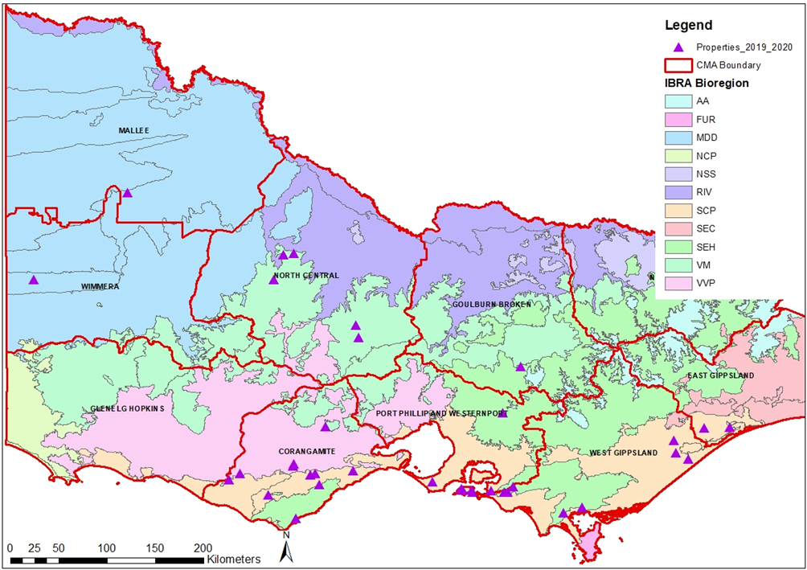

Figure 1. The locations of the sites monitored in 2019 and 2020. In our study area, the IBRA Bioregions included the South-east Coastal Plains (SCP), South-eastern Highlands (SEH), Victorian Volcanic Plains (VVP), Victorian Midlands (VM) and the Murray Darling Depression (MDD).

Table 1. The number of sites and plots surveyed across Victoria from June 2019 – April 2020

|  |  |  |
| --- | --- | --- |
| **CMA** | **# Sites** | **# Plots** |
| West Gippsland | 21 | 39 |
| Corangamite | 15 | 25 |
| Port Phillip & Westernport | 12 | 27 |
| North Central | 11 | 31 |
| East Gippsland | 2 | 5 |
| Wimmera | 2 | 4 |
| Mallee | 1 | 4 |
| Goulburn Broken | 1 | 2 |
| **TOTAL** | **65** | **137** |

* 1. Revegetation monitoring methods

Three data sheets were provided to participants that included the following.

* Recording a participant’s project and site information, including data about the project and site, the purpose of the revegetation, the previous land-use history at the site, and details about site preparation.
* An initial data monitoring sheet to record the species planted during or shortly after planting. This detailed how to set-up a monitoring plot; and how to survey the site to record the species planted and other relevant information. It was recommended that participants used plots that were 50 m x 4 m in size for tubestock plantings (Figure 2), and 20 m x 20 m in size for direct seeding sites - although size and shape could differ depending on the site. Ideally, it was suggested that 2 - 3 plots be set-up per site, depending on the size of the planting. If the site was larger than 1 ha, it was suggested that more plots be established.
* A follow-up monitoring sheet to record plant growth and survival after the first summer (Autumn). This sheet was to record follow-up monitoring data including the species and counts of species that had survived and their average height after the first summer (usually surveyed in March and April).
  + 1. Plot layout

To set-up a monitoring plot at a site, participants selected an area that was representative of the planting site and established permanent markers using star pickets or wooden stakes at each corner of the plot, and then recorded the GPS coordinates for the start and the end of the plot. A stake was also added in the centre of the two long sides of the plot to assist in defining the plot boundary. Photo-points were used to record the degree of change and growth of the planting areas.

Participants surveyed the plot by walking within the plot area and recording (counting) all the native species that were planted and any pre-existing native plants. They then measured the average height of the first five plants for each planted species, and recorded these heights using the categories provided (0-0.25 m, 0.25-0.5 m, 0.5-1 m, 1-1.5 m, 1.5-2 m, >2 m). Participants also recorded if the plants were protected by guards (yes/no) and the presence or absence of grazing (by macropods, rabbits, livestock or deer - yes/no) whilst on-site. An estimate of weed cover and cover of bare ground was taken in spring and autumn (<5 %, 6 - 25 %, 26 - 50 %, >51 %). For direct-seeding projects, participants were asked to record the kilograms (kg) of seed used per hectare (ha) for each species sown. Initial monitoring (after planting) was not required for direct seeding projects.

Data were sent to La Trobe University staff, either via Excel spreadsheets or photos of the data sheets, and then entered into an Access database. All participants were given a unique identifier to ensure their information remained anonymous.

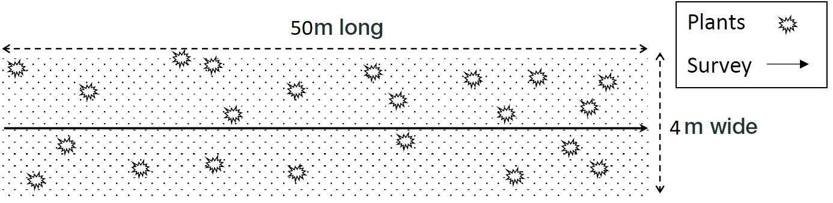

Figure 2: An example of the monitoring plot used to assess plant survival in tubestock plantings

* + 1. Analysis

We used data collected during spring (post planting) and autumn to determine how different species and life-forms survived after the first summer. Species data were initially gathered at the transect and site level, and all analysis was undertaken at the site level using R Project (R Core Team, 2020). Environmental variables were collected for each site: these included average annual rainfall, average annual temperature and mean annual temperature for the hottest month (BOM, 2020). Soil data, CMA region and IBRA Bioregion were obtained from the Victorian Government website (DELWP, 2020), and aridity data were obtained from Nyman et al. (2014).

A correlation analysis was undertaken to determine which variables were highly correlated (Pearson’s r >0.8). We subsequently removed temperature and aridity, as these variables were highly correlated with rainfall. We analysed the survival rate for all species combined after the first summer (autumn), and between different life-forms using a Generalised Linear Mixed Model in the glmmTMB package (Brooks et al., 2017) in R Project (R Core Team, 2020), by collating the data across sites. Site variables included in the analysis were: if plants were protected by guards, if grazing was occurring, the cover of weed species at the time of autumn surveys, average annual rainfall, maximum mean temperature for the hottest month, and soil type. Site was included as a random effect in the model because there were multiple plots at many sites.

We also identified the 16 most commonly planted species across the CMAs we surveyed, and determined the number of each species that were planted and then subsequently survived the first summer. Although height data was collected, initial results suggested that the growing time was too short to see any major changes so height data has not been included here.

* 1. Participant questionnaire

A quantitative survey was developed as a part of this project to assess how participants viewed the monitoring methods and actions that would assist them to use the methods in the future. The survey questions were assessed by Arthur Rylah Institute and La Trobe University staff prior to the surveys being sent-out. The survey, in the form of a short questionnaire, was undertaken by using SurveyMonkey, a free online program. It asked nine questions relating to participant’s affiliation and location, and how easy or difficult they found the methods to understand and undertake (Appendix 1).

The questionnaire was sent via email in April 2020 to all people who expressed interest in using the monitoring methods (n = 43), even if they did not complete the monitoring. This was done to gain a better understanding of the limitations of people’s participation in the program.

1. Results
   1. Revegetation monitoring

There was a substantial decline in the number of living plants between planting and the end of the first summer, with approximately 61% of plants surviving the summer. Similarly, species richness declined with 68% of the number of species that were planted surviving (Table 2). There was no significant difference in the survival of different lifeform types, although overstorey plants had a higher survival rate than other lifeforms (understorey - 54%, midstorey - 55%, overstorey - 63%).

East Gippsland and Port Phillip and Westernport CMAs had the highest density of plantings (i.e. plants per ha). When CMAs that had only one survey site were removed (Goulburn Broken & Mallee CMA) three CMAs had the highest proportion of plant survival; East Gippsland (65%), West Gippsland (72%) and Port Phillip and Westernport (60%). Plant survival was lowest in North Central (49%) and Corangamite (44%) CMAs (Figure 3). When comparing IBRA Bioregions (Figure 1), species richness per plot was initially highest (at planting) in the South-eastern Highlands (SEH) and Victorian Midlands (VM), and lowest in the South-eastern Coastal Plain (SCP) (Figure 4). Species richness did not decline significantly between spring and summer in the Victorian Midlands, but greatly declined in the Murray Darling Depression (MDD) and the Victorian Volcanic Plains (VVP) (Figure 4). Similarly, the highest planting numbers were in the VVP, SEH and VM, with high proportions of survival in the SEH. The lowest proportion of plant survival was in the VVP and VM (Figure 5). Rainfall was strongly associated with the different IBRA Bioregions (Appendix 2).

Individual species responses over summer for the 16 most commonly planted species differed substantially (Figure 6). Swamp Paperbark (*Melaleuca ericifolia*) and Hop Goodenia (*Goodenia ovata*) were two of the most commonly planted species, with the highest survival over the monitoring period. Similarly, Blackwood (*Acacia melanoxylon*), Silver Wattle (*Acacia dealbata*), Manna Gum (*Eucalyptus viminalis*) and Swamp Gum (*Eucalyptus ovata*) had relatively high survival rates over the planting period. Prickly and Woolly Teatree (*Leptospermum* spp.), Sweet Bursaria (*Bursaria spinosa*) and Drooping Sheoak (*Allocasuarina verticillata*) had low survival after the first summer (Figure 6).

Results from a generalised linear mixed model (Appendix 3) indicated that rainfall (*p* = 0.025) and protection by guards (*p* = 0.012) had a significant influence on overall plant survival, with a greater proportion of plants surviving as rainfall increased and if plants were guarded (Figure 7). Soil type, weed cover, maximum mean temperature for the hottest month and the presence of grazing did not have a significant influence on overall survival.

Table 2. Percentage survival after the first summer of revegetation species

|  |  |
| --- | --- |
| **Revegetation results** | **% Survival** |
| Overall survival (counts) | 61% |
| Species richness survival | 68% |
| Understorey survival (counts) | 54% |
| Midstorey survival (counts) | 55% |
| Overstorey survival (counts) | 63% |

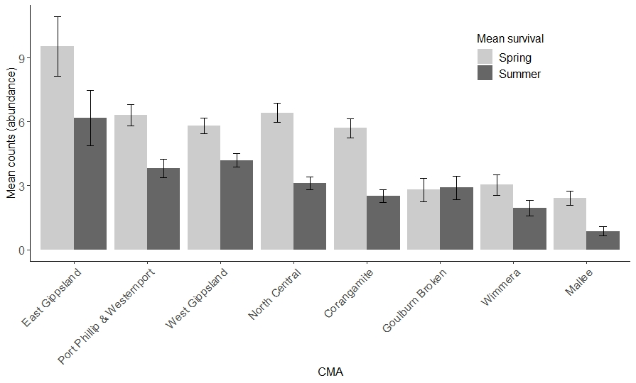

Figure 3. Species counts (abundance) per site within each CMA in spring (June – September 2019) and after the first summer (March – April 2020). Bars represent standard errors

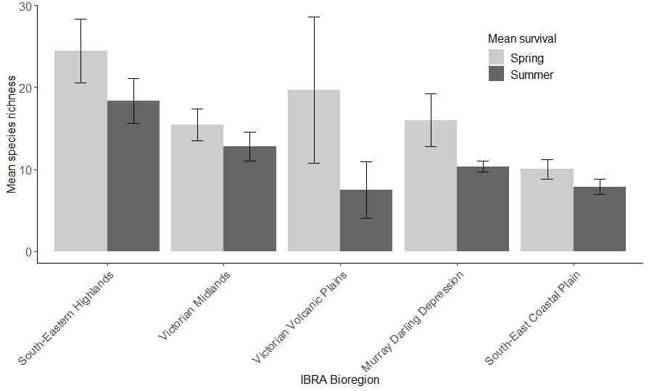

Figure 4. Species richness per site within each of the five IBRA Bioregions in which the study was undertaken from spring (June – September 2019) and after the first summer (March – April 2020). Bars represent standard errors

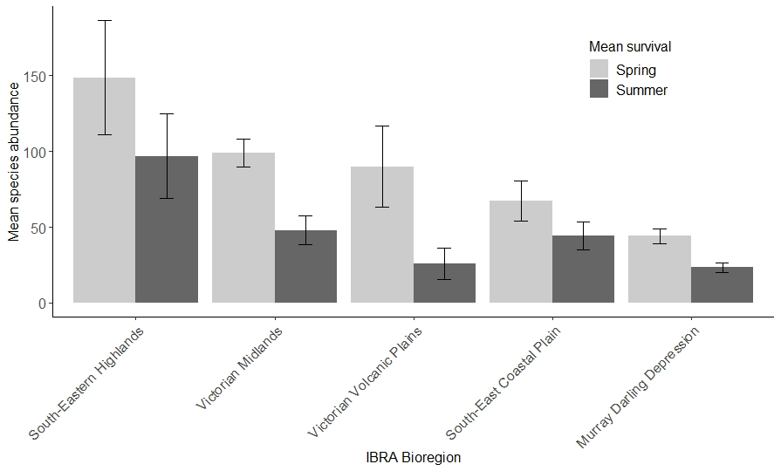

Figure 5. Species abundance (counts) per site within each of the five IBRA Bioregions in which the study was undertaken from spring (June – September 2019) and after the first summer (March – April 2020). Bars represent standard errors



Figure 6. Individual species counts per site for the 16 most commonly planted species during the study undertaken from spring (June – September 2019) to after the first summer (March – April 2020). Bars represent standard errors

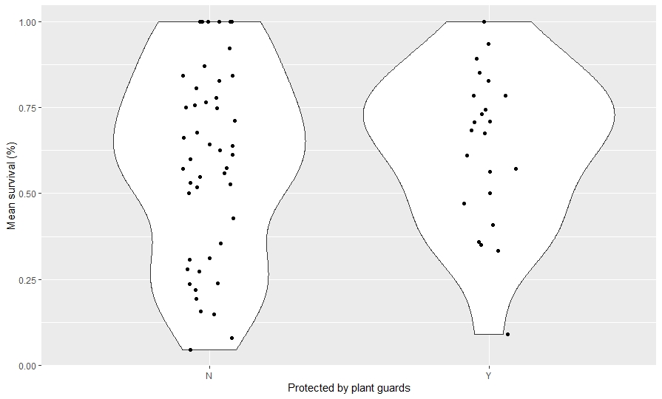

Figure 7. The effect of protection by guards on plant survival between plants that were guarded (Y) compared to those that were not guarded (N). Points represent the percentage survival of plants (all species) at each site

* 1. Questionnaire

In total, 23 participants responded out of a possible 43. The majority of these participants were from Landcare groups or CMAs (Figure 8). Up to 60% of the participants who responded to the survey had used the revegetation monitoring methods in 2019/2020, and 83% said that they planned to use it in the future (an additional 13% were unsure). Of those who responded, 91% believed that revegetation monitoring was important to undertake. Those who did not undertake the monitoring said that they were limited in their staff’s availability and capacity (time) to undertake the monitoring.

Participants generally found the monitoring methods easy to understand and undertake, with one participant saying that the *“method itself was pleasingly simple and captured enough data to determine success of plantings”*. In contrast, 5% of people found the methods difficult to understand, and 14% found them difficult to undertake (Figure 9).

Participants responded that they would be more likely to undertake monitoring in the future if they were provided with funding to undertake monitoring activities (68%), and/or provided with a database in which they could enter the data whilst in the field (64%) (Figure 10). Participants suggested that additions to the monitoring method could include:

* Provide a digital database to enter data and allow people to share data and collaborate.
* Provide reports post-monitoring to participants.
* Provide training in monitoring methods for those who want it.
* Provide an app for identifying species.
* Potentially change the methods to survey a certain number of plants (rather than number of transects) and only monitor to lifeform/genus level, as identification of young plants can be difficult.
* That the project needs to go for longer (10+ years) to get long-term data.
* Groups should be supported (funded) to pay people to undertake the monitoring (e.g., contractors).

Figure 8. Affiliation of participants who responded to the questionnaire (n=23)

Figure 9. Participants response to ease of understanding and undertaking the revegetation monitoring methods (n = 22 respondents)

**Figure 10.** Actions that would make it more likely for respondents to use monitoring methods in the future (n = 22)

1. Discussion
   1. Social outcomes

Our study highlights the importance of community involvement in revegetation monitoring across Victoria, showing that community groups can provide valuable input into the outcomes of restoration activities. A major limitation of many conservation activities is that they lack a robust monitoring method and a field-based monitoring program, resulting in poor monitoring results or programs that rely on desk-based assessments to understand the effectiveness of conservation actions (Lindenmayer, 2020). “Outcomes monitoring” has been heralded as a way to determine whether a given management intervention (in this case revegetation), has an improvement in a certain biotic target (Lindenmayer, 2020). Studies such as this one show that community-based monitoring can be effective when the monitoring method is developed on robust science and community groups are empowered and supported to undertake monitoring to better understand the effectiveness of their actions. Other studies have suggested that community-based monitoring can ‘lead to shared ecological understanding among diverse participants, build trust internally and credibility externally, foster social learning and community-building, and advance adaptive management’ (Fernandez-Gimenez et al., 2008).

Many studies highlight the importance of developing a standardised survey method in order to ensure uptake of the monitoring method, and liaison with community groups, academics and land managers to ensure the monitoring is relevant and easy to use (Sullivan and Molles, 2016, Fernandez-Gimenez et al., 2008, Gann et al., 2019). The social survey from this study confirms that these methods were easy to undertake and understand, and that community groups were likely to use them in the future to monitor revegetation outcomes. As found in our survey, and by Sullivan and Molles (2016), it was important to provide a standardised monitoring method for participants and a way in which monitoring data could be entered in a standardised format. Sullivan and Molles (2016) also suggested that automated outputs generated for community groups from their monitoring results, as well as the public sharing of data regionally, nationally and globally could enhance knowledge around biodiversity monitoring and conservation outcomes.

For community monitoring to be more widely taken-up, discrete budgets for monitoring activities are needed, along with an online database to store monitoring information. This is consistent with other findings that funding for monitoring is often limited or not provided at all (Lindenmayer, 2020, Chapman and Underwood, 2000), and that a database to adequately and easily store monitoring data is rarely made available (Sullivan and Molles, 2016). Funding could be made contingent on agencies and community groups undertaking monitoring, and making the results available to the funding body via an online database. This would ensure that revegetation outcomes are recorded, and systems are put in place to adaptively manage revegetation projects so they are increasingly effective in the future.

* 1. Plant survival

Our study found that overall survival of plants after the first summer was 61%, which is similar to other studies (Jellinek et al., 2020, Clarke, 2002, Hnatiuk et al., 2020). For example, in South Australia survival of different native lifeforms was 69% on average across 5 years after the first summer post-planting (Jellinek et al., 2020), whereas a study in eastern Australia (Australian Capital Territory) found that mean survival across 8 years was 67% (Hnatiuk et al., 2020). Interestingly, our study did not find a significant difference in the survival of lifeforms planted (understorey, midstorey and overstorey), whereas other studies have suggested that midstorey plants (shrubs) and some understorey species survive better than other lifeforms (Jellinek et al., 2020).

The lower survival rate and lack of a clear difference among lifeforms may be because different species and lifeforms were planted across a wide range of environmental and aridity gradients (Nyman et al., 2014), resulting in variation in survival. Other studies we reviewed were across much less variable landscapes, possibly resulting in higher survival and less variable planting results (Hnatiuk et al., 2020, Jellinek et al., 2020). There was variation in survival across different Catchment Management Authorities (CMAs), with CMAs such as East Gippsland, West Gippsland and Port Phillip and Westernport having the highest survival compared to North Central and Corangamite CMAs.

Species richness of plantings and abundance was highest in the South-eastern Highlands, with relatively small declines over the study period compared to the Victorian Volcanic Plains where there was both lower richness at planting and lower survival. These differences may be partly explained by variation in annual rainfall, which substantially influenced survival of plants, with the South-eastern Highlands having the highest average rainfall compared to other bioregions.

Although we did not find a relationship between soil type and plant survival rates, other studies have shown that soil type can be an important predictor of plant growth and survival (Haan et al., 2012, Perring et al., 2015). For example, soils that have higher loam and clay contents have greater water holding capacity than soils that are sandier or more saline, generally allowing higher survival (Perring et al., 2015, Jellinek et al., 2020).

Similarly, we did not find that the cover of weeds or presence of grazing had an effect on plant survival. This is surprising as grazing by animals such as rabbits are known to have a detrimental effect on plant survival (Bennett et al., 2020), and similarly, high weed cover can have negative impacts on native plantings (Gibson-Roy et al., 2010). However, protection by guards had a positive influence on native plant survival as guards reduce the impact of herbivory, as well as creating a microclimate for the growth of plant species (Greet et al., 2020).

Individual species such as wattles (*Acacia* spp*.*)and gums (*Eucalyptus* spp*.*) survived best, probably because these species are hardy, less palatable than some other species, and widespread in the state, enabling them to persist in a variety of different soil typesand environments. These findings are similar to those outlined by Hnatiuk et al. (2020), who reported the survival rates of these species were above 70% in eastern Australia. Swamp Paperbark (*M. ericifolia*) and Hop Goodenia (*Goodenia ovata*) also survived well in this study, possibly because these are hardy and widespread species. In comparison, Teatree (*Leptospermum* spp*.*), Sweet Bursaria (*B. spinosa*) and Drooping Sheoak (*A. verticillata*) had low rates of survival, possibly because these species are commonly impacted by grazing (e.g., Sweet Bursaria and Drooping Sheoak) (Jellinek et al., 2020), or because they may not have been planted in the most appropriate locations.

Although we did not find an effect of extreme climate events such as temperature, climate is recognised as having a significant impact on plant survival, especially changes in rainfall and extremes in temperature (Jellinek et al., 2020, Harrison et al., 2017). This may mean that under a changing climate, species that were once commonly associated with certain communities or ecosystems may not persist into the future due to extreme conditions (Camarretta et al., 2020, Mac Nally et al., 2009). Thus, provenances from hotter and drier regions may be necessary to boost the resilience of locally adapted species in order to ensure the success of revegetated areas into the future (Jellinek and Bailey, 2020, Prober et al., 2015, Prober et al., 2019). Other strategies such as altering the timing of planting and potentially adapting the species that are planted may also be necessary (Broadhurst et al., 2015), especially as winter and spring rainfall is projected to decline (DELWP, 2019).

1. Recommendations

Below we present recommendations to support the ongoing implementation of the monitoring, and knowledge gaps that need to be filled.

|  |  |  |
| --- | --- | --- |
| **Subject** | **Recommendation** | **Description** |
| **Revegetation monitoring** | **Monitoring budgets be incorporated into revegetation funding** to ensure that monitoring is undertaken by all groups who receive funds to undertake restoration activities. | Funding to support staff from CMAs, Landcare group as well as staff from non-government organisations to undertake revegetation monitoring activities. This will ensure that there are robust, state-wide data on the outcomes of revegetation actions, allowing for adaptive management of planting activities and ultimately more effective restoration. |
|  | **Funding and development of a state-wide database and associated ‘app’ to store monitoring data.** This would enable groups to enter data whilst in the field and better understand their revegetation outcomes. | A database that is cloud-based and well managed is essential to ensure revegetation data are stored effectively. Time and resources are often wasted if monitoring data are not properly entered into a database at time of collection, and data can get lost if entered on data sheets. A well-developed app to enter the data, and a database that allows groups to learn from their monitoring activities via automated reports will support ongoing uptake of the monitoring methods. |
|  | **Ongoing support for coordination to oversee the revegetation monitoring program.** | Liaison with and training of community groups and organisations is necessary to ensure the ongoing uptake of these monitoring methods. A point of contact would also ensure community members have trust in the importance of this monitoring. A coordinator, with appropriate research skills, could analyse the monitoring data and provide ongoing feedback to groups, enabling adaptive management practices. |
|  | **Ongoing support for the Revegetation Monitoring program** to develop long-term datasets. | One limitation of revegetation monitoring is that it is usually undertaken over a short time period, with few repeat visits. A long-term dataset would be invaluable for learning how effective revegetation actions are, and could provide important data for the Strategic Management Prospects (SMP) program on individual plant survival. |
| **Knowledge gaps** | Effect of climate change and climate extremes on revegetation activities and individual plant species. | There is limited knowledge on how climate change is likely to impact revegetated species and existing plantings. Developing a program to focus on climate-adapted provenances would enable a better understanding of how different species and communities will be impacted by a changing climate. Similarly, modelling how species distributions will change could inform revegetation practitioners on what species could be most appropriate to plant. |
|  | Understanding how species survival and growth varies across the state, and how environmental gradients and soil impacts, along with land-use history and other environmental and anthropogenic factors influence the growth and survival of restored species. | While this study sought to gain a better understanding of the biotic and abiotic factors that impact revegetation, ongoing monitoring is needed to build a fuller picture of how to more effectively undertake revegetation activities. Ongoing, long-term studies are needed to understand not only how well different species and communities grow and survive, but also the habitats they form into the future. |
|  | Tracking the development of structural and functional attributes in different revegetated communities and how these attributes change over time in comparison to reference remnant habitat. | Tracking the change of revegetated areas as well as the reference ecosystems they seek to mimic is important to ensure the habitats we restore provide the necessary ecosystem functions. These data could enable us to better understand if the ecosystems we are creating are functionally appropriate, or novel. |
|  | Faunal use of revegetation attributes and the persistence of faunal communities in restored habitats over time. | Monitoring how different animal species use revegetated habitats and the surrounding landscape is an important aspect to consider. While the influence of restoration on birds, and to a lesser extent mammals, is relatively well studied, more work needs to be undertaken on reptiles, amphibians and invertebrates. Similarly, a better understanding of the effects of introduced species (such as deer) on revegetation is an important study area. |
|  | Tracking the survival and growth of direct seeded vegetation communities in comparison to tubestock plantings and reference remnant habitats. | While this study focussed on tubestock plantings, many plantings across the state are undertaken by direct seeding, especially for larger-scale projects. Testing and adapting these methods where necessary on direct seeding plantings would provide more data on the effectiveness of revegetation outcomes. |
|  | Testing new technologies such as drones, LiDAR and aerial imagery to track revegetation outcomes. | The use of new technologies has the capability to revolutionise the way we monitor restored and remnant habitats, as they can provide cost effective and accurate monitoring outcomes. |

References

BENNETT, A., DUNCAN, D. H., RUMPFF, L. & VESK, P. A. 2020. Disentangling chronic regeneration failure in endangered woodland ecosystems. *Ecosphere,* 11**,** e02998.

BENNETT, A. F., RADFORD, J. Q. & HASLEM, A. 2006. Properties of land mosaics: Implications for nature conservation in agricultural environments. *Biological Conservation,* 133**,** 250-264.

BOM. 2020. *Bureau of Meterology* [Online]. Australian Government. Available: <http://www.bom.gov.au/climate/averages/wind/wind_rose.shtml> [Accessed May 2017].

BROADHURST, L. M., JONES, T. A., SMITH, F. S., NORTH, T. & GUJA, L. 2015. Maximizing Seed Resources for Restoration in an Uncertain Future. *BioScience,* 66**,** 73-79.

BROOKS, M. E., KRISTENSEN, K., VAN BENTHEM, K. J., MAGNUSSON, A., BERG, C. W., NIELSEN, A., SKAUG, H. J., MAECHLER, M. & BOLKER, B. M. 2017. glmmTMB Balances Speed and Flexibility Among Packages for Zero-inflated Generalized Linear Mixed Modeling. *The R Journal,* 9**,** 378–400.

CAMARRETTA, N., HARRISON, P. A., BAILEY, T., POTTS, B., LUCIEER, A., DAVIDSON, N. & HUNT, M. 2020. Monitoring forest structure to guide adaptive management of forest restoration: a review of remote sensing approaches. *New Forests,* 51**,** 573-596.

CATTERALL, C. P., FREEMAN, A. N., KANOWSKI, J. & FREEBODY, K. 2012. Can active restoration of tropical rainforest rescue biodiversity? A case with bird community indicators. *Biological Conservation,* 146**,** 53-61.

CHAPMAN, M. G. & UNDERWOOD, A. J. 2000. The need for a practical scientific protocol to measure successful restoration. *Wetlands (Australia),* 19**,** 28-49.

CLARKE, P. J. 2002. Experiments on tree and shrub establishment in temperate grassy woodlands: seedling survival. *Austral Ecology,* 27**,** 606-615.

COLLARD, S. J., O’CONNOR, P. J., PROWSE, T. A., GREGG, D. & BOND, A. J. 2020. Objectives versus realities: Spatial, temporal, financial and social deficiencies in Australia’s public revegetation investment model. *Ecological Management & Restoration,* 21**,** 35-41.

DELWP 2017. Protecting Victoria’s Environment – Biodiversity 2037. Port Melbourne, VIctoria: Department of Environment, Land, Water and Planning.

DELWP 2019. Victorias Climate Science Report 2019. *In:* PEARCE, K. & COMMUNICATION, B. (eds.). Melbourne, Victoria, Australia: Department of Environment, Land, Water and Planning.

DELWP. 2020. *DataVic* [Online]. Melbourne, Australia: Victorian Government. Available: <https://www.data.vic.gov.au> [Accessed].

DRISCOLL, D., CHRISTENSEN, B. & RITCHIE, E. 2017. Government needs to front up billions, not millions, to save Australia’s threatened species. .

ENGLAND, J. R., FRANKS, E. J., WESTON, C. J. & POLGLASE, P. J. 2013. Early growth of environmental plantings in relation to site and management factors. *Ecological Management & Restoration,* 14**,** 25-31.

FERNANDEZ-GIMENEZ, M. E., BALLARD, H. L. & STURTEVANT, V. E. 2008. Adaptive management and social learning in collaborative and community-based monitoring: a study of five community-based forestry organizations in the western USA. *Ecology and Society,* 13.

FREUDENBERGER, D. 2018. Matching effort to threat: Strategies to increase the scale and effectiveness of revegetation in southern Australia. *Ecological Management & Restoration,* 19**,** 6-10.

GANN, G. D., MCDONALD, T., WALDER, B., ARONSON, J., NELSON, C. R., JONSON, J., HALLETT, J. G., EISENBERG, C., GUARIGUATA, M. R., LIU, J., HUA, F., ECHEVERRÍA, C., GONZALES, E., SHAW, N., DECLEER, K. & DIXON, K. W. 2019. International principles and standards for the practice of ecological restoration. Second edition. *Restoration Ecology,* 27**,** S1-S46.

GEYLE, H. M., WOINARSKI, J. C., BAKER, G. B., DICKMAN, C. R., DUTSON, G., FISHER, D. O., FORD, H., HOLDSWORTH, M., JONES, M. E. & KUTT, A. 2018. Quantifying extinction risk and forecasting the number of impending Australian bird and mammal extinctions. *Pacific Conservation Biology,* 24**,** 157-167.

GIBSON-ROY, P., MOORE, G. & DELPRATT, J. 2010. Testing methods for reducing weed loads in preparation for reconstructing species-rich native grassland by direct seeding. *Ecological Management & Restoration,* 11**,** 135-139.

GREET, J., EDE, F., ROBERTSON, D. & MCKENDRICK, S. 2020. Should I plant or should I sow? Restoration outcomes compared across seven riparian revegetation projects. *Ecological Management & Restoration,* 21**,** 58-65.

HAAN, N. L., HUNTER, M. R. & HUNTER, M. D. 2012. Investigating predictors of plant establishment during roadside restoration. *Restoration Ecology,* 20**,** 315-321.

HARRISON, P. A., VAILLANCOURT, R. E., HARRIS, R. M. & POTTS, B. M. 2017. Integrating climate change and habitat fragmentation to identify candidate seed sources for ecological restoration. *Restoration ecology,* 25**,** 524-531.

HNATIUK, S., RAYNER, I., BROOKHOUSE, M. & FREUDENBERGER, D. 2020. Survival of native seedlings planted by volunteers: The Lower Cotter, ACT case study. *Ecological Management & Restoration*.

HOBBS, R. 2018. Where to from here? Challenges for restoration and revegetation in a fast-changing world. *The Rangeland Journal,* 39**,** 563-566.

JELLINEK, S. & BAILEY, T. G. 2020. *Establishing Victoria’s Ecological Infrastructure: A Guide to Creating Climate Future Plots,* Melbourne, Victoria, Greening Australia and the Victorian Department of Environment, Land, Water and Planning.

JELLINEK, S., PARRIS, K. P. & DRISCOLL, D. A. 2013a. Are only the strong surviving? Little influence of restoration on beetles (Coleoptera) in an agricultural landscape. *Biological Conservation,* 162**,** 17-23.

JELLINEK, S., PARRIS, K. P., DRISCOLL, D. A. & DWYER, P. D. 2013b. Are incentive programs working? Landowner attitudes to ecological restoration of agricultural landscapes. *Journal of Environmental Management,* 127**,** 69-76.

JELLINEK, S., PARRIS, K. P., MCCARTHY, M., WINTLE, B. A. & DRISCOLL, D. A. 2014. Reptiles in restored agricultural landscapes: The value of linear strips, patches and habitat condition. *Animal Conservation,* 17**,** 544-554.

JELLINEK, S., TUCK, J., TE, T. & HARRISON, P. A. 2020. Replanting agricultural landscapes: How well do plants survive after habitat restoration? *Restoration Ecology*.

JELLINEK, S., WILSON, K. A., HAGGER, V., MUMAW, L., COOKE, B., GUERRERO, A. M., ERICKSON, T. E., ZAMIN, T., WARYSZAK, P. & STANDISH, R. J. 2019. Integrating diverse social and ecological motivations to achieve landscape restoration. *Journal of Applied Ecology,* 56**,** 246-252.

LINDENMAYER, D. 2020. Improving Restoration Programs Through Greater Connection With Ecological Theory and Better Monitoring. *Frontiers in Ecology and Evolution,* 8**,** 50.

LINDENMAYER, D., MORTELLITI, A., IKIN, K., PIERSON, J., CRANE, M., MICHAEL, D. & OKADA, S. 2017. The vacant planting: limited influence of habitat restoration on patch colonization patterns by arboreal marsupials in south‐eastern Australia. *Animal Conservation,* 20**,** 294-304.

MAC NALLY, R., BENNETT, A. F., THOMSON, J. R., RADFORD, J. Q., UNMACK, G., HORROCKS, G. & VESK, P. A. 2009. Collapse of an avifauna: climate change appears to exacerbate habitat loss and degradation. *Diversity and Distributions,* 15**,** 720-730.

MUNRO, N. T., FISCHER, J., WOOD, J. & LINDENMAYER, D. B. 2009. The effect of structural complexity on large mammal occurrence in revegetation. *Ecological Management & Restoration,* 10**,** 150-153.

NLP. 2019. *20 Million Trees Program* [Online]. Australian Government: National Landcare Program. Available: <http://www.nrm.gov.au/national/20-million-trees> [Accessed].

NYMAN, P., SHERWIN, C. B., LANGHANS, C., LANE, P. N. & SHERIDAN, G. J. 2014. Downscaling regional climate data to calculate the radiative index of dryness in complex terrain. *Australian Meteorological and Oceanographic Journal,* 64**,** 109-122.

PERRING, M. P., JONSON, J., FREUDENBERGER, D., CAMPBELL, R., ROONEY, M., HOBBS, R. J. & STANDISH, R. J. 2015. Soil-vegetation type, stem density and species richness influence biomass of restored woodland in south-western Australia. *Forest Ecology and Management,* 344**,** 53-62.

PROBER, S., BYRNE, M., MCLEAN, E., STEANE, D., POTTS, B., VAILLANCOURT, R. & STOCK, W. 2015. Climate-adjusted provenancing: a strategy for climate-resilient ecological restoration. *Frontiers in Ecology and Evolution,* 3**,** 65.

PROBER, S. M., DOERR, V. J., BROADHURST, L. M., WILLIAMS, K. J. & DICKSON, F. 2019. Shifting the conservation paradigm: a synthesis of options for renovating nature under climate change. *Ecological Monographs,* 89**,** e01333.

R CORE TEAM. 2020. *R: A language and environment for statistical computing* [Online]. Vienna, Austria: R Foundation for Statistical Computing. Available: <http://www.R-project.org> [Accessed 2020].

RUIZ-JAEN, R. C. & AIDE, M. T. 2005. Restoration success: How is it being measured? *Restoration Ecology,* 13**,** 569-577.

SULLIVAN, J. J. & MOLLES, L. E. 2016. Biodiversity monitoring by community‐based restoration groups in New Zealand. *Ecological Management & Restoration,* 17**,** 210-217.

WALDRON, A., MILLER, D. C., REDDING, D., MOOERS, A., KUHN, T. S., NIBBELINK, N., ROBERTS, J. T., TOBIAS, J. A. & GITTLEMAN, J. L. 2017. Reductions in global biodiversity loss predicted from conservation spending. *Nature,* 551**,** 364-367.

Appendices

## Appendix 1. Survey questions

Thank you for taking part in the Adaptive Management - Revegetation Monitoring project being undertaken by La Trobe University and the Arthur Rylah Institute. Your feedback will help us improve the way we monitor revegetated areas in the future.

1. What organisation are you affiliated with, and please specify what Catchment Management Authority region you are located?
2. Did you undertake monitoring this year using the La Trobe University/DELWP Revegetation Monitoring methods?

* Yes, please answer question 4 onwards
* No, please answer questions 3 & 4

1. If you did not undertake monitoring this year, what was the reason for this?

* Lack of time
* Lack of available staff
* Lack of plant knowledge
* Lack of funding
* No revegetation undertaken this year
* Other (please specify)

1. How likely are you to undertake revegetation monitoring in the future?

* (5 point Likert scale, Very Likely - Very Unlikely)

1. How easy was the Revegetation Monitoring methodology to understand?

* (5 point Likert scale, Very Easy - Very Difficult)

1. How easy was the Revegetation Monitoring methodology to undertake?

* (5 point Likert scale, Very Easy - Very Difficult)

1. How valuable do you think Revegetation Monitoring is for your restoration project/projects?

* (5 point Likert scale, Extremely Valuable - Not At All Valuable)

1. Do you have any suggestions on how the monitoring methodology could be made easier to understand, or if any additions could be made?
2. What would make you more likely to undertake Revegetation Monitoring in the future?

* More funding for monitoring activities
* An online database/app to enter data into
* More staff time allocated to monitoring
* More training in monitoring methods
* Feedback on the effectiveness of our revegetation

## Appendix 2. The variation in annual rainfall in different IBRA Bioregions

A plot outlining the average annual rainfall in different bioregions across Victoria. Points represent sites within each bioregion.

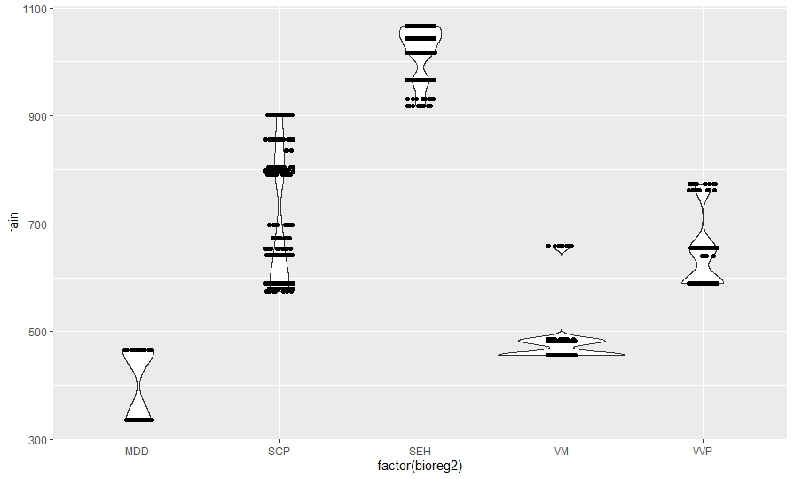

## Appendix 3. Output of the Generalised Linear Mixed Model analysing the influence of environmental variables on plant survival.

|  |  |  |  |  |
| --- | --- | --- | --- | --- |
| **Variables** | **Estimate** | **Std Error** | **Z Value** | **P Value** |
| Intercept | -1.29 | 1.39 | -0.93 | 0.35 |
| Weed cover | 0.09 | 0.11 | 0.8 | 0.43 |
| Guard (Y) | 0.67 | 0.27 | 2.5 | 0.01* |
| Graze (Y) | 0.48 | 0.37 | 1.31 | 0.18 |
| Max. Temp. | 0.34 | 0.26 | 1.3 | 0.19 |
| Rainfall (average annual) | 0.74 | 0.33 | 2.24 | 0.03* |
| Soil type (DE) | 0.35 | 0.95 | 0.37 | 0.71 |
| Soil type (FE) | 1.5 | 1.33 | 1.12 | 0.26 |
| Soil type (HY) | 0.74 | 1.23 | 0.61 | 0.54 |
| Soil type (KA) | 1.34 | 1.15 | 1.16 | 0.24 |
| Soil type (KU) | 0.29 | 1.08 | 0.27 | 0.79 |
| Soil type (PO) | -0.25 | 0.92 | -0.28 | 0.78 |
| Soil type (RU) | 0.91 | 0.95 | 0.96 | 0.33 |
| Soil type (SO) | 0.1 | 0.97 | 0.1 | 0.91 |
| Soil type (VE) | 1.42 | 1.18 | 1.2 | 0.23 |

[www.delwp.vic.gov.au](http://www.delwp.vic.gov.au)

www.ari.vic.gov.au