|  |
| --- |
| **Bushfire Biodiversity Response**  **and Recovery Program:**  **Post-fire assessment of Alpine Bogs**  **Arn Tolsma**  **May 2020** |

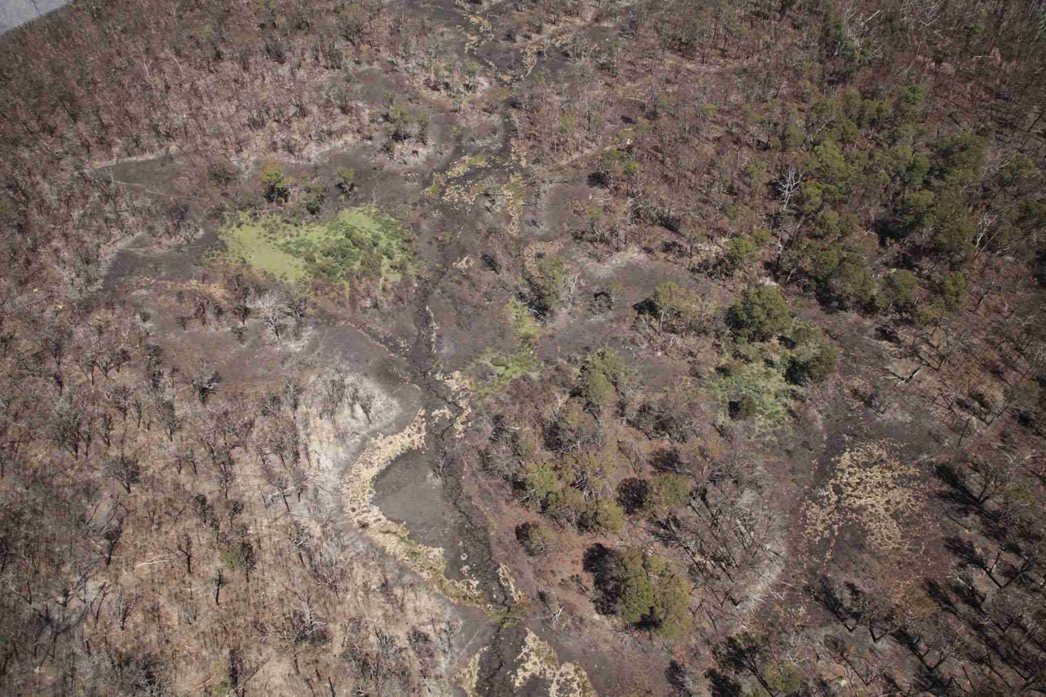

Arthur Rylah Institute for Environmental Research   
Client Report

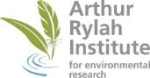

|  |
| --- |
| **Acknowledgment**  We acknowledge and respect Victorian Traditional Owners as the original custodians of Victoria's land and waters, their unique ability to care for Country and deep spiritual connection to it. We honour Elders past and present whose knowledge and wisdom has ensured the continuation of culture and traditional practices.  We are committed to genuinely partner, and meaningfully engage, with Victoria's Traditional Owners and Aboriginal communities to support the protection of Country, the maintenance of spiritual and cultural practices and their broader aspirations in the 21st century and beyond. |

**Contact for Enquiries**

Dr Arn Tolsma, Program Leader, Disturbance Ecology, [arn.tolsma@delwp.vic.gov.au](mailto:arn.tolsma@delwp.vic.gov.au)

Arthur Rylah Institute for Environmental Research  
Department of Environment, Land, Water and Planning  
PO Box 137  
Heidelberg, Victoria 3084  
Phone (03) 9450 8600  
Website: [www.ari.vic.gov.au](http://www.ari.vic.gov.au)

**Citation**

Tolsma, A. (2020). Bushfire Biodiversity Response and Recovery Program: Post-fire assessment of Alpine Bogs. Published Client report for DELWP. Arthur Rylah Institute for Environmental Research, Department of Environment, Land, Water and Planning, Heidelberg, Victoria.

**Front cover photo**

Aerial view of part of burnt Forlorn Hope Plain, 27 February 2020 (Photo: Mark Norman, Parks Victoria). The pale crescent shape in centre foreground is the remains of a burnt *Sphagnum* bog.

Logo© The State of Victoria Department of Environment, Land, Water and Planning 2020

This work is licensed under a Creative Commons Attribution 3.0 Australia licence. You are free to re-use the work under that licence, on the condition that you credit the State of Victoria as author. The licence does not apply to any images, photographs or branding, including the Victorian Coat of Arms, the Victorian Government logo, the Department of Environment, Land, Water and Planning logo and the Arthur Rylah Institute logo. To view a copy of this licence, visit <http://creativecommons.org/licenses/by/3.0/au/deed.en>

**ISBN** 978-1-76105-891-2 **(pdf/online/MS word)**

**Disclaimer**This publication may be of assistance to you but the State of Victoria and its employees do not guarantee that the publication is without flaw of any kind or is wholly appropriate for your particular purposes and therefore disclaims all liability for any error, loss or other consequence which may arise from you relying on any information in this publication.

**Accessibility**

If you would like to receive this publication in an alternative format, please telephone the DELWP Customer Service Centre on 136 186, email [customer.service@delwp.vic.gov.au](mailto:customer.service@delwp.vic.gov.au) or contact us via the National Relay Service on 133 677 or [www.relayservice.com.au](http://www.relayservice.com.au). This document is also available on the internet at [www.delwp.vic.gov.au](http://www.delwp.vic.gov.au)

# Acknowledgements

This activity was funded through the Victorian Government’s Bushfire Biodiversity Response and Recovery program (Phase 1).

Tim O’Brien, Matt White, Jim Thomson and Nick Clemann (Arthur Rylah Institute, DELWP) provided input into the project, fire severity data or site observations. Mark Norman, Jarrod Bowd and Jeremy Tscharke (Parks Victoria) provided aerial photographs and/or observations from reconnaissance flights and site visits. Additional information or assistance was provided by Sue Berwick, Ryan Incoll, Janet Pakan and Marc Perri (DELWP).

Lindy Lumsden and Kaylene Morris (Arthur Rylah Institute, DELWP) provided comments that improved the final report.

# Contents

Acknowledgements iii

Contents iv

1 Summary 1

2 Introduction 1

3 Methods 2

4 Assessment of condition and risks 2

5 Climate change and increased fire 13

6 Conclusions 14

7 References 15

1. Summary

Alpine Bog is a threatened ecological community that provides significant benefits to the natural environment, contributing to plant and animal diversity, carbon storage, and the provision of high-quality water to downstream users and ecological processes. Substantial numbers of alpine bog were known to be within the 2019-20 fire area, but the broad impacts on this fire-sensitive community were largely unknown. Therefore, the aim of this project was to investigate the potential effects of the 2019-20 fires on alpine bogs in east Victoria, their likely condition, and the major risks to bogs in the immediate post-fire period.

A total of 537 ha of alpine bog across eight broad regions was potentially burnt in the 2019-20 fires, representing approximately 20% of the total area of bog in fire-affected north-eastern Victoria. Some bogs were burnt severely, and some have now been burnt twice or more in recent decades, and they will require long times without disturbance to recover. This report has identified feral horses, deer, pigs, cattle, and willows as presenting the greatest risks to bogs (and other alpine ecosystems) in the immediate post-fire period. Without urgent management action to address these threats, many burnt bogs are likely to contract in size or disappear entirely.

In the longer term, the threats posed by wide-ranging ungulates and transformer weeds will be exacerbated by the impacts of climate change, and actions to buffer alpine bogs against pervasive threats will maximise the chances that some of this important vegetation community will be able to persist in the future.

1. Introduction

The Bushfire Biodiversity Response and Recovery program provided funding for immediate relief and early recovery to species and ecological communities most at-risk from the impacts of the 2019-20 Victorian bushfires.

Theme Plans were developed to provide information on the actions required to address identified actual and potential impacts of the Victorian 2019–20 fires on Victoria’s biodiversity. These activities are funded through the Victorian Government’s $17.5 million funding package to assist Phase 1 of the Bushfire Biodiversity Response and Recovery program.

**Theme 1: Immediate reconnaissance of critical fauna, flora and habitat and targeted actions**. This theme aims to identify fauna and flora species and habitats most at risk from post-fire threats in order to target management actions that prevent significant decline or species extinctions and maximise recovery opportunities for impacted threatened species and ecological systems.

**Activity 9: Threatened flora and vegetation communities targeted assessments.**  Within Theme 1, this activity aims to assess rainforest, alpine bogs and key flora which have been identified as at risk.

**This report documents post-fire assessment of alpine bogs under Activity 9.**

Alpine bogs are fascinating ecosystems that occupy a transitional position between land and water in high-altitude regions. They occur in waterlogged conditions where net primary productivity exceeds the rate of plant decomposition, allowing peat to accumulate (Rydin and Jeglum 2013). This peat may be metres deep, preserving plant material such as pollen, or layers of charcoal, which researchers can use to estimate changes in vegetation, climate and fire regime going back thousands of years. Alpine bogs also provide significant benefits to the natural environment, contributing to plant and animal diversity, carbon storage, and the provision of high quality water to downstream users and ecological processes (Hope *et al.* 2012).

Alpine bog, geographically restricted to areas above 1000 m altitude, is generally characterised by the presence of hummock-forming Peat Moss (*Sphagnum cristatum*), in association with other groundwater-dependent plant species such as Spreading Rope-rush (*Empodisma minus*), Candle Heath (*Richea continentis*), Alpine Baeckea (*Baeckea gunniana*), Alpine Bottlebrush (*Callistemon pityoides*) and various Heath species (*Epacris* spp.) (Department of the Environment 2015; DEWHA 2009). Nonetheless, vegetation composition, species dominance and structure can vary substantially across the alpine region (McDougall and Walsh 2007; Shannon and Morgan 2007), depending on altitude, rainfall and geomorphological setting.

Alpine Bog is a threatened ecological community listed at a state level under the *Flora and Fauna Guarantee Act 1988* (FFG), and at a federal level under the *Environment Protection and Biodiversity Conservation Act 1999* (EPBC). It contains many endemic and threatened plants and animals, with some species listed under FFG or EPBC, including Bogong Eyebright (*Euphrasia eichleri*), Alpine Water Skink (*Sphenomorpus kosciuskoi*) and Baw Baw Frog (*Philoria frosti*) (DEPI 2014; DEWHA 2009; DSE 2013). In the current fire area, other listed species, such as Austral Moonwort (*Botrychium australe*) or Mountain Burr-daisy (*Calotis pubescens*) may be found in vegetation abutting bogs (Tolsma and Sutter 2018). Accordingly, considerable work is being undertaken by various agencies to protect the Alpine Bog community from a range of threats, including (but not limited to) infrastructure and development, invasive plants and animals, livestock, recreational use, climate change and, most pertinent to this report, increased severity and frequency of fire (McMahon *et al.* 2015).

Fire is a natural, albeit historically infrequent factor in Australian alpine environments (Banks 1989; Richards *et al.* 2001; Zylstra 2006). However, climate change is predicted to increase fire frequency and severity, with higher temperatures and reduced rainfall leading to more days of very high or extreme fire danger (BoM and CSIRO 2018; Hennessy *et al.* 2005; Hennessy 2007). We are already seeing an increase in large fires affecting alpine bogs. Bogs on the southern part of Mt Buffalo were burnt in 1985, and over 300 ha of alpine bog were potentially burnt in the Caledonia fire (Wonnangatta-Moroka area) of 1998. Then in 2003, during the biggest conflagration since 1939, 2566 ha (59%) of Victoria’s 4372 ha of alpine bog were within the modelled burn area (DELWP unpublished data). Another 1207 ha were within the extent of the 2006-07 Great Divide fire (355 ha of these bogs had also been within the 2003 Alpine fire area), and 307 ha were potentially affected in another fire in the Wonnangatta-Moroka area in 2019. Smaller areas of alpine bog were within the boundaries of fires in 2009, 2013 and 2018, and the extensive bogs on the Baw Baw plateau are now the only Victorian bogs that have not been burnt at least once since 1939.

Repeated burning at short intervals is likely to have a highly detrimental effect on alpine bogs (Whinam *et al.* 2010), as recovery from even a single fire requires many decades (Good 2006; McDougall 2007; Walsh and McDougall 2004), without considering peat accumulation which may require centuries, if it can recover at all. In addition, it is critical that alpine bogs that are impacted by bushfires are buffered as much as possible against post-fire disturbance, to maximise their chances of recovery.

The aim of this project is to investigate the potential effects of the 2019-20 fires on alpine bogs in Victoria, their likely condition, and the major risks to bogs in the post-fire recovery period.

1. Methods

An existing high-resolution map of alpine bog distribution (DELWP unpublished data) was overlain with fire severity mapping (as at March 10, 2020) to extract the areas of bog that had been potentially burnt. Previous work by the author has shown that bogs can be burnt severely even when fire severity in surrounding woodland is low (Tolsma and Shannon 2007), so all bogs within the fire boundary were assumed to be burnt to at least some extent, regardless of modelled severity.

Condition, threats and risks to bogs were determined from post-fire inspections and reconnaissance flights undertaken by colleagues, and from numerous previous surveys in fire-affected areas by the author. Additional field surveys had been proposed to assess a larger cross-section of burnt bogs, but this was prevented by access restrictions, unsafe tracks and the requirement for social distancing as a result of the Covid-19 pandemic.

1. Assessment of condition and risks

A total of 537 ha of alpine bog across eight broad regions was within the boundary of the 2019-20 fire (Table 1, Figure 1), representing around 12% of the total amount of alpine bog in Victoria, or around 20% of bog area in fire-affected north-east Victoria. Evidence from reconnaissance flights suggests that numerous bogs were burnt, and that fire severity in areas such as Forlorn Hope Plain and Davies Plain was sometimes high (Figures 2 & 3). Nonetheless, the fire was patchy at a landscape scale and many bogs were scorched rather than burnt at high intensity (Jarrod Bowd, Parks Victoria, pers. comm.). Previous work has shown that there is often little relationship between the modelled severity of fire and the severity in alpine bogs, due to large variations in wetness at the time of fire, the extent of *Sphagnum* development and the amount of shrub cover. Thus, areas of deep *Sphagnum* can be merely scorched while areas dominated by tall shrubs can be severely burnt. We can assume that bogs in all broad regions within the fire boundary have formed a similar burn mosaic of fire severity.

Based on numerous previous surveys across all main areas burnt in 2019-20, and observations from post-fire reconnaissance flights and field inspections, the most serious threats to alpine bogs in the immediate post-fire period (excluding climate change) are feral horses, deer, pigs, cattle, and willows, in approximately that order. However, these threats do not operate equally across the fire area, as outlined in Table 2.

**Table 1**. Areas of alpine bog within the extent of the 2019-20 fires, by broad region as per Figure 1.

|  |  |  |  |
| --- | --- | --- | --- |
| Broad region containing burnt alpine bogs | Area of bog potentially burnt 2019-20 (ha) | Burnt bog as proportion of all bog area in region | Key locations of burnt alpine bogs |
| Mount Buffalo | 60 | 45% | Lyrebird Plain, Giants Playground, Bogong Plain, in the southern end of the plateau |
| Dargo High Plains | 13 | 8% | Gow Plain and woodland areas to the west |
| Bogong High Plains | 125 | 9% | Cope South to Buckety Plain, Youngs Top to MacNamaras Hut, at the south-east end of the plains |
| Cobungra | 66 | 26% | Dinner Plain to northern half of Cobungra State Forest |
| Nunniong Plateau | 60 | 24% | Low Plain and woodland areas to the north-west, Diggers Hole and surrounding woodland areas |
| Forlorn Hope | 35 | 32% | Forlorn Hope Plain |
| Rocky Plains / Cowombat | 48 | 16% | Rocky Plains and woodland areas to the south, Cowombat Flat |
| Davies Plain | 130 | 83% | Davies Plain and woodland areas to the west |

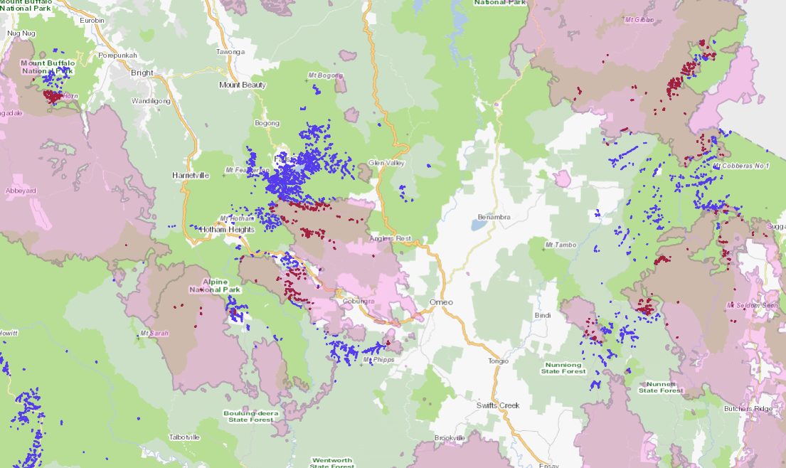

**MOUNT BUFFALO**

**DARGO HIGH PLAINS**

**COBUNGRA**

**BOGONG HIGH PLAINS**

**NUNNIONG PLATEAU**

**FORLORN HOPE**

**DAVIES PLAIN**

**ROCK PLAINS / COWOMBAT**

**Figure 1**. Alpine bogs with respect to the 2019-20 fire (pink shading), by broad region. Burnt bogs are red, unburnt bogs are blue.

**Figure 2**. Burnt bog below Davies Plain Hut, 27 February 2020 (Photo: Mark Norman).

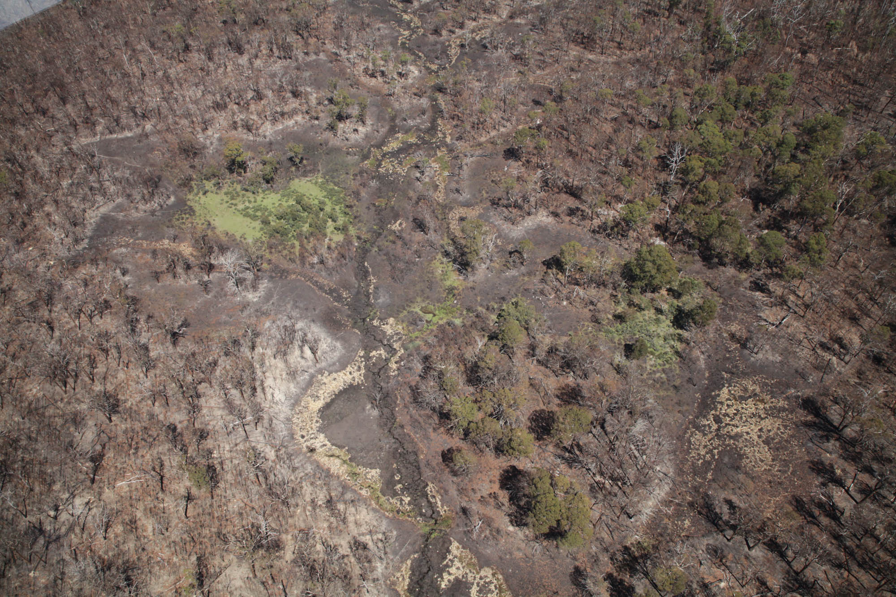

**Figure 3**. Aerial view of part of burnt Forlorn Hope Plain, 27 February 2020 (Photo: Mark Norman). The pale crescent shape in centre foreground is the remains of a burnt *Sphagnum* bog.

**Table 2**. Condition and threat information for alpine bogs within the extent of the 2019-20 fire. Existing threats are ranked in approximate order of their potential impact. This information can be used to prioritise potential management actions.

| **Broad region** | **Pre-2019-20 fire bog condition\*** | **2019-20 Fire impact\*\***  **1 (no impact) 5 (Severe impact)** | **Fire history** | **Existing threats that pose a risk to recovery, ranked by potential impact** | **Comments** |
| --- | --- | --- | --- | --- | --- |
| Mount Buffalo | mostly good* | n/a | 1985, 2003, 2006-07 | Deer, willows | Many bog areas now appear to be converting to wet grassland because of repeated fire. |
| Dargo High Plains | mostly good | n/a | 2003 | Deer, cattle?, willows? | Some cattle recently escaped from freehold land. |
| Bogong High Plains | medium to poor | n/a | 2003, some 2006-07 | Feral horses, deer, willows | Horses being actively trapped. |
| Cobungra | medium to poor | n/a | 2003 | Feral horses, cattle, deer, willows? | Cattle currently graze under State Forest licence. |
| Nunniong Plateau | mostly poor | n/a | Some 2003 | Feral horses, cattle, deer, pigs?, willows, blackberries | Blackberries seen at Mossbed Lake. Cattle currently graze under State Forest licence. |
| Forlorn Hope | poor | 4 | 2003 | Feral horses, deer, pigs?, willows? | Plains area 40% burnt in 2019-20, bog burnt severely. Fauna monitoring site. |
| Rocky Plains / Cowombat | mostly poor | n/a | 2003 | Feral horses, pigs, deer, willows? | Cowombat Flat has horse exclusion monitoring. Intensive pig trapping undertaken. |
| Davies Plain | mostly poor | 4 | 2003 | Feral horses, deer, pigs?, willows? | Some burnt severely in 2019-20. Fenced exclosure damaged. |

*Pre-fire condition was estimated from the proportion of bog area visibly affected by weeds and ungulate disturbance during pre-2019-20 surveys (DELWP unpublished data). Condition did not consider the effects of previous fires, or the extent to which sections of bog have converted to a different vegetation type (especially on Mt Buffalo).

**2019-20 fire impact was estimated from post-fire reconnaissance surveys: n/a = not assessed on-ground for this report.

? = threat not observed but considered realistic given the location.

**Feral Horses**

The total population of feral horses in the Australian Alps in 2019 was around 25,000, a substantial increase from that estimated in 2014 (~9,000 individuals) (Cairns 2019). The number of horses in the Byadbo-Victoria block (which includes the southern end of Kosciuszko National Park and the north-east end of the Alpine National Park) was estimated at 8,518 in 2019, around double the estimate in 2014 (4,316 individuals). These data suggest that the number of feral horses has been increasing across the alps at 23% per annum (Cairns 2019), around the maximum intrinsic rate for wild populations (Walter 2002). The effects of even a small number of horses are both obvious and accumulative (Tolsma and Shannon 2018), with these impacts magnified markedly due to the large numbers currently across the alps.

The environmental impacts of feral horses around the globe are well documented, and include damage to riparian and wetland systems, erosion, pugging, soil compaction, weed invasion, reductions in plant biomass, decreases in plant species richness and abundance, and reductions in ground-dwelling fauna (Beever and Brussard 2000; Beever *et al.* 2008; Giuliano and Homyack 2004; Loydi and Zalba 2009; Rogers 1991; Summer 1986; Zalba and Cozzani 2004).

Australia’s alpine ecosystems may be especially susceptible to these negative impacts, as they did not evolve with heavy, hard-hoofed animals (Ashton and Williams 1989; Carr and Turner 1959; Green *et al.* 2005). Activity by feral horses (and other large ungulates such as deer and cattle) represents a type and intensity of impact to which alpine plants and communities are unlikely to be adapted, hence ‘Degradation and loss of habitats caused by feral horses (*Equus caballus*)’ is listed as a threatening process under the FFG Act. Feral horses can cause severe damage to alpine bogs and their fauna habitat (Figure 4) and prevent or hinder post-fire recovery by continual trampling of regenerating *Sphagnum* (Tolsma 2008). For example, five years after the 2003 fires, high horse activity in the east alps was preventing many areas of *Sphagnum* hummock from recovering (Figure 5) (Tolsma 2008).

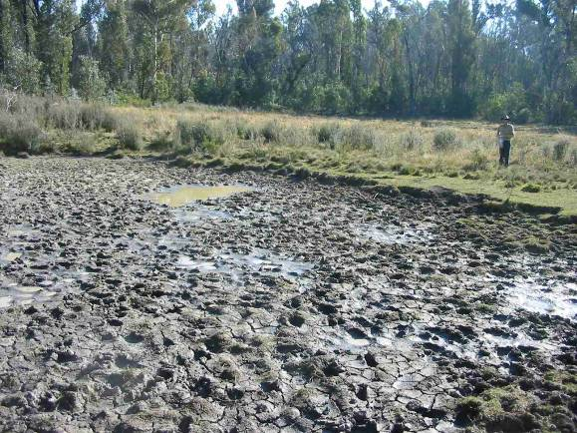

Figure 4. Alpine bog trampled to mud by feral horses, near Cowombat Flat Track (2008).

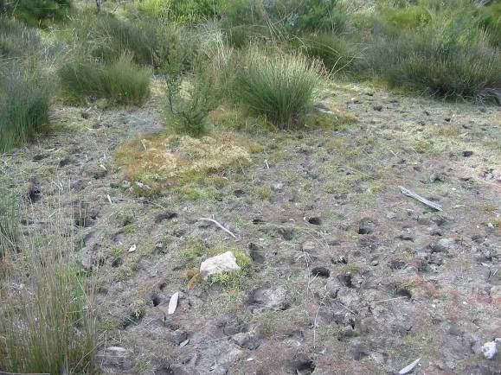

Figure 5. Five years after the 2003 fire, feral horse trampling was preventing *Sphagnum* recovery at Playground Plain in the east alps.

Six of the eight regions with bogs impacted by the 2019-20 fires are known to be affected by feral horse activity (Table 2), especially in the north-eastern region of the alps but also to a lesser extent on the Bogong High Plains and in the Cobungra State Forest to the south-east of Mt Hotham. On the Bogong High Plains, feral horses have been recently subject to a concerted trapping effort, and only a single stallion appears to have avoided capture (Mark Norman, Parks Victoria, pers. comm.), although without continued control efforts numbers could rapidly build up again from the Cobungra population to the south-east. In contrast, post-fire surveys and aerial reconnaissance indicate that feral horse activity is high in the east alps, with large mobs observed from the air, from Forlorn Hope Plain in the south to the Cobberas and Davies Plain in the north (Mark Norman, Parks Victoria, pers. comm.).

Around 40% of Forlorn Hope Plain was burnt in 2020, including most of the bog area (Figure 3), and feral horses are active there as they are drawn to remaining green feed and water (Figure 6). At Forlorn Hope Plain, “*horses are very clearly causing the most severe and widespread damage. Large areas of what was Sphagnum bog and wet heath have been lost. The water seepage has been channelised, which rapidly moves the water off the plain, drying the area out, and undoubtedly contributing to its flammability. There are many horse roll pits, large areas of pugging, and the new water channel is widening and having its banks further broken away by feral horses. The areas of former bog are now hard-packed and paddock-like. Horses are the greatest immediate threat to threatened reptiles and frogs there*” (Nick Clemann, ARI, pers. comm.).

At Davies Plain, horse damage had been worsening for many years, with damage to streams and bogs evident, and horses have recently breached the fire-damaged exclusion plot (Nick Clemann, ARI, pers. comm.). Horses are presently active in burnt bogs and drainage lines in this area (Figure 7) and numbers are likely to increase as more horses return to the main range after the fire (Jarrod Bowd, Parks Victoria, pers. comm.). Damage by feral horses is not confined to bog areas however, as horses also degrade riparian strips, grasslands, open heathlands and Snowgum woodlands, with selective grazing, trampling, bank erosion, tracks, roll pits, dung piles and damage to threatened fauna habitat. Post-fire management of feral horses has spin-off benefits for all alpine and sub-alpine flora and fauna in the broader fire area.

**Figure 6.** Horses at Forlorn Hope Plain, 27 February 2020 (photo: Mark Norman).

**Figure 7**. Horses in drainage line at Davies Plain,27 February 2020 (Photo: Mark Norman).

**Cattle**

In 2005, the Victorian Government decided not to renew remaining grazing licences in the Alpine National Park, and alpine grazing largely ceased. However, cattle still graze in some sub-alpine areas, such as the Nunniong Plateau and Cobungra State Forest within the current fire region. Some wild cattle have also been active in recent years in parts of the Alpine and Snowy River National Parks (DELWP 2015).

Cattle do similar damage to that by feral horses, including pugging of wet areas and streams, erosion, soil compaction, weed invasion, changes in species composition and structure, and destruction of fauna habitat (DELWP 2015). Grazing has no environmental benefit and, despite popular myth, it does not reduce the severity or likelihood of fire (Williams *et al.* 2006; Williamson *et al.* 2014). Accordingly, ‘Soil erosion and vegetation damage and disturbance in the alpine regions of Victoria caused by cattle grazing’ is listed as a threatening process under the FFG Act. Bogs contain water and palatable plants that draw cattle in, and their soft structure and the fact that they remain wet year-round makes them highly susceptible to physical damage. On the Nunniong Plateau, for example, from a study undertaken in 2008, the average proportion of alpine bog impacted by cattle activity exceeded 20% (DELWP, unpublished data), and only five of 33 bogs assessed were considered to be in good condition (Tolsma 2008). On the Bogong High Plains, the only bog previously assessed as high quality was one that had been fenced off from cattle in 1944 (Tolsma *et al.* 2005).

Cattle trampling can cause severe, lasting damage after fire given the friable nature of exposed alpine peats and other organic soils, and very slow recovery times. Moreover, post-fire grazing will impede recovery by trampling regenerating vegetation and maintaining bare ground. In alpine heathlands on the Bogong High Plains, protective vegetation cover was mostly restored within 10 years of fire in the absence of cattle, but had not recovered after 15 years in the presence of cattle (Wahren *et al.* 1999). Thus, cattle grazing represents a threat to burnt alpine bogs on parts of the Nunniong Plateau (Low Plain and Diggers Hole to the north) and in the Cobungra State Forest (Table 2). Bogs in the Alpine National Park adjacent to Cobungra State Forest are also at risk, as cattle do not confine themselves to their licence areas (Tolsma and Sutter 2018) (Figure 8). Cattle were also spotted after the 2019-20 fire outside freehold land on the Dargo High Plains (Nick Clemann, ARI, pers. comm.).

**Figure 8.** Pugging of alpine bog by cattle, Alpine National Park, around 1 km from Cobungra State Forest licence boundary in 2018. This bog is within the 2019-20 fire area.

Immediate action on cattle grazing is complicated by the Department’s requirement to give 3 months notice to licensees before changing licence conditions, and incomplete post-fire fencing assessments and works to support local landowners to manage cattle on their freehold land (Janet Pakan, DELWP, pers. comm.). Given that the current focus is on minimising stress on fire-affected communities, regional staff hope to determine a process for future grazing seasons whereby standard licence conditions are developed for areas impacted by fire (Janet Pakan, DELWP, pers. comm.).

**Deer**

As with feral horses, the number of deer (mostly Sambar, *Cervus unicolor*) in the alpine region is high and has increased at around 27% per annum over the last five years (Cairns 2019). In the Byadbo-Victoria block (the southern end of Kosciuszko National Park and the north-east end of the Alpine National Park) estimates of deer numbers were 2,280 in 2014 and more than triple that (7,630) in 2019 (Cairns 2019). Forlorn Hope Plain in particular has had many deer photographed by remote cameras (Nick Clemann, ARI, pers. comm.), and the author has observed increasing signs of activity in regions such as the Bogong High Plains.

Despite high numbers of deer across the broader high country, the extent of deer damage in alpine bogs tends to be substantially less than that caused by feral horses and cattle. Impacts are generally in the form of faint tracks and scats and the occasional wallow (in around 10% of bogs previously assessed) (Tolsma 2009) (Figure 9). Wallows tend to be found in bogs close to the treeline and are rarely seen in bogs on exposed plains. This suggests that deer prefer ready access to protective cover and use the alpine treeless zone in a different way to feral horses and cattle. Nonetheless, deer can destroy threatened reptile habitat (Nick Clemann, ARI, pers. comm.) and affect other vegetation types, particularly when depleted by fire. Thus, ‘Reduction in biodiversity of native vegetation by Sambar (*Cervus unicolor*)’ is also listed as a threatening process under the FFG Act. Smaller bogs may incur proportionately more damage from deer wallows than larger bogs, but overall the author has not seen extensive areas of alpine bog converted to a different vegetation type from deer activity, as is common from persistent horse and cattle activity. For example, in 65 alpine bogs assessed on-ground in Victoria’s east alps in 2008, the mean proportion of bog area showing deer damage was less than 1%, while the mean proportion of bog area showing feral horse damage was 25% (Tolsma 2008).

Nonetheless, despite deer causing less impacts in burnt alpine bogs than feral horses, they are abundant and active in all areas burnt in 2019-20, indeed the entire Victorian high country. Deer activity in non-bog vegetation types, particularly riparian zones and rainforest, is substantial, hence on-going actions to reduce deer numbers in and around burnt areas will have benefits for a wide range of ecosystems (Table 2).

**Figure 9**. Deer wallow in bog, Cobungra State Forest, 2018.

**Pigs**

Feral pigs have been present in Namadgi and Kosciuszko National Parks for many decades (Hone 2002; Saunders 1993), and are now also active in parts of Victoria, particularly in the far east of the state. Pigs have been observed in sub-alpine treeless vegetation around the Limestone Road (at Native Cat, Rocky Plains and Playgrounds), Mt Stradbroke through to the Snowy River corridor, Green Hills NCR west of Gelantipy, the Deddick Valley, and Cowombat Flat (Marc Perri, DELWP and Jarrod Bowd, Parks Victoria, pers. comm.). Over 100 pigs have been removed from Rocky Plains and Cowombat Flat over the last few years and this has been successful in significantly reducing the population in those areas (Jarrod Bowd, Parks Victoria, pers. comm.).

Pigs uproot vegetation, create large patches of bare ground, reduce plant species richness, foul waterbodies, and prey on slow-moving animals such as frogs and turtles (Bengsen *et al.* 2017; Hone 1988; 2002; McDougall and Walsh 2002; 2007). Pigs require frequent access to water (Bengsen *et al.* 2017), so also damage drainage lines and other aquatic habitat, and are likely to impact on burnt bogs within the study region, as well as other sub-alpine vegetation, particularly herb-rich communities (McDougall and Walsh 2002).

At Rocky Plains and Cowombat Flat, they have exposed extensive areas of soil that are then compacted by feral horses (Jarrod Bowd, Parks Victoria, pers. comm.), and the pigs may be as great a threat there as the horses (Table 2). Other areas such as Davies Plain, Forlorn Hope and Nunniong Plateau appear to be pig-free at present but are sufficiently close to known habitat that they could be at risk.

Parks Victoria have undertaken a concerted aerial shooting program targeting pigs (and deer) around burnt bogs and will also be delivering a major control program over the next two years (Jarrod Bowd, Parks Victoria, pers. comm.). A major aim of this is to prevent feral pigs returning to Rocky Plains and Cowombat Flat from NSW and the Snowy River corridor, or from establishing in areas where they are currently not present.

**Willows and other weeds**

Cold-tolerant willows, with their deep, dense root mats, high water use and seasonal leaf drop, have the capacity to fundamentally alter the structure and hydrology of alpine bogs and other riparian systems. Most species of willow are Weeds of National Significance, but Grey Sallow (*Salix cinerea*), the common alpine species, is considered to be the most seriously invasive (NHT 2003). A halo of hairs enables their small seeds to be blown hundreds of metres on the slightest breeze, and many kilometres with winds of sufficient turbulence (Cremer 1995), such as occur during large fire events.

The small seeds of Grey Sallow are short lived, remaining viable for only around two to six weeks (NHT 2003). For germination, their seeds require continuously wet, bare soil, conditions that do not commonly occur in undisturbed alpine vegetation. However, fire exposes large areas of bare, moist peat in burnt alpine bogs, creating optimal conditions for invasion, as seen after the 2003 and 2006-07 fires when thousands of seedlings became established on the Bogong High Plains and Mt Buffalo (McMahon *et al.* 2009; Tolsma and Shannon 2007). Willows require a mature seed source, which for the Bogong High Plains and Mt Buffalo in those fires was most likely the dense infestations along watercourses in the Ovens Valley. These two regions are highly likely to experience willow invasion again after the 2019-20 fire, as is the Nunniong Plateau from mature parent plants in the Tambo River valley (Table 2). However, all burnt areas are potentially susceptible to some level of invasion from unidentified seed sources. For example, hundreds of willows were removed between 2013 and 2018 from the Wonnangatta-Moroka Unit of the Alpine National Park (pers. comm., Mike Dower, Parks Victoria), despite having no obvious seed source nearby.

Seedlings will be difficult to detect soon after fire but should be noticeable by summer 2020-21. Autumn in particular is a good time to look for willow infestations, especially when the plants are larger, as their deciduous leaves turn yellow and make them stand out from other vegetation.

Other potential weeds of concern include Blackberry (*Rubus* spp.), which has already been observed at burnt Mossbed Lake on the Nunniong Plateau (Marc Perri, DELWP, pers. comm.), and Soft Rush (*Juncus effusus* subsp. *effusus*), which can form dense tussocks in wet areas. Many ubiquitous weeds, such as Sheep Sorrel (*Acetosella vulgaris*), Spear Thistle (*Cirsium vulgare*) and Cat’s-ear (*Hypochaeris radicata*), will be abundant in the first few years post-fire, but are not likely to cause long-term impacts as they are crowded out eventually by regenerating native plants.

1. Climate change and increased fire

Climate change poses one of the greatest long-term threats to the extent and condition of alpine bogs, both through its effects on direct drivers of bog development and its potential to exacerbate other threats, particularly fire.

Evapotranspiration in the warmest months is the limiting factor for the growth of *Sphagnum* moss (Whinam *et al.* 2003), and desiccation from a warmer, drier climate may affect the balance between growth and decomposition that underpins peat formation. There appears to be a relationship between minimum summer water inflows and the area of *Sphagnum* within a bog (Wimbush 1970), so a long-term reduction in precipitation could lead to reductions in bog size or condition and the encroachment of dryland plant species.

Climate change will also increase the frequency and intensity of fire, as already appears to be happening. Many bogs in the current fire area have been burnt twice or even more often since 1985, and there are grave concerns for their long-term persistence, especially at Mt Buffalo. *Sphagnum* and underlying peat are known to be very fire sensitive (Hope *et al.* 2005; Whinam and Chilcott 2002), and there is a potential positive feedback between shrub establishment and fire (Camac *et al.* 2017). *Sphagnum* sporophytes are rarely seen in Australia, and the vegetative regeneration of this moss is dependent on the presence of remnant unburnt fragments (Whinam *et al.* 2010). However, in severely burnt bogs *Sphagnum* cover can be virtually destroyed with the underlying peat burnt down to mineral soil (Walsh and McDougall 2004), removing much of the material needed for vegetative recovery. In contrast, many bog-dependent shrubs such as Candle Heath rely solely on seedling recruitment, with germination taking up to eighteen months (Whinam *et al.* 2010). In both cases, long delays in post-fire recovery leave the bog vulnerable to soil erosion, ungulate trampling and weed invasion (McDougall 2007; Walsh and McDougall 2004).

Repeated burning at short intervals is likely to have a highly detrimental impact on alpine bogs (Whinam *et al.* 2010), as recovery from even a single fire requires many decades (Good 2006; McDougall 2007; Walsh and McDougall 2004), without considering peat accumulation which may require centuries, if it can recover at all. Protection during fire events may be impractical, although bogs have been included in relevant fire operations plans and a high-resolution GIS layer is available which documents the details on the location of each.

In some instances, fire will promote erosion channels in bogs, and subsequent drainage will reduce their water-holding capacity, slowing or preventing the recovery of groundwater-dependent vegetation. Active rehabilitation has been useful in the past to improve water retention and enhance recovery, but the potential for this needs to be assessed on a bog-by-bog basis. In general, however, most bogs will recover from fire if they are able to retain water and are given enough time without additional disturbance.

1. Conclusions

A total of 537 ha of alpine bog across eight broad regions was potentially burnt in the 2019-20 fires, representing approximately 20% of the area of bog in fire-affected north-east Victoria. Some bogs were burnt severely, and some have now been burnt twice or more in recent decades. Bogs require long times without disturbance to recover, but an increasing frequency of fire suggests that time is a luxury that many bogs no longer have. This report has identified feral horses, deer, pigs, cattle, and willows as presenting the greatest risks to bogs (and other alpine ecosystems) in the immediate post-fire period. Without urgent management action to address these threats, many burnt bogs are likely to contract or disappear entirely. Smaller bogs at lower elevation that are already marginal with respect to water availability are at most risk, with or without fire. Hence, larger bogs at high elevation will become increasingly important refugia for flora and fauna that are dependent on this ecosystem.

In the longer term, the threats posed by wide-ranging ungulates and transformer weeds will be exacerbated by the impacts of climate change, and fire management plans may need to play a role in protecting alpine bogs. There is little we can do to mitigate the direct impacts of climate change on alpine bogs, but actions to buffer them against pervasive threats will maximise the chances that some of this important vegetation community will be able to persist in the future.

1. References

Ashton D. H. & Williams R. J. (1989) Dynamics of the sub-alpine vegetation in the Victorian region. In: *The Scientific Significance of the Australian Alps: The Proceedings of the First Fenner Conference on the Environment* (ed R. Good) pp. 143-68. Australian Alps National Parks Liaison Committee.

Banks J. C. G. (1989) A history of forest fire in the Australian Alps. In: *The Scientific Significance of the Australian Alps* (ed R. Good) pp. 265-80. Australian Alps National Parks Liaison Committee, Canberra.

Beever E. A. & Brussard P. F. (2000) Examining ecological consequences of feral horse grazing using exclosures. *Western North American Naturalist* **60**, 236-54.

Beever E. A., Tausch R. J. & Thogmartin W. E. (2008) Multi-scale responses of vegetation to removal of horse grazing from Great Basin (USA) mountain ranges. *Plant Ecology* **196**, 163-84.

Bengsen A. J., West P. & Krull C. R. (2017) Feral pigs in Australia and New Zealand: Range, trend, management, and impacts of an invasive species. In: *Ecology, Conservation and Management of Wild Pigs and Peccaries*. Cambridge University Press.

BoM and CSIRO. (2018) State of the Climate 2018. Bureau of Meteorology and CSIRO, Canberra.

Cairns S. (2019) Feral horses in the Australian Alps: the analysis of aerial surveys conducted in April-May, 2014 and April-May 2019. Report to the Australian Alps Liaison Committee, G.E. & S.C. Cairns Consulting Pty Ltd, Armidale.

Camac J. S., Williams R. J., Wahren C.-H., Hoffmann A. A. & Vesk P. A. (2017) Climatic warming strengthens a positive feedback between alpine shrubs and fire. *Global Change Biology* **23**, 3249-58.

Carr S. G. M. & Turner J. S. (1959) The ecology of the Bogong High Plains I. The environmental factors and the grassland communities. *Australian Journal of Botany* **7**, 12-33.

Cremer K. W. (1995) Willows spreading by seed - implications for Australian river management. *Australian Journal of Soil and Water Conservation* **8**, 18-27.

DELWP. (2015) Flora and Fauna Guarantee Action Statement No. 266. Soil erosion and vegetation damage and disturbance in the alpine regions of Victoria caused by cattle grazing. Department of Environment, Land, Water and Planning, Melbourne.

Department of the Environment. (2015) National Recovery Plan for the Alpine Sphagnum Bogs and Associated Fens Ecological Community. Department of the Environment, Canberra.

DEPI. (2014) Advisory List of Rare or Threatened Plants in Victoria - 2014. Department of Environment and Primary Industries, Melbourne.

DEWHA. (2009) Alpine Sphagnum Bogs and Associated Fens, a Nationally Threatened Ecological Community, EPBC Policy Statement 3.16. Department of the Environment, Water, Heritage and the Arts, Canberra.

DSE. (2013) Advisory List of Threatened Vertebrate Fauna in Victoria. Department of Sustainability and Environment, Melbourne.

Giuliano W. M. & Homyack J. D. (2004) Short-term grazing exclusion effects on riparian small mammal communities. *Journal of Range Management* **57**, 346-50.

Good R. (2006) Post-fire ecosystems rehabilitation in Namadgi and Kosciuszko National Parks. In: *NPA ACT Symposium 2006: Caring for Namadgi - Science and People*.

Green K., Good R. B., Johnston S. W. & Simpson L. A. (2005) Alpine grazing in the Snowy Mountains of Australia: degradation and stabilization of the ecosystem. In: *Land Use Changes and Mountain Biodiversity* (eds E. Spehn, M. Liberman and C. Korner). CRC Press LLC, Boca Raton, FL.

Hennessy K., Lucas C., Nicholls N., Bathols J., Suppiah R. & Ricketts J. (2005) Climate Change Impacts on Fire-Weather in South-East Australia. CSIRO Marine and Atmospheric Research, Bushfire CRC and Australian Bureau of Meteorology.

Hennessy K. J. (2007) Fire weather. In: *Climate Change in Australia: Technical Report 2007* (eds K. B. Pearce, P. N. Holper, M. Hopkins, W. J. Bouma, P. H. Whetton, K. J. Hennessy and S. B. Power). CSIRO Marine and Atmospheric Research, Aspendale.

Hone J. (1988) Feral pig rooting in a mountain forest and woodland: Distribution, abundance and relationships with environmental variables. *Austral Ecology* **13**, 393-400.

Hone J. (2002) Feral pigs in Namadgi National Park, Australia: dynamics, impacts and management. *Biological Conservation* **105**, 231-42.

Hope G., Nanson R. & Jones P. (2012) Peat-Forming Bogs and Fens of the Snowy Mountains of NSW. Technical Report. Office of Environment and Heritage, Sydney South.

Hope G., Whinam J. & Good R. (2005) Methods and preliminary results of post-fire experimental trials of restoration techniques in the peatlands of Namadgi (ACT) and Kosciuszko National Parks (NSW). *Ecological Management & Restoration* **6**, 214-6.

Loydi A. & Zalba S. M. (2009) Feral horses dung piles as potential invasion windows for alien plant species in natural grasslands. *Plant Ecology* **201**, 471-80.

McDougall K. L. (2007) Grazing and fire in two subalpine peatlands. *Australian Journal of Botany* **55**, 42-7.

McDougall K. L. & Walsh N. G. (2002) The flora of Nungar Plain, a treeless sub-alpine frost hollow in Kosciuszko National Park. *Cunninghamia* **7**, 601-10.

McDougall K. L. & Walsh N. G. (2007) Treeless vegetation of the Australian Alps. *Cunninghamia* **10**, 1-57.

McMahon A., Carr G. & Sutton F. (2009) Fainter Ridge Willow Infestation. Report to Parks Victoria, Ecology Australia.

McMahon A., Tolsma A., McMahon J., Coates F. & Lawrence R. (2015) Victorian Alpine Peatlands Spatial Action Plan: A Framework for Managing Victoria's Peatlands. Report to Parks Victoria, Ecology Australia, Fairfield.

NHT. (2003) Weeds of National Significance: Weed Management Guide, Willow - *Salix* spp. Department of the Environment and Heritage and the CRC for Australian Weed Management.

Richards R. M., Cary G. J. & Bradstock R. A. (2001) The sensitivity of snow gum to fire scarring in relation to Aboriginal landscape burning. In: *Australasian Bushfire Conference* pp. 285-92, Christchurch.

Rogers G. M. (1991) Kaimanawa feral horses and their environmental impacts. *New Zealand Journal of Ecology* **15**, 49-64.

Rydin H. & Jeglum J. K. (2013) *The Biology of Peatlands, 2nd Edition*. Oxford University Press, Oxford.

Saunders G. (1993) The demography of feral pigs (*Sus scrofa*) in Kosciusko National Park, New South Wales. *Wildlife Research* **20**, 559-69.

Shannon J. M. & Morgan J. W. (2007) Floristic variation in Sphagnum-dominated peatland communities of the Central Highlands, Victoria. *Cunninghamia* **10**, 59-76.

Summer R. (1986) Geomorphic impacts of horse traffic on montane landforms. *Journal of Soil and Water Conservation* **41**, 126-8.

Tolsma A. (2008) An Assessment of the Management Needs of Mossbeds in Victoria's Alps, 2004-2008. Report to Parks Victoria. Arthur Rylah Institute for Environmental Research.

Tolsma A. & Shannon J. (2007) Evaluating the Rehabilitation Needs of Mossbeds in the Alpine and Mt Buffalo National Parks After the 2006/07 Fires. Unpublished report to Parks Victoria. Arthur Rylah Institute for Environmental Research.

Tolsma A. & Shannon J. (2018) Assessing the impacts of feral horses on the Bogong High Plains, Victoria. Report to Parks Victoria. Arthur Rylah Institute for Environmental Research, Department of Environment, Land, Water and Planning, Heidelberg.

Tolsma A., Shannon J., Papst W., Rowe K. & Rosengren N. (2005) An Assessment of the Condition of Mossbeds on the Bogong High Plains. Report to the Department of Sustainability and Environment. Arthur Rylah Institute for Environmental Research and Research Centre for Applied Alpine Ecology, La Trobe University.

Tolsma A. & Sutter G. (2018) Alpine Bogs in the Cobungra State Forest. Arthur Rylah Institute for Environmental Research. Unpublished Client Report. Department of Environment, Land, Water and Planning, Heidelberg, Victoria.

Wahren C.-H. A., Papst W. A. & Williams R. J. (1999) Post-fire regeneration in Victorian alpine and sub-alpine vegetation. In: *Australian Bushfire Conference*. School of Environmental & Information Sciences, Charles Sturt University, Albury.

Walsh N. G. & McDougall K. L. (2004) Progress in the recovery of the flora of treeless subalpine vegetation in Kosciuszko National Park after the 2003 fires. *Cunninghamia* **8**, 439-52.

Walter M. (2002) The Population Ecology of Wild Horses in the Australian Alps. University of Canberra.

Whinam J. & Chilcott N. (2002) Floristic description and environmental relationships of Sphagnum communities in NSW and the ACT and their conservation management. *Cunninghamia* **7**, 463-500.

Whinam J., Hope G., Good R. & Wright G. (2010) Post-fire experimental trials of vegetation restoration techniques in the peatlands of Namadgi (ACT) and Kosciuszko National Parks (NSW), Australia. In: *Terra Australis 32. Altered Ecologies: Fire, Climate and Human Influence on Terrestrial Landscapes* (eds S. G. Haberle, J. Stevenson and M. Prebble). ANU E Press, Canberra.

Whinam J., Hope G. S., Clarkson B. R., Buxton R. P., Alspach P. A. & Adam P. (2003) *Sphagnum* in peatlands of Australasia: Their distribution, utilisation and management. *Wetlands Ecology and Management* **11**, 37-49.

Williams R. J., Wahren C.-H., Bradstock R. A. & Muller W. J. (2006) Does alpine grazing reduce blazing? A landscape test of a widely-held hypothesis. *Austral Ecology* **31**, 925-36.

Williamson G. J., Murphy B. P. & Bowman D. M. J. S. (2014) Cattle grazing does not reduce fire severity in eucalypt forests and woodlands of the Australian Alps. *Austral Ecology* **39**, 462-8.

Wimbush D. J. (1970) Hydrological Studies on Sphagnum Bogs in the Snowy Mountains, New South Wales. Masters thesis, University of Sydney.

Zalba S. M. & Cozzani N. C. (2004) The impact of feral horses on grassland bird communities in Argentina. *Animal Conservation* **7**, 35-44.

Zylstra P. (2006) Fire History of the Australian Alps - Prehistory to 2003. Australian Alps Liaison Committee and Department of the Environment and Heritage.

delwp.vic.gov.au

ari.vic.gov.au