Victorian Semi-arid Woodlands
Annual Monitoring: southern Murray-Sunset and southern Wyperfeld











Arthur Rylah Institute for Environmental Research
Program Update – April 2026
S. Kenny and C. Moxham
deeca.vic.gov.au
Key Messages
- Ongoing browser control is important for the recovery of grazing-sensitive, slow growing Semi-arid Woodlands.
- Semi-arid Woodland Condition Monitoring over 13-years (2012-2025) shows:
  - Condition improved in 11 of 24 sites at southern Wyperfeld due to increased natural recruitment, large shrub and native plant richness.
  - Condition improved in 7 of 22 sites at southern Murray-Sunset due to increased native plant richness and stable tree life stage distribution.
  - Low levels of browsing on tree recruitment.
- This highlights positive progress towards woodland recovery. However, most woodlands are not self-sustaining and ongoing browser control, fire prevention and targeted revegetation will enable long-term woodland viability.

Semi-arid Woodlands
Semi-arid woodlands are characterised by one or more canopy species – Belah (Casuarina pauper), Buloke (Allocasuarina luehmannii), Slender Cypress Pine (Callitris gracilis), and Sugarwood (Myoporum platycarpum) – over a diverse ground layer of saltbushes, herbs, grasses and biological soil crust.

Management and monitoring long-term recovery
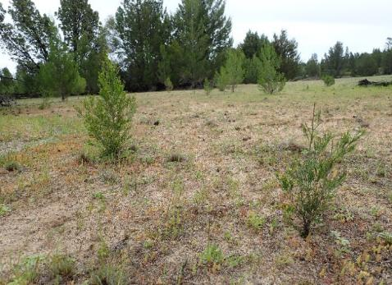
Victoria’s Semi-arid Woodlands are severely degraded due to historical land use. They are slow-growing and reliant on high rainfall events to enhance regeneration. Woodland recovery is slow and impeded by browsing. Thus, historical and current ecological impacts (e.g. grazing, altered fire regimes) have long-lasting impacts on condition. To improve woodland condition, a long-term restoration program (The Total Grazing Management Plan – Parks Victoria 2025) has been running for over 10 years focusing on browser control and revegetation works. In addition to this, the Semi-arid Woodland Condition Monitoring Program is being implemented to measure recovery success and improve our knowledge base.
Slender Cypress Pine recruitment.

Annual Monitoring
This monitoring program update provides a summary of the findings of the 2025-2026 monitoring of 48 sites across Dunstans Flora and Fauna Reserve, and southern Murray-Sunset and Wyperfeld National Parks. These sites are part of a broader suite of 240 sites across the Mallee National Parks and Flora and Fauna Reserves. It investigates changes in woodland condition states (poor, fair, good) over three monitoring periods for southern Murray-Sunset (M1: 2012, M2: 2019, M3: 2025) and southern Wyperfeld (M1: 2012, M2: 2020, M3: 2025).

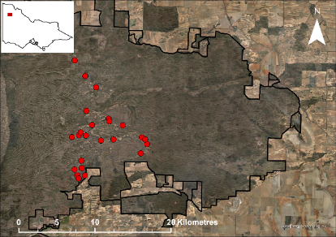
Southern Wyperfeld
Twenty-four sites were monitored in southern Wyperfeld National Park (map on the right). Historically, Wyperfeld has been variably cleared, grazed by stock and has had targeted revegetation works since the 1970s (e.g. Slender Cypress Pine). This is reflected in the fair to good condition of Semi-arid Woodlands with reasonable tree numbers (across all life stages), variable tree and shrub recruitment and the slow recovery of these woodlands.

Main findings
- Over a 13-year period, 11 of 24 sites have improved in overall condition: poor to good (one site), poor to fair (two sites) and fair to good (eight sites). The remaining 13 sites either fluctuated (two sites) in condition or remained stable (11 sites).
- Tree life stage distribution (demographic condition) has improved with a steady increase in the number of recruits and mature trees, while the number of senescent and dead trees has remained relatively unchanged. Recruitment occurred at 21 sites which was mostly Slender Cypress Pine with Buloke recruitment at one site.
- Browsing was recorded at 67% of sites with tree recruitment predominantly at low levels. Not all recruits at a site were browsed, often only a small number of recruits had browsing damage, the remainder being healthy.

- Understorey vegetation condition is improving with large shrub and native plant richness increasing. However, weed cover has also increased over the 13-year period.








Condition attribute | M1 (2012) |  |  | M2 (2020) |  |  | M3 (2025)
Condition attribute | Poor | Fair | Good | Poor | Fair | Good | Poor | Fair | Good
  SAW condition state | 3 | 21 | 0 | 3 | 19 | 2 | 2 | 13 | 9
  Tree life stage distribution | 3 | 12 | 9 | 3 | 11 | 10 | 2 | 5 | 17
  Tree recruitment | 4 | 10 | 10 | 3 | 7 | 14 | 3 | 5 | 16
  Large shrub richness | 23 |  | 1 | 20 |  | 4 | 7 |  | 17
  Native plant richness | 21 |  | 3 | 18 |  | 6 | 11 |  | 13
  Weed cover | 0 | 0 | 24 | 0 | 5 | 19 | 7 | 8 | 9
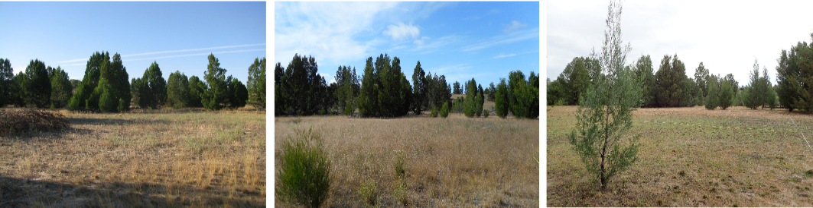
Pine Woodland showing improvement in condition from poor (2012; left) to fair (2020, 2025; middle and right) condition. Condition increased following increased Slender Cypress Pine recruitment highlighted by the juvenile Slender Cypress Pine in the foreground of the photo.

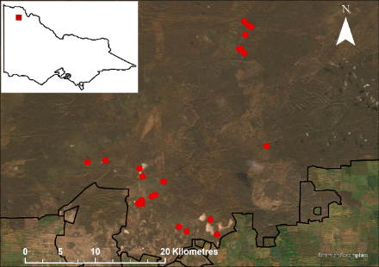
Southern Murray-Sunset
Twenty-two sites were monitored in southern Murray-Sunset National Park (map on the right). Historically, southern Murray-Sunset has been variously cleared, grazed by stock and used for salt mining. This is currently reflected in fair to good condition of these woodlands with reasonable tree numbers (across most life stages), variable tree and shrub recruitment and the overall slow recovery of these woodlands.

Main findings
- Over a 13-year period, seven of 22 sites have improved from fair to good condition. The remaining 15 sites either fluctuated (five sites), declined (four sites) or remained stable (six sites).
- Tree life stages (demographic condition) declined with unchanged recruitment levels, a decline in mature trees and associated increase in senescent trees. Tree recruitment occurred at nine sites in 2025. However, most Belah (73%) and Buloke (96%) juveniles were recorded at a single site.
- Browsing was recorded at 33% of sites with recruitment and was generally low. Not all recruits at a site were browsed, often only a small number of recruits had browsing damage, the remainder being healthy.
- Understorey vegetation condition is improving with large shrub and native plant richness increasing. However, weed cover has also increased over the 13-year period.


Condition attribute | M1 (2012) |  |  | M2 (2019) |  |  | M3 (2025)
Condition attribute | Poor | Fair | Good | Poor | Fair | Good | Poor | Fair | Good
  SAW condition state | 1 | 21 | 0 | 9 | 12 | 1 | 5 | 10 | 7
Tree life stage distribution | 1 | 19 | 2 | 5 | 15 | 2 | 7 | 12 | 3
Tree recruitment | 17 | 2 | 3 | 15 | 4 | 3 | 17 | 3 | 2
Large shrub richness | 22 |  | 0 | 17 |  | 5 | 14 |  | 8
Native plant richness | 20 |  | 2 | 7 |  | 15 | 1 |  | 21
  Weed cover | 0 | 2 | 20 | 9 | 2 | 11 | 4 | 7 | 11
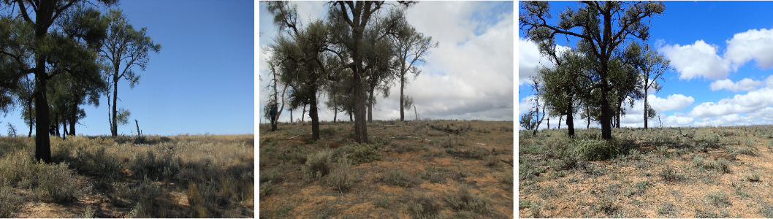
Buloke Woodland in fair condition from 2012 to 2025 (left to right). Individual components of the condition score have remained stable over the 13-year monitoring period thus the woodland has remained in fair condition.

Management implications
These woodlands are slowly showing signs of recovery with monitoring detecting improvements in condition between 2012 and 2025, particularly in southern Wyperfeld. Findings indicate large shrubs and native species richness are improving; however, tree recruitment remains inadequate. Improvements in condition are taking too long for many of these woodlands to be self-sustaining (successful recruitment and transition through life stages) and resilient to a changing climate. Thus, restoration actions such as revegetation, browser control and fire prevention are required to ensure that example woodlands remain in the landscape.
Active revegetation works are required in combination with ongoing herbivore browsing control to improve woodland condition at southern Wyperfeld and Murray-Sunset. At southern Wyperfeld, revegetation works should be undertaken at priority sites including interplanting of medium to large shrubs, small trees and canopy trees. At southern Murray-Sunset, revegetation works should be undertaken at key Buloke and Slender Cypress Pine sites targeting those in fair condition, including interplanting of medium to large shrubs, small trees and canopy trees.
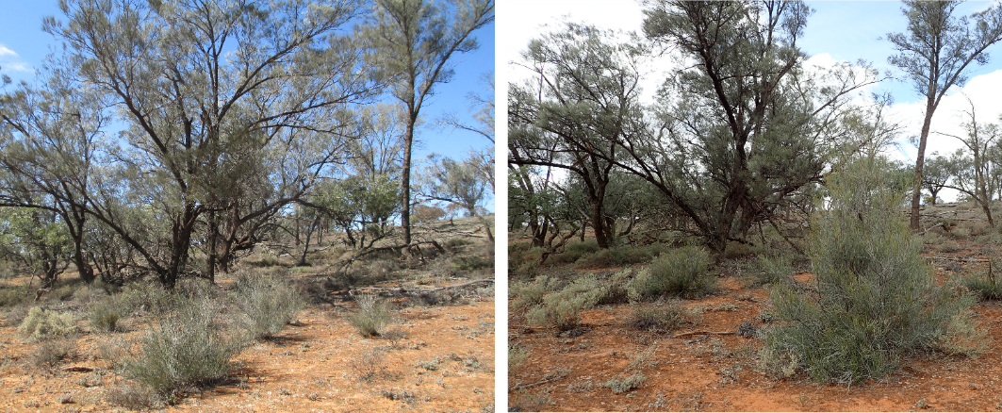
Belah regeneration within southern Murray-Sunset in (left) 2019 and (right) 2025 which has benefited from browser control.

Fire impacts and resilience
A rapid response to bushfires is required to limit negative impacts to these fire sensitive Semi-arid Woodlands. For example, protecting individual trees, where fire conditions allow, as was done during the 2020 Pine Plains fire. Increased fire in the landscape is now having significant negative impacts on Semi-arid Woodlands, especially in Wyperfeld National Park. The recent 2026 bushfires have negatively impacted many woodlands and monitoring sites. This fire, combined with recent previous fires (e.g. 2014, 2020) has resulted in the loss and degradation of significant tracts of woodland, including 92% of monitoring sites within this park. In addition, Semi-arid Woodlands have been impacted in Hattah-Kulkyne (2026 bushfires) and north-western Murray-Sunset (2023 bushfires) National Parks. Thus, there is an urgent need to understand the impacts of fire on Semi-arid Woodlands and how to manage these woodlands into the future.

Where to next?
Overall, some of the Total Grazing Management Plan outcomes have currently been met; however, continued monitoring is required to ensure these changes are maintained into the future. Positive changes include increased large shrub and native species richness, an increase in juvenile trees in some woodlands and low browsing levels. Program recommendations include:
- Ongoing implementation of the Semi-arid Woodland Monitoring Program to inform recovery.
- Continued browser control to reduce negative impacts on regenerating woody plants.
- Urgent investigation into fire impacts on Semi-arid Woodlands, including the prioritisation of focal woodlands for preservation and targeted management.
- Rapid response to bushfires to limit negative impacts on Semi-arid Woodlands. Many Semi-arid Woodland plants are sensitive to fire and may be lost from the ecosystem following fire, including from increased browsing pressure.
- Determine priority focal woodland sites for protection and enhanced management to ensure good quality examples of Semi-arid Woodlands remain in the landscape.
- Prioritise revegetation works at locations where the best return on investment can be confidently expected to improve (or maintain) woodland condition. For example, fair condition sites where interplanting of tube stock will result in increased large shrub richness in the short to medium term (3-5 years) and increased healthy mature trees in the long-term (> 10 years). Where possible, this should be undertaken in good rainfall years to increase revegetation success.
- Determine revegetation success of existing works and the characteristics which made them successful. This will help inform future revegetation works.

Further reading
See the Semi-arid Woodland Condition Monitoring ARI webpage (and associated fact sheets):
https://www.ari.vic.gov.au/research/environmental-management/field-techniques-and-monitoring/health-of-semi-arid-non-eucalypt-woodlands

Kenny S. and Moxham C. (2026). Victorian Semi-arid Woodlands Vegetation Condition Monitoring Program 2025-2026: southern Wyperfeld National Park annual report. Arthur Rylah Institute for Environmental Unpublished Report for Parks Victoria. Department of Energy, Environment and Climate Action, Heidelberg, Victoria.
Kenny S., Osler D. and Moxham C. (2026). Victorian Semi-arid Woodlands Vegetation Condition Monitoring Program 2025-2026: southern Murray-Sunset National Parks and Dunstans Flora and Fauna Reserve annual report. Arthur Rylah Institute for Environmental Unpublished Report for Parks Victoria. Department of Energy, Environment and Climate Action, Heidelberg, Victoria.
Moxham C., Kenny S. and Moloney P. (2023). Semi-arid Woodland Condition Monitoring Program five-year evaluation: progress towards the Total Grazing Management Plan key evaluation questions. Unpublished Report for Parks Victoria. Arthur Rylah Institute for Environmental Research, Department of Energy, Environment and Climate Action, Heidelberg, Victoria.
Parks Victoria (2025) The total grazing management plan for the restoration of semi-arid woodland and floodplain vegetation communities in the north-western (Mallee) parks. Internal Parks Victoria report, Mildura, Victoria.

For further information contact Sally Kenny (sally.kenny@deeca.vic.gov.au) or Claire Moxham (claire.moxham@deeca.vic.gov.au)
© The State of Victoria Department of Energy, Environment and Climate Action April 2026.
Citation: Kenny S. and Moxham C. (2026) Victorian Semi-arid Woodlands Vegetation Annual Monitoring: southern Murray-Sunset and Wyperfeld. Program Summary for Parks Victoria. Department of Energy, Environment and Climate Action, Heidelberg, Victoria.
This work is licensed under a Creative Commons Attribution 4.0 International licence, visit the Creative Commons website (http://creativecommons.org/licenses/by/4.0/).
ISBN 978-1-76176-887-3 (pdf/online/MS word)
Accessibility
If you would like to receive this publication in an alternative format, please telephone the DEECA Customer Service Centre on 136186, email customer.service@deeca.vic.gov.au, or via the National Relay Service on 133 677

We acknowledge Victorian Traditional Owners and their Elders past and present as the original custodians of Victoria’s land and waters and commit to genuinely partnering with them and Victoria’s Aboriginal community to progress their aspirations.

