Glenelg Ark—2023 monitoring and evaluation update
OFFICIAL




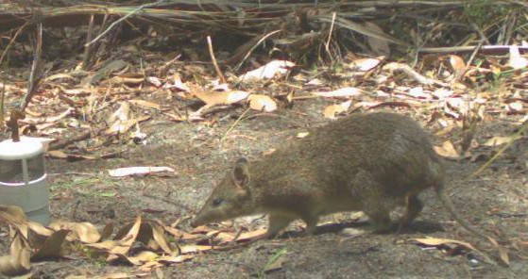
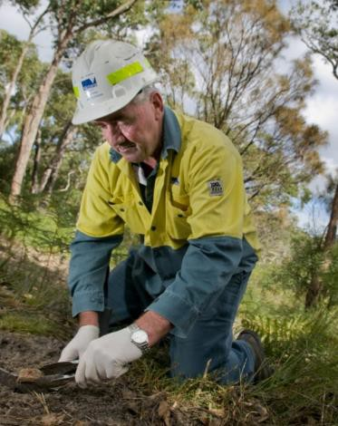
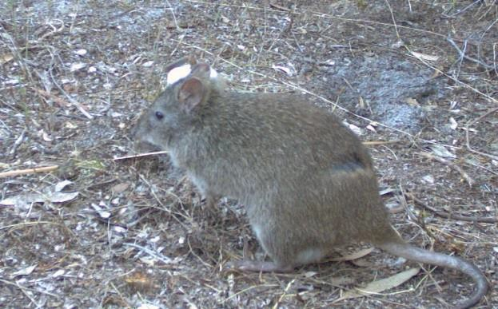
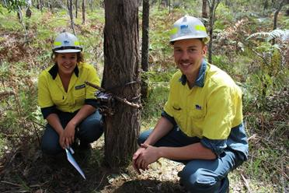
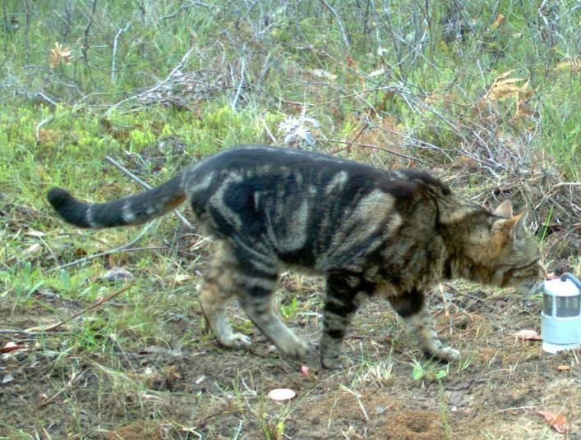

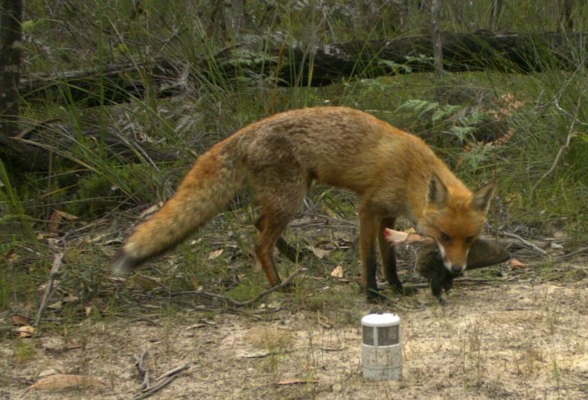
A. Robley, P.D. Moloney and E. Le Duc July 2024

Arthur Rylah Institute for Environmental Research Technical Report Series No.380



Arthur Rylah Institute for Environmental Research Department of Energy, Environment and Climate Action PO Box 137, Heidelberg, Victoria 3084
Phone (03) 9450 8600
Website: www.ari.vic.gov.au
Citation: Robley, A., Moloney, P.D. and Le Duc, E. (2023). Glenelg Ark—2023 monitoring and evaluation update. Arthur Rylah Institute for Environmental Research Technical Report Series No. 380. Department of Energy, Environment and Climate Action, Heidelberg, Victoria.

Front cover photo: (a) Red Fox; (b) feral cat; (c) DEECA crew monitoring native species’ (d) and setting bait station;
(e) Long-nosed Potoroo; and (f) Southern Brown Bandicoot (photographer: Ethan Le Duc).
Edited by Fox Writing Services ISSN 1835-3827 (print)
ISSN 1835-3835 (pdf))
ISBN 978-1-76136-753-3 (Print)
ISBN 978-1-76136-754-0 (pdf/online/MS word)


We acknowledge and respect Victorian Traditional Owners as the original custodians of Victoria’s land and waters, their unique ability to care for Country and deep spiritual connection to it.
We honour Elders past and present whose knowledge and wisdom has ensured the continuation of culture and traditional practices.
DEECA is committed to genuinely partnering with Victorian Traditional Owners and Victoria’s Aboriginal community to progress their aspirations.

© The State of Victoria Department of Energy, Environment and Climate Action July 2024
Creative Commons
This work is licensed under a Creative Commons Attribution 4.0 International licence, visit the Creative Commons website (http://creativecommons.org/licenses/by/4.0/).
You are free to re-use the work under that licence, on the condition that you credit the State of Victoria as author. The licence does not apply to any images, photographs or branding, including the Victorian Coat of Arms, and the Victorian Government, the Department and the ARI logos.
Disclaimer
This publication may be of assistance to you but the State of Victoria and its employees do not guarantee that the publication is without flaw of any kind or is wholly appropriate for your particular purposes and therefore disclaims all liability for any error, loss or other consequence which may arise from you relying on any information in this publication.

Accessibility
To receive this document in an alternative format, phone the Customer Service Centre on 136 186, email customer.service@deeca.vic.gov.au, or contact National Relay Service on 133 677. Available at DEECA website (www.deeca.vic.gov.au).

Glenelg Ark—2023 monitoring and evaluation update

Alan Robley1, Paul D. Moloney1 and Ethan Le Duc2

1Arthur Rylah Institute for Environmental Research Department of Energy, Environment and Climate Action 123 Brown Street, Heidelberg, Victoria 3084
2Barwon Southwest, Forest, Fire and Regions Department of Energy, Environment and Climate Action 12 Murray Street, Heywood, Victoria 3304

Arthur Rylah Institute for Environmental Research
Technical Report Series No. 380

Acknowledgements

This project was funded by Department of Energy, Environment and Climate Action under the Environment and Community Program, and we thank Damian McMaster for facilitating this funding.
Members of the Glenelg Ark Working Group provided guidance and input throughout.
Members of the works crew at the Heywood and Dartmoor Depots undertook invaluable project support activities, including baiting and camera set-up: Tyler Britten, Jack Gibbons, Jess Greenwood, Amber Mirtchen, Jamie Brown, James Gray, Samantha Sheppard, Gordie Slade, Ebony Stiles, Sarah Smith, Dylan Thomas and Jess Pridmore. Baiting for the control of foxes was also undertaken by Ray Albert, Josh Ferguson, James Gray, Jess Pridmore and Dylan Thomas.
Camera trapping and other field activities were performed under Research Permit Number 10010908 and AEC Permit Number AEC 23-003.
Lindy Lumsden, Jim Thomson and Lauren White provided comments that improved this report.

Contents
Acknowledgements ii
Summary 1
- Introduction 4
- Methods 5
  - Location 5
  - Monitoring and evaluation design 5
  - Data collection 6
  - Species occupancy 7
  - Fox and feral cat activity 8
- Results 9
  - Initial occupancy, survival, colonisation, and growth rates 9
    - Common Brushtail Possum 9
    - Long-nosed Potoroo 11
    - Southern Brown Bandicoot 14
  - Predator activity 17
    - Fox activity 17
    - Feral cat activity 18
  - Other species’ naïve occupancy 19
- Discussion 20
- References 24
Appendix 28

Tables
Table 1. Description of the site-level covariates used in the multi-season occupancy models 7
Table 2. Summary of fox detections across all years by location 17
Table 3. Summary of feral cat detections across all years by location 18

Figures
Figure 1. Glenelg Ark operational areas 5
Figure 2. Monitoring sites in the ‘fox-control monitoring locations’ (FCMLs; dark-tan areas) and ‘no-fox-control monitoring locations’ (NFCMLs; pale-tan areas) are indicated by purple dots 6
Figure 3. Occupancy rates for the Common Brushtail Possum over time by fox control status 9
Figure 4. Estimated site survival rates for the Common Brushtail Possum in relation to distance to non-native vegetation, terrain ruggedness, ecological vegetation division, and elevation given all other covariates were held at their mean values 10
Figure 5. Estimated site colonisation rates for the Common Brushtail Possum in relation to ecological vegetation division, given all other covariates were held at their mean values 11
Figure 6. Occupancy rates for the Long-nosed Potoroo over time by fox control status and the difference in that occupancy 12
Figure 7. Estimated site survival rates for the Long-nosed Potoroo in relation to distance to nearest water, by fox-control status, and topographical wetness index, given all other covariates were held at their mean values 13
Figure 8. Estimated site colonisation rates for the Long-nosed Potoroos in relation to vegetation group and elevation, by fox-control status, given all other covariates were held at their mean values. The lines (blue – fox control, red – no fox control) indicate the median fitted values, and the shaded areas represent the 95% credible intervals 13
Figure 9. Occupancy rates for the Southern Brown Bandicoot over time by fox control status 14
Figure 10. Site survival rate for the Southern Brown Bandicoot across different times-since-fire, distances to nearest water and elevations separated by fox control status, given all other covariates were average. 15
Figure 11. Estimated local colonisation rate for the Southern Brown Bandicoot related to distance to non-native vegetation and time since last fire, separated by fox control status 16
Figure 12. The modelled fox activity index in each FCML and NFCML over time 17
Figure 13. The modelled feral cat activity index at each location over time. 19

Summary

Context:
Launched in 2005, the Glenelg Ark project aims to support the recovery of specific native mammal species threatened by Red Fox (Vulpes vulpes) predation. That year, continuous landscape-scale fox baiting was implemented across 90,000 ha of state forest and national park in south-western Victoria. Three native mammal species, identified as vulnerable to fox predation due to their low numbers, fragmented distributions, and susceptibility to fox predation, were selected for monitoring: the Common Brushtail Possum (Trichosurus vulpecula), Long-nosed Potoroo (Potorous tridactylus), and Southern Brown Bandicoot (Isoodon obesulus). This report provides an update on the fox control and monitoring efforts of the Glenelg Ark project for 2023. Covering the monitoring period from 2005 to 2023, this report re-evaluates the factors influencing the drivers of occupancy for the three target species, including factors other than fox control, and updates the outcomes of the monitoring program.

Aims:
The aims of this report were to:
- update information on the outcomes of the fox-control operation and the responses of target native species as of 2023
- aid land managers and policy groups in decision-making regarding the project’s future directions.

Methods:
To evaluate differences in fox occurrence and native species response between areas with fox control (Fox Control Monitoring Locations, FCMLs) and without fox control (No Fox Control Monitoring Locations, NFCMLs), presence/absence data from camera traps deployed in 2023 were added to data from 2005–2022. Data collection and analysis methods matched those in Robley et al. (2023). Seven environmental factors were assessed at both fox-controlled and non-fox-controlled sites to understand their influence on the occupancy of three targeted native species. To represent habitat type we used two variables: the ecological vegetation division (EVD) Tall Mixed Forest (Eastern), and ‘other EVDs’, which was comprised of several other vegetation divisions where low detection rates of target species prevented the use of separate EVDs in the analysis.
We measured the success of fox control by examining four population parameters: (i) occupancy rate,
(ii) colonisation rate (the rate at which new sites are occupied each year), (iii) site survival rate (the proportion of sites occupied in the previous year that are still occupied in the following year), and (iv) site growth rate (the rate at which the number of occupied sites increases over time). These metrics were compared between locations with and without ongoing fox control.
Data on native species detection from 240 monitoring sites, split between three locations with fox control and three without, were used in Bayesian multi-season occupancy models. Changes in site colonisation and survival rates of the three target native mammals were expressed as odds ratios (ORs), indicating the strength of the relationship between variables. Site growth rates for the occupied sites were then calculated. Changes in fox and feral cat activity were assessed from 2013–2023. An activity index was calculated using the number of detections at a camera site scaled to 1500 camera nights and analysed using a negative binomial regression model within a Bayesian framework. The naïve occupancy rates for a range of native species were also calculated.

Results:

Native species response
Common Brushtail Possum
The rate at which sites survived from one year to the next declined with distance to non-native vegetation in NFCLMs but tended to increase with increasing distance to non-native vegetation with fox control, while site survival increased with increasing Terrian Ruggedness Index (TRI) in fox control areas, but not in locations without fox control. Site survival declined with increases in elevation regardless of treatment.
With fox control, the odds of a site becoming occupied (colonised) was 3.33 (95% credible interval (CI):
1.76–6.73) higher in Tall Mixed Forest than in other vegetation types. In the absence of fox control, there was no detectable difference in colonisation between vegetation groups.

Since 2009, the difference in the average annual rate of sites increasing (site growth rate) between locations with and without fox control has been very close to zero (0%, 95% CI: -1–1%), suggesting that most available suitable habitat has been occupied.
Long-nosed Potoroo
Fox control improved the odds of an occupied site remaining occupied by a factor of 2.9 (95% CI: 1.0–8.6) when keeping distance from water at its average value. Incorporating distance from water decreased site survival at locations without fox control but site survival remained constant with increasing distance to water with fox control. Terrain wetness had a positive effect on site survival regardless of the presence of fox control.
Fox control had a positive effect on site colonisation, with site colonisation being higher in the ‘other EVDs’ group than in Tall Mixed Forest and increasing with elevation. Without fox control site colonisation rates were consistently low and did not differ between forest types or vary with elevation.
Fox control resulted in an increase in the average annual site growth rate by +3.1% (95% CI: -0.00–6.5%).
Southern Brown Bandicoot
When keeping all variables at their mean values, fox control had a positive effect on occupancy by a factor of
3.2 (95% CI: 2.0–5.3).
Including the environmental variables indicated that higher rates of site survival were associated with increasing distance to water (without fox control), and higher elevation (with fox control). Site survival declined with increasing time-since-fire, regardless of treatment.
Colonisation increased with distance to non-native vegetation and decreased with time-since-fire in both FCMLs and NFCMLs
The annual average difference between FCMLs and NFCMLs in bandicoot occupancy growth rate was 0.08% (95% CI: -4.0–2.0%). This effectively indicates that there was no growth in site occupancy by Southern Brown Bandicoots from 2005 to 2023.
Other native species
Twenty-six native species were detected on cameras between 2013 and 2023. Of these, the Short-beaked Echidna (Tachyglossus aculeatus) tended to be detected more frequently across the ten years at fox-control sites (n=760) compared with no-fox-control sites (n=540). This observation is worth further investigation in the next round of analysis, as echidnas are known to form part of the fox diet.

The differences in fox and feral cat activity between locations with and without fox control and over time
Overall, the fox activity index at locations without fox control was 3 times higher (95% CI: 1.7–5.0) than the fox activity index at locations with fox control in 2023.
The feral cat activity index varied between locations and over time. Our models provide some support for a reduced feral cat activity index in locations with fox control and indicate a slight decline in the feral cat activity index across locations over time, except for 2022–2023 when cat activity increased at all locations.

Conclusions and implications:
The Glenelg Ark program highlights the positive effects of reducing fox populations on native species such as the Common Brush-tailed Possum, Southern Brown Bandicoot and Long-nosed Potoroo.
The program's adaptive management framework allows for ongoing research and strategic planning to address knowledge gaps and unintended consequences. Further studies, particularly on feral cat management and the response of species like the endangered Heath Mouse (Pseudomys shortridgei), are crucial for guiding future management strategies and funding priorities.
Here we provide some recommendations on possible next steps in the monitoring program.
- Continue the current monitoring to improve the estimates and model predictions for better informed management.
- Review the variables used in the modelling and update with both site-specific data and more representative remotely sensed variables, e.g. the fraction of absorbed photosynthetically active radiation (FAPAR) as a more informative measure of changes in productivity.

- Improve our assessment of fox and feral cat densities across all sites, through (i) data derived from genetic material collected from scats, and/or (ii) the use of distance-sampling using data collected from camera traps.
- Commence planning for the integration of feral cat control. A possible design for the rollout of feral cat control is provided in Robley et al. (2019). This approach would continue to add to the current long-term monitoring dataset, but would allow for the integration of feral cat control.
- Look for opportunities to assess the response of small mammals to fox control, in particular the Heath Mouse.
- Include Short-beaked Echidna response in the 2024 data analysis.

Introduction

The Red Fox (Vulpes vulpes, hereafter the fox) has played a role in the decline and extinction of Australian mammals (Short and Smith 1994; Salo et al. 2007), and there are examples of mammal recovery following sustained reduction in fox abundance (McLeod et al. 2008).
Since its inception in 2005, the Glenelg Ark project has implemented continuous, large-scale Red Fox baiting over 90,000 ha of state forest and national park in south-western Victoria. The project's monitoring and evaluation efforts have focused on assessing the impact of fox control on fox activity and the occupancy rates of three native mammal species at risk from fox predation: the Common Brushtail Possum (Trichosurus vulpecula), Long-nosed Potoroo (Potorous tridactylus), and Southern Brown Bandicoot (Isoodon obesulus). These species were selected for monitoring due to their low numbers in the area (Robley et al. 2011), patchy distributions (Menkhorst 1995), and susceptibility to fox predation (Seebeck, 1978). Studies have shown that these species respond positively to reduced fox presence (Kinnear et al. 2002; Arthur et al. 2012).
The presence of predators, such as foxes, likely forces these species to persist in refuges that may not reflect their typical habitat needs. According to Hutchinson's (1978) niche concept and further supported by Kinnear et al. (1988), fox predation alters a species’ realised niche by increasing its need for protective shelter and nearby food. When predation pressure is removed, these requirements lessen, allowing for niche expansion, as observed in the Black-flanked Rock-wallaby (Petrogale lateralis) when foxes were controlled (Kinnear et al. 2002). This relaxation may be reflected in various occupancy metrics over time.
Environmental factors also play a role in species distribution (MacKenzie et al. 2017). To account for these influences, several explanatory variables were included in the Glenelg Ark’s dynamic spatial occupancy models (Royle and Kéry 2007) to evaluate the native species' response to fox control.
We measured the success of fox control by examining four population parameters: (i) occupancy rate,
(ii) colonisation rate (the rate at which new sites are occupied each year), (iii) survival rate (the rate at which previously occupied sites remain occupied), and (iv) growth rate (the rate at which the number of occupied sites increases over time). These metrics were compared between locations with and without ongoing fox control.
We predicted that effective fox control at Glenelg Ark would lead to niche expansion in the target species, indicated by:
- higher colonisation rates associated with fox control, suggesting that reduced predation pressure allows populations to expand into new sites
- higher site survival rates in areas with fewer foxes, indicating better survival rates
- greater overall growth rates at locations with fox-control compared to those without fox control.
This fourteenth annual report provides an update on the Glenelg Ark project, building on the previous report (Robley et al. 2023), and highlighting the project's progress in managing fox threats and monitoring the responses of three native species vulnerable to fox predation.
This report includes new data from the 2023 monitoring of the fox-control operation and target native species. It introduces a revised occupancy modelling approach that incorporates plausible environmental variables to explore the drivers of species responses to reduced predation risk. Additionally, future directions for the monitoring and evaluation of Glenelg Ark are suggested, providing land managers, policymakers, and the community with the information needed to make informed decisions about the success and future of this large-scale fox control initiative.

Methods

Descriptions of the study site, fox control operation, data collection and analytical approach used are summarised below, for a full description see Robley et al. (2023).

Location
The Glenelg Ark operations area is in far south-western Victoria, near the township of Heywood (38°07’50"S, 147°37’45"E), and encompasses 90,000 hectares of public land (Figure 1).
Fox control efforts have been concentrated in the southern half of the operations area to broadly reduce fox numbers across public lands. Ideally, random allocation of fox control across public land blocks would have enhanced the assessment's rigor by better isolating the impact of fox control ('the treatment') on native species occurrence ('the response'). However, this was not possible for operational and logistic reasons.
Fox baiting was conducted using commercial shelf-stable baits containing either sodium fluoroacetate (1080) or para-aminopropiophenone (PAPP). These baits were buried at designated bait stations (Figure 1). The stations were checked, and any taken baits were replaced, every two weeks throughout the year.
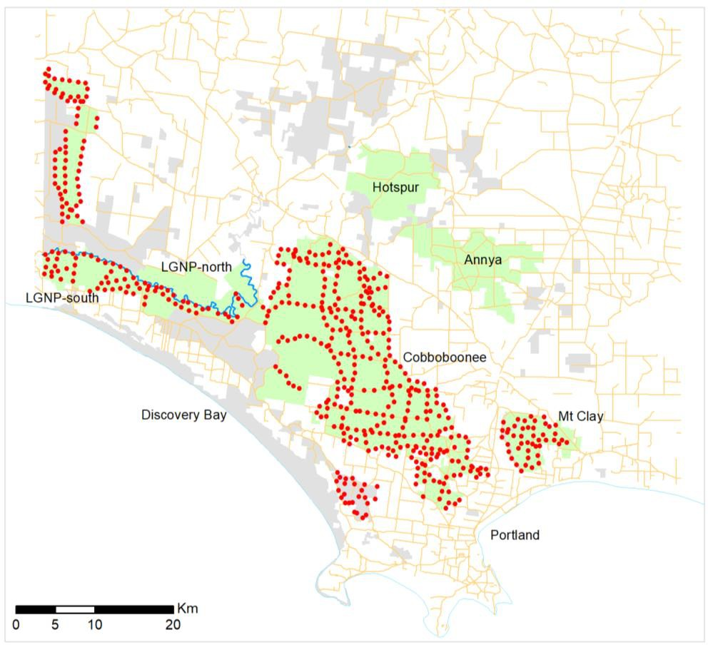

Figure 1. Glenelg Ark operational areas.
Green = Glenelg Ark operational areas; red dots indicate poison bait stations; pale grey = other public land.

Monitoring and evaluation design
Three fox-control monitoring locations (FCMLs) and three no-fox-control monitoring locations (NFCMLs) were used to assess the benefits of fox control to native species (Figure 2). There had been no fox control in the FCMLs and NFCMLs before 2005.
The monitoring locations were:
- Annya State Forest (NFCML; 8520 ha)
- Hotspur State Forest (NFCML; 6940 ha)

- Lower Glenelg National Park – North (LGNP-north; NFCML; 4659 ha) (separated from LGNP-south by the Glenelg River)
- Cobboboonee National Park (FCML; 9750 ha)
- Lower Glenelg National Park – South (LGNP-south; FCML; 8954 ha)
- Mount Clay State Forest (FCML; 4703 ha).

Data collection
Monitoring was first conducted in winter 2005, before the commencement of poison baiting, and then was usually undertaken in spring (2005, 2008–2023). In 2006, sampling for monitoring was conducted in late winter, and the spring 2007 samplings at Mount Clay and Hotspur were delayed until the 2007–2008 summer.
Within each of the six locations, 40 monitoring sites were established (Figure 2). The placement of the monitoring sites was chosen based on descriptions of the habitat preferred by the target native mammal species (Menkhorst 1995) and aligned with Ecological Vegetation Classes (EVCs); the number of sites within an EVC was proportional to the size of the preferred habitat within each FCML and NFCML. The positions of the monitoring sites within locations were randomly assigned but constrained to be within 50 m of tracks.
From 2005 to 2012, at each monitoring site, nine ‘Handiglaze’ hair-collection tubes (Murray 2005) baited with peanut butter, rolled oats, and golden syrup were set and checked daily for four consecutive days, with tapes being replaced each day. These daily tape replacements represented four repeat surveys of the monitoring site per sampling period. Microscopic examination of hairs allows for the identification to species level.
Hair-tubing was discontinued from spring 2013, and a single digital camera (Reconyx RapidFire HC600, Reconyx, LLP Wisconsin, USA) was randomly set at one of four possible points within a hair-tube grid at each monitoring site. Cameras were attached to the nearest tree 20–30 cm above the ground. A lure of truffle oil, peanut butter, rolled oats, and golden syrup was secured to the ground in a small, ventilated container 2 m in front of the camera. Cameras were set to take five images per trigger and operated for a minimum of 30 days, with each day representing a repeat survey of the monitoring site per sampling period.
.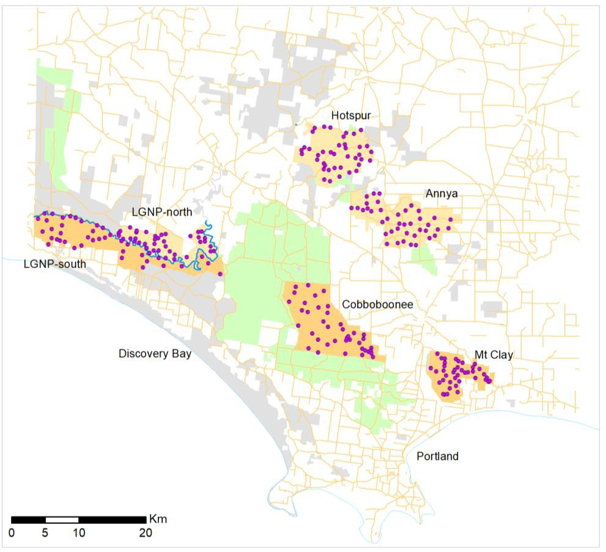

Figure 2. Monitoring sites in the ‘fox-control monitoring locations’ (FCMLs; dark-tan areas) and ‘no-fox-control monitoring locations’ (NFCMLs; pale-tan areas) are indicated by purple dots.
LGNP = Lower Glenelg National Park.

Species occupancy
A multi-season occupancy model (MacKenzie et al. 2017) was utilised to estimate occupancy (ψ), detection (p), local colonisation (γ), and local survival (η) rates for the Common Brushtail Possum, Long-
nosed Potoroo, and Southern Brown Bandicoot. The model was developed in a Bayesian framework using a space-state formulation (Royle and Kéry 2007) and considered six locations, three with fox control (Cobboboonee National Park, Mount Clay State Forest, and Lower Glenelg National Park – South) and three without (Annya State Forest, Hotspur State Forest, and Lower Glenelg National Park – North) with all six locations considered fixed effects in the model.
The models included several site-level covariates affecting the local survival and colonisation rates (Table 1). The model comparisons and analyses were performed using Bayesian methods to determine the impact of these covariates on the occupancy dynamics of the target species.
If there was evidence that the covariate was important (i.e. the 95% high-density interval or 95% confidence interval excluded 0), then that covariate was included in a combined model for that rate. Only the final combined model has been reported (see Table A2 for definitions of model parameters).

Table 1. Description of the site-level covariates used in the multi-season occupancy models.

Covariate | Description
Distance to non-native vegetation (DTNV) patches of >30 ha | Distance in metres to the nearest patch (>30 ha) of non-native vegetation,  e.g. pine plantation, open pasture. Invasive predators prefer edges, so the distance to substantial non-native vegetation was considered (DELWP 2019; Geary et al. 2020).
Distance to water (DTW) | The distance to the nearest stream, river or permanent wetland from the camera monitoring station (in metres). Reflects habitat complexity and productivity, influencing shelter and food availability (Beven and Kirby 1979).
Elevation | The elevation above sea level of the camera station. Influences rainfall, moisture, and temperature gradients, affecting resource availability.
Vegetation group | Two categories were used to describe vegetation groups representing habitat – one was the EVD Tall Mixed Forest (Eastern) and the second comprised of a grouping of all other ecological vegetation divisions (‘other EVDs’).
Terrain ruggedness index (TRI) | A measure of the difference in elevation between a centre cell and the eight cells directly surrounding it. The eight elevation differences were squared and averaged. The square root of this average result was a TRI measurement for the centre cell. High ruggedness can limit predator movement and predation rates (Hohnen et al. 2016; McDonald et al. 2017; Stobo-Wilson et al. 2020).
Time-since-fire (TSF) | Time (in years) since the camera site was last recorded as being burnt. Used to account for the time since the last fire, impacting habitat structure and resources (food and shelter).
Topographic wetness index (TWI) | A quantitative measure of the terrain-driven variation in soil moisture. TWI is calculated as log to the base e (specific catchment area/slope) and estimates the relative wetness at a camera site. TWI impacts vegetation and food sources (Beven and Kirkby 1979; Lobert 1990; Riley et al. 1999; Gallant and Austin 2012; Nuske et al. 2017; DELWP 2020).
Treatment | A binary variable that indicates whether or not fox control occurred at a location: 0 = no fox control, 1 = fox control.

The models accounted for variations in daily detection rates depending on whether a hair-tube or camera was used for detection. Additionally, they considered differences in Long-nosed Potoroo and Southern Brown Bandicoot detection based on whether Common Brushtail Possums were detected at the site in a hair-tube. This adjustment was made because hair-tubes could be overwhelmed with Common Brushtail Possum hairs, potentially hindering the collection of hair from other species, and leading to the

underreporting of Long-nosed Potoroos and Southern Brown Bandicoots when Common Brushtail Possums were present.
Odds ratio
The model calculates colonisation and survival equations in the log-odds (logit) scale, which can range from negative to positive infinity. These parameters are transformed into a more interpretable scale when discussing their effects by using the odds ratio (OR). The OR measures the strength of the association between an explanatory variable and an outcome and can range from zero to infinity. It represents the ratio of the odds of an outcome occurring given a particular event to the odds of the outcome not occurring. An OR less than 1 indicates a decrease in the odds of the event occurring, while an OR greater than 1 indicates an increase. An OR of 1 suggests no detectable effect. For instance, if the chance of detecting a bandicoot at a location without fox control is 20%, the odds would be 0.25:1. If the chance at a location with fox control is 60%, the odds would be 1.5:1. Comparing these odds, the OR for detection at a fox-control site would be 6, implying a six-fold increase in the odds of detection compared to a no-fox-control site. Applying this OR to a different area where the detection rate without fox control is 10% (=0.111 odds), we would expect a 40% (=0.666 odds) chance of detection at a fox-control site.
Growth rate
We derived the growth rate from the posterior distributions for the number of occupied sites. The growth rate compares the current occupancy rate with the previous season's rate:

Growth𝑡
𝜓𝑡
=
𝜓𝑡−1

A growth rate greater than 1 indicates increasing occupancy, while a rate less than 1 indicates decreasing occupancy. A rate of 1 shows no change. To assess the impact of fox control on growth rates, we converted the average growth rate to a percentage and calculated the difference between locations with and without fox control. For instance, if the annual growth rates at a fox control location were 110%, 120%, 110%, 90%, 100%, and 110%, the net change would be 144%, with a geometric mean of 106.2%, indicating a 6% annual increase in site occupancy.
The models were constructed in JAGS (Plummer 2003) via R (R Core Team 2022) using the package R2jags (Su and Yajima 2015). Convergence was achieved when the Gelman-Rubin convergence diagnostic (scale reduction factor) was less than 1.05 for all parameters (Gelman et al. 2004). Model selection involved running models with each variable separately and including a variable in the final model if its 95% confidence interval excluded 0, indicating its importance.

Fox and feral cat activity
From 2013 to 2023, we used presence and absence data from 40 camera traps in three fox-controlled (FCMLs) and three non-fox-controlled monitoring locations (NFCMLs) to calculate an activity index for foxes and feral cats.
The annual activity index was scaled to a per 1500 camera nights basis and analysed using a negative binomial regression within a Bayesian framework (McCarthy, 2007; Hilbe, 2011). Five models were developed to explore differences between locations and temporal changes.
- Null Model: Assumes the activity index is constant across all locations and years.
- Location Model: Assumes the activity index varies by location but is constant over years.
- Independent Location and Year Model: Assumes the activity index varies independently across locations and years.
- Interacting Location and Year Model: Assumes the activity index varies by year for each location separately.
- Location and Year Model: Assumes that there is no interaction between years and fox-control status, with the activity index varying independently across locations and years.
Model comparison was done using leave-one-out cross-validation, with significance determined by 95% credible intervals excluding zero. Bayesian models were constructed in STAN using (Carpenter et al. 2017) the brms package (Bürkner 2017) in R (R Core Team, 2021), with non-informative priors and No-U-Turn sampling. Convergence was confirmed visually and with the Gelman-Rubin diagnostic (Gelman et al. 2004), ensuring model adequacy through residual plots and posterior predictive checks.

Results

Initial occupancy, survival, colonisation, and growth rates
Several environmental variables were included in the final model for the three target native mammal species. There was no single or set of common environmental variables that consistently explained relationships with the odds of a site being occupied, surviving, or being colonised for any of the three species. The presence of fox control at locations was positively associated with the odds a site was both colonised and endured for Long-nosed Potoroos and Southern Brown Bandicoots, and in combination with other variables for Common Brush-tailed Possums.

Common Brushtail Possum

Occupancy
None of the modelled covariates were important for determining initial occupancy, i.e., occupancy in 2005 pre-baiting (Table A3-A).
The number of occupied sites increased steadily from 2005–2009 across all locations, before decreasing from 2009–2011 across all locations, and then increasing and remaining steady from 2018 to 2020, with another drop in 2021 and signs of recovery since then. However, there was clear separation between FCMLs and NFCMLs from 2015, with the occupancy rate of Common Brush-tailed Possums being higher at sites in FCMLs (Figure 3).
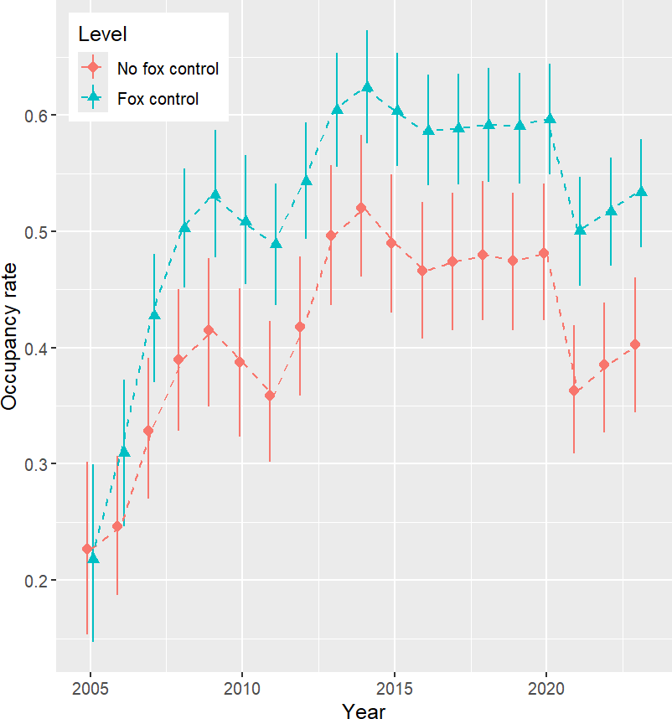

Figure 3. Occupancy rates for the Common Brushtail Possum over time by fox control status.
The symbols indicate the median fitted values, and the bars represent the 95% credible intervals.

Site survival
Survival declined with distance to non-native vegetation in NFCLMs but tended to increase with increasing distance-to-non-native-veg in FCLMs, while survival increased with increasing TRI in fox control areas but

not in NFCLMs. Site survival declined with increases in elevation regardless of treatment (Table A3-B; Figure 4).
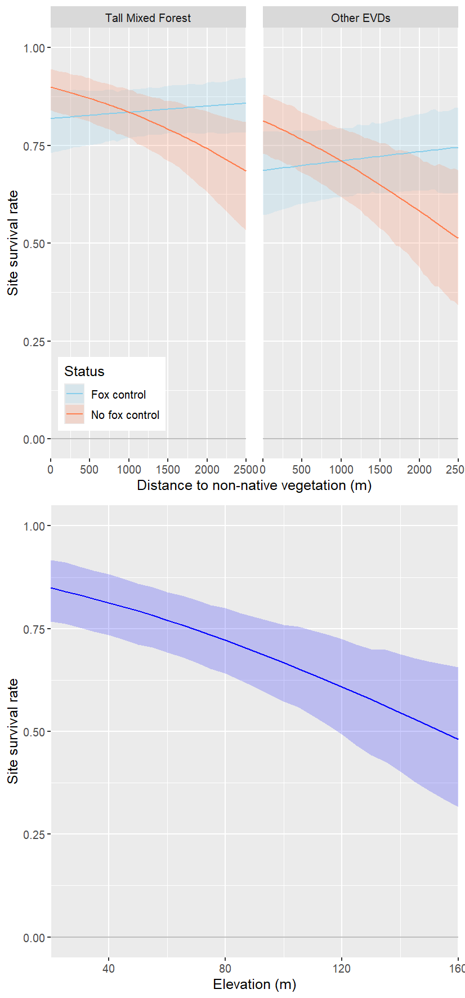
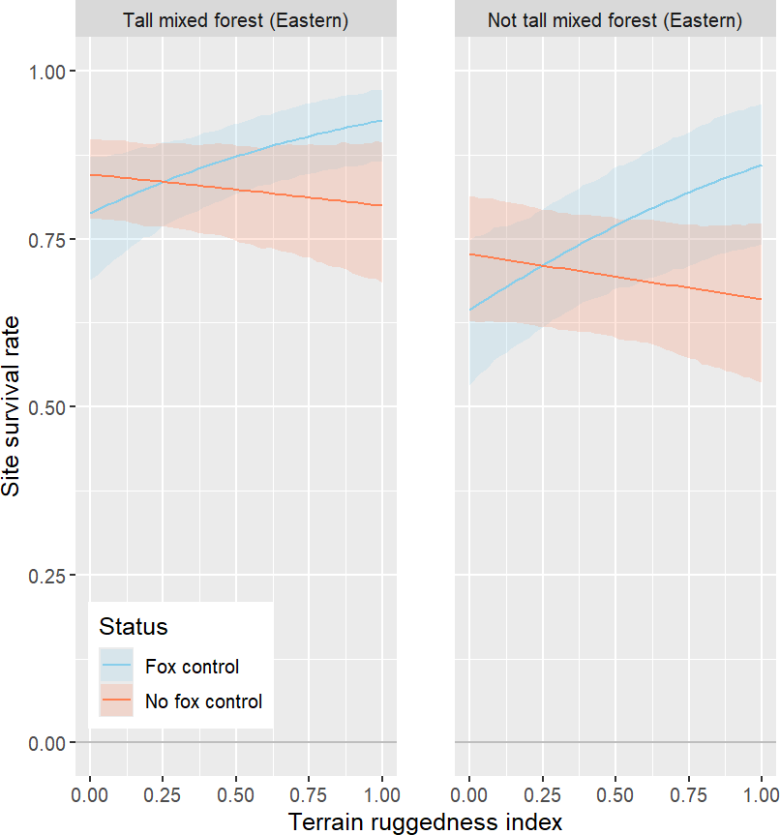

Figure 4. Estimated site survival rates for the Common Brushtail Possum in relation to distance to non-native vegetation, terrain ruggedness, ecological vegetation division, and elevation given all other covariates were held at their mean values.
The lines indicate the median fitted values, and the shaded area represent the 95% credible intervals.

Site colonisation
In FCMLs, the odds of an unoccupied site becoming occupied was 3.33 (95% credible interval (CI): 1.76–
6.73) higher in Tall Mixed Forest than in ‘other EVDs’. In the absence of fox control, there was no detectable difference in colonisation between EVD classifications.

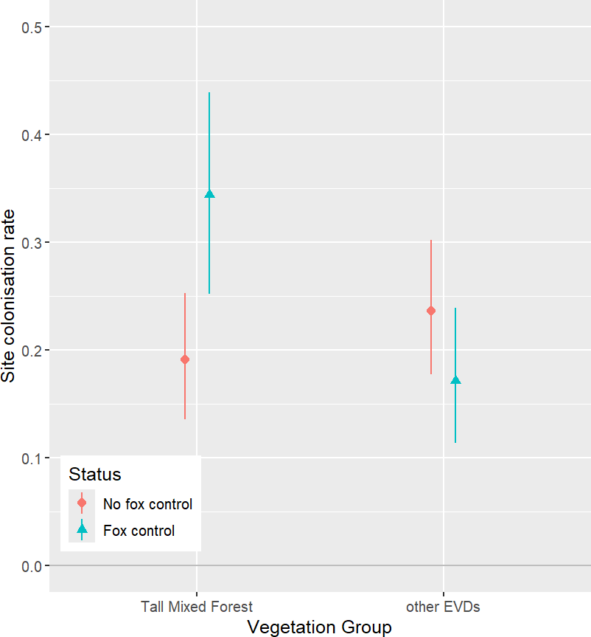

Figure 5. Estimated site colonisation rates for the Common Brushtail Possum in relation to ecological vegetation division, given all other covariates were held at their mean values.
The symbols indicate the median fitted values, and the bars represent the 95% credible intervals.

Growth rates
The annual average growth rate of Common Brushtail Possum occupancy in NFCMLs was 101% (95% CI: 100–103%), while in FCMLs the growth rate was 101% (95% CI: 100–107%). There was no difference in average annual growth rate (0%, 95% CI: -1–1%) at sites in FCMLs compared to at sites in NFCMLs.

Long-nosed Potoroo

Occupancy
None of the modelled covariates were important for determining initial occupancy (Table A4-A).
The number of occupied sites has remained steady in both FCMLs and NFCMLs over time. There is strong evidence that the average occupancy rate for Long-nosed Potoroo in FCMLs was greater than in NFCMLs and has been so since 2008 (Figure 6).

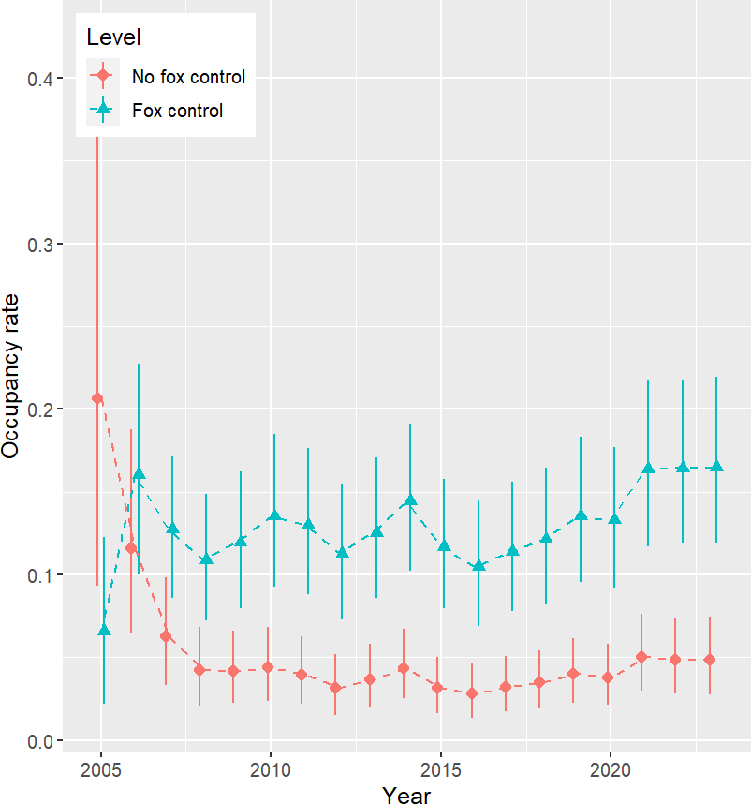

Figure 6. Occupancy rates for the Long-nosed Potoroo over time by fox control status and the difference in that occupancy.
The symbols indicate the median fitted values, and the bars represent the 95% credible intervals.

Site survival
Site survival decreased with distance to water in NFCMLs but was constant with increasing distance to water FCMLs (Table A4-B; Figure 7).
At the average distance to water, the odds of an occupied site remaining occupied was larger by a factor of
2.9 (95% credible interval 1.0–8.6) in FCMLs than in NFCMLs.
Site survival rates increased with increasing TWI regardless of the presence of fox control (Figure 7).

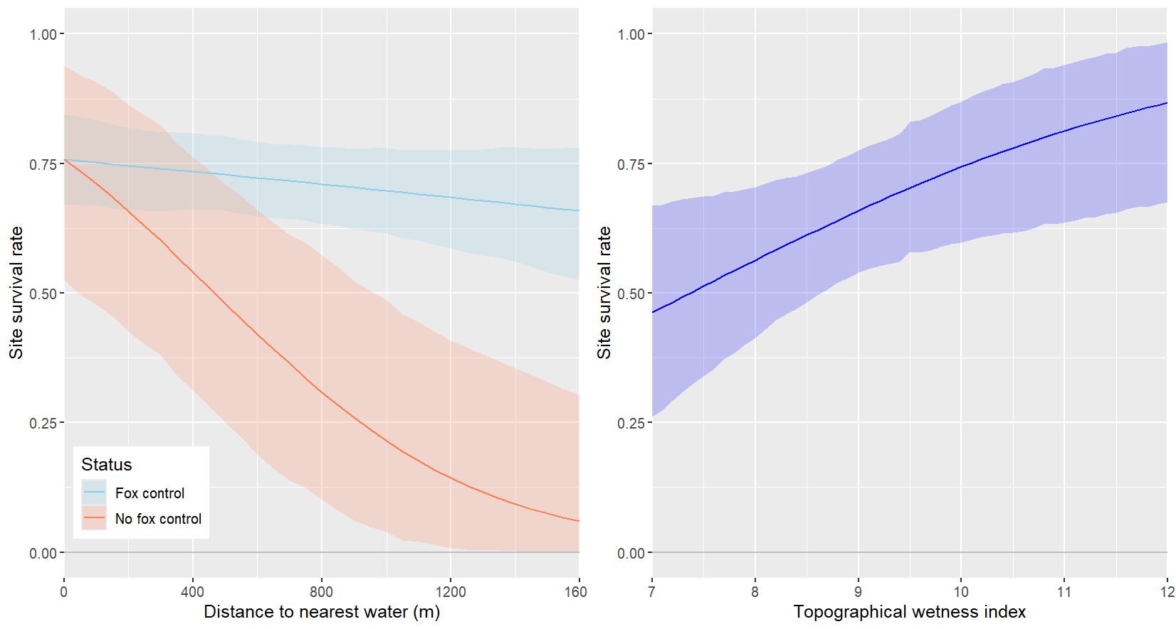

Figure 7. Estimated site survival rates for the Long-nosed Potoroo in relation to distance to nearest water, by fox-control status, and topographical wetness index, given all other covariates were held at their mean values.
The lines indicate the median fitted values, and the shaded areas represent the 95% credible intervals.

Colonisation
At sites in FCMLs, the odds of an unoccupied site becoming occupied was larger by a factor of 25 (95% CI: 11–62) than at an equivalent site in NFCMLs.
In FCLMs, site colonisation was higher in other EVDs than in Tall Mixed Forest and increased with increasing elevation. Colonisation rates were consistently low and did not differ between vegetation types or vary with elevation in NFCLMs (Table A4-C; Figure 8).
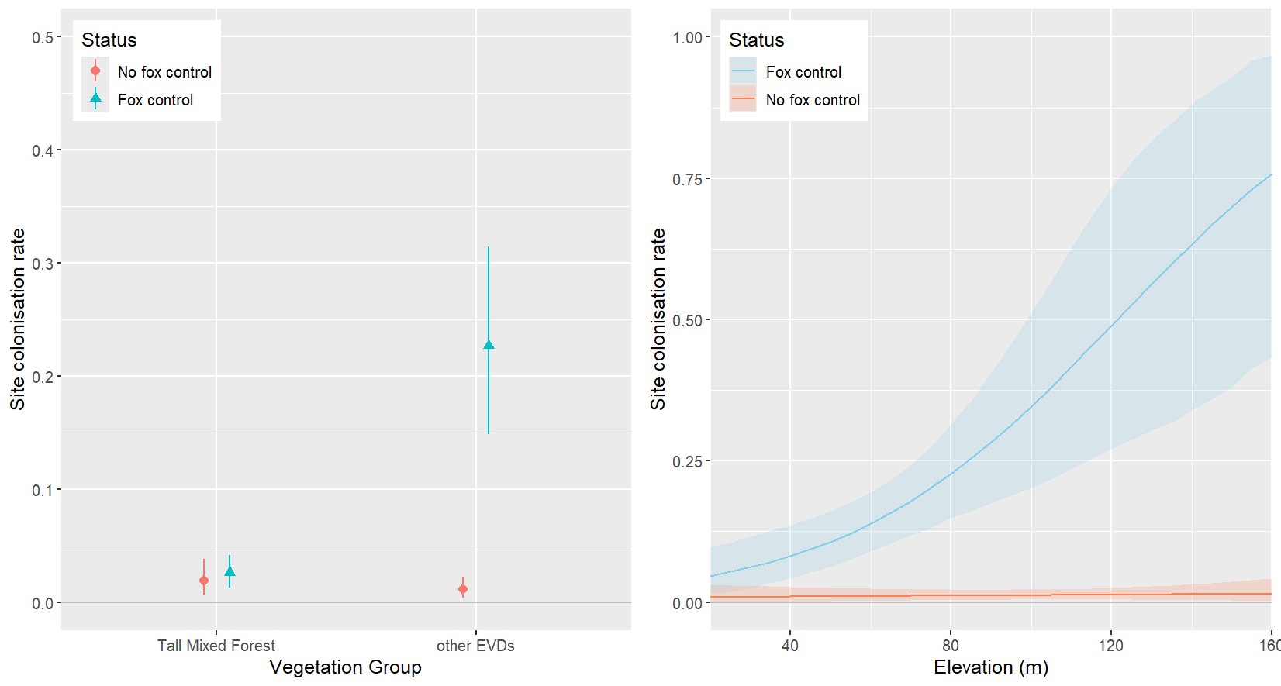
Figure 8. Estimated site colonisation rates for the Long-nosed Potoroos in relation to vegetation group and elevation, by fox-control status, given all other covariates were held at their mean values. The lines (blue – fox control, red – no fox control) indicate the median fitted values, and the shaded areas represent the 95% credible intervals.

Growth rate
Growth rates in both FCMLS and NFCMLs have remained around zero (no relative change in population). However, the growth rate at FCMLs has been consistently greater than in NFCMLs. The annual average growth rate in NFCMLs was 99% (95% CI: 95–102%), while the growth rate in FCMLs was 102% (95% CI: 99–104%), with the difference being a net annual average increase of +3.1% (95% CI: 0.00–6.5%).

Southern Brown Bandicoot

Occupancy
The only covariate that influenced initial occupancy rates was elevation in FCMLs (Table A5-A). At sites with greater elevation, the initial occupancy rate was higher in NFCMLs and lower in FCMLs.
Overall occupancy rate (considering all important covariates) has been consistently higher in FCMLs than in NFCMLs since 2006. It has also been relatively consistent through time, with indications of two years of increases in 2022 and 2023 across both FCMLs and NFCMLs (Figure 9).
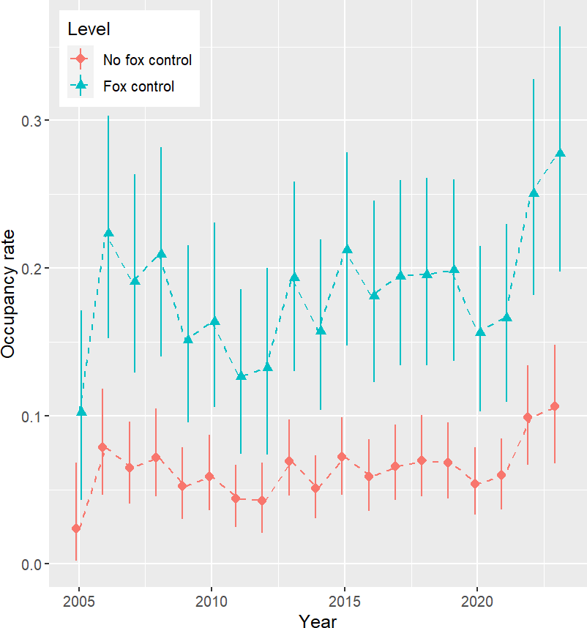

Figure 9. Occupancy rates for the Southern Brown Bandicoot over time by fox control status.
The line is the median occupancy rate, and the vertical bars represent the 95% high density interval.

Site survival
The probability that a site survived declined with increasing time-since-fire in both FCMLs and NFCMLs (Table A5-B; Figure 10).
At sites further away from water in FCMLs, the probability a site survived tended to decline. At sites in NFCMLs, the opposite occurred, with the probability of site survival increasing further form water.
At sites in FCMLs, sites with higher elevation were associated with higher local survival, whereas the opposite occurred at sites in NFCMLs.

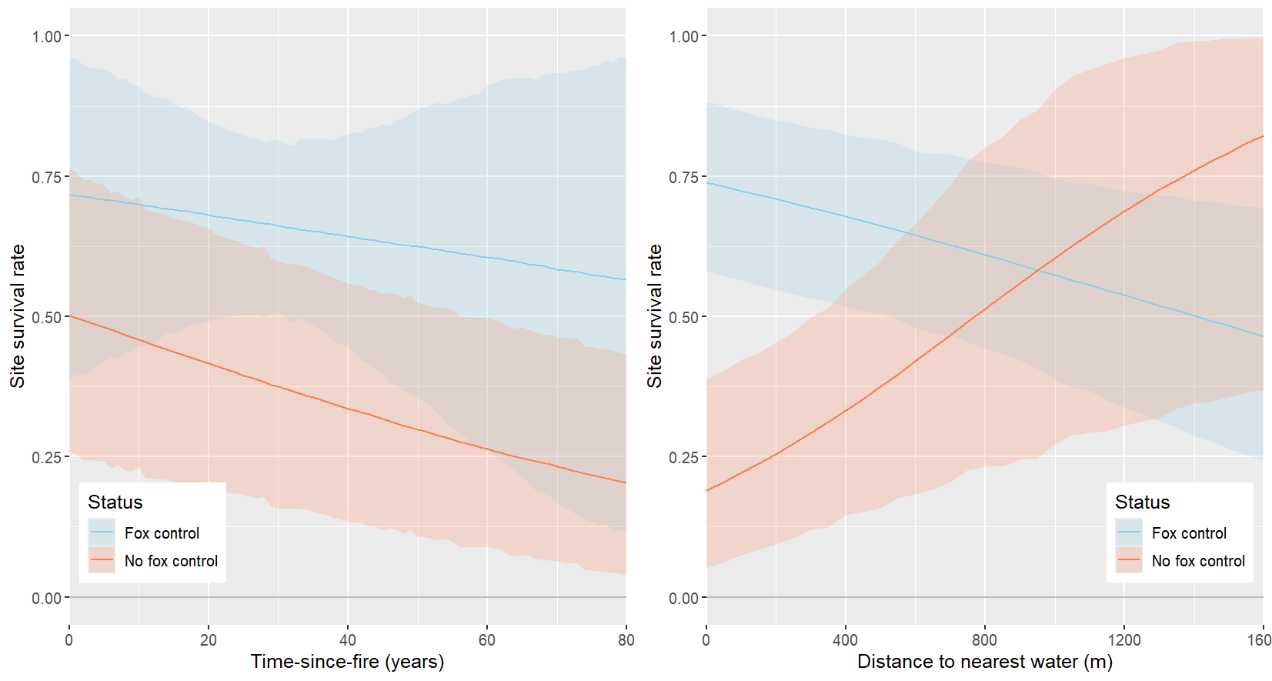
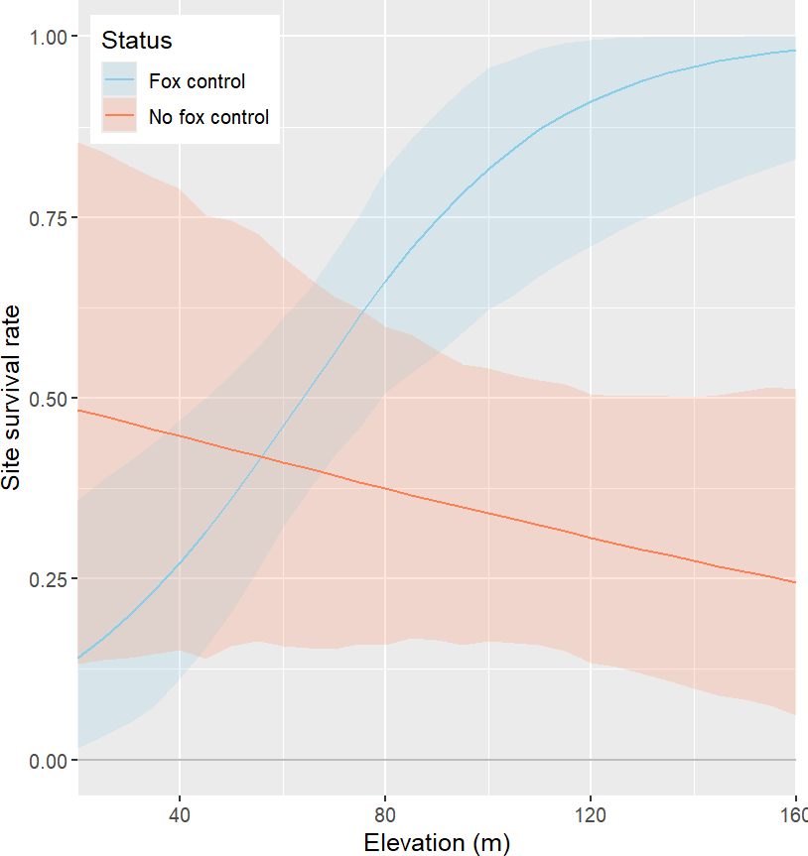

Figure 10. Site survival rate for the Southern Brown Bandicoot across different times-since-fire, distances to nearest water and elevations separated by fox control status, given all other covariates were average.
The line is the median fitted value and the shaded areas represent the 95% high density interval.

Site colonisation
The odds of an unoccupied site becoming occupied were consistently larger in FCMLs than in NFCMLs, by a factor of 3.2 (95% CI: 2.0–5.3). Colonisation increased with distance to non-native vegetation and decreased with time-since-fire in both FCMLs and NFCMLs (Table A5-C; Figure 11).

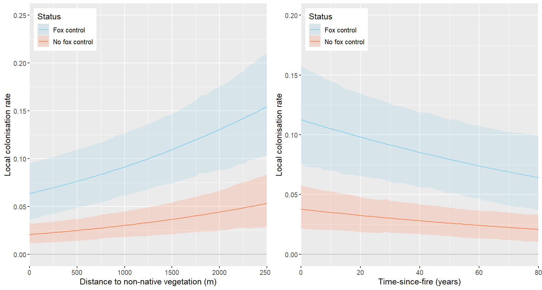

Figure 11. Estimated local colonisation rate for the Southern Brown Bandicoot related to distance to non-native vegetation and time since last fire, separated by fox control status.
The line is the median fitted value and the shaded areas represent the 95% high density interval.

Growth rate
Growth rates in both FCMLs and NFCMLs remained around zero (i.e. there were no relative changes in population) except for in 2022, when they were clearly positive at all locations. However, the reduced growth rate in 2023 could have just been an artifact of the model. The proportion of sites that were estimated to be occupied in 2023 may change once the 2024 data is included. For example, consider the case where a site was occupied in 2022, but Southern Brown Bandicoots were not detected in 2023, then there would be a fraction of the posterior distribution for that site that would be unoccupied. Then, if in 2024 that site detected Southern Brown Bandicoots, the fraction of the posterior distribution for that site that was unoccupied would decrease, because it may be more likely that it was occupied from 2022 to 2024 and not detected in 2023 rather than going from occupied to unoccupied to occupied over the same period.
There was no real difference in average growth rate between fox control treatments (0.8%, 95% CI: -0.4-0.2%), with the annual growth rate in NFCMLs being 103% (95% CI: 100–106%) and the annual growth rate in FCMLs being 102% (95% CI: 100–105%). This effectively indicates that there has been a slight increase in the population growth rate of Southern Brown Bandicoots from 2005 to 2023 in both FCMLs and NFCMLs.

Predator activity

Fox activity
Over the 11 years of camera trapping, foxes were never detected at 7.5% to 17.5% of sites within the FCMLs (Table 2). However, foxes were detected at least once in nearly all sites inside the NFCMLs. It should be noted that in 2023, foxes were detected for the first time at eight camera sites in FCMLs, including by five cameras (12.5% of cameras) at Mt Clay. The overall fox index in NFCMLs was greater than in FCMLs.

Table 2. Summary of fox detections across all years by location.

Treatment | Location | No foxes detected (% of sites) | Total fox detections | Fox activity index
Fox control | Cobboboonee | 7.5 | 232 | 22.5
Fox control | Mount Clay | 10.0 | 196 | 19.1
Fox control | LGNP-south | 17.5 | 154 | 14.2
No fox control | Annya | 2.5 | 1,143 | 109.0
No fox control | Hotspur | 0.0 | 957 | 85.8
No fox control | LGNP-north | 0.0 | 882 | 88.7
LGNP-north: Lower Glenelg National Park – North; LGNP-south: Lower Glenelg National Park – South.
The fox models showed a preference for the treatment interacting with time model (Table A6). That model showed there was a difference between the locations, with fox activity higher but declining in NFCLs, while remaining consistently low in FCMLs (Figure 12 and Table A6).
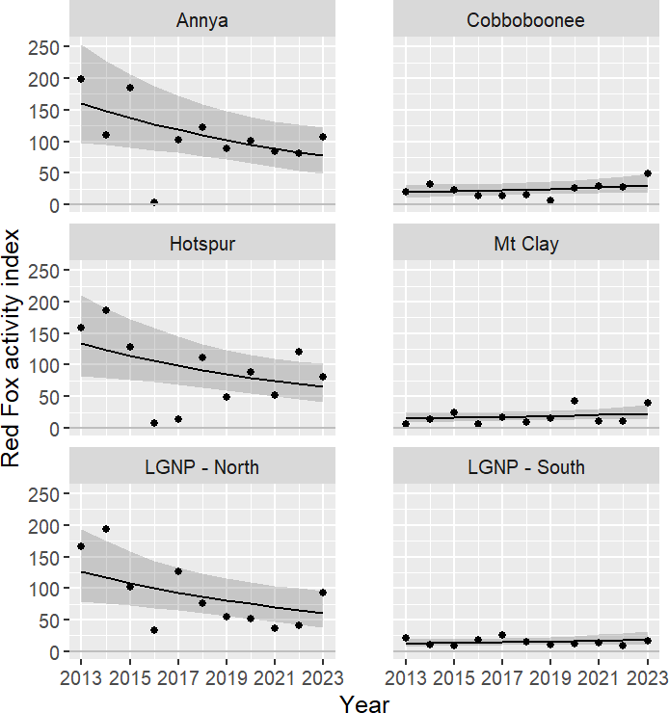

Figure 12. The modelled fox activity index in each FCML and NFCML over time.
The dots indicate the observed fox activity indices, the lines represent the model medians, and the shaded regions represent the 95% credible intervals. The left-hand panels show data for NFCMLs, and the right-hand panels show data for FCMLs.

On average, the fox activity index in NFCMLs declined by 7% per annum (95% CI: 1–12%). In comparison, there was no evidence of a change in FCMLs over time (increase of 4% per annum, with 95% CI: -2–12%). However, given the fox activity index was initially (in 2013) 9.5 times larger (95% CI: 5.5–15.6) in NFCMLs than in FCMLs, they were still 3.0 times larger (95% CI: 1.7–5.0) in 2023.

Feral cat activity
Over the 11 years of camera trapping, feral cats were never detected at less than 25% of sites outside of LGNP North and South. Rather, they were detected at least once at 97.5% (39 out of 40) of sites in the LGNP-North and 87.5% (35 out of 40) of sites in the LGNP-South (Table 3). In 2023, six camera sites – two camera sites each at Annya, Mt Clay and LNGP-South – detected feral cats for the first time. The overall feral cat index varied greatly between locations.
The feral cat models showed a preference for the independent location and year model; however, there was also some support for the location only model (Table A7). The best model showed that there was a difference between the locations and that feral cat activity declined at locations over time until 2021, before increasing again (Figure 13).

Table 3. Summary of feral cat detections across all years by location.

Treatment | Location | No feral cats detected  (% of sites) | Total feral cat detections | Feral cat activity index
Fox control | Cobboboonee | 27.5 | 96 | 8.6
Fox control | Mount Clay | 55.0 | 53 | 4.7
Fox control | LGNP-south | 12.5 | 169 | 14.5
No fox control | Annya | 47.5 | 55 | 4.8
No fox control | Hotspur | 32.5 | 90 | 7.5
No fox control | LGNP-north | 2.5 | 199 | 18.5
LGNP-north: Lower Glenelg National Park – North; LGNP-south: Lower Glenelg National Park – South.
There were differences in the feral cat activity index across locations (Figure 13), but these differences did not relate to treatment. The feral cat activity index was similar in the average FCMLs and NFCMLs, with the former being 9% larger (95% CI: -20–47%).

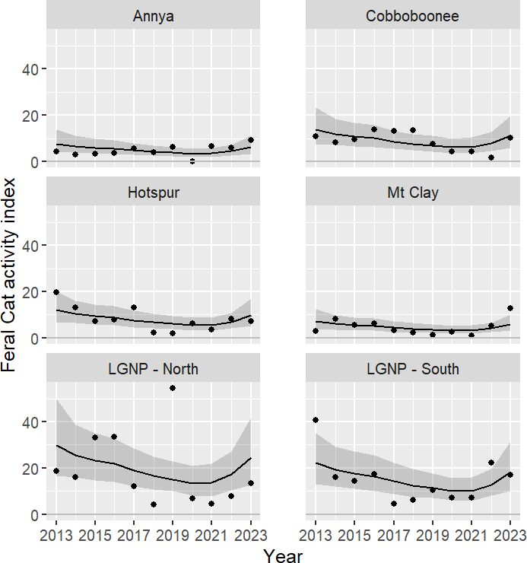

Figure 13. The modelled feral cat activity index at each location over time.
The dots indicate the observed feral cat activity indices, the lines represent the model medians, and the shaded regions represent the 95% credible intervals.

Other species’ naïve occupancy
Forty native and introduced species (not including the three native target species, foxes or feral cats) were detected on cameras from 2013 to 2023, including four introduced mammal, 6 marsupial, 1 monotreme, 1 rodent, 1 reptile, and 23 bird species (Figure A1). Several other species were also detected intermittently during this time; however, we only presented data for species that were detected for at least 6 of the 11 years of camera trapping. The mean naïve occupancy (percentage of sites at which a species was detected) was higher at fox-control sites for Short-beaked Echidna (Tachyglossus aculeatus) (Figure A1). The mean naïve occupancy was higher at sites in NFCMLs than at sites in FCMLs for Koalas (Phascolarctos cinereus). In comparison, the mean naïve occupancy percentages for all other species were highly variable over time and did not clearly differ between FCMLs and NFCMLs.

Discussion

All three target species had higher rates of occupancy across locations subject to 19 years of fox control compared to locations without fox control. Growth rates of occupied sites across all locations were stable over the longer-term, with short term fluctuations likely driven by responses to factors other than predation pressure from foxes. Fox activity was substantially lower where there was long term control in place.
The Glenelg Ark monitoring program employs an occupancy modelling approach to explore the dynamics influencing changes in site occupancy for three native species. Changes in site occupancy can mirror changes in abundance, with site colonisation and persistence likely to reflect birth and survival rates when surveys are conducted over a short period (MacKenzie et al. 2017). By evaluating these rates alongside the factors affecting them, we can gain insights into how reduced predation risk might impact habitat use by the target species.
We made three predictions about the response of the target species to fox control at Glenelg Ark. The first two were:
- higher colonisation rates associated with fox control, suggesting that reduced predation pressure allows populations to colonise new sites
- higher survival rates associated with fox control, suggesting that reduced predation pressure allows populations to persist.
These predictions held true for the survival and colonisation rates of Long-nosed Potoroos and the colonisation rates of Southern Brown Bandicoots, with these rates being significantly positively influenced by fox control. Common Brush-tailed Possums tended to use aspects of habitat differently in the presence of fox control. All three species exhibited distinct responses to various biotic and abiotic factors, indicating that reduced predation pressure enables these species to overcome limitations and expand their occupied habitats.
Possum survival and colonisation rates were higher and tended to increase in Tall Mixed Forest with fox control compared to in other EVDs with fox control and as TRI increased. This likely indicates a habitat preference for Tall Mixed Forest, which is more likely to provide shelter (hollows, nesting sites and better food quality; eucalypt leaves account for 72% of the diet of possums in New South Wales [Kerle 1984]). Our findings support those of Pickett et al. (2005) who investigated the influence of predation risk on the foraging behaviour of brushtail possums across a range of fox densities in eucalypt forest and cypress-pine stands. They found no effect of fox removal on behaviour, body condition or reproduction in eucalypt-dominated forests. By contrast, in cypress-pine (more open habitat, poorer food quality), possums travelled further on the ground, used a greater number of feeders, and had remained at feeders longer in low-fox-density areas than in high-fox-density areas.
In areas without fox control, possum survival rates declined as the distance to non-native vegetation and TRI increased, irrespective of the EVD group – with no difference in colonisation rates between EVD types without fox control. It is possible that foxes prefer Tall Mixed Forest, close to non-native vegetation in low TRI areas. Modelling fox occurrence in relation to environmental variables could clarify the effects of distance and EVD in locations without fox control.
Fox control generally resulted in higher survival rates for Southern Brown Bandicoots. While survival and colonisation rates typically declined with increasing time-since-fire, they tended to be higher in areas with fox control. The negative relationship between time-since-fire and colonisation for bandicoots appears counterintuitive. As vegetation recovers post-wildfire, habitat complexity increases, shifting from low complexity immediately post-fire to a more structurally complex forest in later years (Coop et al. 2000), which should provide protection against fox predation. Arthur et al. (2012) observed that bandicoots (Isoodon obesulus and Perameles nasuta combined) presence initially increased with rising shrub cover post-fire (up to 25 years), but then declined more rapidly than expected, likely due to interactions with feral cats rather than foxes. This relationship with fire is consistent with our findings, where bandicoot colonisation probability was high initially before declining over time, and while the model outcome did not include fox control as a substantial influence, colonisation rates were generally higher in areas with fox control.
Distance to water and distance from non-native vegetation influence bandicoot survival and colonisation. Research indicates that foxes preferentially utilise ecotones or edges, selecting human-modified habitats such as reservoirs, forest edges, and roads (Hradsky et al. 2017). These areas are both productive and offer ample hunting opportunities (Storch et al. 2005). The tendency of bandicoots to colonise new sites away

from open non-native vegetation, such as farm paddocks and pine plantations, suggests an avoidance of areas with higher predation risk.
Potoroos exhibited significantly higher colonisation rates in vegetation communities outside of Tall Mixed Forest under fox control, while colonisation rates were very low and showed no variation between EVD groupings at sites without fox control. This pattern likely reflects a habitat preference for areas outside Tall Mixed Forest and suggests that foxes may limit colonisation within this EVD. According to Bennett (1993), Long-nosed Potoroos are associated with dense ground and shrub vegetation across their geographic range. However, Bennett's study also found that potoroos were present in areas with varied vegetation compositions and densities and were not strongly tied to a specific vegetation type or structural feature. This mosaic of dense and open habitats provided both shelter from predators and abundant food resources in more open areas (Bennett 1993). To better understand the local drivers affecting both potoroos and bandicoots, the collection of detailed site-specific habitat variables from each camera site is recommended.
The relationship between elevation, potoroo and bandicoot parameters remains unclear. Landscape position has been shown to influence the presence of both foxes and Long-footed Potoroos (Lumsden et al. 2012). Lumsden et al. (2012) found that foxes were more likely to occur at sites with either high or low elevation and easterly aspects, but less likely on steep, mid-slope habitats. Conversely, Long-footed Potoroos were somewhat more likely to occur at sites with intermediate elevations, higher stream density, and easterly aspects. The elevation range at our sites was relatively small (sea level to 160 m). Elevation was included as a proxy for soil moisture and temperature gradients, which affect resource availability. However, this may be a poor proxy in our study, and a more informative variable could provide deeper insights. We recommend using the fraction of absorbed photosynthetically active radiation (FAPAR; Qin et al. 2018), which characterises the energy absorption capacity of vegetation canopies and is crucial for estimating the net primary production of terrestrial ecosystems. This variable could help interpret patterns in site occupancy, such as the peaks and troughs observed in Southern Brown Bandicoots, which roughly coincided with significant rainfall events in 2010-2011 and 2020.
The third prediction we made about the target species response was that there would be greater overall growth rates at sites with fox control than at those without fox control.This prediction held true only for potoroos, and even then, to a limited and variable extent. After 19 years of fox control, the growth of occupied sites has stabilised across locations with fox control and remains lower but constant in locations without fox control, resulting in minimal differences between the two. This may indicate that fox abundance has not been sufficiently reduced to eliminate growth limitations, or that other factors, or a combination of factors, such as the availability of suitable habitat, are restricting growth.
In 2005 (pre-fox control), the occurrence of all three species overlapped across all locations, with each species exhibiting distinct responses. Common Brush-tailed Possum occurrence increased at a similar rate across both treated and untreated locations, but with higher rates at treated sites. Long-nosed Potoroo occurrence decreased at untreated sites while initially increasing at treated sites before stabilising. Southern Brown Bandicoot occurrence initially increased at all locations, with higher rates at treated sites, before also stabilising. This suggests that while occurrence is higher at locations with fox control, the populations are now responding to drivers other than reduced fox densities.
An exception to this was the uplift in Southern Brown Bandicoot occupancy from 2021 to 2023. This increase occurred across all locations except LGNPN and was generally more pronounced at locations with fox control. The observation that occupancy and overall growth increased in 2022 but not in 2023 is likely an artifact of the modelling process. Sites occupied in 2022 where bandicoots were undetected in 2023 may have been reoccupied in 2024, leading the model to predict these sites as occupied in 2023, and therefore increasing the predicted number of occupied sites for that year.
Variable selection
The static variables incorporated into our model offer valuable insights into the habitat characteristics influencing species presence. For instance, Tall Mixed Forest appears crucial for possums and potoroos, particularly in tandem with fox control, while proximity to water bodies emerges as significant for bandicoots and potoroos, again in areas with fox control. Selecting the most informative predictors for modelling species response presents a challenge. Ideally, factors directly impacting population growth, survival, distribution, or relevant biotic and abiotic processes should be prioritised (Phillips et al. 2006). While our analysis considered these criteria, future refinement may involve reviewing and potentially adding or removing variables to elucidate any disparities in habitat use between locations with and without fox control.
Time-varying variables, such as time-since-fire, provide insight into temporal changes in species occurrence. Increasing time-since-fire, for instance, emerged as significant for Southern Brown Bandicoots, but not for other species. Another potentially informative variable could reflect changes in productivity. Terrain Wetness Index (TWI), serving as a proxy for soil moisture and vegetation productivity (Kopecky and Cizkova 2010), and Terrain Ruggedness, representing microhabitat diversity (Dilts et al. 2023), offer broad representations

of underlying conditions. However, TWI was found to be only significant for potoroo colonisation. Another promising variable is FAPAR, as previously discussed.
Native species
Twenty-seven native species other than the target species have been detected by camera traps since 2013. Among these, the Short-beaked Echidna has been detected more frequently at locations with fox control, suggesting that either this species has responded positively to the reduction in foxes, or that it was always more common at these locations. This is something that is worth further investigation, and we propose to include the Short-beaked Echidna in next year’s analysis. While no other native species has been detected more often across the fox-control locations, this does not necessarily mean they have not benefited from the reduction in foxes.
Foxes and feral cats
The weight of the available evidence indicates that foxes are at lower levels across locations with fox control than at locations without fox control (this report, Rees et al. 2023). Determining the threshold fox density below which prey species populations are no longer limited by predation, remains challenging. For example, FoxNet modelling was incorporated into occupancy models to investigate the impact of the 2019–2020 bushfires in Gippsland (Robley et al. 2022). This work showed that fox density significantly affected the occurrence of Long-footed Potoroo (Potorous longipes), the probability of which was zero at a site when fox density was higher than 0.5/km2. Habitat structure and diversity also influence species survival, highlighting the complexity of predator-prey dynamics.
The fox activity results indicate a slow decline in fox activity at untreated sites, possibly due to long-term control efforts. This is possible because the Annya, Hotspur and LGNPN (no fox control) locations are within probable movement and dispersal distances for foxes (Robley et al. 2016) to the Cobboboonee and Mt Clay (fox control) locations. This trend could be further explored using spatially explicit population models, such as FoxNet (Hradsky et al. 2019).
Predator interactions and the availability of habitat refugia play significant roles in prey mortality rates through interference, competition, or cooperative predation (Stallings and Dingeldein 2012). Furthermore, habitat modifications, such as planned burning, can escalate predator activity (McGregor et al. 2017), posing challenges for management strategies. Feral cats, known for their substantial impact on native wildlife, exhibit heightened densities in areas subject to fox control (Rees et al. 2019), although the relationship is multifaceted. Nevertheless, there is little uncertainty regarding the deleterious effects of feral cats on native fauna within the Glenelg Ark operations area.
Emerging tools like Curiosity® feral cat bait offer promising avenues for landscape-scale feral cat management. Integrated predator control has demonstrated positive outcomes for native species elsewhere. For instance, Comer et al. (2020) documented favorable responses from both the Western Ground Parrot (Pezoporus flaviventris) and the Chuditch (Dasyurus geoffroii) following five years of integrated fox and feral cat control at a coastal south-western Australian site.
General summary
The findings of the Glenelg Ark program underscore the beneficial impacts of fox reduction on species such as Southern Brown Bandicoots and Long-nosed Potoroos. The results also provide evidence for the potential of habitat quality to interact with the outcome of the fox control effort. Changes to ground vegetation and tree species composition resulting from wildfire or planned burning (Rees et al. 2023a) or the presence of feral cats (Rees et al. 2023b) are factors that most likely influence the degree of fox impact on native species, and the success of fox control in benefiting biodiversity.
We advocate for the initiation of landscape-scale feral cat control planning, slated to commence in the financial year 2025–2026. Robley et al. (2019) offer a potential framework for the implementation of feral cat control. This approach not only contributes to the ongoing long-term monitoring dataset, but also facilitates the integration of feral cat control measures.
The primary objective of the Glenelg Ark project is to mitigate the threat of fox predation on native species, thereby safeguarding or enhancing biodiversity. This project stands out as one of the few long-term
(19 years) fox control initiatives in Australia that incorporates ongoing monitoring and encompasses areas both actively managed for foxes and those left untreated. This unique approach provides an unparalleled opportunity to investigate the enduring shifts in prey and predator dynamics and the underlying drivers of these changes. Such comprehensive monitoring programs are vital for yielding ecological insights and are indispensable for advancing the management of ecosystems and natural resources (Lindenmayer et al.
2009).
There are only a handful of extensively documented instances where fox control has resulted in the increased abundance of native species, particularly within open systems (Reddiex and Forsyth 2006). Most

of the success stories originate from fenced areas where foxes (and feral cats) have been eradicated from within enclosures (de Torres and Marlow 2012; Dickman 2012), or from insular habitats such as islands (Jones et al. 2016). Notably, in a review of pest control operations in Australia, only 2.5% of 627 fox control initiatives involved treatment and non-treatment areas and monitored both prey and predator responses, with the Glenelg Ark project being among this small fraction (Reddiex and Forsyth 2006).
The program's adaptive management framework, characterised by its flexibility, enables ongoing research and strategic planning to tackle knowledge gaps and unintended consequences. Further studies, especially regarding the impact of feral cat management and the response of species like the endangered Heath Mouse (Pseudomys shortridgei), listed as Endangered in Victoria (DELWP 2022) and Vulnerable under the Environment Protection and Biodiversity Conservation Act 1999 (Cwlth), hold promise for informing future management strategies and funding priorities.

Recommendations
Here we provide some recommendations on possible next steps in the monitoring program.
- Continue the current monitoring to improve the estimates and model predictions to better inform management.
- Review the variables used in the modelling and update with both site-specific data and more representative remotely sensed variables, e.g., FAPAR as a more informative measure of changes in productivity.
- Improve our assessment of fox and feral cat densities across all sites, through (i) data derived from genetic material collected from scats, and/or (ii) the use of distance-sampling using data collected from camera traps.
- Model fox occurrence in relation to environmental variables to determine whether fox’s habitat preferences interact with prey species responses.
- Commence planning for the integration of feral cat control. A possible design for the rollout of feral cat control is provided in Robley et al. (2019). This approach would continue to add to the current long-term monitoring dataset but allow for the integration of feral cat control.
- Look for opportunities to assess the response in small mammals to fox control, in particular the Heath Mouse.
- Include Short-beaked Echidna response in the 2024 data analysis.

References

Arthur, A.D., Catling, P.C. and Reid, A. (2012). Relative influence of habitat structure, species interactions and rainfall on the post-fire population dynamics of ground-dwelling vertebrates. Austral Ecology 37, 958–970 https://doi.org/10.1111/j.1442-9993.2011.02355.x
Bennett, A.F. (1993). Microhabitat use by the long-nosed potoroo, Potorous tridactylus, and other small mammals in remnant forest vegetation, south-western Victoria. Wildlife Research 20, 267–285 https://doi.org/10.1071/WR9930267
Beven, K.J. and Kirkby, M.J. (1979). A physically based, variable contributing area model of basin hydrology.
Hydrological Sciences Journal 24, 43–69.
Bürkner, P.-C. (2017). brms: An R Package for Bayesian multilevel models using Stan. Journal of Statistical Software 80, 1–28 https://doi.org/10.18637/jss.v080.i01
Carpenter, B., Gelman, A., Hoffman, M.D., Lee, D., Goodrich, B., Betancourt, M. and Riddell, A. (2017).
Stan: A probabilistic programming language. Journal of Statistical Software 76, 1–32 https://doi.org/10.18637/jss.v076.i01
Comer, S., Clausen, L., Cowen, S., Pinder, J., Thomas, A., Burbidge, A.H., Tiller, C., Algar, D. and Speldewinde, P. (2020). Integrating feral cat (Felis catus) control into landscape-scale introduced predator management to improve conservation prospects for threatened fauna: A case study from the south coast of Western Australia. Wildlife Research 47, 762–778.
Department of Environment, Land, Water and Planning (DELWP). (2019). Native vegetation – modelled 2005 ecological vegetation classes (with bioregional conservation status). http://services.land.vic.gov.au/catalogue/metadata?anzlicId=ANZVI0803003495&publicId=guest&ext ractionProviderId=1 (accessed June 2024).
Department of Environment, Land, Water and Planning (DELWP). (2020). Vicmap Elevation Digital Elevation Model (DEM) 10m. https://www.land.vic.gov.au/maps-and-spatial/spatial-data/vicmap-catalogue/vicmap-elevation (accessed June 2024).
Department of Environment, Land, Water and Planning (DELWP). (2022). Flora and Fauna Guarantee Act 1988 – Threatened List. https://www.environment.vic.gov.au/conserving-threatened-species/threatened-list (accessed October 2023).
Dickman, C. (2012). Fences or ferals? Benefits and costs of conservation fencing in Australia. In: Somers, M. and Hayward, M. (eds) Fencing for Conservation, pp. 43–63. Springer, New York, NY 10.1007/978-1-4614-0902-1_4 (accessed May 2024).
Dilts, T.E., Blum, M.E., Shoemaker, K.T., Weisberg, P.J., and Stewart, K.M. (2023). Improved topographic ruggedness indices more accurately model fine-scale ecological patterns. Landscape Ecology 38, 1395–1410 https://doi.org/10.1007/s10980-023-01646-6
de Torres, P. and Marlow, N. (2012). The relative merits of predator-exclusion fencing and repeated fox baiting for protection of native fauna: Five case studies from Western Australia. In: Somers, M. and Hayward, M. (eds) Fencing for Conservation, pp. 21–42. Springer, New York, NY DOI 10.1007/978-1-4614-0902-1_3 (accessed May 2024).
Gallant, J. and Austin, J. (2012). Topographic Wetness Index derived from 1ʺ SRTM DEM-H. V2. 11 CSIRO. Data Collection. https://data.csiro.au/collection/csiro:5588 (accessed October 2023 ).
Geary, W.L., Hradsky, B.A., Robley, A. and Wintle, B.A. (2020). Predators, fire or resources: What drives the distribution of herbivores in fragmented mesic forests? Austral Ecology 45, 329–339.
Gelman, A.B., Carlin, J.S., Stern, H.S. and Rubin, D.B. (2004). Bayesian Data Analysis, 2nd edn. Chapman and Hall/CRC, Boca Raton, Florida, USA.

Hilbe, J.M. (2011). Negative Binomial Regression, 2nd edn. Cambridge University Press. https://doi:10.1017/CBO9780511973420 (accessed June 2024).
Hohnen, R., Tuft, K., McGregor, H.W., Legge, S., Radford, I.J. and Johnson, C.N. (2016). Occupancy of the invasive feral cat varies with habitat complexity. PLoS One 11, e0152520.
Hradsky, B.A., Robley, A., Alexander, R., Ritchie, E.G., York, A. and Di Stefano, J. (2017). Human-modified habitats facilitate forest-dwelling populations of an invasive predator (Vulpes vulpes). Scientific Reports 7, 1–12.
Hradsky, B.A., Kelly, L.T., Robley, A. and Wintle, B.A. (2019). FoxNet: An individual-based model framework to support the management of an invasive predator, the red fox. Journal of Applied Ecology 56, 1460–1470 https://doi.org/10.1111/1365-2664.13374
Hutchinson, G.E. (1978). An Introduction to Population Ecology. Yale University Press, New Haven, USA.
Jones, H.P., Holmes, N.D., Butchart, S.H.M., Tershy, B.R., Kappes, P.J., Corkery, I., Aguirre-Munoz. A., Armstrong, D.P., Bonnaud, E., Burbridge, A.A., Campbell, K., Courchamp, F., Cowan, P.E., Cuthbert, R.J., Ebbert, S., Genovesi, P., Howald, G.R., Keitt, B.S., Kress, S.W., Miskelly, C.M., Oppel, S., Poncet, S., Rauzon, M.J., Rocamora, G., Russell, J.C., Samaniego-Herrera, A., Seddon, P.J., Spatz, D.R., Towns, D.R. and Croll, D.A. (2016). Invasive mammal eradication on islands results in substantial conservation gains. Proceedings of the National Academy of Sciences of the United States of America 113, 4033–4038.
Kinnear, J.E., Onus, M.L. and Bromilow, R.N. (1988). Fox control and rock-wallaby population dynamics.
Wildlife Research 15, 435–450.
Kinnear, J.E., Sumner, N.R. and Onus, M.L. (2002). The red fox in Australia – an exotic predator turned biocontrol agent. Biological Conservation 108, 335–359.
Kopecky, M. and Cizkova, S. (2010). Using topographic wetness index in vegetation ecology: Does the algorithm matter? Applied Vegetation Science 13, 450-459
https://doi.org/10.1111/j.1654-109X.2010.01083.x
Kerle, J.A. (1984). Variation in the ecology of Trichosurus: Its adaptive significance. In: Smith, A.P. and Hume, I.D. (eds) Possums and Gliders, pp. 115–128. Australian Mammal Society, Sydney, NSW.
Lobert, B. (1990). Home range and activity period of the Southern Brown Bandicoot (Isoodon obesulus) in a Victorian heathland. In: Seebeck, J.H., Brown, P.R., Wallis, R.L. and Kemper, C.M. (eds) Bandicoots and Bilbies, pp. 319–325. Surrey Beatty & Sons/The Australian Mammal Society, Chipping Norton, NSW.
MacKenzie, D.I., Nicols, J.D., Royle, J.A., Pollock, K.H., Bailey, L.L. and Hines, J.E. (2017). Occupancy Estimation and Modeling. Inferring Patterns and Dynamics of Species Occurrence. Elsevier, San Diego, California, USA.
McCarthy, M.A. (2007). Bayesian Methods for Ecology. Cambridge University Press, Cambridge, UK.
McDonald, P.J., Nano, C.E.M., Ward, S.J., Stewart, A., Pavey, C.R., Luck, G.W. and Dickman, C.R. (2017). Habitat as a mediator of mesopredator-driven mammal extinction. Conservation Biology 31, 1183–1191.
McGregor, H.W., Hannah, B.C. and Kanowski, J. (2017). Habitat preference for fire scars by feral cats in Cape York Peninsula, Australia. Wildlife Research 43, 623–633.
McLeod, L.J., Saunders, G.R. and Kabat, T.J. (2008). Do control interventions effectively reduce the impact of European red foxes on conservation values and agricultural production in Australia? Systematic Review No. 24. The Collaboration for Environmental Evidence review 06-003, https://www.environmentalevidence.org/wp-content/uploads/2014/07/SR24.pdf (accessed June 2023).
Menkhorst, P. (1995). Mammals of Victoria. Distribution, Ecology and Conservation. Oxford University Press, South Melbourne, Victoria.

Nuske, S., Vernes, K., May, T., Claridge, A., Congdon, B., Krockenberger, A. and Abell, S. (2017).
Redundancy among mammalian fungal dispersers and the importance of declining specialists.
Fungal Ecology 27, 1–13.

Phillips, S.J., Anderson, R.P. and Schapire, R.E. (2006). Maximum entropy modeling of species geographic distributions. Ecological Modelling 190, 231–259.
Plummer, M. (2003). JAGS: A program for analysis of Bayesian graphical models using Gibbs sampling. In: Hornik, K., Leisch, F. and Zeileis, A. (eds) Proceedings of the 3rd International Workshop on Distributed Statistical Computing (DSC 2003), Vienna, Austria, 20–22 March 2003. http://www.R-project.org/conferences/DSC-2003/ (accessed June 2024).
Qin, Haiming, Wang, Cheng, Zhao, Kaiguang, Xi, Xiaohuan (2018). Estimation of the fraction of absorbed photosynthetically active radiation (fPAR) in maize canopies using LiDAR data and hyperspectral imagery. PLOS ONE 13 (5), e0197510 doi:10.1371/journal.pone.0197510
R Core Team. (2021). R: A Language and Environment for Statistical Computing (Version 4.2.1). R Foundation for Statistical Computing, Vienna, Austria. http://www.R-project.org (accessed June 2024).
Reddiex, B. and Forsyth, D.M. (2006). Control of pest mammals for biodiversity protection in Australia. II. Reliability of knowledge. Wildlife Research 33, 711–717.
Rees, M.W., Pascoe, J.H., Wintle, B.A., Le Pla, M., Birnbaum, E.K. and Hradsky, B. (2019). Unexpectedly high densities of feral cats in a rugged temperate forest. Biological Conservation 239, 108287 https://doi.org/10.1016/j.biocon.2019.108287
Rees, M.W., Pascoe, J.H., Wintle, B.A., Robley, A., Pascoe, J., Le Pla, M., Birnbaum, E.K. and Hradsky, B. (2023a). Fox control and fire influence the occurrence of invasive predators and threatened native prey. Biological Invasions 26, 685–703 https://doi.org/10.1007/s10530-023-03200-6
Rees, M.W., Pascoe, J.H., Le Pla, Robley, A., M., Birnbaum, E.K., Wintle, B.A. and Hradsky, B. (2023b).
Mesopredator release among invasive predators: Controlling red foxes can increase feral cat density and alter their behaviour. Journal of Applied Ecology 60,1100–1114 https://doi.org/10.1111/1365-2664.14402
Riley, S.J., DeGloria, S.D. and Elliot, R. (1999). A terrain ruggedness that quantifies topographic heterogeneity. Intermountain Journal of Sciences 5, 23–27.
Robley, A. Gormley, A., Albert, R., Bowd, M., Hatfield, C., McDonald, R., Thorp, A., Scroggie, M., Smith, A. and Warton, F. (2011). Glenelg Ark 2005–2010: Evidence of sustained control of foxes and benefits for native mammals. Arthur Rylah Institute for Environmental Research Technical Report Series No.
226. Department of Sustainability and Environment, Heidelberg, Victoria
Robley, A., Moloney, P., Moxham, C., Neave, G., Friend, G. and Fraser, I. (2016). The effects of interaction between planned burning and foxes on the presence of native mammals. Arthur Rylah Institute for Environmental Research Technical Report Series No. 273. Department of Environment, Land, Water and Planning, Heidelberg, Victoria.
Robley, A., Stringer, L. and Hale, R. (2019). Glenelg Ark 2005–2018. Arthur Rylah Institute for Environmental Research Technical Report Series No. 297. Department of Environment, Land, Water and Planning, Heidelberg, Victoria.
Robley, A., Cally, J.G., Murray, A., Bluff, L., Collyer, A., Borg, N. and Phillips, L. (2022). The response of native species to the 2019–20 bushfires and introduced predators in far East Gippsland. Arthur Rylah Institute for Environmental Research Technical Report Series No. 329. Department of Environment, Land, Water and Planning, Heidelberg, Victoria.
Robley, A., Moloney, P.D. and Le Duc, E. (2023). Glenelg Ark—2022 monitoring and evaluation update.
Arthur Rylah Institute for Environmental Research Technical Report Series No. 358. Department of Energy, Environment and Climate Action, Heidelberg, Victoria.

Royle, J.A. and Kéry, M. (2007). A Bayesian state–space formulation of dynamic occupancy models.
Ecology 88, 1813–1823.
Salo, P., Korpimaki, E., Banks, P.B., Nordstrom, M. and Dickman, C. (2007). Alien predators are more dangerous than native predators to prey populations. Proceedings of the Royal Society B 274, 1237–1243.
Seebeck, J.H. (1978). Diet of the fox Vulpes vulpes in a western Victorian forest. Australian Journal of Ecology 3, 105–108 https://doi.org/10.1111/j.1442-9993.1978.tb00856.x
Short, J. and Smith, A. (1994). Mammal decline and recovery in Australia. Journal of Mammalogy 75, 288–297.
Stallings, C.D. and Dingeldein, A.L. (2012). Intraspecific cooperation facilitates synergistic predation. Bulletin of Marine Science 88, 317–318.
Stobo-Wilson, A.M., Stokeld, D., Einoder, L.D., Davies, H.F., Fisher, A., Hill, B.M., Mahney, T., Murphy, B.P., Stevens, A., Woinarski, J.C.Z., Rangers, B., Rangers, W. and Gillespie, G.R. (2020). Habitat structural complexity explains patterns of feral cat and dingo occurrence in monsoonal Australia.
Diversity and Distributions 26, 832–842.
Storch, I., Woitke, E. and Krieger, S. (2005). Landscape-scale edge effect in predation risk in forest-farmland mosaics of Central Europe. Landscape Ecology 20, 927–940 https://doi.org/10.1007/s10980-005-7005-2
Su, Y.S. and Yajima, M. (2015). R2jags: Using R to Run ‘JAGS’. R package version 0.7-1. https://CRAN.R-project.org/package=R2jags (accessed June 2024).

Appendix

Table A1. Ecological vegetation classes within each FCMLs' and 'NFCMLs.

Location | Ecological Vegetation Division (EVD) | Area (ha) | % | Ecological Vegetation Class (EVC) | Area (ha) | %
Mt Clay State Forest | Other EVDs | 1597 | 36.3 | Heathy Woodland/Damp Heathy Woodland/Damp Heathland Mosaic | 1597 | 35.6
(fox control) | Tall Mixed Forest | 2797 | 63.7 | Herb-rich Foothill Forest | 847 | 18.9
 |  |  |  | Lowland Forest | 1950 | 43.4
LGNP-South | Tall Mixed Forest | 1319 | 16.5 | Damp Sands Herb-rich Woodland | 1319 | 14.9
(fox control) | Other EVDs | 6654 | 83.5 | Damp Sands Herb-rich Woodland/Heathy Woodland Mosaic | 2855 | 32.2
 |  |  |  | Damp Sands Herb-rich Woodland/Heathy Woodland/Sand Heathland Mosaic | 972 | 11
 |  |  |  | Heathy Woodland/Limestone Woodland Mosaic | 2827 | 31.9
Cobboboonee National Park | Tall Mixed Forest | 7557 | 79.9 | Lowland Forest | 7557 | 79.9
(fox control) | Other EVDs | 1035 | 11.0 | Wet Heathland/Heathy Woodland Mosaic | 1035 | 11
Hotspur State Forest | Tall Mixed Forest | 5332 | 91.5 | Heathy Woodland | 2235 | 32.9
(no fox control) | Other EVDs | 493 | 8.5 | Lowland Forest | 3097 | 45.6
 |  |  |  | Wet Heathland | 493 | 7.3
LGNP-North | Tall Mixed Forest | 2021 | 45.1 | Damp Sands Herb-rich Woodland | 2021 | 43.5
(no fox control) | Other EVDs | 2458 | 54.9 | Damp Sands Herb-rich Woodland/Heathy Woodland Mosaic | 417 | 9
 |  |  |  | Wet Heathland/Heathy Woodland Mosaic | 2041 | 43.9
Annya State Forest | Tall Mixed Forest | 6810 | 100.0 | Damp Sands Herb-rich Woodland | 1106 | 13.5
(no fox control) | Tall Mixed Forest | 6810 | 100.0 | Lowland Forest | 5704 | 69.8

Table A2. Parameters and their definitions used in the multi-season occupancy model.

Parameter | Description
𝑡 | The survey period since the initial survey in 2005
𝑌𝑖,𝑡,𝑗 | Observation status of a species at site 𝑖 in period 𝑡 on the 𝑗 observation: 1 (detected), 0 (otherwise)
𝑍𝑖,𝑡 | True occupancy status of a species at site 𝑖 in period 𝑡: 1 (occupied), 0 (otherwise)
𝜓𝑖,𝑡 | The occupancy rate for a species at site 𝑖 in period 𝑡
𝑝𝐷𝑗 | The daily detection rate of a species depending on the device 𝐷 used on day 𝑗 at a site, given the site is occupied
𝑥𝑖,𝑡,ℎ | Variable of interest ℎ at site 𝑖 in period 𝑡
𝛾𝑖,𝑡 | Colonisation rate at site 𝑖 in period 𝑡
𝜂𝑖,𝑡 | Survival rate at site 𝑖 in period 𝑡
𝜀𝐶,𝑡 | Random variation in colonisation rates in period 𝑡
𝜀𝑆,𝑡 | Random variation in survival rates in period 𝑡
𝜎𝐶 | Standard deviation in the random variation in colonisation rates between periods
𝜎𝑆 | Standard deviation in the random variation in survival rates between periods

Table A3. Parameter estimates (posterior median and 95% credible limits) and corresponding odds ratios for initial occupancy, local survival and colonisation for the Common Brushtail Possum.

Parameter | Median (95% CI) | Odd ratio (95% CI) | Interpretation
A: Initial occupancy
Distance to water | -0.31  (-0.95, 0.31) | 0.73  (0.39, 1.35) | No influence of initial occupancy
Tall Mixed Forest (Eastern) | 0.82  (-0.78, 2.68) | 2.27  (0.46, 14.7) | No influence of initial occupancy
Distance to water in fox control area | 0.671  (-0.05, 1.471) | 1.96  (0.95, 4.35) | No influence of initial occupancy
Tall Mixed Forest (Eastern) in fox control area | 9.277  (0.63, 19.9) | 10689  (1.88, >4 mil) | Highly uncertain positive relationship with initial occupancy and Tall Mixed Forest in fox control locations
Fox control area | -5.92  (-12.9, 0.08) | 0.00  (0.0, 1.09) | No influence of initial occupancy
B: Site survival
Distance to non-native vegetation | -0.56  (-0.9, -.22) | 0.57  (0.41, 0.80) | 43% decline in site survival as distance increases
Terrain ruggedness index | -0.16  (-0.45, 0.12) | 0.85  (0.64, 1.13) | No influence on the probability a site remains occupied through time
Tall Mixed Forest (Eastern) | 0.60  (0.16, 1.05) | 1.83  (1.17, 2.87) | An 83% increase in local survival in Tall Mixed Forest (Eastern) compared to in other EVDs
Elevation | -0.52  (-0.80, -0.22) | 0.60  (0.45, 0.80) | A 40% decline in local survival with every 40 m increase in elevation
Distance to non-native vegetation in fox control area | 0.68  (0.25, 1.11) | 1.98  (1.28, 3.02) | 98% increase in the odds a site survives compared to in non-fox control areas for every 1 km closer to native vegetation
Terrain ruggedness index in fox control area | 0.77  (0.22, 1.38) | 2.16  (1.25, 3.99) | For every 500 m change in TRI, the odds slightly more than double compared to in non-fox control areas
Fox control area | 0.12  (-0.28, 0.54) | 1.13  (0.75, 1.72) | No influence on the probability a site remains occupied through time
C: Site colonisation
Terrain ruggedness index | 0.11  (-0.11, 0.33) | 1.12  (0.90, 1.40) | No influence on the probability a site becomes occupied through time
Elevation | -0.23  (-0.47, 0.02) | 0.80  (0.63, 1.02) | No influence on the probability a site becomes occupied through time
Tall Mixed Forest (Eastern) | -0.27  (-0.65, 0.13) | 0.76  (0.52, 1.14) | No influence on the probability a site becomes occupied through time
Terrain ruggedness index in fox control area | 0.48  (-0.03, 1.0) | 1.61  (0.94, 2.73) | No influence on the probability a site becomes occupied through time
Tall Mixed Forest (Eastern) in fox control area | 1.20  (0.56, 1.91) | 3.33  (1.76, 6.73) | A 3.3-fold increase in the odds a site is colonised in Tall Mixed Forest compared to at non-fox control sites
Fox control area | -0.40  (-0.91, 0.06) | 0.67  (0.40, 1.06) | No influence on the probability a site becomes occupied through time
Bold type indicates evidence that the covariate was important. All estimates are on the logit scale. CI = credible interval.

Table A4. Parameter estimates (posterior median and 95% credible limits) and corresponding odds ratios for initial occupancy, local survival and colonisation for the Long-nosed Potoroo.

Parameter | Median (95% CI) | Odd ratio (95% CI) | Interpretation
A: Initial occupancy
Tall Mixed Forest (Eastern) | 1.46  (-1.10, 5.25) | 4.31  (0.33, 189.81) | No relationship with sites in Tall Mixed Forest (Eastern)
Tall Mixed Forest (Eastern) in fox control area | (-10.00, -4.15) | 0.00  (0.00, 0.02) | No relationship with EVD and fox control
Fox control area | -7.29  (-23.49, 2.01) | 0.00  (0.00, 7.47) | No relationship with fox control locations
B: Local survival
Distance to water | -1.22  (-2.10, -0.32) | 0.30  (0.12, 0.73) | Local survival declines by 70% with every 500 m from water
Topographic wetness index | 0.81  (0.01, 1.62) | 2.25  (1.01, 5.05) | With every 2 units of TWI there is a 2.25-fold increase in local survival
Tall Mixed Forest (Eastern) | -0.32  (-2.10, 1.56) | 0.73  (0.12, 4.76) | No relationship with Tall Mixed Forest (Eastern)
Time-since-fire | 0.33  (-0.23, 0.86) | 1.39  (0.79, 2.36) | No relationship with time-since-fire
Distance to water in fox control area | 1.07  (0.18, 2.05) | 2.92  (1.20, 7.77) | Nearly 3-fold increase in local survival with every 500 m from water in fox control areas compared with in non-fox control areas
Topographic wetness index in fox control area | -0.41  (-1.37, 0.41) | 0.66  (0.25, 1.51) | No relationship with TWI
Tall Mixed Forest (Eastern) in fox control area | -0.70  (-2.63, 1.21) | 0.50  (0.07, 3.35) | No relationship with EVD
Time-since-fire in fox control area | -0.22  (-0.92, 0.48) | 0.80  (0.40, 1.62) | No relationship with TSF
Fox control area | 1.06  (0.04, 2.16) | 2.89  (1.04, 8.67) | A nearly 3-fold increase in local survival in fox control areas
C: Local colonisation
Elevation | 0.14  (-0.51, 0.84) | 1.15  (0.60, 2.32) | No relationship with change in elevation
Tall Mixed Forest (Eastern) | 0.51  (-0.50, 1.64) | 1.67  (0.61, 5.16) | No relationship with EVD
Tall Mixed Forest (Eastern) in fox control area | -2.90  (-4.14, -1.64) | 0.05  (0.016, 0.19) | A 95% increase in the odds a site is colonised if in Tall Mixed Forest at fox control sites
Elevation in fox control areas | 1.03  (0.06, 1.97) | 2.81  (1.06, 7.15) | Nearly a 3-fold increase in the odds a site is colonised with each 50 m increase in elevation
Fox control area | 3.22  (2.39, 4.13) | 24.95  (10.94, 62.11) | Fox control has a significant influence on colonisation
Bold type indicates evidence that the covariate was important. All estimates are on the logit scale. CI = credible interval.

Table A5. Parameter estimates (posterior median and 95% credible limits) and corresponding odds ratios for initial occupancy, local survival and colonisation for the Southern Brown Bandicoot.

Parameter | Median (95% CI) | Odd ratio (95% CI) | Interpretation
A: Initial occupancy
Terrain ruggedness index | -5.13  (-9.07, -0.99) | 0.01  (0.0, 0.37) | Uncertain slightly negative relationship
Elevation | 3.27  (-0.18, 7.38) | 26.39  (0.83, 1603.59) | No relationship with elevation
Terrain ruggedness index in fox control area | 5.95  (2.08, 9.98) | 383.75  (8.02, 21655.18) | Highly uncertain positive relationship with TRI in fox control locations
Elevation in fox control area | -4.65  (-9.42, -0.21) | 0.01  (0.0, 0.81) | Uncertain negative relationship with elevation in fox control locations
Fox control area | 2.27  (-13.65, 20.35) | 9.69  (0.0, >6 million) | No relationship with fox control locations
B: Site survival
Time-since-fire | -0.43  (-0.83, -0.03) | 0.65  (0.44, 0.97) | Local survival declines by 35% with each year since fire
Tall Mixed Forest (Eastern) | 0.23  (-0.95, 1.42) | 1.26  (0.39, 4.14) | No relationship with EVD
Distance to water | 0.93  (0.02, 1.88) | 2.53  (1.02, 6.55) | A 2.5-fold increase in the odds a site will persist with each 500 m closer to water
Elevation | -0.30  (-1.05, 0.41) | 0.74  (0.35, 1.51) | No relationship with elevation
Time-since-fire in fox control area | 0.04  (-0.49, 0.57) | 1.04  (0.61, 1.77) | No relationship with TSF
Tall Mixed Forest (Eastern) in fox control area | -0.59  (-1.95, 0.87) | 0.55  (0.14, 2.39) | No relationship with EVD in fox control locations
Distance to water in fox control area | -1.30  (-2.26, -0.27) | 0.27  (0.10, 0.67 | 73% decline in local survival with every 500 m away from water
Elevation in fox control area | 1.95  (0.56, 3.37) | 7.03  (1.75, 29.08) | A 7-fold increase in the odds a site would survive with every 50 m increase in elevation
Fox control area | 1.18  (0.01, 2.33) | 3.25  (1.01, 10.28) | Just over 3-fold increase in local survival at fox control sites compared with at non-fox control sites
C: Site colonisation
Distance to non-native vegetation | 0.39  (0.19, 0.59) | 1.48  (1.21, 1.80) | 48% increase in the odds a site is colonised with each km away from non-native vegetation
Tall mixed Forest (Eastern) | 0.39  (-0.16, 0.96) | 1.48  (0.85, 2.61) | No relationship with EVD
Time-since-fire | -0.19  (-0.35, -0.05) | 0.83  (0.70, 0.95) | A 17% decrease in the odds a site is colonised with each year since the last fire
Tall mixed Forest (Eastern) in fox control area | -0.60  (-1.33, 0.12) | 0.55  (0.26, 1.13) | No relationship with EVD in fox control areas
Fox control area | 1.17  (0.67, 1.67) | 3.22  (1.95, 5.31) | > 3-fold increase in the odds a site is colonised in fox control areas compared with non-fox control areas
Bold type indicates evidence that the covariate was important. All estimates are on the logit scale. CI = credible interval.

Table A6. Summary of the fox activity index model comparisons.

Model | Weight
Location + Year + Treatment:Year | 0.720
s(Year) + Location | 0.213
Null | 0.067
Location + Year | 0.000
Location | 0.000
Location * Year | 0.000

Table A7. Summary of the feral cat activity index model comparisons.

Model | Weight
Year + Location | 0.785
Location | 0.215
Location + Year | 0.000
Location * Year | 0.000
Location + Year + Treatment:Year | 0.000

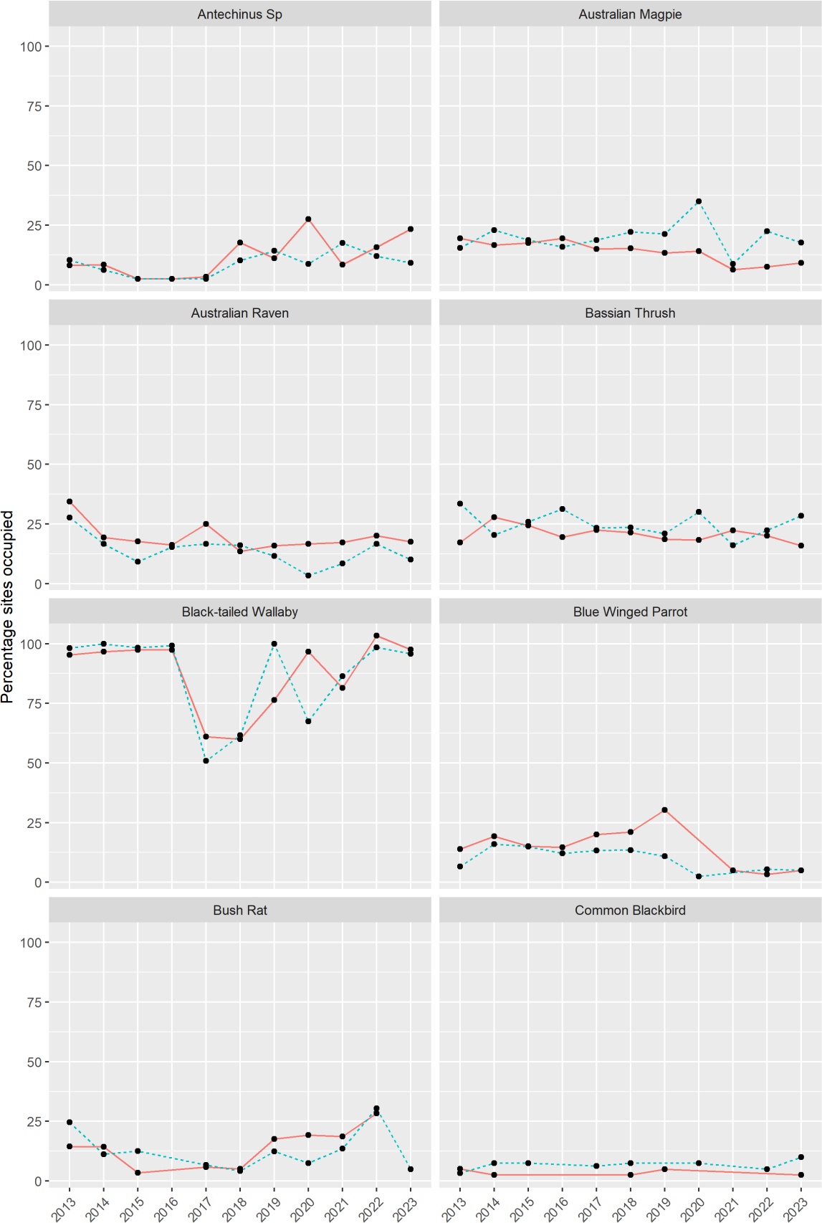

Figure A1. The average naïve occupancy (percentage of sites occupied) of native and introduced species at Glenelg Ark FCMLs' and 'NFCMLs' from 2013 to 2023.
Red solid lines: treated locations; aqua dashed lines: untreated locations.

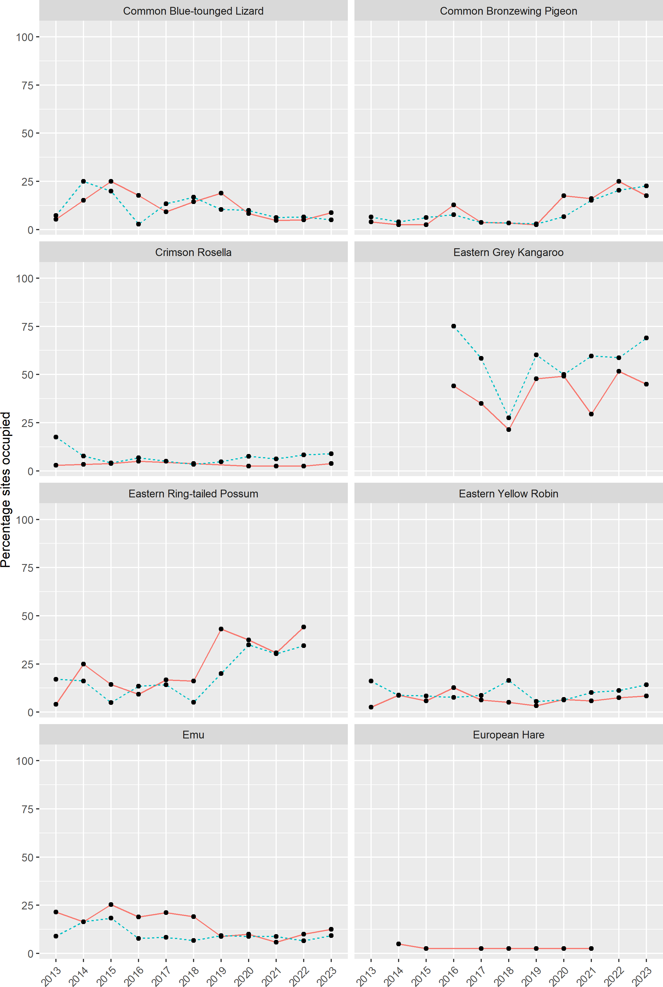

Figure A1 continued. The average naïve occupancy (percentage of sites occupied) of native and introduced species at Glenelg Ark FCMLs' and 'NFCMLs' from 2013 to 2023.
Red solid lines: treated locations; aqua dashed lines: untreated locations.

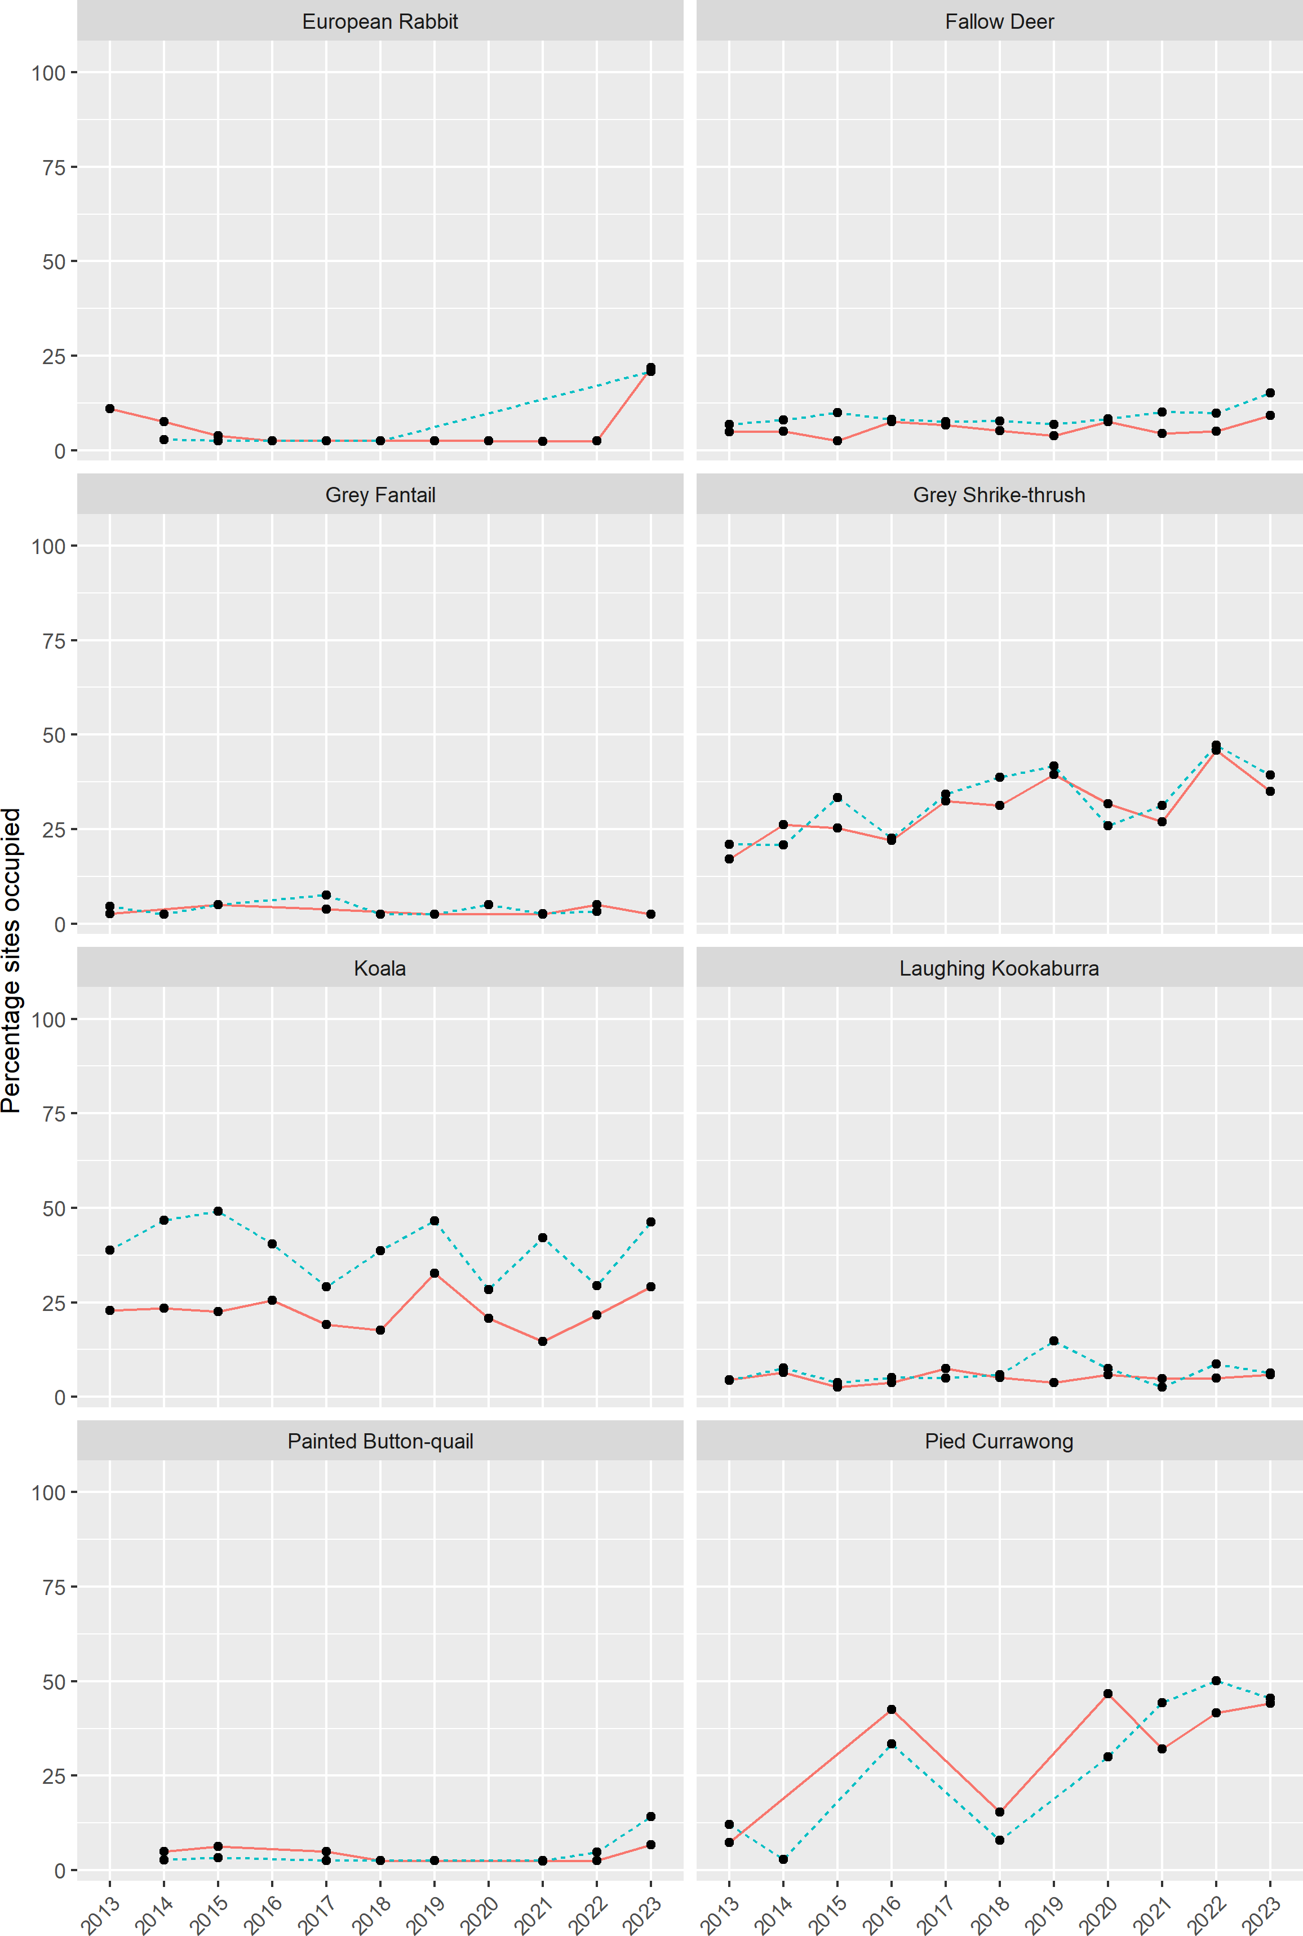

Figure A1 continued. The average naïve occupancy (percentage of sites occupied) of native and introduced species at Glenelg Ark FCMLs' and 'NFCMLs' from 2013 to 2023.
Red solid lines: treated locations; aqua dashed lines: untreated locations.

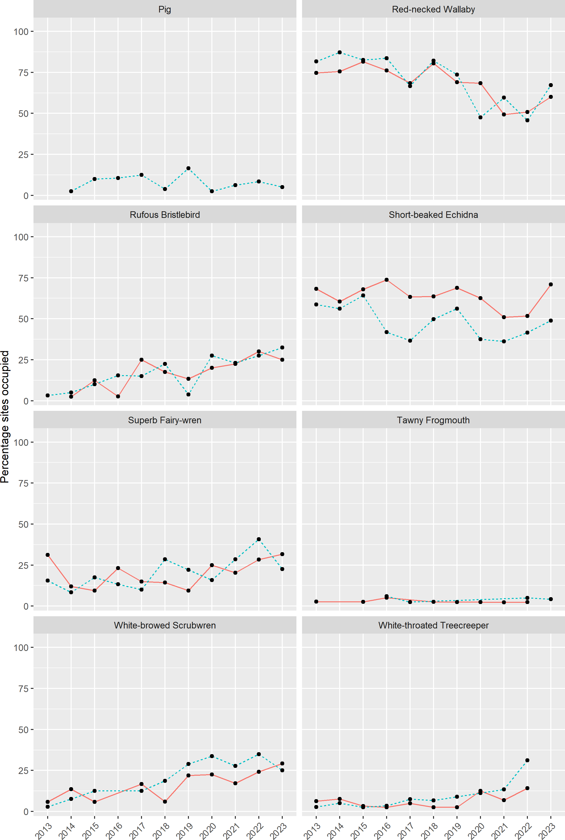

Figure A1 continued. The average naïve occupancy (percentage of sites occupied) of native and introduced species at Glenelg Ark FCMLs' and 'NFCMLs' from 2013 to 2023.
Red solid lines: treated locations; aqua dashed lines: untreated locations.

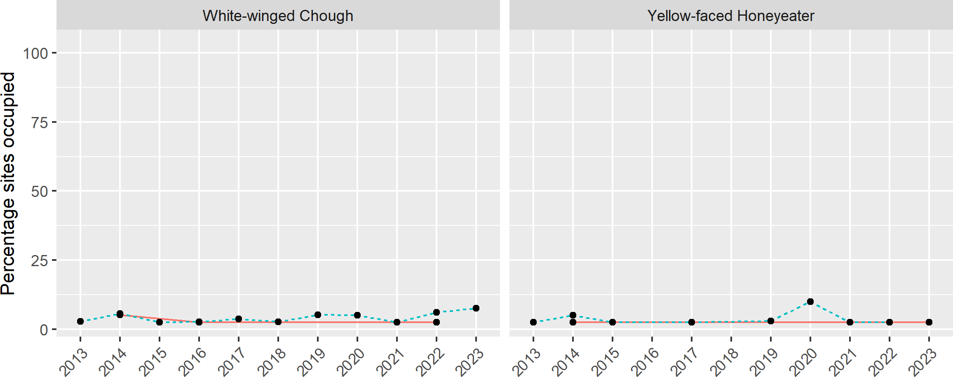

Figure A1 continued. The average naïve occupancy (percentage of sites occupied) of native and introduced species at Glenelg Ark FCMLs' and 'NFCMLs' from 2013 to 2023.
Red solid lines: treated locations; aqua dashed lines: untreated locations.

www.decca.vic.gov.au www.ari.vic.gov.au

