|  |
| --- |
| Victorian Environmental Flows Monitoring and Assessment Program (VEFMAP) Stage 6 |
| Vegetation Project Update – 2018  Monitoring of Aquatic and River Bank Vegetation: **Campaspe River** |

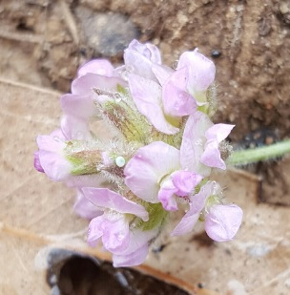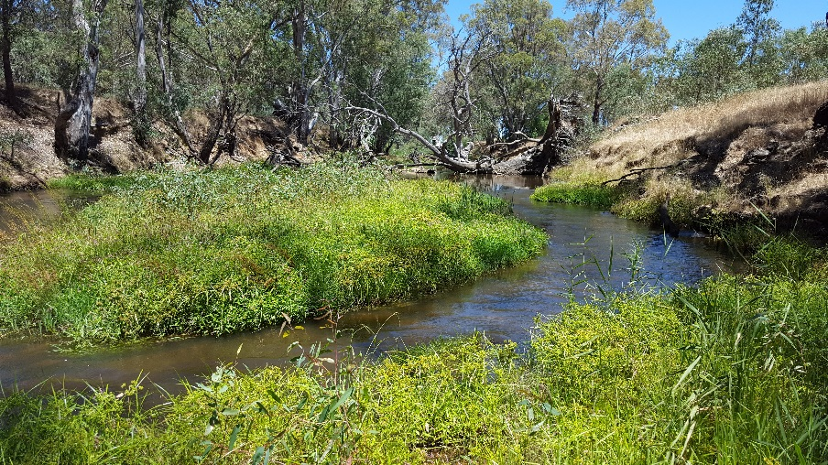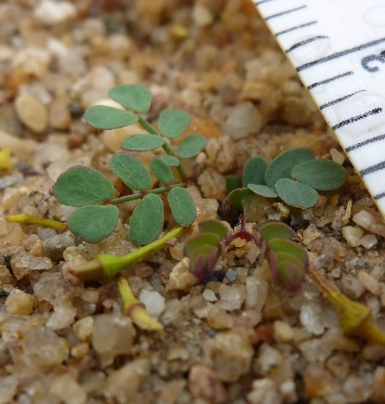

* 1. **VEFMAP Stage 6**

The Victorian Environmental Flows Monitoring and Assessment Program (VEFMAP) is now in its sixth stage of delivery. VEFMAP Stage 6 will run from 2016 to 2020, funded through the Victorian government’s $222 million investment in waterway and catchment health. VEFMAP Stage 6 focusses on ‘intervention’ or ‘event-based’ monitoring of fish and vegetation responses to flows and incorporates data from previous VEFMAP stages.

## Stage 6 – Vegetation Objectives

Stage 6 vegetation objectives aim to measure vegetation responses to environmental flows. The monitoring approach has been substantially modified from previous stages of the program and is initially focussing on individual flow events in individual waterways to detect short-term responses of native and exotic plant species to environmental water delivery. A longer-term understanding will be gained by repeated short-term assessments and by using data from previous stages of VEFMAP to create longer-term datasets. Importantly, these responses will be considered in relation to other factors that may influence flow responses, such as grazing, rainfall, soil properties and season (see program overview for details, DELWP 2017a).

## 2017/18 Monitoring on the Campaspe River

The Campaspe River was the first river to be surveyed as part of Stage 6 vegetation monitoring. Surveys were conducted at six sites that were used for the previous stages of VEFMAP but using the updated methods. In 2017/18, the same six sites were surveyed again to look at changes through time and in response to different flow events (Figure 1).

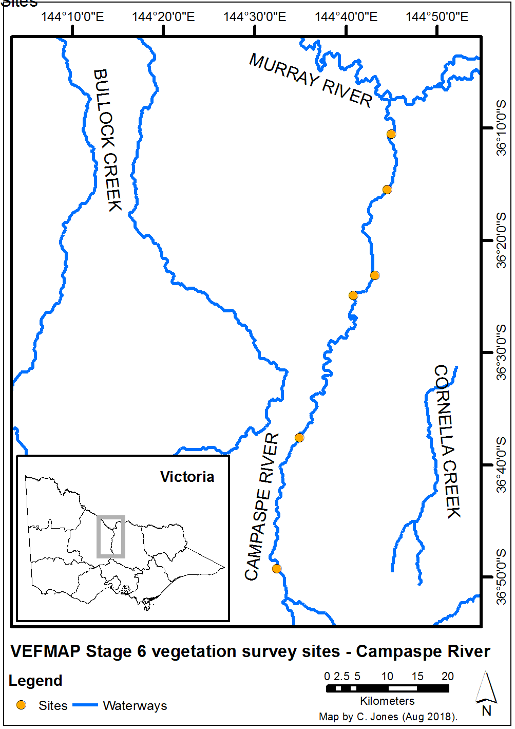

**Figure 1 – Map of survey sites on the Campaspe River.**

## Survey timing and hydrology

Timing for the VEFMAP surveys considers rainfall and managed flow deliveries. The sampling design recommends surveys occur before a planned flow delivery and two to 12 weeks after the event, depending on the flow regime (to provide adequate time for vegetation to respond and for germinants to emerge). Timing is altered if rainfall increases the flow prior to a planned survey. In 2017/18, rainfall on the Campaspe River, measured near Rochester, did not result in large changes to the river flow outside of the managed flow events (Figure 2).

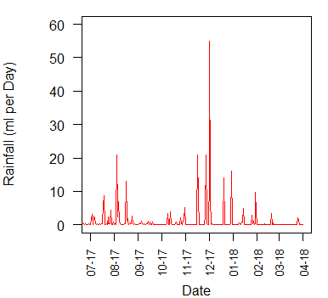

**Figure 2 – Daily rainfall recorded at Rochester in 2017/18.**

In 2017, this resulted in a survey prior to the first of two spring freshes in September and November, a second survey in January between the second fresh and summer high flows, and a third survey after the high flow period (Figure 3).

A small additional survey was conducted at one site only in November 2017, prior to the second, and larger, spring fresh. This was done to monitor the survival of plant seedlings between and after each flow event.

The first spring flow peak lasted three days, while the second flow peak lasted six days. The long summer high flow was a consumptive delivery and lasted a considerable time, through the hottest part of the year.

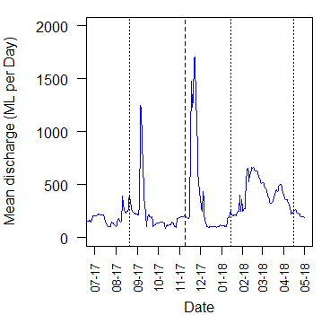

**Figure 3 – River flow discharge recorded at Rochester in 2017/18 and VEFMAP vegetation survey timing for the three full surveys (dotted lines) and one additional part-survey (dashed line).**

## Methods

Survey methods are outlined in detail in VEFMAP Stage 6 Part B: Monitoring design and sampling methods (DELWP 2017b). The surveys include a wide range of methods: fine-scale vegetation measurements, broad-scale mapping, tree canopy assessments and hydrology assessments.

## Survey observations

The first short fresh in September 2017 was too brief to have any negative impact on terrestrial exotic species and we observed good vegetation growth of native and exotic plants on the bank through this period, with plenty of water available for growth. This event was successful in encouraging growth and recruitment of seedlings, although many seedlings would also have recruited earlier in the year.

The second event in November was double the duration and slightly higher in magnitude than the first. This event was too late in the season to have any negative impact on annual grasses, which had reached maturity just a week or two prior to the event. The duration did not kill the inundation tolerant native plants on the bank either, including many seedlings. This event did result in increased recruitment of monocots on the river bank (Figure 4).

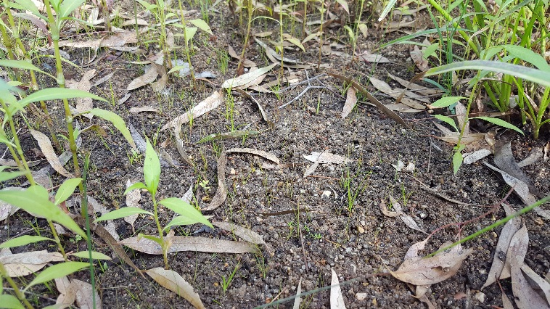**Figure 4 – Monocot recruitment (grasses, sedges and rushes) on the river bank following the November fresh in 2017.**

The third major event on the Campaspe River in 2017/18 was a long high flow that was released as a consumptive delivery, not an environmental flow. This event was not very high but remained for far longer than expected under natural flows. Plants that are very tolerant of inundation (mostly native) were mostly very successful in persisting through this long period of flow, but only if they were well enough established. Plants that recruited in winter were often large enough by this time to persist, while most of the monocot recruits from the November fresh were killed by the flow.

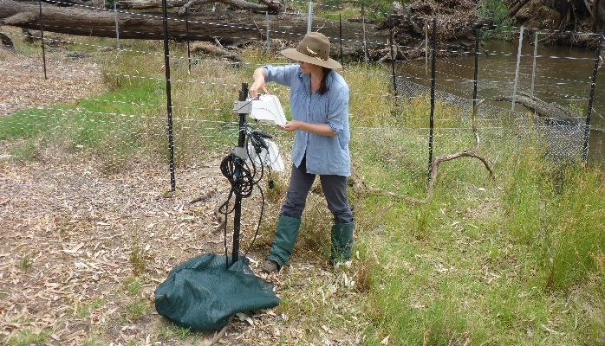After the long summer high flow event, we recorded the recruitment of a new cohort of plants that will be monitored during surveys of the same sites in 2018/19.

## Grazing Exclosures

Six grazing exclosure plots have been constructed on the banks of the Campaspe River across three sites; these will continue to be surveyed in 2018/19. Each site has river frontage that is intermittently grazed by livestock. Evidence from the exclosure plots during 2017/18 shows livestock impacts depend heavily on the type of livestock (e.g. cattle or sheep), the number of individuals and the duration of grazing. Under light grazing, the vegetation can persist reasonably well and there seems to be a suitable balance between grazing pressure and growth. However, in most cases the grazing pressure was too high and the negative impacts to native riparian vegetation were significant. The magnitude of the difference is highlighted through comparison of the vegetation inside and outside the grazing exclosures. There was a clear reduction in native vegetation cover in response to grazing (outside the exclosure plots) and only the least palatable plants persisted (Figure 5).

Typically, sheep cause less damage to both the bank (e.g. pugging) and instream vegetation because of their smaller size compared to cows, and their tendency to not enter water as commonly as cows. However, sheep can cause significant damage where they are in high abundance or when they graze for long periods.

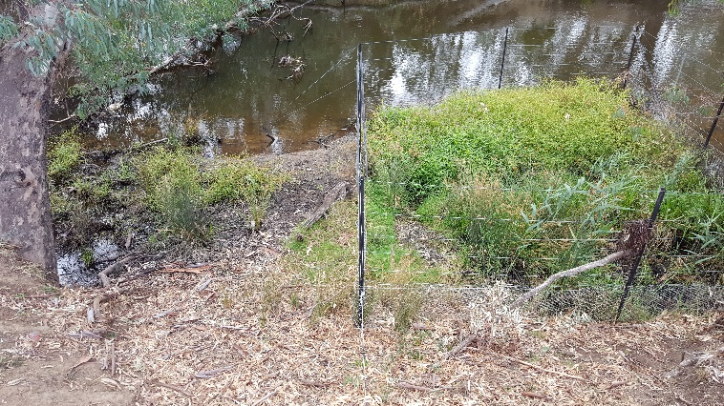In order to realise any benefits of environmental water for native vegetation, it will be important to continue to manage the level of grazing at all sites with livestock access throughout the river.

**Figure 5 – A comparison of vegetation inside and outside a grazing exclosure at Doaks Reserve.**

## Soil moisture

Six soil moisture recording probes have been installed on the Campaspe River at three sites. Soil moisture monitoring will continue at these sites through 2018/19. Each probe records soil moisture and temperature at 10 cm intervals along its length, to 85 cm deep. Data are continuously recorded every hour.

**Figure 6 – Soil moisture monitoring at Doaks Reserve.**

The two freshes in spring and summer 2017 increased soil moisture levels on the river bank. At the Bryant’s Lane site, the bank response was different for locations low on the bank compared to higher on the bank. Elevations low on the bank remained almost saturated at all depths (apart from the top 5cm through winter to summer (Figure 7). In contrast, at elevations higher up the bank, the soil moisture decreased between flow events and the two freshes in September and December increased soil moisture throughout the depth profile (Figure 8).

Similar patterns were found at the other recording sites, with differences depending on the exact position of the probe, the soil type and the flow at each location.

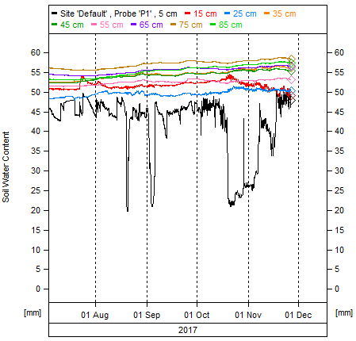

**Figure 7 – Soil moisture monitoring at Bryant’s lane, low on the river bank, close to the baseflow water’s edge.**

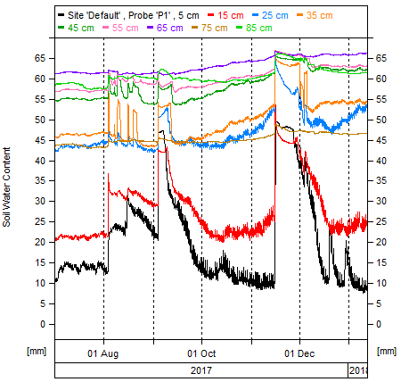 **Figure 8 – Soil moisture monitoring at Bryant’s lane, higher on the river bank, a few metres up from the baseflow water’s edge.**

## Summary

Using multiple methods and surveying at regular intervals to directly address the VEFMAP Stage 6 monitoring objectives, the program has so far been successful in evaluating vegetation responses to flows. The observations summarised here form part of a larger story relating to vegetation responses to environmental water. Further information on the other systems surveyed and research projects is also available.

Environmental flows are being delivered on the Campaspe River to deliver benefits to vegetation and a wide range of fauna. Waterway managers are working closely with researchers, waterway authorities and a range of other stakeholders to manage flow deliveries as effectively as possible for the environment and other water users. Flows delivered at the right time, magnitude and duration can be beneficial to vegetation on the river banks, in the channel and beyond the channel. Flows delivered at non-ideal times or sizes may have detrimental effects on vegetation, but the native riparian vegetation is mostly very tolerant of variable flow conditions.

## Collaboration

VEFMAP Stage 6 includes many collaborations between DELWP staff, waterway managers and authorities, academics (internal and external) and students.

## References

DELWP (2017a) VEFMAP Stage 6 Part A: Program context and rationale. A report by Arthur Rylah Institute for Environmental Research and Integrated Water and Catchments Division, Department of Environment, Land, Water and Planning.

DELWP (2017b) VEFMAP Stage 6 Part B: Program design and monitoring methods. A report by Arthur Rylah Institute for Environmental Research and Integrated Water and Catchments Division, Department of Environment, Land, Water and Planning, Victoria.Department of Environment, Land, Water and Planning.

## Contact Chris.Jones@delwp.vic.gov.au

Darren.White@nccma.vic.gov.au

|  |  |
| --- | --- |
| © The State of Victoria Department of Environment, Land, Water and Planning 2018  LogoThis work is licensed under a Creative Commons Attribution 4.0 International licence. You are free to re-use the work under that licence, on the condition that you credit the State of Victoria as author. The licence does not apply to any images, photographs or branding, including the Victorian Coat of Arms, the Victorian Government logo and the Department of Environment, Land, Water and Planning (DELWP) logo. To view a copy of this licence, visit http://creativecommons.org/licenses/by/4.0/  ISBN 978-1-76077-354-0 (print), 978-1-76077-355-7 (pdf/online/MS word)  Disclaimer  This publication may be of assistance to you but the State of Victoria and its employees do not guarantee that the publication is without flaw of any kind or is wholly appropriate for your particular purposes and therefore disclaims all liability for any error, loss or other consequence which may arise from you relying on any information in this publication. | Accessibility  If you would like to receive this publication in an alternative format, please telephone the DELWP Customer Service Centre on 136186, email [customer.service@delwp.vic.gov.au](mailto:customer.service@delwp.vic.gov.au), or via the National Relay Service on 133 677 [www.relayservice.com.au](http://www.relayservice.com.au). This document is also available on the internet at https://www.ari.vic.gov.au/research/rivers-and-estuaries/assessing-benefits-of-environmental-watering |